**High pollinator population connectivity in heavily disturbed landscapes: substantial gene flow despite large urbanized areas in two hoverflies**

Julian Wittische 1,2,*, Ximo Mengual 3, Frank Drygala, Joerg Mehnert, Stéphanie Lippert1,2, Amanda Luttringer1,2, Hinatea Ariey1,2, Alain Frantz 1,2

1: Musée National d’Histoire Naturelle, 25, rue Muenster, L-2160, Luxembourg, Luxembourg

2: Fondation Faune-Flore, 24, rue Muenster, L-2160, Luxembourg, Luxembourg

3: Zoologisches Forschungsmuseum Alexander Koenig, Leibniz‐Institut zur Analyse des Biodiversitätswandels, Adenauerallee127, D‐53113 Bonn, Germany

*: Corresponding author (julian.wittische@mnhn.lu)

IDEAS:

~~Landscape genetics~~

Migraine (bugs)

IBE (not conclusive so far but more to try)

Potential destinations:

Evolutionary Applications

Ecography (5000 words; IF: 6.8)

Molecular Ecology (8000 words; IF: 6.6)

Landscape Ecology (8500 words; IF=5.1)

**ABSTRACT**

Hoverflies (Syrphidae) are essential pollinators, and their severe decline jeopardizes their enormous contribution to plant diversity and agricultural production. However, we know little about the dispersal abilities of hoverflies in urbanized landscapes, limiting our understanding of the spatiotemporal dynamics of plant–pollinator systems, and reducing our ability to preserve biodiversity in the context of global changes. Previous work has not addressed how urbanization affects the functional connectivity of hoverflies, and whether dispersal is a limiting factor in their population dynamics. In this study, we investigate the spatial genetic structure and spatial variation in genetic diversity of two species of hoverflies in two urban areas. Using thousands of specimens collected by hand netting from two western Europe urbanized study areas of 490 km2 and 460 km2 in 2021, we identified XX and 24 microsatellite SNP loci for *Syritta pipiens* and *Myathropa florea*, respectively. Using STRUCTURE, DAPC and IBD analyses, we found evidence for high genetic connectivity for both species, suggesting effective dispersal at scales larger than metropoles, despite urbanization. Although anthropogenic land cover changes generally have dramatic consequences on biodiversity, some hoverfly species retain high connectivity, which suggests that dispersal is not a strong limiting factor in their metapopulational dynamics. Provided we maintain or restore habitat, recolonization should therefore be prompt even in urban areas.

**KEYWORDS**

Landscape genetics; Spatial ecology; Diptera; Urbanization; Machine learning

# INTRODUCTION

Pollinators provide a key ecosystem service to agricultural crops and wild plants, but they are declining across the world. It has been estimated that, globally, the economic value of pollination is worth hundreds of billions of US dollars (Doyle et al., 2020; Gallai et al., 2009). The vast majority of crops (Klein et al., 2007; Reilly et al., 2020) and of wildflowers (Ollerton et al., 2011) benefit from insect pollination by, in particular, bees and hoverflies (Potts et al., 2015). Pollinators also support an immense range of other organisms (Ollerton, 2017). However, evidence of the loss of pollinators is clear-cut: wild pollinators are declining at local, regional and global scales, in both diversity and abundance (Biesmeijer et al., 2006; Hallmann et al., 2017; Sánchez-Bayo and Wyckhuys, 2021, 2019; Senapathi et al., 2015). The main underlying drivers behind declines are the intensification of land-use, climate change, and the spread of invasive species and parasites/pathogens (Dicks et al., 2021; Ollerton, 2017; Potts et al., 2010; Vanbergen et al., 2013). The spread of urban areas and the intensification of agriculture have resulted in the destruction and fragmentation of many of pollinator habitats (Seibold et al., 2019). There is still a considerable lack of knowledge on the mechanisms underlying the responses of invertebrate pollinators to fragmentation resulting from land-use change (Dicks et al., 2013; Gill et al., 2016; Simmons et al., 2019; Winfree et al., 2011).

Because of demographic growth, land use change for new infrastructure and urban development is expected to be considerable even in already heavily urbanized countries. This, in turn, will lead to further loss and fragmentation of natural and semi-natural habitats (Jaeger et al., 2016). Cologne is the fourth-most populous city in Germany and recently commissioned a major inventory of pollinators (Stadt Köln, 2022), notably stimulated recent findings about country-wide insect declines (Hallmann et al., 2017; Seibold et al., 2019). Luxembourg has recognized that habitat loss and fragmentation are threatening its biodiversity in general and insect pollinators in particular (Ministère de l’Environnement, du Climat et du Développement durable, 2022). Key strategies to counteract the negative effects of habitat fragmentation include the design of a network of ecological corridors as well as land set-a-side to support pollinators within the agricultural landscape. In order for these mitigating measures to be successful, however, it is important to understand the functional connectivity of the landscape from the viewpoint of the pollinator (Dreier et al., 2014; Rands, 2014).

Although dispersal is a key trait to deal with habitat fragmentation, we only have a limited understanding of dispersal for most insect pollinators.Dispersal is required to maintain connectivity in the face of landscape fragmentation, to colonize new habitats and to allow re-colonization after local extinction. Dispersal therefore impacts species distribution, community structure, (meta-)population dynamics, gene flow and extinction risk (Bowler and Benton, 2005). Species with high dispersal ability generally are better able to move efficiently between suitable habitat patches and may exploit fragmented resources more efficiently (Öckinger et al., 2010). Nevertheless, the results from work on Apiformes suggest that even good dispersers can be impacted by habitat fragmentation. Bumblebee (Bombus) species normally exhibit very little genetic structure (Dreier et al., 2014; Lozier et al., 2011). However, impervious cover associated with built-up areas significantly limited gene flow in a North American bumblebee (Jha and Kremen, 2013). Even at larger spatial scales, urban areas can be a substantial gene flow barrier for pollinators (Davis et al., 2010). A particular difficulty with evaluating the impact of land-use change relates to the fact that flying ability and response to habitat fragmentation differs significantly between pollinators, even between closely related species (Greenleaf et al., 2007; Jauker et al., 2009; Steffan-Dewenter et al., 2002). We thus need to better understand the effect of landscape disturbance on the connectivity of pollinators (Taylor et al., 1993), the geographic scale at which mitigation measures should be implemented, and which element of the population dynamics of pollinators is the most sensitive to anthropogenic disturbance.

Hoverflies (Syrphidae) are an important group of pollinators, but they are understudied relative to bees, and little is known about their dispersal and their response to landscape fragmentation. Hoverflies are a biologically very diverse family of flower-visiting flies (Bickel et al., 2009; Speight, 2017; Wardhaugh, 2015). Their dependence on floral resources makes hoverflies the most important pollinators besides bees, providing a major contribution to plant diversity and agricultural production (Hodgkiss et al., 2018; Jauker et al., 2009; Pekas et al., 2020; Rader et al., 2016; Ssymank et al., 2008). Species do not display strict selectivity for specific flower species (Branquart and Hemptinne, 2000; Lucas et al., 2018) which make them especially important in disturbed landscapes (Jauker et al., 2009). Many hoverfly larvae feed on aphids and are effective biocontrol agents, especially in agricultural landscapes (Pekas et al., 2020; Speight, 2017), which adds to their large contribution to human food security.

Molecular genetic methods are powerful tools to investigate the effect of fragmentation on target species where dispersal capability is hard to evaluate directly, but such methods have seldom been used on hoverflies. Capture-mark-recapture (CMR) methods have been used to study hoverfly dispersal in the past (Aubert et al., 1969; Aubert and Goeldlin de Tiefenau, 1981; Rotheray et al., 2014). However, given the limitations of conducting CMR across a large area for abundant small insects, landscape connectivity is easier to investigate using molecular genetic methods. Genetic connectivity is evaluated through a quantification of gene flow, which is directly related to dispersal as genes are propagated by individuals or propagules which disperse before reproduction (Broquet and Petit, 2009; Cayuela et al., 2018). Therefore, the greater the genetic connectivity is, the easier it is to disperse through the landscape. One population genetics study of hoverflies described continental-scale patterns for a migratory species (Raymond et al., 2013) for which one would expect no strong isolation-by-distance or landscape resistance signal at a regional scale, due to the extreme genetic mixing associated with mass migration. Another hoverfly study found no substantial barriers to gene flow, though they used a small number of individuals, from a fraction of a low disturbance forest landscape (Schauer et al., 2018). However, the effect of urbanization on hoverfly functional connectivity has, to our knowledge, never been studied.

In this study, we investigated the genetic diversity, structure, and isolation-by-distance (IBD) of two species of hoverflies, *S. pipiens* and *M. florea*, based onthousands of individuals in two urbanized landscapes in Western Europe.We expected some population-wide and fine-scale genetic structure due to the large extent and the anthropogenic nature of the study areas, notably the large unvegetated impervious areas present in and around cities.

# METHODS

## | Study areas, study organisms, and sampling

To evaluate the genetic connectivity of hoverflies in the face of disturbance, we chose two urbanized study areas of around 400km2. This specific extent is a key parameter. Indeed, it should allow us to feasibly sample the whole landscape to improve the accuracy of our inferences, while being large enough to detect potential effects of large-scale anthropogenic disturbance on genetic variation. The shape of the Luxembourg study area was chosen to include most parts of the urban sprawl between the two largest urban agglomerations in the country (Luxembourg and Esch-sur-Alzette), as well as sufficient amount of adjoining countryside. The Cologne study area focused on administrative city limits as it fit our requirements. Indeed, although Cologne (Fig. X) is the fourth most populous and the third largest city in Germany, it has a large number of green surfaces, protected areas, riparian forest fragments and wetlands (Braun and Herold, 2004; Curdes, 1998; Mitter and Weber, 2011). As study organisms, we chose *Syritta pipiens* (Linnaeus, 1758) and *Myathropa florea* (Linnaeus, 1758), two hoverfly species with long flight seasons and likely to occur across the whole study areas based on known preferred habitats preliminary field experience and previous inventories (Leopold et al., 1996). We avoided migratory species because their genetic variation is less likely to bear signal of isolation by distance and structure (Raymond et al., 2013) given their sometimes massive ability to spread (Jia et al., 2022). Our sampling design was to catch at least one individual per squared kilometer in order to have as few gaps in geographical coverage as possible, following a uniform grid. The analytical purpose of this sampling design was to decrease bias and improve our accuracy in detect influential landscape features, if there were any (Oyler-McCance et al., 2013; Schwartz and McKelvey, 2009). The size of the sampling unit (1km2) reflects the spatial scale at which hoverfly density optimally relates to landscape context (Kleijn and van Langevelde, 2006). We caught 831 and 1226 *S. pipiens* individuals, and 559 and 394 *M. florea* individuals in Cologne and the Luxembourg study area, respectively (Fig. 1).

## | Laboratory procedures

DNA was extracted using an ammonium acetate-based salting-out procedure (Miller et al., 1988). DNA extracts were quantified using a Drop-Sense 16 spectrophotometer (Trinean, Gentbrugge, Belgium).

We used blast-2.11.0+ to perform a stand-alone blast of each of the 500 microsatellite sequences against the genome of [*Syritta pipiens* (assembly idSyrPipi1.1)](https://www.ncbi.nlm.nih.gov/genome/98123?genome_assembly_id=1557693) and against an ‘in-progess assembly’ of the genome of Myathropa florea (20200119.hicanu.purge) obtained from Darwin Tree of Life Project (<https://github.com/darwintreeoflife/darwintreeoflife.data>, accessed 08/11/2022), respectively. For each species, we tested fifty microsatellite loci that only matched one site in the respective reference genome and that differed in their number of microsatellite repeats relative to the reference genome.

We tested the amplification success of all 50 primers using a universal tail approach for fluorescent labelling of Polymerase Chain Reaction (PCR) products, as described by Culley et al. ([2013](https://link.springer.com/article/10.1007/s10531-020-01941-7#ref-CR29)) and eight good- quality DNA samples originating from individuals sampled across both study areas. Each PCR contained 1x GoTaq Master Mix (Promega, Walldorf, Germany), 0.2 μM of each primer and 10 ng of DNA. After a 3-min denaturation at 95 °C, the PCR consisted of 35 cycles of denaturation at 95 °C for 30 s, annealing at 60 °C for 45 s and an extension at 72 °C for 30 s. The PCR was ended with a final extension for 10 min at 72 °C. The PCRs were performed in a Mastercycler nexus (Eppendorf, Hamburg, Germany). Loci that were polymorphic and that gave rise to clear peaks were retained for further analysis. We then used the PRIMER3 software to develop new primer pairs that gave rise to products of differing length to allow multiplexing. The primers were specified to have a melting temperature of 59-61 °C (optimum 60 °C), a length of 18 to 26 base pairs (20 bp optimum), the presence of a G/C clamp, a maximum poly-X of three tandemly repeating nucleotides (e.g. TTT), with all other parameters set to default.

For *Syritta pipiens* we retained 14 microsatellite loci that were amplified in two multiplex PCRs, while the 24 microsatellite loci for *Myathropa florea* were amplified in three multiplex recations (Table 1) [all what follows should be summarized in a table].

EXAMPLE



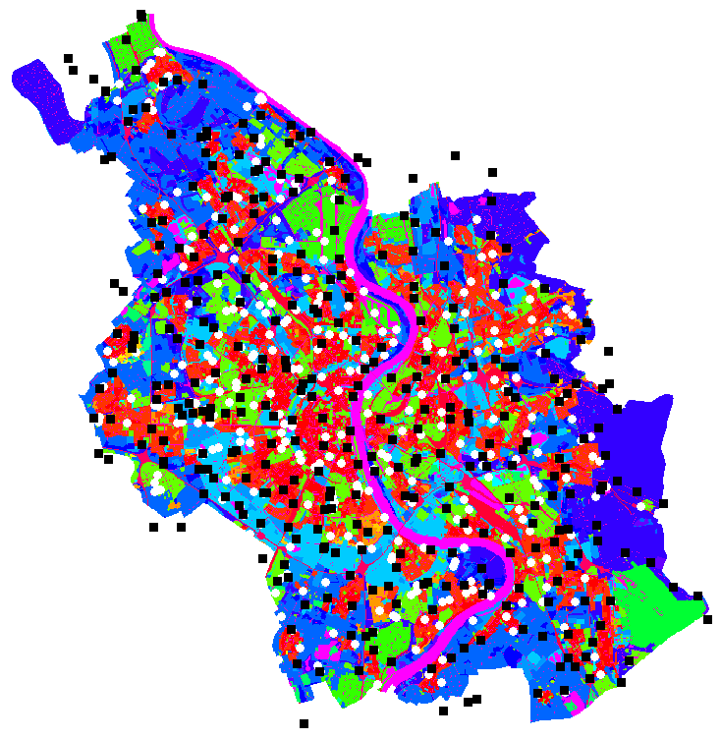

**Figure 1** [PLACEHOLDER]. Map of Cologne showing the diversity and quantity of disturbed land covers (legend, north, scale and Lux map will be created later). White disks represent *S. pipiens* samples and black squares represent *M. florea*.

Each PCR contained 1x GoTaq Master Mix (Promega, Walldorf, Germany), and between 0.1-0.4 μM of each primer (Table X). PCRs started with 3 min denaturation at 95 °C, followed by 35 cycles of denaturation at 94 °C for 30 s, annealing at 60°C for 45 s and extension at 72 °C for 30 s. The final incubation was at 72 °C for 10 min. Allele sizes were determined using GENEMAPPER version 4.0 (Applied Biosystems). The genetic profiles of all samples consisted of at least 11 loci for Syritta pipiens and at least 18 loci for Myathropa florea. Extreme outliers based on a preliminary PCA analysis were sent to sequencing to verify their species identification. They all belonged to our target species and were kept in the dataset.

## | Genetic diversity

We conducted all analyses in this manuscript in R (R Core Team, 2022) using RStudio (RStudio Team, 2022), except for the STRUCTURE analysis. We conducted basic analyses of our genetic datasets using the *adegenet* v. 2.1.7 (Jombart, 2008; Jombart and Ahmed, 2011) ,the *hierfstat* v.0.5.11 (Goudet, 2005), the *pegas* v. 1.1 (Paradis, 2010), the *PopGenReport* v. 3.0.7 (Adamack and Gruber, 2014) and the *poppr* v. 2.9.3 (Kamvar et al., 2014) R packages. We evaluated allelic richness, heterozygote deficiency, overall fixation indices with bootstrap confidence interval, fixations indices per locus, and the pairwise genetic distance between our study areas. To explore linkage disequilibrium in our dataset, we also calculated standardized indices of association over all loci with a one-sided permutation test, as well as pairwise indices among all loci (Agapow and Burt, 2001; Kamvar et al., 2014). We also evaluated whether null alleles were likely using two resampling-based tests (Brookfield, 1996; Chakraborty et al., 1994). The percentage of missing data was 2.24% for *S. pipiens* and 2.93% for *M. florea*.

## | Clustering and isolation-by-distance

We used two different approaches to estimate the most likely number of distinct genetic clusters (K). First, we considered a Bayesian model-based approach and used STRUCTURE v. 2.3.4 (Pritchard et al., 2000), and chose the admixture model and correlated allele frequencies. An important parameter to set it α, the Dirichlet prior parameter for the degree of admixture (Hubisz et al., 2009) which conceptually represents the number of ancestral populations from which each individual’s alleles originate. We set the inference of a different α for each study area and allowed unequal representation of source populations in the sample (alternative ancestry prior). We also set initial values of α it to 1/K because this parametrization led to lower average assignment errors in a simulation study (Wang, 2017). We conducted ten independent runs with 200 000 Markov Chain Monte Carlo burn-in iterations followed by 1 000 000 iterations for one to five clusters. To determine the most likely number of clusters, we directly compared log-likelihoods for all *K* values across the ten runs, and we used the Δ*K* statistic which is based on the rate of change in the log probability of data given *K* (Evanno et al., 2005). We also surveyed the variation in STRUCTURE outputs and matched clusters across runs to avoid issues with label change and multimodality, using STRUCTURE HARVESTER (Earl and vonHoldt, 2012) and CLUMPAK (Kopelman et al., 2015).

Secondly, we considered a model-free approach which is less reliant on assumptions and used discriminant analysis of principal components (DAPC; Jombart et al., 2010, 2009). We considered both a grouping prior based on study areas (2 study areas = 2 potential clusters) and *de novo* grouping because several studies have highlighted that those two alternatives may produce different clustering outcomes (Glück et al., 2022; Miller et al., 2020). When no grouping is input (*de novo*), DAPC uses sequential *k*-means to find potential clusters prior to the estimation of the best number of genetic clusters. We followed the up-to-date recommendations from the development team regarding the appropriate steps to conduct DAPC (Jombart and Collins, 2022). When using the *de* novo method, we first conducted a principal components analysis that transforms the genotype data to a new coordinate system and generates linear combinations of genetic information. Each of those combinations, also called components or eigenvectors, aligns with the direction of maximum variance in the rotated data while being orthogonal to the previous component. Using all the principal components, we then ran *k*-means with 1000000 iterations and used Bayesian Information Criterion (BIC) to evaluate the performance of *K* values from 1 to 40. We chose the *K* value using a criterion that evaluates the decrease of BIC between successive *K* and selects the first sharp change. Sharpness of change was defined using a hierarchical analysis of all BIC changes. We chose this method of *K* selection because it is similar to the moment interpretation of likelihood values for STRUCTURE. We ran this *de novo K* selection procedure 100 times, and chose the most common *K* among those independent runs. Regardless of the method we used to describe potential clusters, we chose the best number of components to retain for the DAPC based on both cross-validation (1000 iterations) and *a*-score optimization. This is a necessary step because the first few components represent most of the genetic variation, we want to find a balance to preserve discrimination power while avoiding overfitting. We systematically used all discriminant functions for the assignment of individuals into clusters, and used cross-validation to evaluate the general performance of the DAPC and compared it with a random classifier.

To explore whether isolation-by-distance (IBD) is responsible for genetic differentiation in our study landscapes, we first evaluated the linear relationship between the natural logarithms of geographic distance and Loiselle’s kinship values (Loiselle et al., 1995) which measure the genetic relatedness between pairs of individuals. We chose this genetic distance because it is considered a less biased estimator with low sampling variance (Vekemans and Hardy, 2004). Finally, to understand the scale at which genetic structure is shaped by dispersal we created a Mantel correlogram using Sturge’s rule to define distance classes and used a Monte Carlo procedure to test whether Mantel correlation (Mantel, 1967) values are significant. We used a progressive (Legendre and Legendre, 2012) Holm correction for multiple testing for the Mantel correlograms, which is admittedly less conservative than other options, giving us more chance of detecting spatial structure.

# RESULTS

## | Genetic diversity

Prior to running genetic structure analyses, we decided to remove only loci that presented both linkage disequilibrium and extreme heterozygote deficiency, as well as a frequency of null alleles at a locus significantly different from zero. Therefore, we removed one locus from the *S. pipiens* dataset (Spp141).

Average expected (He +- sd) and observed heterozygosity (Ho + sd) were comparable in both spiecies ~~were rather high both species~~ 0.61 +- x and 0.57 +- for *S. pipiens*; 0.49 and 0.46 for *M. florea*). [or something similar]

For *S.* pipiens, overall *FST* was very low (0.0017 [95%CI -0.0001; 0.0055]) with a larger part of the genetic variation being captured by within population variation (*FIS*= 0.0609 [95%CI 0.0312; 0.0937]). For *M. florea*, overall *FST* was even lower (0.0009 [95%CI 0.0001; 0.0029]) with, again, a larger part of the genetic variation being captured by within population variation (*FIS*= 0.0717 [95%CI 0.0410; 0.1134]). Consequently, pairwise population differentiation was very low between our two study areas.

## | Clustering and isolation-by-distance

Bayesian ancestry inference using STRUCTURE did not conclusively support a certain number of clusters for either species. Different approaches to choose *K* generally supported *K*=2 for *M. florea* (one metric chose *K*=6; Table 1) whereas one to three clusters were selected for *S. pipiens*. Importantly, inferred clusters were not geographically meaningful at all, with extreme genetic mixing as almost all individuals assign to both clusters with the second one representing only a minor fraction of the genetic variation within all individuals (Table 1; Fig. 2). There was no substantial difference in cluster assignment between areas.

*De* novo DAPC analyses selected *K*=3 in 62% of runs for *S. pipiens*, and *K*=6 in 15% of runs for *M. florea*, which no other number of clusters reaching 15% of runs. The best number of clusters for both species was not obvious from the BIC value graph given a gradual decline without a very sharp turning point (Sup. Mat. 1). 22 and 21 PCA axes were found to be the number of axes achieving both the highest success and the lowest mean squared error for *S. pipiens* and *M. florea, respectively*. In both species, DAPC-based classifiers performed much better than random chance (Sup. Fig. 2) with successes of 99.9% and 92.8%, and root mean squared errors of 0.0025 and 0.076 for *S. pipiens* and *M. florea*, respectively.

The single discrimination functions (responsible to distinguish clusters) for *a priori* DAPC showed a lot of overlap for both species (Fig. 3). 50 and 83 PCA axes were found to be the number of axes achieving both the highest success and the lowest mean squared error for *S. pipiens* and *M. florea*, respectively. *A priori* grouping individuals by their geographic origin (i.e., Cologne and Luxembourg) performed very poorly across species (Fig. 3). Indeed, cross-validation results showed that a classifier based on DAPC, even after a-score optimization, did not reach a high precision (56.97% for *S. pipiens* and 55.91% for *M. florea*), partially overlapping with the success of a random chance classifier (Sup. Fig. 2).   
  
Regarding *S. pipiens*, while there is significant IBD between study areas when using the whole dataset, it is very low and has negligible explanatory power (estimate = -0.0005; p-value < 2e-16; adjusted R2 = 7e-05). There was no IBD within study areas (Cologne: estimate = -0.00004; p-value = 0.87; adjusted R2 = -3e-06; Luxembourg: estimate = 0.0001; p-value = 0.53; adjusted R2 = -8e-07). Similarly, very low IBD existed between study areas for *M. florea* (estimate = -0.0002; p-value < 2e-16; adjusted R2 = 2e-05). For this species there was also no IBD within Cologne (estimate = -0.0001; p-value = 0.68; adjusted R2 = -5e-06) or Luxembourg (estimate = 0.0001; p-value = 0.70; adjusted R2 = -1e-05). Mantel correlograms did not show a significant correlation in any distance classes within study areas (all p-values > 0.09).

**Table 1**. Clustering solutions and derivatives for values of *K* from 1 to 7, over ten runs for each *K* value. SD refers to standard deviation. Rates of changes are given as means. Δ*K* is calculated as the ratio of the absolute value of the second order rate of change over the standard deviation of the logarithm of the likelihood of K given the data.

|  |  |  |  |  |  |  |
| --- | --- | --- | --- | --- | --- | --- |
| ***Myathropa florea*** | |  |  |  |  |  |
| ***K*** | **Mean Log *Pr*(data|*K*)** | **SD Log *Pr*(data|*K*)** | **Median-based *Pr*(data|*K*)** | **Rate of change** | **Absolute 2nd order rate of change** | **Δ*K*** |
| 1 | -45682.48 | 0.114 | <0.0001 | *NA* | *NA* | *NA* |
| 2 | **-45608.06** | 1.84 | **1** | **74.42** | 584.32 | **317.91** |
| 3 | -46117.96 | 397.91 | <0.0001 | -509.9 | 437.18 | 1.10 |
| 4 | -46190.68 | 616.80 | <0.0001 | -72.72 | 50.86 | 0.082 |
| 5 | -46212.54 | 293.07 | <0.0001 | -21.86 | 113.12 | 0.39 |
| 6 | -46347.52 | 153.69 | <0.0001 | -134.98 | **747.92** | 4.87 |
| 7 | -47230.42 | 680.77 | 0 | -882.9 | *NA* | *NA* |
| **Best *K*** | **2** |  | **2** | **2** | **6** | **2** |
| ***Syritta pipiens*** | |  |  |  |  |  |
| ***K*** | **Mean Log *Pr*(data|*K*)** | **SD Log *Pr*(data|*K*)** | **Median-based *Pr*(data|*K*)** | **Rate of change** | **Absolute 2nd order rate of change** | **Δ*K*** |
| 1 | **-65213.43** | 0.0675 | **1** | *NA* | *NA* | *NA* |
| 2 | -66201.97 | 1607.07 | <0.0001 | -988.54 | **1584.29** | 0.99 |
| 3 | -65606.22 | 35.64 | <0.0001 | **595.75** | 1039.33 | **29.16** |
| 4 | -66049.8 | 193.78 | 0 | -443.58 | 702.34 | 3.62 |
| 5 | -67195.72 | 474.23 | 0 | -1145.92 | 332.66 | 0.70 |
| 6 | -68008.98 | 610.14 | 0 | -813.26 | 350.20 | 0.57 |
| 7 | -69172.44 | 1435.84 | 0 | -1163.46 | *NA* | *NA* |
| **Best *K*** | **1** |  | **1** | **3** | **2** | **3** |

***Myathropa florea***

A)

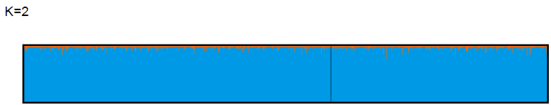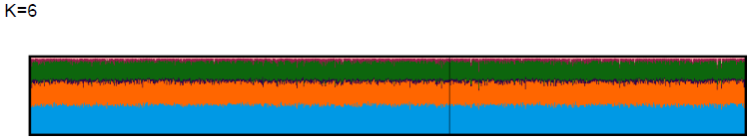

B)

Cologne Luxembourg

***Syritta pipiens***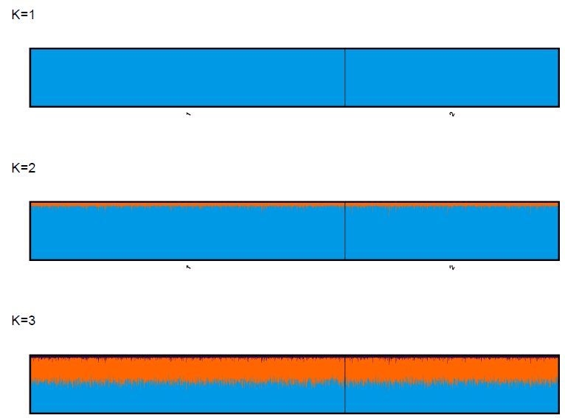

Luxembourg Cologne

**Figure 2.** Average cluster assignment the best solutions. A) *K*=2 and *K*=6 for *M. florea*; B) *K*=1, *K*=2, and *K*=3 for *S. pipiens*. Note that for *K*=6 (*M. florea*) and *K*=3 (*S. pipiens*) we displayed the average of runs for the major mode. Sample sizes ratios are divided among pop as follows: 32% (*M.* florea) and 70% (*S.* pipiens) individuals from Luxembourg.

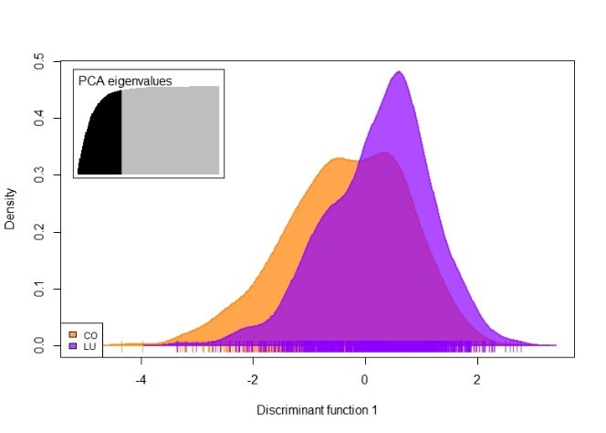

A)

Density

*M. florea S. pipiens*

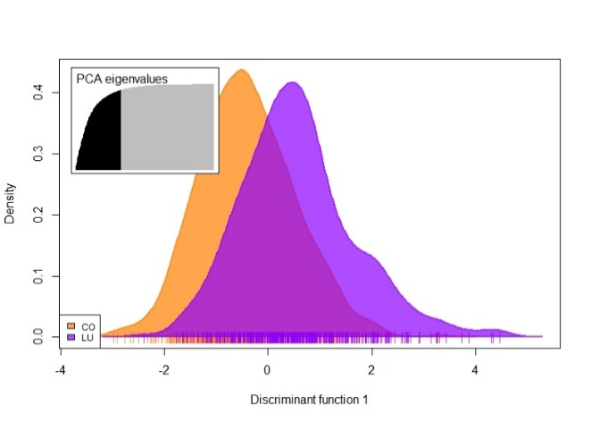

Discrimination function

B)

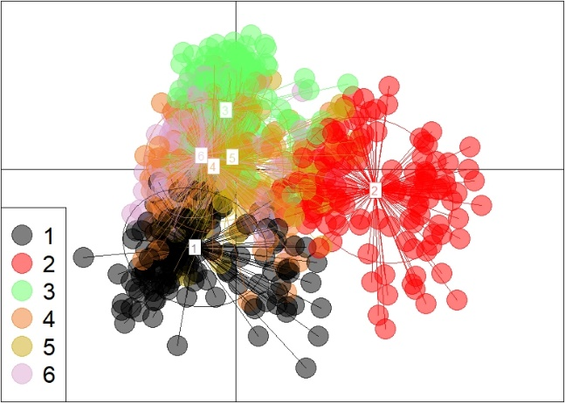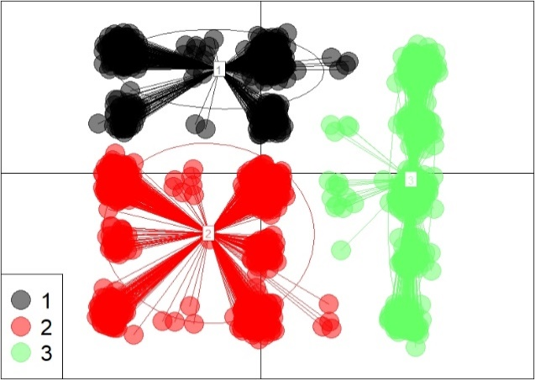

C)

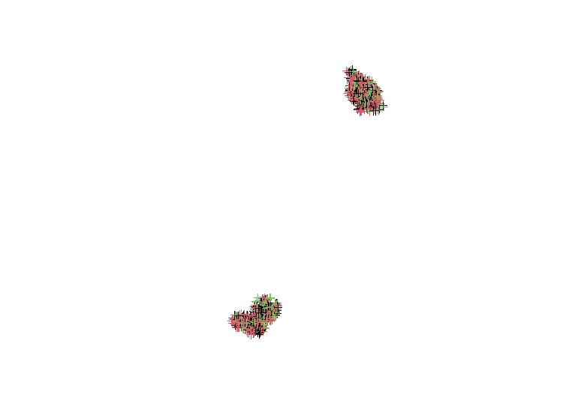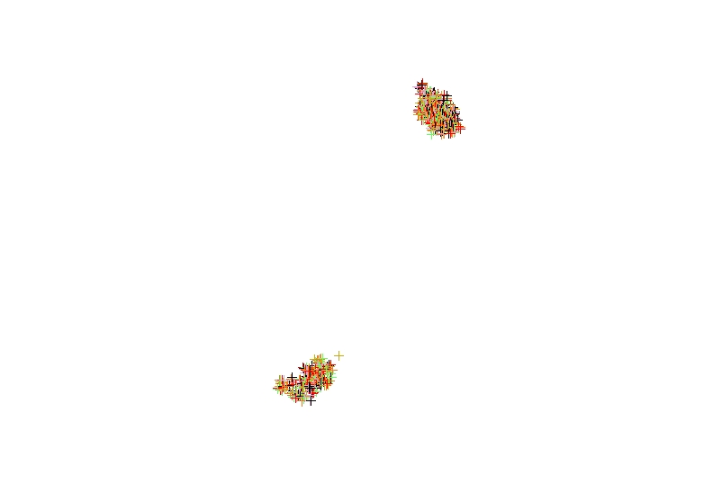

Cologne





Luxembourg

**Figure 3.** *De novo* and *a priori* DAPC. A) Discrimination functions for *a priori* DAPC; high overlap demonstrates poor distinction between geographic populations. B) Scatterplots for the selected *de novo* DAPC. C) Assignment results for each individual in both urban areas; apparent “random” mixing of colors highlights the lack of spatial structure.

# DISCUSSION

This study aimed to increase our knowledge about hoverfly connectivity in heavily disturbed ecological contexts. Briefly, our study showed that two species of hoverflies present remarkably high genetic connectivity across tens of kilometers of urbanized landscapes bearing potential (!) natural and artificial barriers. This putatively high ability to disperse in urbanized landscapes has implications for hoverfly conservation and maintaining pollination as an ecosystem service.

## | High large-scale population connectivity

The characteristics of genetic structure measured in this study indicates no strong recent effect of the landscape on gene flow *S. pipiens* and *M.* *florea*. Six genetic clusters for *M. florea* and three genetic clusters for *S. pipiens* were supported by both structure detection approaches (Table 1; Fig.2-3). Superficially, this cross-methodological agreement may strengthen our confidence in the clustering of individuals. However, two major limits belie this simple conclusion. First, the structure did not map at all on geographic origins, within or even between study areas (Fig. 2-3). This can be seen in the spatially random and mixed assignments in the STRUCTURE analyses (Fig. 2). Not a single cluster is restricted to a specific study area. Similarly, DAPC outcomes show very poor performance for *a priori* DAPC (Fig. 3A) where the grouping corresponds to study areas, and again assignments seem to be randomly distributed across study area (Fig. 3C). Second, although both approaches partially supported the same number of clusters, the inferred clusters are very different with no apparent concordance between approaches. *De novo* runs selected a wide range of *K* values, especially for *M. florea*. Finally, some performance metrics for the Bayesian analysis did select lower number of clusters (*K*=1 for *S.* pipiens and *K*=2 for *M. florea*) which further highlights the likely spatial structure of those two species.

Genetic isolation (?) Analysis of fine-scale genetic structure support the conclusions drawn from structure analyses. An extremely low IBD is detected for both species when using both study areas, which denotes that local individuals (e.g., Cologne) are slightly more similar to each other. However, the significance of this relationship between genetic similarity and geographic distance is likely driven by the large number of individuals, and therefore, of pairwise measures, and high significance values should be contrasted with the low goodness-of-fit. No such relationship exists within study areas, even when splitting pairwise indices of similarity and distance into geographic distance classes.

While unexpected given the large amount of disturbance and apparent costs of dispersal in urban contexts, high genetic connectivity is not unheard of in hoverflies. Hoverflies usually move a few hundred meters and tall vegetation and bare soil including ploughed fields and roads can act as barriers (Lövei et al., 1998; Wratten et al., 2003). Similarly, studies investigating hoverfly richness in relation to habitat patch isolation suggest that hoverflies are significantly impacted by habitat fragmentation (Jauker et al., 2019; Moquet et al., 2018; Ouin et al., 2006). This had led us to expect an effect of fragmentation on genetic variation. However, other studies have highlighted the high dispersal ability of hoverfly species. Some individuals are able to cover more than 100 km in less than 3 days during migration (Aubert et al., 1969; Aubert and Goeldlin de Tiefenau, 1981), and potentially more than a thousand kilometer over the whole migration season (Jia et al., 2022; Ouin et al., 2011), especially when aided by wind (Gao et al., 2020; Wotton et al., 2019). Those last seven studies focused on migratory species which have very different life history traits. Hence, we did (wrongly) predict that some level of IBD within study areas because our study species are not migratory. Given the high prevalence of hoverfly species presenting a partial migration syndrome (Doyle et al., 2022; Menz et al., 2019; Speight, 2017), the genetic and structural pathways to efficient dispersal might also be present in non-migratory hoverflies such as *S. pipiens* and *M. florea*. Indeed, even rare non-migratory species may fly several kilometers away from their emergence sites (Rotheray et al., 2014).

Alain: Both the IBD and the STRUCTURE results can be artefacts of high effective population size. Have a look at my 2009 paper on ibd and structure. The higher the effective density, the lower the IBD pattern. Similarly, there may be an effect of the landscape but the effective population size of these things will be too large for genetic drift to have an effect (relative to the time scale of the disturbance). You could mention that relatedness-based resistance modelling might detect an effect earlier (see Landguth et al. (2010) ). However, we cannot apply these methods here as not IBD to work with.

## | Methodological limits and future directions

Detecting genetic structure is rarely a straightforward endeavor and there a known limits to certain approaches. Although STRUCTURE may perform better than DAPC in some scenarios because DAPC may be sensitive to IBD, DAPC performs well for scenarios with low IBD (Blair et al., 2012) which was the case in our study. There are known biases towards selecting *K*=2 when using STRUCTURE (Janes et al., 2017), but we are confident that we lowered this bias by using more flexible parameters in our runs and by comparing outcomess with DAPC. The somewhat intriguing pattern displayed in the DAPC scatterplot for *S. pipiens* disappeared when dropping other alleles. Because the structure is so low, only a few alleles may be driving the visual grouping of some observations on the first two axes. The general conclusions about clustering were maintained after removing several loci to disrupt this pattern. Therefore, we kept all loci except the one mentioned in the methods. Given the large number of *de novo* DAPC runs we conducted, we had to choose the best number of genetic clusters programmatically, based on a fixed criterion rather than using the visual “elbow in the curve” or the minimum methods. However, it is important to note that in most runs, using the visual heuristic (or minimum approach) led to much higher numbers of clusters, notably for *S. pipiens* (Sup. Fig. 1). Such a situation where STRUCTURE selects fewer clusters than DAPC has been described for other pollinators (Frantine-Silva et al., 2021; Glück et al., 2022).

## | Implications for hoverfly biodiversity and pollination services

We could not use sophisticated landscape genetics models, however there might still be effects of the landscape on movement and on population health. Indeed, while we could not identify features associated with a hindrance on gene flow, there may be costs to dispersal (Bonte et al., 2012). For example, there could be high mortality rates in some urban or peri-urban agricultural habitats, which would likely lower population density and genetic diversity although a large number of local dispersers could offset their genetic signal. Finally, although we did not find constraints on gene flow within urbanized landscapes for those two species, they are likely to exist in other systems, including for hoverflies.

Based on our results, given proper habitats, hoverfly with similar life history traits as the ones we studied could quickly colonize the landscape. Habitat quality and quantity are likely more limiting that isolation between habitat patches. Wildflower strips distributed homogenously in an agricultural or urban landscapes could support some hoverfly species and would foster their pollinator services and their large contribution to aphid control. For some species, urban centers could act as a refuge (Hall et al., 2017; Theodorou et al., 2020) when the surrounding landscape is unfavorable due to heavy pesticide use or lack of floral resources. However, urban areas may not often support species-rich hoverfly communities (Svenningsen et al., 2020, 2021). Gene flow associated with high connectivity might not be sufficient to compensate for low urban genetic diversity and, low genetic diversity could limit resilience when facing catastrophic events or gradual environmental changes. Indeed, genetic diversity is the raw material for evolutionary adaptation necessary to overcome environmental constraints on survival and growth. The hoverfly populations we studied could be at risk such as a new disease, or the ongoing threat of climate change, which may affect the sequential use of flower by the hoverfly community throughout the season by affecting plant phenology.

Some introduced hoverflies can potentially outcompete native species due to their high polyphagy and dispersal abilities and understanding connectivity is key to understand, prevent, and mitigate their negative impacts. The high effective dispersal ability of *M. florea* suggested in our study suggests that this species could become established quickly once introduced. *M. florea* has already been introduced on the west coast of North America pre-2005 (BugGuide, 2022), likely through the timber trade because their larvae often develop among decaying roots or in rot-holes of trees, or with associated decaying matter (Rotheray, 1993). Unfortunately, but unsurpringsly given our conclusios, *M. florea* has quickly spread towards the east in its introduced range (GBIF.org, 2022; Miranda et al., 2013). *M. florea* were seen feeding on more than 10 species of flowers during the fieldwork for this study (Wittische, unpublished); many hoverflies are known to be highly polyphagous (Branquart and Hemptinne, 2000). Furthermore, given a similar climatic niche, widespread larval habitat, high dispersal ability and its tolerance for disturbance and urbanization suggested by our study, we expect *M. florea* to spread further East in North America. *Merodon equestris* is a European species now present in East Asia, North America, and Oceania (Hong et al., 2012; Thompson, 2008) and is a major pest of daffodils. *Eristalis tenax*, another European species, is a strong competitor due to its polyphagy, strong dispersal and aggressive territorial behavior towards other pollinators (Wellington and Fitzpatrick, 1981). *E. tenax* has spread through North America and New Zealand where they reach high abundances. Finally, *Simosyrphus grandicornis* is an Australasian species which has been introduced to Hawaii and French Polynesia where no previous hoverfly species occurred (Doyle et al., 2020), which may have affected the floral and pollinator communities. The lack of knowledge about hoverfly introductions and their potential consequences on biodiversity is dire and further highlight why it is crucial to understand hoverfly dispersal and their population dynamics.

**ACKNOWELDGEMENTS**

We thank Balint Andrasi, Dylan Thissen, Antonio Cruzony, Caroline Grounds, Fernanda Andrea Herrera Mesías, Monique Kirsch, Jérôme Herr, and the other people who helped on the field or in the lab. This study was funded by a CORE grant (C20/SR/14748041) from the Luxembourg National Research Fund (FNR). We thank the government of Luxembourg and Germany from granting us netting permits.

# REFERENCES

Adamack, A.T., Gruber, B., 2014. PopGenReport: simplifying basic population genetic analyses in R. Methods Ecol. Evol. 4.

Agapow, P.M., Burt, A., 2001. Indices of multilocus linkage disequilibrium. Mol. Ecol. Notes 1, 101–102. https://doi.org/10.1046/j.1471-8278.2000.00014.x

Aubert, J., Goeldlin de Tiefenau, P., 1981. Observations sur les migrations de Syrphides (Dipt.) dans les Alpes de Suisse occidentale. J. Swiss Entomol. Soc. 54. https://doi.org/10.5169/SEALS-402013

Aubert, J., Goeldlin, P., Lyon, J.-P., 1969. Essais de marquage et de reprise d’insectes migrateurs en automne 1968. J. Swiss Entomol. Soc. 42. https://doi.org/10.5169/SEALS-401588

Bickel, D., Pape, T., Meier, R. (Eds.), 2009. Diptera Diversity: Status, Challenges and Tools. Brill.

Biesmeijer, J.C., Roberts, S.P.M., Reemer, M., Ohlemüller, R., Edwards, M., Peeters, T., Schaffers, A.P., Potts, S.G., Kleukers, R., Thomas, C.D., Settele, J., Kunin, W.E., 2006. Parallel Declines in Pollinators and Insect-Pollinated Plants in Britain and the Netherlands. Science 313, 351–354. https://doi.org/10.1126/science.1127863

Blair, C., Weigel, D.E., Balazik, M., Keeley, A.T.H., Walker, F.M., Landguth, E., Cushman, S., Murphy, M., Waits, L., Balkenhol, N., 2012. A simulation-based evaluation of methods for inferring linear barriers to gene flow. Mol. Ecol. Resour. 12, 822–833. https://doi.org/10.1111/j.1755-0998.2012.03151.x

Bonte, D., Van Dyck, H., Bullock, J.M., Coulon, A., Delgado, M., Gibbs, M., Lehouck, V., Matthysen, E., Mustin, K., Saastamoinen, M., Schtickzelle, N., Stevens, V.M., Vandewoestijne, S., Baguette, M., Barton, K., Benton, T.G., Chaput-Bardy, A., Clobert, J., Dytham, C., Hovestadt, T., Meier, C.M., Palmer, S.C.F., Turlure, C., Travis, J.M.J., 2012. Costs of dispersal. Biol. Rev. 87, 290–312. https://doi.org/10.1111/j.1469-185X.2011.00201.x

Bowler, D.E., Benton, T.G., 2005. Causes and consequences of animal dispersal strategies: relating individual behaviour to spatial dynamics. Biol. Rev. 80, 205–225. https://doi.org/10.1017/S1464793104006645

Branquart, E., Hemptinne, J.-L., 2000. Selectivity in the exploitation of floral resources by hoverflies (Diptera: Syrphinae). Ecography 23, 732–742. https://doi.org/10.1111/j.1600-0587.2000.tb00316.x

Braun, M., Herold, M., 2004. Mapping imperviousness using NDVI and linear spectral unmixing of ASTER data in the Cologne-Bonn region (Germany), in: Remote Sensing for Environmental Monitoring, GIS Applications, and Geology III. Presented at the Remote Sensing for Environmental Monitoring, GIS Applications, and Geology III, SPIE, pp. 274–284. https://doi.org/10.1117/12.510978

Brookfield, J.F.Y., 1996. A simple new method for estimating null allele frequency from heterozygote deficiency. Mol. Ecol. 5, 453–455.

Broquet, T., Petit, E.J., 2009. Molecular Estimation of Dispersal for Ecology and Population Genetics. Annu. Rev. Ecol. Evol. Syst. 40, 193–216. https://doi.org/10.1146/annurev.ecolsys.110308.120324

Brownstein, M.J., Carpten, J.D., Smith, J.R., 1996. Modulation of non-templated nucleotide addition by Taq DNA polymerase: primer modifications that facilitate genotyping. BioTechniques 20, 1004–1006, 1008–1010. https://doi.org/10.2144/96206st01

BugGuide, 2022. Species account - Myathropa florea.

Cayuela, H., Rougemont, Q., Prunier, J.G., Moore, J.S., Clobert, J., Besnard, A., Bernatchez, L., 2018. Demographic and genetic approaches to study dispersal in wild animal populations: A methodological review. Mol. Ecol. 27, 3976–4010. https://doi.org/10.1111/mec.14848

Chakraborty, R., Zhong, Y., Jin, L., Budowle, B., 1994. Nondetectability of Restriction Fragments and Independence of DNA Fragment Sizes Within and Between Loci In RFLP Typing of DNA. Am. J. Hum. Genet. 55, 391–401.

Curdes, G., 1998. Urban form and innovation: The case of Cologne. Urban Morphol. 2, 11–18.

Davis, E.S., Murray, T.E., Fitzpatrick, Ú., Brown, M.J.F., Paxton, R.J., 2010. Landscape effects on extremely fragmented populations of a rare solitary bee, Colletes floralis. Mol. Ecol. 19, 4922–4935. https://doi.org/10.1111/j.1365-294X.2010.04868.x

Dicks, L.V., Abrahams, A., Atkinson, J., Biesmeijer, J., Bourn, N., Brown, C., Brown, M.J.F., Carvell, C., Connolly, C., Cresswell, J.E., Croft, P., Darvill, B., De Zylva, P., Effingham, P., Fountain, M., Goggin, A., Harding, D., Harding, T., Hartfield, C., Heard, M.S., Heathcote, R., Heaver, D., Holland, J., Howe, M., Hughes, B., Huxley, T., Kunin, W.E., Little, J., Mason, C., Memmott, J., Osborne, J., Pankhurst, T., Paxton, R.J., Pocock, M.J.O., Potts, S.G., Power, E.F., Raine, N.E., Ranelagh, E., Roberts, S., Saunders, R., Smith, K., Smith, R.M., Sutton, P., Tilley, L.A.N., Tinsley, A., Tonhasca, A., Vanbergen, A.J., Webster, S., Wilson, A., Sutherland, W.J., 2013. Identifying key knowledge needs for evidence-based conservation of wild insect pollinators: a collaborative cross-sectoral exercise. Insect Conserv. Divers. 6, 435–446. https://doi.org/10.1111/j.1752-4598.2012.00221.x

Dicks, L.V., Breeze, T.D., Ngo, H.T., Senapathi, D., An, J., Aizen, M.A., Basu, P., Buchori, D., Galetto, L., Garibaldi, L.A., Gemmill-Herren, B., Howlett, B.G., Imperatriz-Fonseca, V.L., Johnson, S.D., Kovács-Hostyánszki, A., Kwon, Y.J., Lattorff, H.M.G., Lungharwo, T., Seymour, C.L., Vanbergen, A.J., Potts, S.G., 2021. A global-scale expert assessment of drivers and risks associated with pollinator decline. Nat. Ecol. Evol. 5, 1453–1461. https://doi.org/10.1038/s41559-021-01534-9

Doyle, T., Hawkes, W.L.S., Massy, R., Powney, G.D., Menz, M.H.M., Wotton, K.R., 2020. Pollination by hoverflies in the Anthropocene. Proc. R. Soc. B Biol. Sci. 287, 20200508. https://doi.org/10.1098/rspb.2020.0508

Doyle, T., Jimenez-Guri, E., Hawkes, W.L.S., Massy, R., Mantica, F., Permanyer, J., Cozzuto, L., Hermoso Pulido, T., Baril, T., Hayward, A., Irimia, M., Chapman, J.W., Bass, C., Wotton, K.R., 2022. Genome-wide transcriptomic changes reveal the genetic pathways involved in insect migration. Mol. Ecol. 31, 4332–4350. https://doi.org/10.1111/mec.16588

Dreier, S., Redhead, J.W., Warren, I.A., Bourke, A.F.G., Heard, M.S., Jordan, W.C., Sumner, S., Wang, J., Carvell, C., 2014. Fine-scale spatial genetic structure of common and declining bumble bees across an agricultural landscape. Mol. Ecol. 23, 3384–3395. https://doi.org/10.1111/mec.12823

Earl, D.A., vonHoldt, B.M., 2012. STRUCTURE HARVESTER: a website and program for visualizing STRUCTURE output and implementing the Evanno method. Conserv. Genet. Resour. 4, 359–361. https://doi.org/10.1007/s12686-011-9548-7

Evanno, G., Regnaut, S., Goudet, J., 2005. Detecting the number of clusters of individuals using the software structure: a simulation study. Mol. Ecol. 14, 2611–2620.

Frantine-Silva, W., Augusto, S.C., Tosta, T.H.A., Pacheco, A.S., Kotelok-Diniz, T., Apolinário da Silva, C., Sofia, S.H., 2021. Genetic diversity and population structure of orchid bees from the Brazilian savanna. J. Apic. Res. 60, 385–395. https://doi.org/10.1080/00218839.2021.1898788

Gallai, N., Salles, J.-M., Settele, J., Vaissière, B.E., 2009. Economic valuation of the vulnerability of world agriculture confronted with pollinator decline. Ecol. Econ. 68, 810–821. https://doi.org/10.1016/j.ecolecon.2008.06.014

Gao, B., Wotton, K.R., Hawkes, W.L.S., Menz, M.H.M., Reynolds, D.R., Zhai, B.-P., Hu, G., Chapman, J.W., 2020. Adaptive strategies of high-flying migratory hoverflies in response to wind currents. Proc. R. Soc. B Biol. Sci. 287, 20200406. https://doi.org/10.1098/rspb.2020.0406

GBIF.org, 2022. Occurrence Download - Myathropa florea - North America (05 September 2022) https://doi.org/10.15468/dl.ctqqr2.

Gill, R.J., Baldock, K.C.R., Brown, M.J.F., Cresswell, J.E., Dicks, L.V., Fountain, M.T., Garratt, M.P.D., Gough, L.A., Heard, M.S., Holland, J.M., Ollerton, J., Stone, G.N., Tang, C.Q., Vanbergen, A.J., Vogler, A.P., Woodward, G., Arce, A.N., Boatman, N.D., Brand-Hardy, R., Breeze, T.D., Green, M., Hartfield, C.M., O’Connor, R.S., Osborne, J.L., Phillips, J., Sutton, P.B., Potts, S.G., 2016. Chapter Four - Protecting an Ecosystem Service: Approaches to Understanding and Mitigating Threats to Wild Insect Pollinators, in: Woodward, G., Bohan, D.A. (Eds.), Advances in Ecological Research, Ecosystem Services: From Biodiversity to Society, Part 2. Academic Press, pp. 135–206. https://doi.org/10.1016/bs.aecr.2015.10.007

Glück, M., Geue, J.C., Thomassen, H.A., 2022. Environmental differences explain subtle yet detectable genetic structure in a widespread pollinator. BMC Ecol. Evol. 22, 8. https://doi.org/10.1186/s12862-022-01963-5

Goudet, J., 2005. hierfstat, a package for R to compute and test hierarchical F‐statistics. Mol. Ecol. Notes 5, 184–186.

Greenleaf, S.S., Williams, N.M., Winfree, R., Kremen, C., 2007. Bee foraging ranges and their relationship to body size. Oecologia 153, 589–596. https://doi.org/10.1007/s00442-007-0752-9

Hall, D.M., Camilo, G.R., Tonietto, R.K., Ollerton, J., Ahrné, K., Arduser, M., Ascher, J.S., Baldock, K.C.R., Fowler, R., Frankie, G., Goulson, D., Gunnarsson, B., Hanley, M.E., Jackson, J.I., Langellotto, G., Lowenstein, D., Minor, E.S., Philpott, S.M., Potts, S.G., Sirohi, M.H., Spevak, E.M., Stone, G.N., Threlfall, C.G., 2017. The city as a refuge for insect pollinators. Conserv. Biol. 31, 24–29. https://doi.org/10.1111/cobi.12840

Hallmann, C.A., Sorg, M., Jongejans, E., Siepel, H., Hofland, N., Schwan, H., Stenmans, W., Müller, A., Sumser, H., Hörren, T., Goulson, D., Kroon, H. de, 2017. More than 75 percent decline over 27 years in total flying insect biomass in protected areas. PLOS ONE 12, e0185809. https://doi.org/10.1371/journal.pone.0185809

Hodgkiss, D., Brown, M.J.F., Fountain, M.T., 2018. Syrphine hoverflies are effective pollinators of commercial strawberry. J. Pollinat. Ecol. 22, 55–66. https://doi.org/10.26786/1920-7603(2018)five

Hong, K.-J., Lee, J.-H., Lee, G.-S., Lee, S., 2012. The status quo of invasive alien insect species and plant quarantine in Korea. J. Asia-Pac. Entomol. 15, 521–532. https://doi.org/10.1016/j.aspen.2012.06.003

Hubisz, M.J., Falush, D., Stephens, M., Pritchard, J.K., 2009. Inferring weak population structure with the assistance of sample group information. Mol. Ecol. Resour. 9, 1322–1332.

Jaeger, J.A.G., Soukup, T., Schwick, C., Madriñán, L.F., Kienast, F., 2016. Landscape Fragmentation in Europe, in: European Landscape Dynamics. CRC press, Boca Raton, Florida, USA, p. 42.

Janes, J.K., Miller, J.M., Dupuis, J.R., Malenfant, R.M., Gorrell, J.C., Cullingham, C.I., Andrew, R.L., 2017. The K = 2 conundrum. Mol. Ecol. 26, 3594–3602. https://doi.org/10.1111/mec.14187

Jauker, F., Diekötter, T., Schwarzbach, F., Wolters, V., 2009. Pollinator dispersal in an agricultural matrix: opposing responses of wild bees and hoverflies to landscape structure and distance from main habitat. Landsc. Ecol. 24, 547–555. https://doi.org/10.1007/s10980-009-9331-2

Jauker, F., Jauker, B., Grass, I., Steffan-Dewenter, I., Wolters, V., 2019. Partitioning wild bee and hoverfly contributions to plant–pollinator network structure in fragmented habitats. Ecology 100, e02569. https://doi.org/10.1002/ecy.2569

Jha, S., Kremen, C., 2013. Urban land use limits regional bumble bee gene flow. Mol. Ecol. 22, 2483–2495. https://doi.org/10.1111/mec.12275

Jia, H., Liu, Y., Li, X., Li, H., Pan, Y., Hu, C., Zhou, X., Wyckhuys, K.A., Wu, K., 2022. Windborne migration amplifies insect-mediated pollination services. eLife 11, e76230. https://doi.org/10.7554/eLife.76230

Jombart, T., 2008. Adegenet: A R package for the multivariate analysis of genetic markers. Bioinformatics 24, 1403–1405. https://doi.org/10.1093/bioinformatics/btn129

Jombart, T., Ahmed, I., 2011. adegenet 1.3-1: New tools for the analysis of genome-wide SNP data. Bioinformatics 27, 3070–3071. https://doi.org/10.1093/bioinformatics/btr521

Jombart, T., Collins, C., 2022. A tutorial for Discriminant Analysis of Principal Components (DAPC) using adegenet 2.1.6.

Jombart, T., Devillard, S., Balloux, F., 2010. Discriminant analysis of principal components: a new method for the analysis of genetically structured populations. BMC Genet. 11, 94. https://doi.org/10.1186/1471-2156-11-94

Jombart, T., Pontier, D., Dufour, a-B., 2009. Genetic markers in the playground of multivariate analysis. Heredity 102, 330–341. https://doi.org/10.1038/hdy.2008.130

Kamvar, Z.N., Tabima, J.F., Gr̈unwald, N.J., 2014. Poppr: An R package for genetic analysis of populations with clonal, partially clonal, and/or sexual reproduction. PeerJ 2014, 1–14. https://doi.org/10.7717/peerj.281

Kleijn, D., van Langevelde, F., 2006. Interacting effects of landscape context and habitat quality on flower visiting insects in agricultural landscapes. Basic Appl. Ecol. 7, 201–214. https://doi.org/10.1016/j.baae.2005.07.011

Klein, A.-M., Vaissière, B.E., Cane, J.H., Steffan-Dewenter, I., Cunningham, S.A., Kremen, C., Tscharntke, T., 2007. Importance of pollinators in changing landscapes for world crops. Proc. R. Soc. B Biol. Sci. 274, 303–313. https://doi.org/10.1098/rspb.2006.3721

Kopelman, N.M., Mayzel, J., Jakobsson, M., Rosenberg, N.A., Mayrose, I., 2015. Clumpak: a program for identifying clustering modes and packaging population structure inferences across K. Mol. Ecol. Resour. 15, 1179–1191. https://doi.org/10.1111/1755-0998.12387

Legendre, P., Legendre, L., 2012. Numerical Ecology. Elsevier, Amsterdam, Netherlands.

Leopold, J., Schöne, M., Cölln, K., 1996. Zur Kenntis der Schwebfliegen (Diptera, Syrphidae) der Stadt Köln und ihrer Randgebiete. Dechen. - Beih. Bonn 35, 433–458.

Loiselle, B. a, Sork, V.L., Nason, J., Graham, C., 1995. Spatial Genetic Structure of a Tropical Understory Shrub. Am. J. Bot. 82, 1420–1425.

Lövei, G.L., Macleod, A., Hickman, J.M., 1998. Dispersal and effects of barriers on the movement of the New Zealand hover fly Melanostoma fasciatum (Dipt., Syrphidae) on cultivated land. J. Appl. Entomol. 122, 115–120. https://doi.org/10.1111/j.1439-0418.1998.tb01471.x

Lozier, J.D., Strange, J.P., Stewart, I.J., Cameron, S.A., 2011. Patterns of range-wide genetic variation in six North American bumble bee (Apidae: Bombus) species. Mol. Ecol. 20, 4870–4888. https://doi.org/10.1111/j.1365-294X.2011.05314.x

Lucas, A., Bodger, O., Brosi, B.J., Ford, C.R., Forman, D.W., Greig, C., Hegarty, M., Jones, L., Neyland, P.J., de Vere, N., 2018. Floral resource partitioning by individuals within generalised hoverfly pollination networks revealed by DNA metabarcoding. Sci. Rep. 8, 5133. https://doi.org/10.1038/s41598-018-23103-0

Mantel, N., 1967. Cancer research. Mantel 27, 34.

Menz, M.H.M., Reynolds, D.R., Gao, B., Hu, G., Chapman, J.W., Wotton, K.R., 2019. Mechanisms and Consequences of Partial Migration in Insects. Front. Ecol. Evol. 7.

Miller, J.M., Cullingham, C.I., Peery, R.M., 2020. The influence of a priori grouping on inference of genetic clusters: simulation study and literature review of the DAPC method. Heredity 125, 269–280.

Miller, S.A., Dykes, D.D., Polesky, H.F., 1988. A simple salting out procedure for extracting DNA from human nucleated cells. Nucleic Acids Res. 16, 1215.

Ministère de l’Environnement, du Climat et du Développement durable, 2022. Plan Pollinisateurs Luxembourg [WWW Document]. Plan Pollinis. URL https://www.planpollinisateurs.lu (accessed 9.16.22).

Miranda, G.F.G., Young, A.D., Locke, M.M., Marshall, S.A., Skevington, J.H., Thompson, F.C., 2013. Key to the Genera of Nearctic Syrphidae. Can. J. Arthropod Identif. 23.

Mitter, H., Weber, G., 2011. Green Belt(s)—a Challenge for Urban Policy of Expanding Cities. Reg. Mag. 282, 18–20. https://doi.org/10.1080/13673882.2011.9697692

Moquet, L., Laurent, E., Bacchetta, R., Jacquemart, A.-L., 2018. Conservation of hoverflies (Diptera, Syrphidae) requires complementary resources at the landscape and local scales. Insect Conserv. Divers. 11, 72–87. https://doi.org/10.1111/icad.12245

Öckinger, E., Schweiger, O., Crist, T.O., Debinski, D.M., Krauss, J., Kuussaari, M., Petersen, J.D., Pöyry, J., Settele, J., Summerville, K.S., Bommarco, R., 2010. Life-history traits predict species responses to habitat area and isolation: a cross-continental synthesis. Ecol. Lett. 13, 969–979. https://doi.org/10.1111/j.1461-0248.2010.01487.x

Ollerton, J., 2017. Pollinator Diversity: Distribution, Ecological Function, and Conservation. Annu. Rev. Ecol. Evol. Syst. 48, 353–376. https://doi.org/10.1146/annurev-ecolsys-110316-022919

Ollerton, J., Winfree, R., Tarrant, S., 2011. How many flowering plants are pollinated by animals? Oikos 120, 321–326. https://doi.org/10.1111/j.1600-0706.2010.18644.x

Ouin, A., Menozzi, P., Coulon, M., Hamilton, A.J., Sarthou, J.P., Tsafack, N., Vialatte, A., Ponsard, S., 2011. Can deuterium stable isotope values be used to assign the geographic origin of an auxiliary hoverfly in south-western France? Rapid Commun. Mass Spectrom. 25, 2793–2798. https://doi.org/10.1002/rcm.5127

Ouin, A., Sarthou, J.-P., Bouyjou, B., Deconchat, M., Lacombe, J.-P., Monteil, C., 2006. The species-area relationship in the hoverfly (Diptera, Syrphidae) communities of forest fragments in southern France. Ecography 29, 183–190. https://doi.org/10.1111/j.2006.0906-7590.04135.x

Oyler-McCance, S.J., Fedy, B.C., Landguth, E.L., 2013. Sample design effects in landscape genetics. Conserv. Genet. 14, 275–285. https://doi.org/10.1007/s10592-012-0415-1

Paradis, E., 2010. pegas : an R package for population genetics with an integrated – modular approach 26, 419–420. https://doi.org/10.1093/bioinformatics/btp696

Pekas, A., De Craecker, I., Boonen, S., Wäckers, F.L., Moerkens, R., 2020. One stone; two birds: concurrent pest control and pollination services provided by aphidophagous hoverflies. Biol. Control 149, 104328. https://doi.org/10.1016/j.biocontrol.2020.104328

Potts, S., K., B., Bommarco, R., Breeze, T., Carvalheiro, L., Franzén, M., González-Varo, J.P., A., H., Kleijn, D., Klein, A., Kunin, Lecocq, T., Lundin, O., Michez, D., Neumann, P., A., N., Penev, L., Rasmont, P., Ratamäki, O., Schweiger, O., 2015. Status and trends of European pollinators. Key findings of the STEP project. Pensoft Publishers, Sofia, Bulgaria.

Potts, S.G., Biesmeijer, J.C., Kremen, C., Neumann, P., Schweiger, O., Kunin, W.E., 2010. Global pollinator declines: trends, impacts and drivers. Trends Ecol. Evol. 25, 345–353. https://doi.org/10.1016/j.tree.2010.01.007

Pritchard, J.K., Stephens, M., Donnelly, P., 2000. Inference of Population Structure Using Multilocus Genotype Data.

R Core Team, 2022. R: A language and environment for statistical computing.

Rader, R., Bartomeus, I., Garibaldi, L.A., Garratt, M.P.D., Howlett, B.G., Winfree, R., Cunningham, S.A., Mayfield, M.M., Arthur, A.D., Andersson, G.K.S., Bommarco, R., Brittain, C., Carvalheiro, L.G., Chacoff, N.P., Entling, M.H., Foully, B., Freitas, B.M., Gemmill-Herren, B., Ghazoul, J., Griffin, S.R., Gross, C.L., Herbertsson, L., Herzog, F., Hipólito, J., Jaggar, S., Jauker, F., Klein, A.-M., Kleijn, D., Krishnan, S., Lemos, C.Q., Lindström, S.A.M., Mandelik, Y., Monteiro, V.M., Nelson, W., Nilsson, L., Pattemore, D.E., de O. Pereira, N., Pisanty, G., Potts, S.G., Reemer, M., Rundlöf, M., Sheffield, C.S., Scheper, J., Schüepp, C., Smith, H.G., Stanley, D.A., Stout, J.C., Szentgyörgyi, H., Taki, H., Vergara, C.H., Viana, B.F., Woyciechowski, M., 2016. Non-bee insects are important contributors to global crop pollination. Proc. Natl. Acad. Sci. 113, 146–151. https://doi.org/10.1073/pnas.1517092112

Rands, S.A., 2014. Landscape fragmentation and pollinator movement within agricultural environments: a modelling framework for exploring foraging and movement ecology. PeerJ 2, e269. https://doi.org/10.7717/peerj.269

Raymond, L., Plantegenest, M., Vialatte, A., 2013. Migration and dispersal may drive to high genetic variation and significant genetic mixing: the case of two agriculturally important, continental hoverflies (Episyrphus balteatus and Sphaerophoria scripta). Mol. Ecol. 22, 5329–5339. https://doi.org/10.1111/mec.12483

Reilly, J.R., Artz, D.R., Biddinger, D., Bobiwash, K., Boyle, N.K., Brittain, C., Brokaw, J., Campbell, J.W., Daniels, J., Elle, E., Ellis, J.D., Fleischer, S.J., Gibbs, J., Gillespie, R.L., Gundersen, K.B., Gut, L., Hoffman, G., Joshi, N., Lundin, O., Mason, K., McGrady, C.M., Peterson, S.S., Pitts-Singer, T.L., Rao, S., Rothwell, N., Rowe, L., Ward, K.L., Williams, N.M., Wilson, J.K., Isaacs, R., Winfree, R., 2020. Crop production in the USA is frequently limited by a lack of pollinators. Proc. R. Soc. B Biol. Sci. 287, 20200922. https://doi.org/10.1098/rspb.2020.0922

Rotheray, E.L., Bussière, L.F., Moore, P., Bergstrom, L., Goulson, D., 2014. Mark recapture estimates of dispersal ability and observations on the territorial behaviour of the rare hoverfly, Hammerschmidtia ferruginea (Diptera, Syrphidae). J. Insect Conserv. 18, 179–188. https://doi.org/10.1007/s10841-014-9627-7

Rotheray, G.E., 1993. Colour Guide to Hoverfly Larvae (Diptera: Syrphidae). Dipter. Dig. 9.

RStudio Team, 2022. RStudio: Integrated Development Environment for R.

Sánchez-Bayo, F., Wyckhuys, K.A.G., 2021. Further evidence for a global decline of the entomofauna. Austral Entomol. 60, 9–26. https://doi.org/10.1111/aen.12509

Sánchez-Bayo, F., Wyckhuys, K.A.G., 2019. Worldwide decline of the entomofauna: A review of its drivers. Biol. Conserv. 232, 8–27. https://doi.org/10.1016/j.biocon.2019.01.020

Schauer, B., Bong, J., Popp, C., Obermaier, E., Feldhaar, H., 2018. Dispersal limitation of saproxylic insects in a managed forest? A population genetics approach. Basic Appl. Ecol. 32, 26–38. https://doi.org/10.1016/j.baae.2018.01.005

Schwartz, M.K., McKelvey, K.S., 2009. Why sampling scheme matters: the effect of sampling scheme on landscape genetic results. Conserv. Genet. 10, 441–452. https://doi.org/10.1007/s10592-008-9622-1

Seibold, S., Gossner, M.M., Simons, N.K., Blüthgen, N., Müller, J., Ambarlı, D., Ammer, C., Bauhus, J., Fischer, M., Habel, J.C., Linsenmair, K.E., Nauss, T., Penone, C., Prati, D., Schall, P., Schulze, E.D., Vogt, J., Wöllauer, S., Weisser, W.W., 2019. Arthropod decline in grasslands and forests is associated with landscape-level drivers. Nature 574, 671–674. https://doi.org/10.1038/s41586-019-1684-3

Senapathi, D., Carvalheiro, L.G., Biesmeijer, J.C., Dodson, C.-A., Evans, R.L., McKerchar, M., Morton, R.D., Moss, E.D., Roberts, S.P.M., Kunin, W.E., Potts, S.G., 2015. The impact of over 80 years of land cover changes on bee and wasp pollinator communities in England. Proc. R. Soc. B Biol. Sci. 282, 20150294. https://doi.org/10.1098/rspb.2015.0294

Simmons, B.I., Balmford, A., Bladon, A.J., Christie, A.P., De Palma, A., Dicks, L.V., Gallego-Zamorano, J., Johnston, A., Martin, P.A., Purvis, A., Rocha, R., Wauchope, H.S., Wordley, C.F.R., Worthington, T.A., Finch, T., 2019. Worldwide insect declines: An important message, but interpret with caution. Ecol. Evol. 9, 3678–3680. https://doi.org/10.1002/ece3.5153

Speight, M.C.D., 2017. Species account of European Syrphidae, Syrph the Net, the database of European Syrphidae (Diptera). Syrph the Net publications, Dublin, Ireland.

Ssymank, A., Kearns, C.A., Pape, T., Thompson, F.C., 2008. Pollinating Flies (Diptera): A major contribution to plant diversity and agricultural production. Biodiversity 9, 86–89. https://doi.org/10.1080/14888386.2008.9712892

Stadt Köln, 2022. Insektenschutz [WWW Document]. URL https://www.stadt-koeln.de/leben-in-koeln/klima-umwelt-tiere/insektenschutz (accessed 9.16.22).

Steffan-Dewenter, I., Münzenberg, U., Bürger, C., Thies, C., Tscharntke, T., 2002. Scale-Dependent Effects of Landscape Context on Three Pollinator Guilds. Ecology 83, 1421–1432. https://doi.org/10.1890/0012-9658(2002)083[1421:SDEOLC]2.0.CO;2

Svenningsen, C., Bowler, D.E., Hecker, S., Bladt, J., Grescho, V., van Dam, N.M., Dauber, J., Eichenberg, D., Ejrnæs, R., Fløjgaard, C., Frenzel, M., Guldberg Frøslev, T., Hansen, A.J., Heilmann-Clausen, J., Huang, Y., Colling Larsen, J., Menger, J., Liyana Binti Mat Nayan, N., Pedersen, L.B., Richter, A., Dunn, R.R., Tøttrup, A.P., Bonn, A., 2020. Contrasting impacts of urban and farmland cover on flying insect biomass.

Svenningsen, C.S., Frøslev, T.G., Bladt, J., Pedersen, L.B., Larsen, J.C., Ejrnæs, R., Fløjgaard, C., Hansen, A.J., Heilmann-Clausen, J., Dunn, R.R., Tøttrup, A.P., 2021. Detecting flying insects using car nets and DNA metabarcoding. Biol. Lett. 17, 20200833. https://doi.org/10.1098/rsbl.2020.0833

Taylor, P.D., Fahrig, L., Henein, K., Merriam, G., 1993. Connectivity Is a Vital Element of Landscape Structure. Oikos 68, 571. https://doi.org/10.2307/3544927

Theodorou, P., Radzevičiūtė, R., Lentendu, G., Kahnt, B., Husemann, M., Bleidorn, C., Settele, J., Schweiger, O., Grosse, I., Wubet, T., Murray, T.E., Paxton, R.J., 2020. Urban areas as hotspots for bees and pollination but not a panacea for all insects. Nat. Commun. 11, 576. https://doi.org/10.1038/s41467-020-14496-6

Thompson, F.C., 2008. A conspectus of New Zealand flower flies (Diptera: Syrphidae) with the description of a new genus and species. Zootaxa 1716, 1. https://doi.org/10.11646/zootaxa.1716.1.1

Vanbergen, A.J., 1, 2, 3, 4, 2013. Threats to an ecosystem service: pressures on pollinators. Front. Ecol. Environ. 11, 251–259. https://doi.org/10.1890/120126

Vekemans, X., Hardy, O.J., 2004. New insights from fine-scale spatial genetic structure analyses in plant populations. Mol. Ecol. 13, 921–935. https://doi.org/10.1046/j.1365-294X.2004.02076.x

Wang, J., 2017. The computer program structure for assigning individuals to populations: easy to use but easier to misuse. Mol. Ecol. Resour. 17, 981–990.

Wardhaugh, C.W., 2015. How many species of arthropods visit flowers? Arthropod-Plant Interact. 9, 547–565. https://doi.org/10.1007/s11829-015-9398-4

Wellington, W.G., Fitzpatrick, S.M., 1981. Territoriality in the drone fly, Eristalis tenax (Diptera: Syrphidae). Can. Entomol. 113, 695–704. https://doi.org/10.4039/Ent113695-8

Winfree, R., Bartomeus, I., Cariveau, D.P., 2011. Native Pollinators in Anthropogenic Habitats. Annu. Rev. Ecol. Evol. Syst. 42, 1–22. https://doi.org/10.1146/annurev-ecolsys-102710-145042

Wotton, K.R., Gao, B., Menz, M.H.M., Morris, R.K.A., Ball, S.G., Lim, K.S., Reynolds, D.R., Hu, G., Chapman, J.W., 2019. Mass Seasonal Migrations of Hoverflies Provide Extensive Pollination and Crop Protection Services. Curr. Biol. 29, 2167-2173.e5. https://doi.org/10.1016/j.cub.2019.05.036

Wratten, S.D., Bowie, M.H., Hickman, J.M., Evans, A.M., Sedcole, J.R., Tylianakis, J.M., 2003. Field boundaries as barriers to movement of hover flies (Diptera: Syrphidae) in cultivated land. Oecologia 134, 605–611. https://doi.org/10.1007/s00442-002-1128-9

**SUPPLEMENTARY MATERIAL**

Dilutions for PCR products of Myathropa florea were 1/75 for Multiplex 1, 4/50 for Multiplex 2 and 1/120 for Multiplex 3. Pcr Products of Syritta pipiens were diluted 1/20. PCR products were genotyped using a capillary sequencer (ABI 3730XL, Applied Biosystems). Allele sizes were determined using GENEMAPPER version 4.0 (Applied Biosystems).

**Supplementary table 1.** Primer information.

|  |  |  |  |  |  |  |  |
| --- | --- | --- | --- | --- | --- | --- | --- |
| M.plex | Lous | Forward Primer | Reverse Primer | Pigtail | Dye | Primer conc. | Size range |
| 1 | Spp_193 | CATGAACCGACTCCAGAATG | CGGGAGACGAGACCTGAG |  | FAM | 0,2 | 80-130 |
| 1 | Spp_010 | CACATCTCCTCAGCTTCCATC | GTCCACTAATGGGCCAAATG |  | FAM | 0,2 | 140-180 |
| 1 | Spp_146 | TTACATCGGCAATCCACTTG | ACGAGAACGAGAACGAGGAC |  | FAM | 0,2 | 230-300 |
| 1 | Spp_476 | TTATGGTCTGGCTCGAATGC | CGTCTCTTCGTGAGGTCGTC |  | HEX | 0,1 | 90-130 |
| 1 | Spp_053 | TGATTAGCGAAGAGACCGAATC | CAACCAGCCAGCCATCTC | Pigtail | HEX | 0,15 | 135-175 |
| 1 | Spp_273 | GCTCCCTCCTTGAATGCTC | CCTGCCTCTTAATGGTCCTG |  | HEX | 0,2 | 225-330 |
| 1 | Spp_142 | TCACTGCCCGTTTCTTTCTC | TGGGTGAAGGCAAATTAAGG |  | TAMRA | 0,2 | 70-110 |
| 1 | Spp_231 | GATGGTGTGCTCTCGATGTC | GGTTGGGTACCTTCAGGTTG |  | TAMRA | 0,2 | 120-144 |
| 1 | Spp_080 | CGTTTCGTCATTCATTGCTG | AAGGCCAACAGGTCCTCTG |  | TAMRA | 0,2 | 145-180 |
| 2 | Spp_033 | GGACAATTGTTCACTTGACAGG | CTGTTGGTCCTTTGTCTGTGTC | Pigtail | FAM | 0,15 | 65-100 |
| 2 | Spp_141 | TCTCCACCCACTTCCCTTATC | CAAATTGACTTTCGGCCAAG | Pigtail | FAM | 0,2 | 103-120 |
| 2 | Spp_416 | ATCTTGGAGTGCCCAGTTTG | CCACTCAACCCAGCCTTG | Pigtail | FAM | 0,1 | 130-160 |
| 2 | Spp_108 | TCATCGACTTCCTGATGCTG | TTAAACGTCCACGGTGTGAG | Pigtail | FAM | 0,2 | 160-200 |
| 2 | Spp_313 | CAGGTCAAACCTCCATCACC | AGGAGCTCCAAGGAAGAAGG |  | FAM | 0,2 | 215-250 |
| 2 | Spp_410 | GGCTCATTTCACGCTTGTTG | GATCATTTGCACGCGTCTG |  | HEX | 0,075 | 70-100 |
| 2 | Spp_360 | ACAATGTGTCCCAATGTCG | TCGGGAGTCTCTTGCCTAC | Pigtail | HEX | 0,2 | 115-150 |
| 2 | Spp_391 | CGTGCGATAGATGTCTGGTG | CTCGCCTCTGAAATCATTGAC |  | HEX | 0,2 | 150-185 |
| 2 | Spp_048 | CTCGCTGAAATGGTTGCTC | AAACCTGGAAGCCCTATTCC | Pigtail | TAMRA | 0,2 | 65-105 |
| 2 | Spp_051 | TCGCACATTTACGACTTCTCC | CAAATTGACTTTCGGCCAAG | Pigtail | TAMRA | 0,2 | 110-145 |
| 2 | Spp_387 | TCGAATGTGCATGGCTAATC | CGAGATCCGAGGTAGACAGG | Pigtail | TAMRA | 0,2 | 155-200 |

|  |  |  |  |  |  |  |  |
| --- | --- | --- | --- | --- | --- | --- | --- |
| M.plex | Lous | Forward Primer | Reverse Primer | Pigtail | Dye | Primer conc. | Size range |
| 1 | Mfl_341 | CAATGACAACACAAAGTCATTCC | GAACTGAAGGCGAGTCGTG | Pigtail | TAMRA | 0,2 | 80-140 |
| 1 | Mfl_059 | CAAACGACCCACATTTGATG | GGCACTAGGTCTCGTCGTTC | Pigtail | TAMRA | 0,2 | 150-190 |
| 1 | Mfl_025 | ATGTTGGCACGGACATGG | CCATCTCGGACTTCAGTTTGTC | Pigtail | TAMRA | 0,2 | 210-280 |
| 1 | Mfl_303 | TGGAATGTGGCTTTCATCTC | CCAATTGATTGTTGCTCCAC | Pigtail | HEX | 0,2 | 70-130 |
| 1 | Mfl_301 | CCAATTGTCTGCTCAGCATC | GAAATATTGGGTGCGCTTG | Pigtail | HEX | 0,2 | 150-170 |
| 1 | Mfl_270 | TGTCAGGAAATCCGTTCATTC | TCACTCCCGAAACAATCCTC | Pigtail | HEX | 0,3 | 190-230 |
| 1 | Mfl_322 | AACTTGGGAACGAACGTCTG | CTCAGCAATCCTTCAATCTCG | Pigtail | HEX | 0,3 | 235-300 |
| 1 | Mfl_337 | TTTCTATGGTCATACGCAAACG | CATACGCACGCTAACAGCAC | Pigtail | FAM | 0,2 | 70-90 |
| 1 | Mfl_253 | TTCCGATTCATTCACTTGACC | CGACAGTTCGGAAGGTTAGC | Pigtail | FAM | 0,2 | 105-130 |
| 1 | Mfl_239 | CTCTCGCATTCCCTGTCTTC | GACGCGTCCAACTAATAGGC | Pigtail | FAM | 0,2 | 150-190 |
| 1 | Mfl_265 | ATTGGCTACACTTCGGTTGG | TGCATCAGTTCCCGAAATC | Pigtail | FAM | 0,2 | 210-275 |
| 2 | Mfl_036 | CAGCACTGGAGACGTTCG | GGGTCATCTTGGAATGGTG | Pigtail | FAM | 0,3 | 80-115 |
| 2 | Mfl_130 | ACATTTCACACCGCAAACG | AACCTTCCGTTTCCAGTTCC | Pigtail | FAM | 0,3 | 150-225 |
| 2 | Mfl_419 | TGGTCCAAAGTTCCGTTCTC | AACAGCGTGAGCTTGATGG | Pigtail | FAM | 0,4 | 228-275 |
| 2 | Mfl_358 | TATGTTGCTGTTCCCTGCTG | GGAATACATCACCGCGTTTC | Pigtail | HEX | 0,2 | 70-120 |
| 2 | Mfl_197 | CTTATCGCGCTAATCCAAGC | CAACTCGCTCCACTCAAGC | Pigtail | HEX | 0,15 | 130-160 |
| 2 | Mfl_486 | GGTGCATCACTTGATGTTGG | AACCGAACACATTCCGTCTC | Pigtail | HEX | 0,3 | 188-235 |
| 2 | Mfl_432 | ATCAGCAACAGCAACATTCG | AGGTTCCCACCAATGCAG | Pigtail | HEX | 0,2 | 245-280 |
| 2 | Mfl_159 | CGCGCTACTTACCGATGAC | GTTCATTAGGCTGCGAACG | Pigtail | TAMRA | 0,3 | 83-110 |
| 2 | Mfl_492 | GGGCTGTTAACAAGATGTAAAGG | ACGACTCGCTAAGGTCACG | Pigtail | TAMRA | 0,4 | 130-160 |
| 3 | Mfl_028 | GAACAAGGCTCTTCGCAAAC | CGAGATGGTGGCTATAAAGGAC | Pigtail | FAM | 0,2 | 70-115 |
| 3 | Mfl_103 | ACTCGGTTATGGCTCCACTG | GGTTGCATGCGATTAGTGTG | Pigtail | FAM | 0,2 | 130-155 |
| 3 | Mfl_323 | CCGCACAGTTTGTGAGTGTC | CAGCCTATATTTGGGTGTTTGC | Pigtail | FAM | 0,2 | 165-190 |
| 3 | Mfl_261 | GGTCAAGGGTGTCATCCATC | CATGAGAACCCGCTGGAG | Pigtail | FAM | 0,2 | 205-270 |
| 3 | Mfl_026 | AATGGAAACGAGGTGGGATAC | GCTTGCAGAATGGAAACTACG | Pigtail | HEX | 0,2 | 120-153 |
| 3 | Mfl_457 | TCAACGTGCAGCAACTATCTG | GAGGGCAAAGGACAAACTCTC | Pigtail | HEX | 0,2 | 160-195 |
| 3 | Mfl_269 | TTCTCTTCACATCTGCGATCC | AATGGATGTCCGCAATGG | Pigtail | HEX | 0,3 | 205-280 |
| 3 | Mfl_263 | AAATGCGCTGAAATTGTGG | AACCCAAGCAACAGTCAACC | Pigtail | TAMRA | 0,3 | 70-110 |
| 3 | Mfl_056 | TTGCCACCAAAGGTTAGTCC | AGTCATCCTTCGGTTGTTGC | Pigtail | TAMRA | 0,3 | 115-150 |
| 3 | Mfl_070 | CGACCGCATAGATTCCATAG | AATTTCGTTGCGCATTTG | Pigtail | TAMRA | 0,4 | 160-190 |
| 3 | Mfl_491 | CTGTCGATGGACTCCGATG | GCTTACCCGTTGGTTGAGAG | Pigtail | TAMRA | 0,2 | 195-240 |

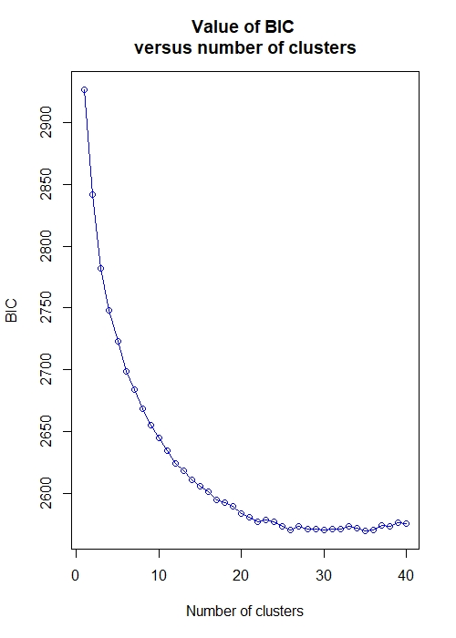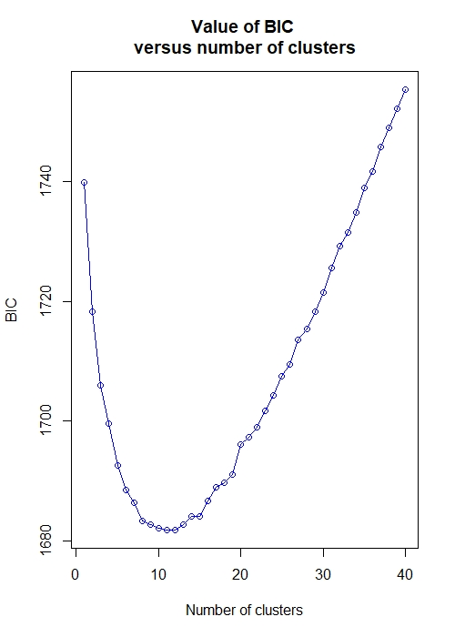

**Supplementary figure 1.** Bayesian Information Criteria values for A) *M. florea* and B) *S. pipiens*.

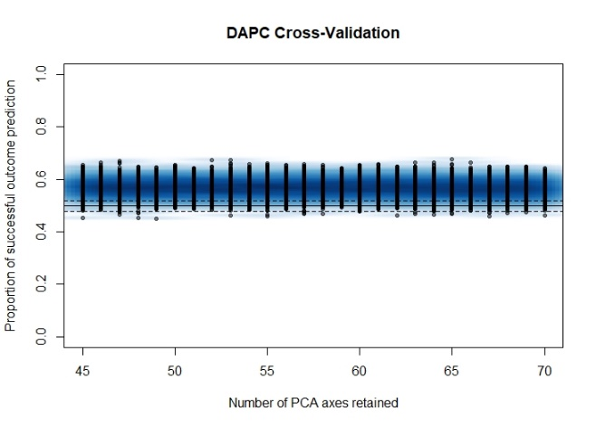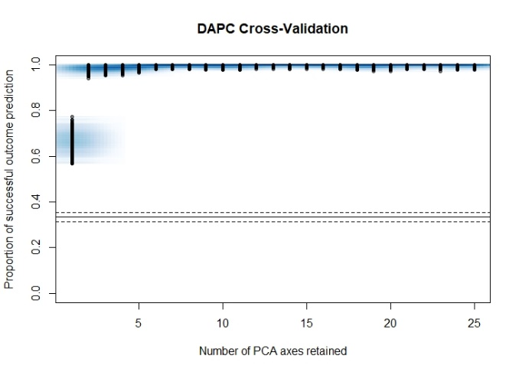

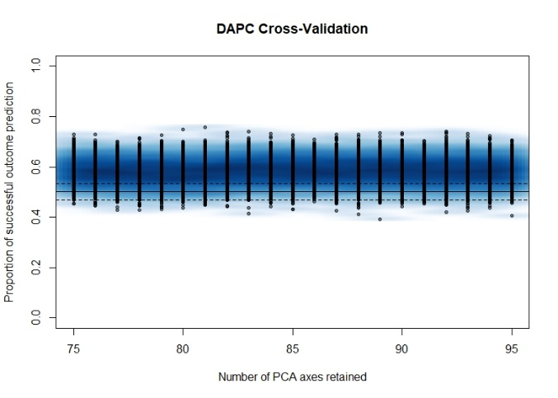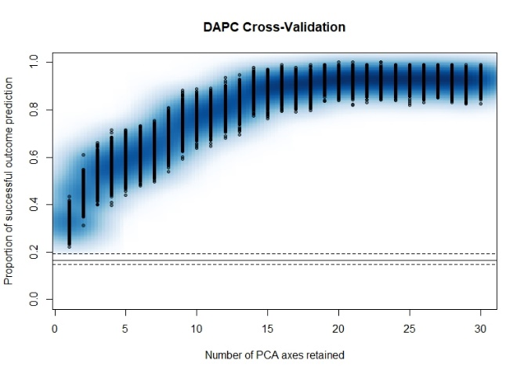

**Supplementary figure 2.** DAPC cross-validation results. A) *S. pipiens* with *a priori* populations; B) *S. pipiens* with *de novo* populations; C) *M. florea* with *a priori* populations; D) *M. florea* with *de novo* populations. The solid and dashed lines represent the median and confidence interval for a random chance classifier.