**High pollinator population connectivity in heavily disturbed landscapes: substantial gene flow despite large urban areas in two hoverflies**

# SUPPLEMENTARY MATERIAL

## Population genetics of *Syritta pipiens*

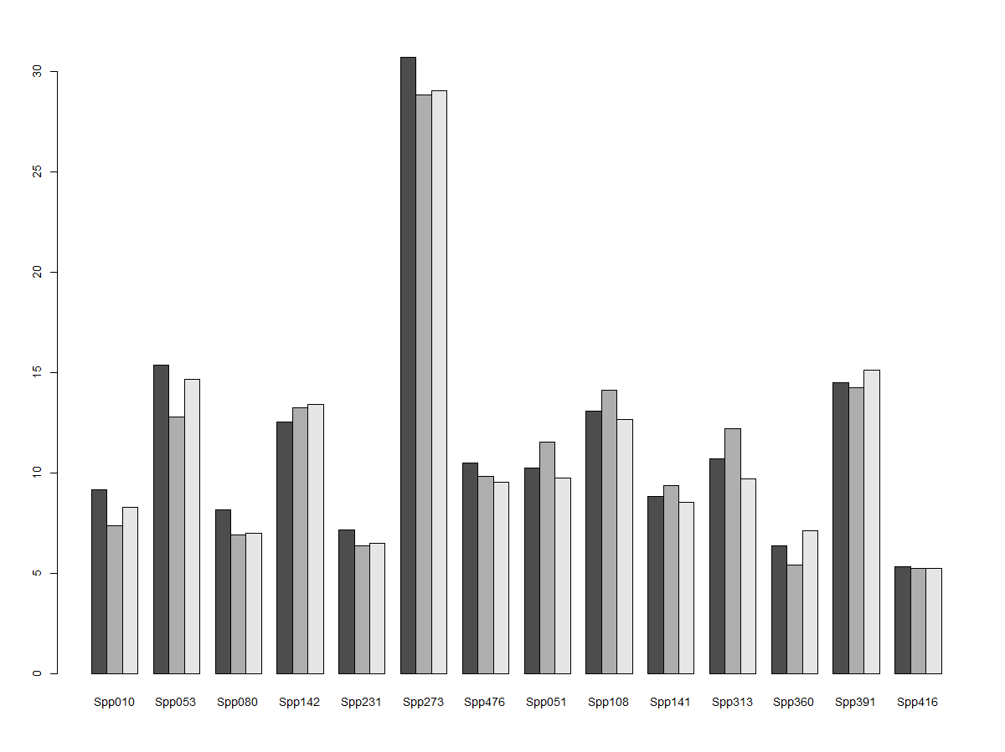

**Sup. Fig. 1.** Allelic richness in the *S. pipiens* dataset.