**LANDGEN PROJECT - FIELDWORK UPDATE REPORT 05/05/2022**

**Table 1:** Fieldwork success and completion, so far.

|  |  |  |  |  |
| --- | --- | --- | --- | --- |
| Species | B. major | O. bicornis | O. cornuta | A. cineraria |
| Number of individuals | 352 | 7 | 40 | 35 |
| Number of cells completed | 194 | 7 | 23 | 27 |
| Percent done | 42.5% | 1.5% | 5.0% | 5.9% |

**Table 2:** Number of individuals caught by each fieldworker.

|  |  |
| --- | --- |
| Balint | 33 |
| Gil | 11 |
| Gil/Balint | 3 |
| Hinatea/Julian | 38 |
| Hinatea | 3 |
| Stephanie | 31 |
| Amanda | 16 |
| Tya | 10 |
| Amanda/Tya | 8 |
| Dylan | 4 |
| Caroline | 14 |
| Bruno | 11 |
| Antonio | 21 |

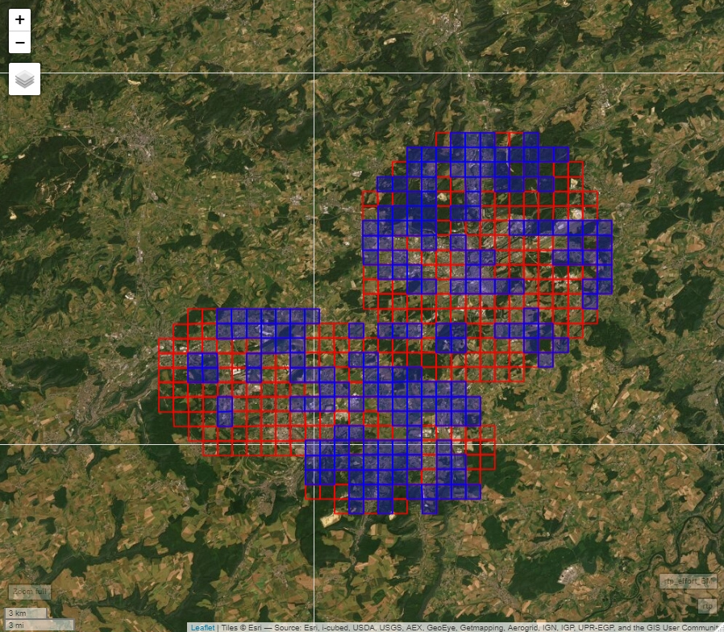

**Figure 1.** Sampling success for B. major. Please note that the southwest and the central area of the study area are major gaps. Let us try to focus them more than filling small gaps in well covered areas. We are passed the peak but we can still find some in May and June. Let’s try hard to catch them!

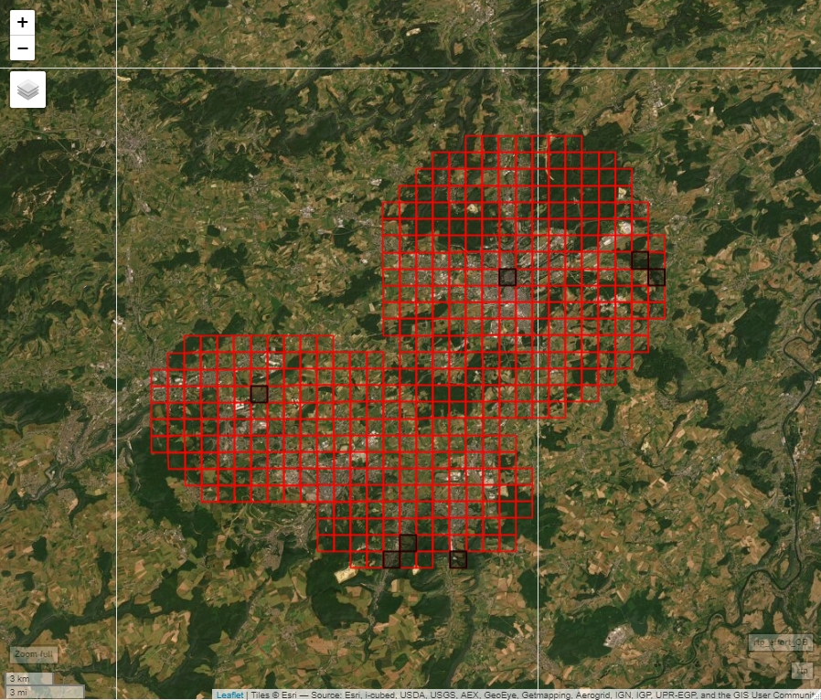

**Figure 2.** Sampling success for O. bicornis.  
  
Unfortunately, we are passed the peak. Could the reason for the bad numbers be bad weather (several days with frost and a big snowstorm) in early April? We could still find some in May and June, but it’s going to be hard.

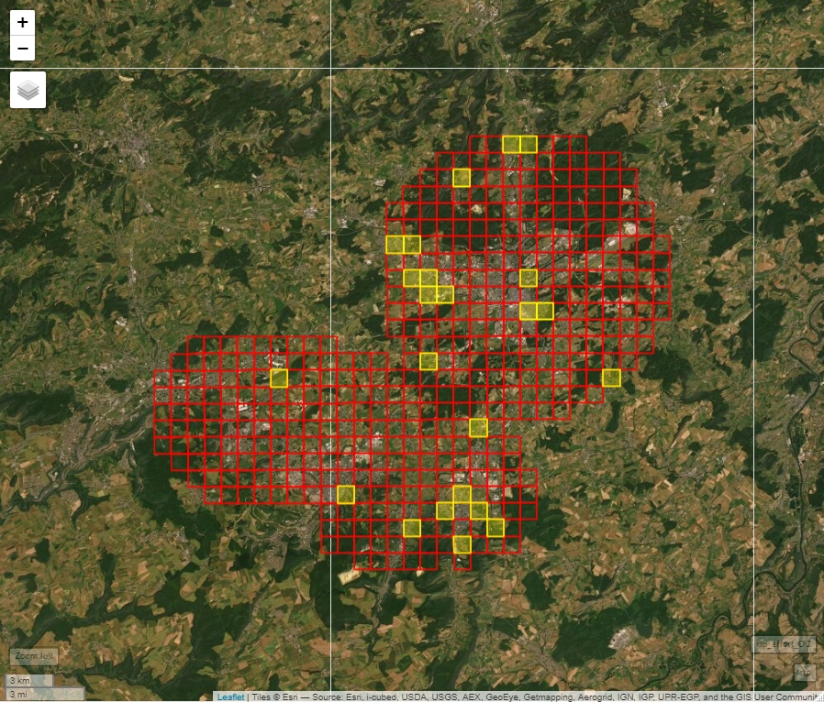

**Figure 3.** Sampling success for O. cornuta.

Better numbers than for O. bicornis, but unfortunately, we are really passed the peak. We are unlikely to find many.

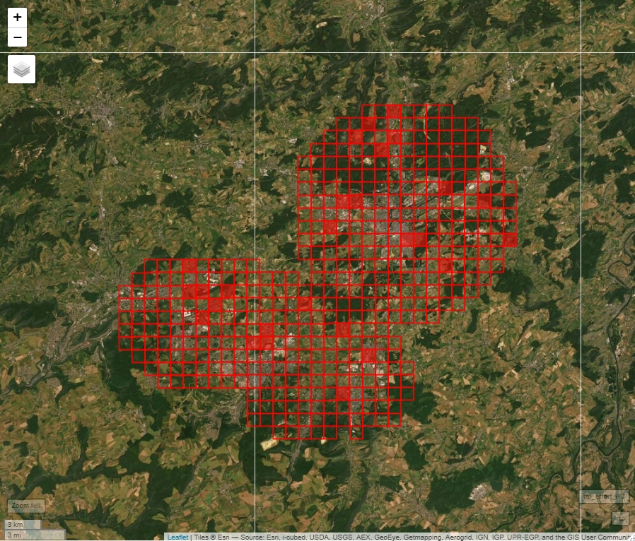

**Figure 4.** Sampling success for A. cineraria.

The peak is still close, let’s try hard to catch them. We could still find some in May and June.