# The Novelist’s Collective

Human-in-the-loop AI system for writing a novel. A central Orchestrator coordinates specialized agents, keeps context tight, and routes work/results through shared storage (Notion + Google Drive) and a vector store for retrieval.

## Roles at a glance

* Human Author (you): Supplies outline, character seeds, approves direction, revises prose.
* Orchestrator Agent: Plans tasks, assembles context, calls sub-agents/tools, tracks versions.
* Prose Agent: Writes scene/chapter drafts in target voice; respects outline and continuity.
* Character Forge: Builds/updates bios, backstories, motivations, voice/accent, relationships.
* The Critic: Reviews outline/plot/drafts; returns structured, actionable notes.
* Research Agent: Produces “fact packs” on time/place/industry/culture with citations.

## Conceptual Flow (end-to-end)

1. Input → Author creates/updates: outline, scene goals, tone constraints.
2. Plan → Orchestrator selects tool(s), compiles context from Notion/Drive/Vector store.
3. Draft → Prose Agent writes a scene (aware of outline + character cards + research).
4. Critique → The Critic checks voice, pacing, logic, continuity; returns change list.
5. Revise → Author revises (or Prose Agent revises under author rules).
6. Persist → Orchestrator commits: drafts to Drive; structured updates to Notion; embeds to vector store.
7. Loop → Repeat per scene/chapter; maintain status and dependencies in Notion.

## Storage & Context Strategy

* Structured (Notion)

Characters (DB): name, archetype, desires, fears, virtues/foibles, voice notes, relationships.

Plot/Scenes (DB): act/chapter/scene, summary, beats, POV, setting, included characters, status.

Research Index (DB): topic, sources, quotes, citations, reliability tag, notes, related scenes.

Decisions/Constraints (DB): style rules, banned tropes, continuity decisions, red lines.

* Unstructured (Google Drive)

/Drafts/<chapter>.gdoc — rolling drafts per chapter/scene.

/Research/<topic>.pdf|.docx — raw sources, clippings.

/Manuscript/Master.gdoc — the canonical, author-approved manuscript.

* Retrieval Layer (Vector Store)

Embed: character cards, scene summaries, prior scene text (chunked), key research notes.

RAG queries by Orchestrator to limit prompts to relevant, recent context.

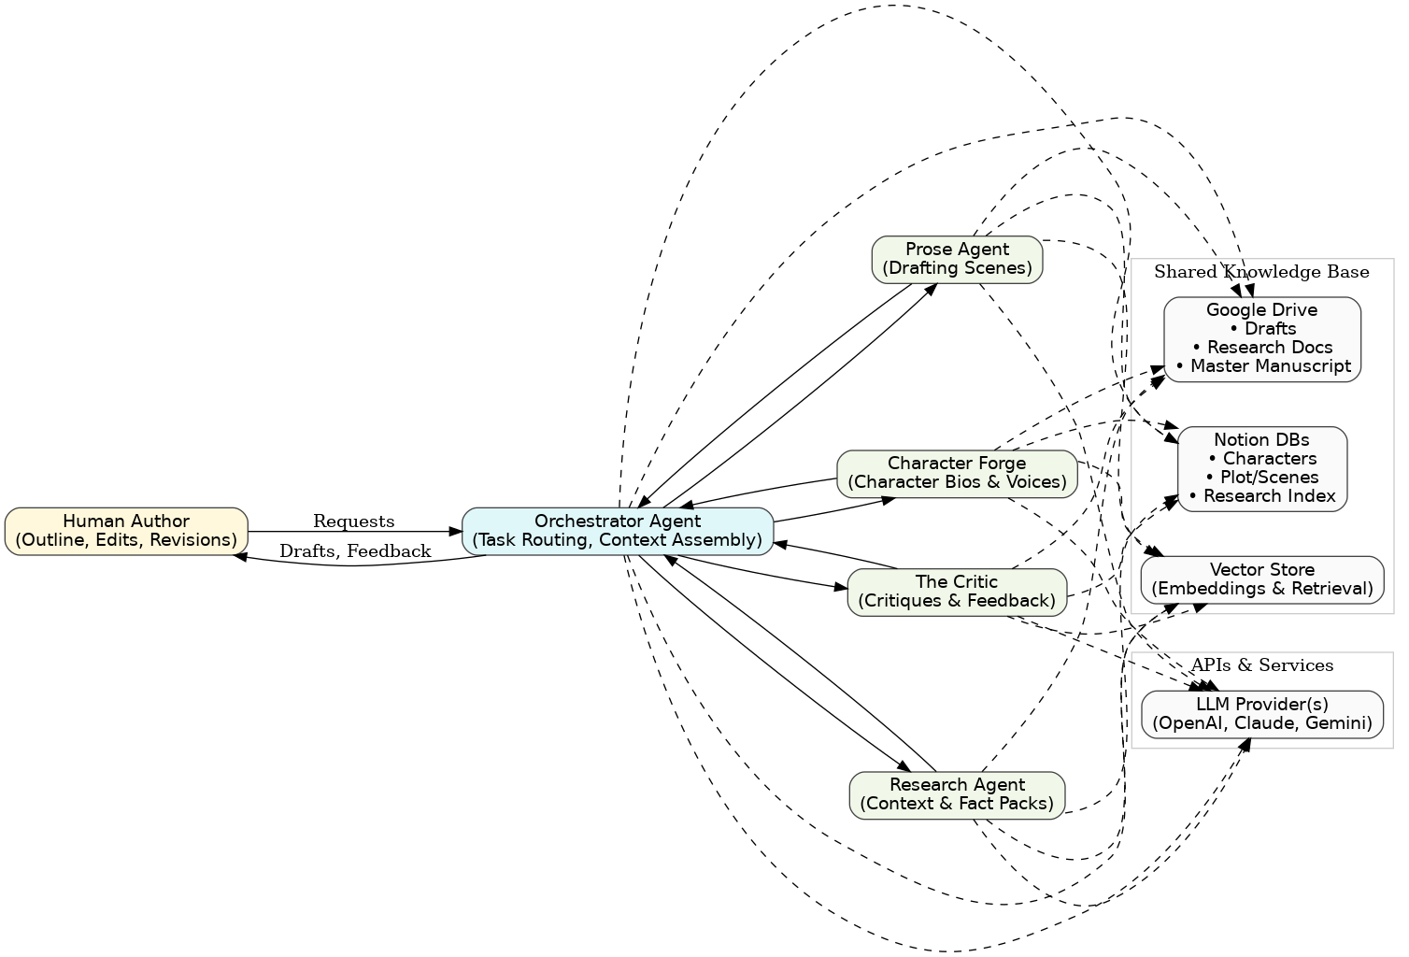

Figure 1. High-Level Architecture

## n8n Implementation (agent-tool pattern)

Main workflow: Orchestrator Agent  
  
Trigger: Manual or Webhook (from a simple UI).  
Set (Normalize Request): Clean/validate inputs; attach user/project IDs.  
  
AI Agent Node (Orchestrator): Analyze requests, select tools, assemble context, call tools, validate results, persist updates.

Tools: writeProse, critiqueText, createCharacter, researchTopic, fetchFromNotion, readGoogleDoc, (optional) updateVectorStore, queryVectorStore.

Switch/If (Task Type): Route results, handle edge cases.

Notify: Slack/Email to author with draft + notes.

Log/Version: Append run metadata and hashes.

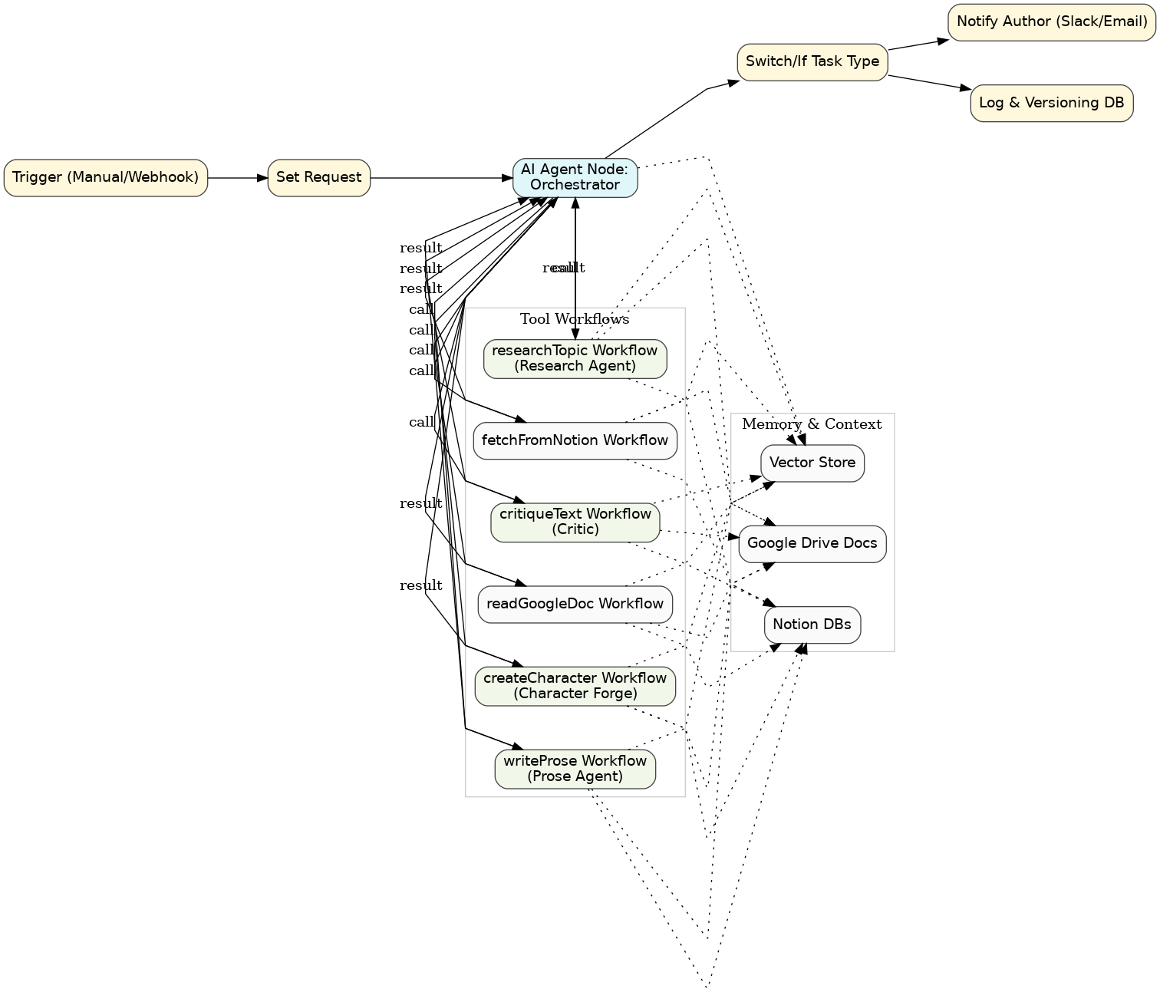

Figure 2. n8n Workflow

## Tool workflows (sub-agents)

writeProse: Input scene goals, POV, style constraints. Fetch context, generate draft with LLM Prose persona.

critiqueText: Input draft + outline. Generate structured notes + optional diffs with Critic persona.

createCharacter: Input seed. Generate bio, backstory, voice, update Notion.

researchTopic: Input topic. Summarize, cite, return fact pack. Update Notion + Drive.

fetchFromNotion/readGoogleDoc: Utility workflows to return structured data.

## Configuration Snippets

Notion DB properties (example):

{  
 "Characters": ["Name","Role","ArcStage","Motivation","Fear","Virtues","Foibles","VoiceNotes","Accent","Relationships","LastUpdatedISO"],  
 "Scenes": ["Act","Chapter","Scene","POV","Goal","Conflict","Setting","CharactersPresent","Beats","Status","Links","LastUpdatedISO"],  
 "Research": ["Topic","Summary","Citations","Reliability","RelatedScenes","Tags","LastUpdatedISO"]  
}

Tool contract (example):

// request  
{ "tool":"writeProse", "projectId":"...", "sceneId":"...", "context":{...} }  
// response  
{ "ok": true, "tool":"writeProse", "outputs": { "draft":"...", "checks": {...} }, "persist": [{ "type":"drive.write", ... }, { "type":"notion.upsert", ... }] }

## Guardrails & QA

Continuity tests: Orchestrator checks character facts/timelines.

Style lints: ban-lists, cadence targets, POV enforcement.

Fact flags: Research Agent tags low-confidence facts.

Versioning: all writes carry run ID + content hash.

## Operating the loop (practical)

Start a scene → Orchestrator assembles context → writeProse.

Draft returns → critiqueText reviews.

Author revises or accepts → Orchestrator saves & updates status.

Loop continues for each scene/chapter.