
EO Overpass Predictor
QGIS plugin — User Guide
When will Landsat 8/9 and Sentinel-2A/B/C image my site? Swath-aware overpass prediction, ESA acquisition-plan cross-check, product IDs and printable field sheets — inside QGIS.
Plugin version 1.0.2 · Guide dated 3 November 2026
Julian Manning · LinkedIn
github.com/julianManning/eo-overpass-qgis · GNU GPL v2.0 or later
Contents
1 What the plugin does 2
2 Installing 3
3 Quick start: Port Phillip Bay 4
4 The Predict overpasses tool 5
5 Outputs in QGIS 7
6 The field pack 9
7 Live tracker dock 14
8 Results expire: re-run before field work 15
9 Accuracy and limitations 16
10 Automation (Python, Model Designer, command line) 17
11 Troubleshooting 18
12 Data sources, licences and citation 19
13 Glossary 19

1 What the plugin does
⚠ Read this first
Predictions are geometric: they say when a satellite's swath can image your site. Whether an image is actually taken depends on the mission's acquisition plan, and whether it is usable depends on cloud.
Every output is stamped Produced and RE-RUN BY (3 days later by default). Re-run the prediction 1–2 days before going into the field.

EO Overpass Predictor answers a planning question that ordinary satellite trackers do not: when will Landsat 8, Landsat 9, Sentinel-2A, Sentinel-2B or Sentinel-2C actually image my area of interest (ROI)? A satellite being above the horizon is not the same as its instrument's swath covering your site, so the plugin models the swath and tests it against your ROI polygon or point.
For each pass it reports:
- the time the swath enters and leaves the ROI and its closest approach (≈ scene centre), in UTC and local time (the ROI's own time zone, with daylight saving);
- the % of the ROI inside the swath, the distance to the swath edge, view angle and sun elevation;
- the orbit (Sentinel-2 relative orbit or Landsat WRS-2 path) and the product IDs that will contain the ROI (Sentinel-2 MGRS tiles, Landsat path/rows);
- for Sentinel-2, whether the pass is in ESA's published acquisition plan.
It produces a styled QGIS layer of swaths, a layer of product footprints, and an optional field pack per ROI: CSV, a standalone live-tracker web page, and one printable A4 field sheet PDF (map and pass table, timeline, how-to-read pages).

What it is not
- Not an acquisition guarantee: only ESA's plan (Sentinel-2) or USGS's schedule (Landsat) decides what is acquired.
- Not a cloud forecast.
- Not a catalogue search: product IDs are computed from the predicted orbit and the grid rules. Use them to search Copernicus Browser or EarthExplorer after the pass.

2 Installing

Requirements
- QGIS 3.34 or later (QGIS 4 / Qt6 supported). Windows, macOS or Linux.
- No account or API key. Python dependencies (sgp4, geographiclib, tzdata) are bundled with the plugin.
- Internet access to celestrak.org (orbital elements) and sentinels.copernicus.eu (ESA plans). Proxy settings from QGIS are used. Basemap tiles come from OpenStreetMap or Esri.

Install from ZIP
- Download eo_overpass_qgis.zip from the GitHub Releases page (or use the one in the repository's dist folder).
- In QGIS: Plugins ▸ Manage and Install Plugins ▸ Install from ZIP, choose the file and click Install Plugin.
- When upgrading from an earlier version, restart QGIS afterwards so the new code is loaded.
After installing you will find, under Plugins ▸ EO Overpass: Predict overpasses…, Help (user guide) (this document, bundled for offline use) and About (section 2.1). There is one toolbar button, and EO Overpass ▸ Predict overpasses in the Processing Toolbox, whose Help button also opens this guide.

2.1 About
Plugins ▸ EO Overpass ▸ About shows the version and release date, your QGIS and Python versions, a short description, the author with a link to LinkedIn, the source code, issue tracker and DOI, how to cite the plugin (with a Copy citation button), data credits and the licence.
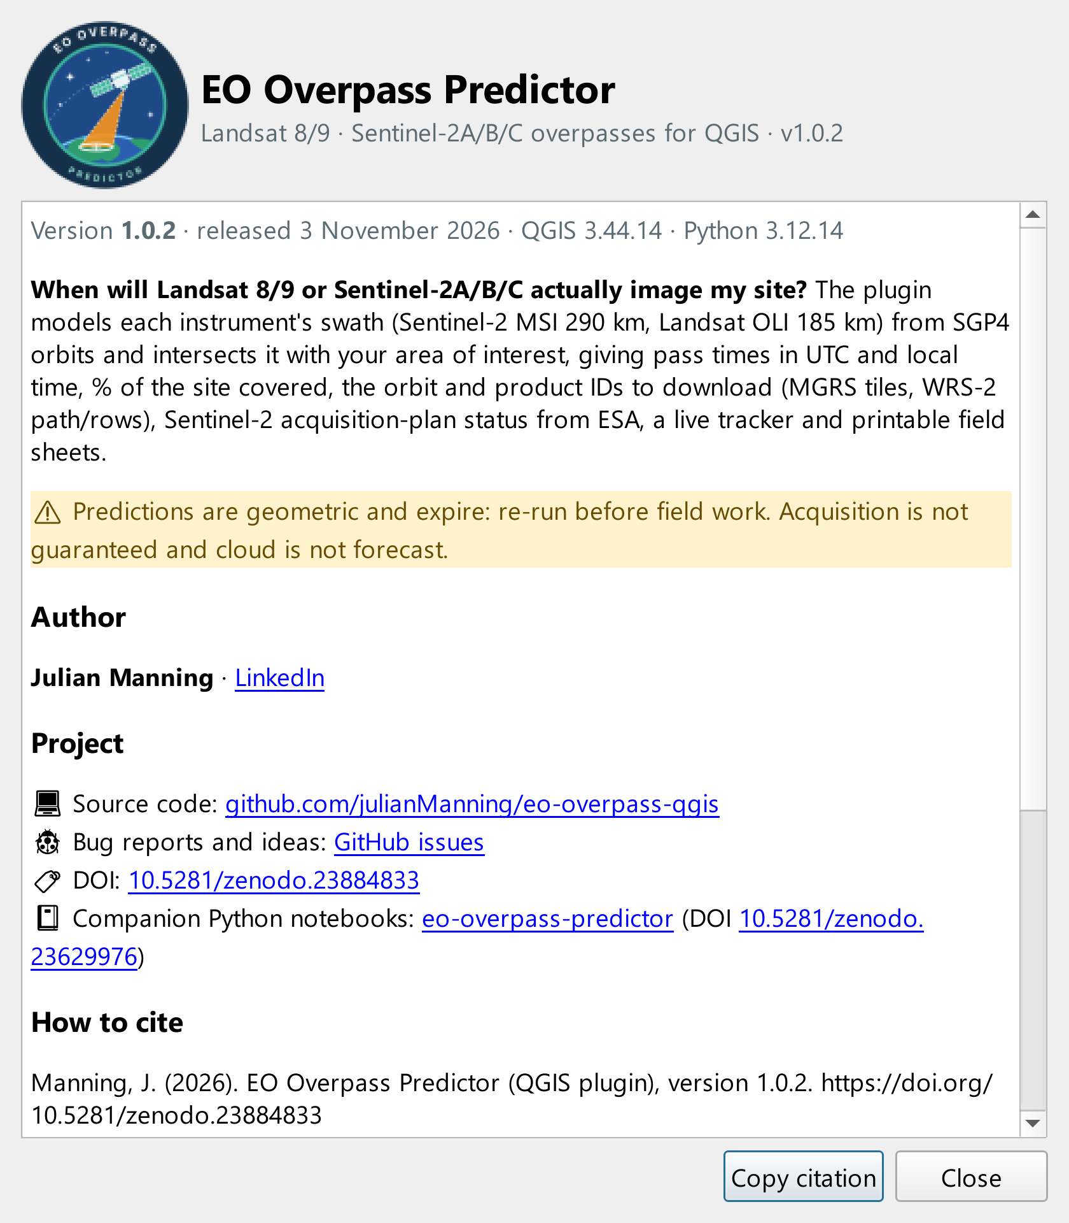
Figure 1 — The About dialog.

3 Quick start: Port Phillip Bay
This walkthrough uses the example ROI from the companion notebook repository (eo-overpass-predictor): DATA/SHP/Port_Phillip_Bay_Extent_EPSG_32755.shp, a single rectangle over Port Phillip Bay, Victoria, in WGS 84 / UTM zone 55S. Any polygon or point layer in any CRS works the same way.
- Add the shapefile to QGIS (drag it onto the map, or Layer ▸ Add Layer ▸ Add Vector Layer).
- Open Plugins ▸ EO Overpass ▸ Predict overpasses….
- Set Region(s) of interest to Port_Phillip_Bay_Extent. Leave the name field empty: the plugin uses a name or site field if there is one, or the layer name for a single feature.
- Keep the defaults: start now, 16 days, all five satellites ticked, daytime descending passes only, ESA cross-check on.
- Under Field pack folder choose a folder, e.g. C:/Fieldwork/PortPhillip/field_pack.
- Optionally pick Add a basemap to the map (Esri World Imagery is the default) and click Run.
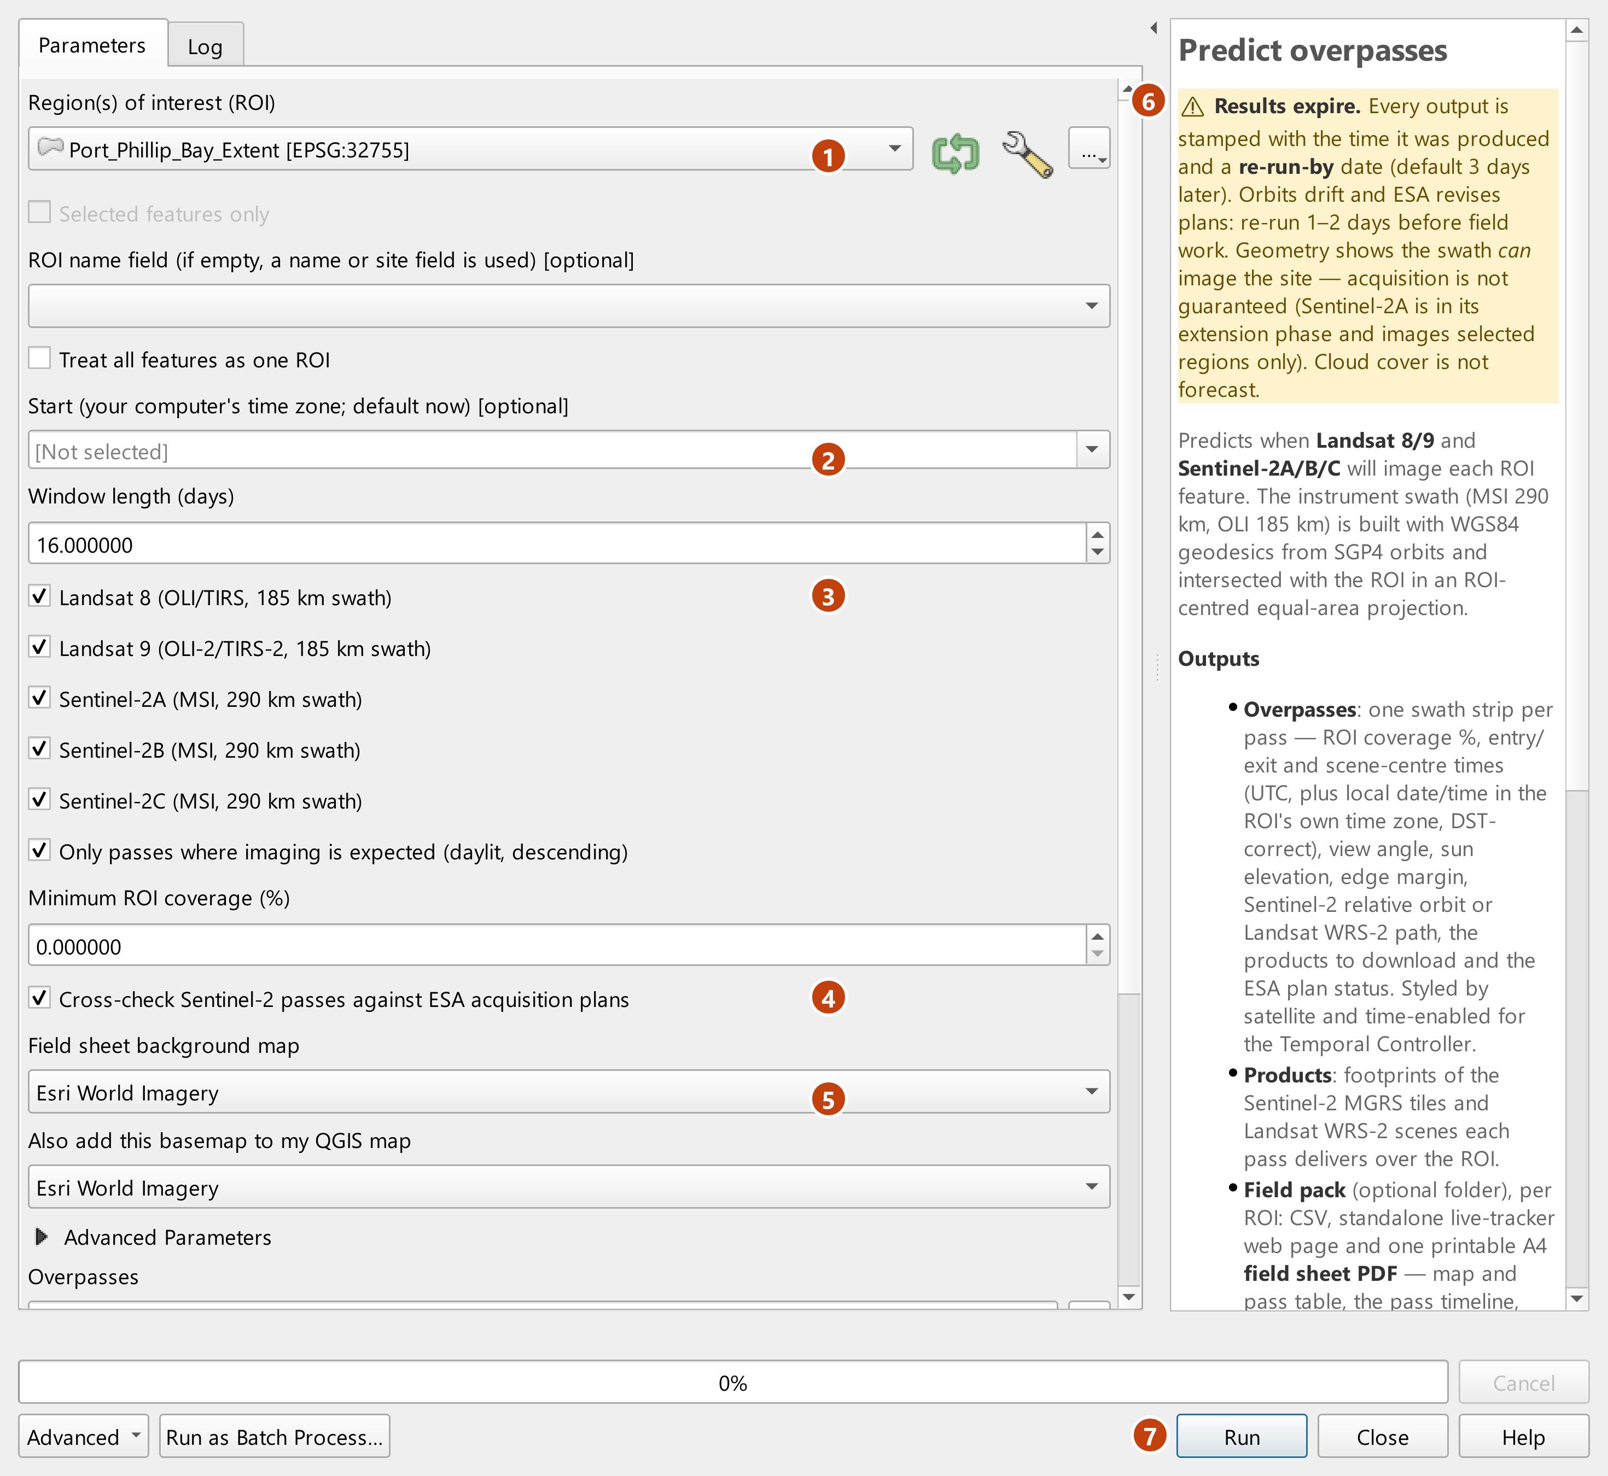
Figure 2 — The Predict overpasses dialog, with the expiry warning at the top of the help panel.
1 | Region(s) of interest (ROI): pick a layer, or press … to choose a file.
2 | Start time (empty means now). The window length is the field below it.
3 | Satellites to include, and the daytime-descending filter.
4 | Cross-check Sentinel-2 passes against ESA acquisition plans.
5 | Basemap for the field sheet, and the one added to your QGIS map.
6 | The “Results expire” warning at the top of the help panel.
7 | Run. The live tracker opens by itself when the tool finishes.

The Log tab lists the orbital elements used, the ESA plans loaded and every pass. For Port Phillip Bay, starting 26 October 2026:
Orbital elements (TLE):
LANDSAT 8 NORAD 39084 epoch 2026-10-23 05:33 UTC (3.2 d old)
SENTINEL-2A NORAD 40697 epoch 2026-10-21 15:33 UTC (4.7 d old)
SENTINEL-2B NORAD 42063 epoch 2026-10-21 06:59 UTC (5.1 d old)
SENTINEL-2C NORAD 60989 epoch 2026-10-21 04:28 UTC (5.2 d old)
LANDSAT 9 NORAD 49260 epoch 2026-10-19 05:08 UTC (7.2 d old) ⚠ older than 7 days
ESA Sentinel-2 acquisition plans:
✔ 3 plan files loaded (S2A, S2B, S2C), 2277 planned data-takes.

Port Phillip Bay — time zone Australia/Melbourne. 14 overpasses predicted:
# | Satellite | Local (UTC+11) | UTC | ROI % | Orbit | Products | ESA plan
1 | Sentinel-2B | 26 Oct 11:27 | 26 Oct 00:27 | 100.0 | R116 | T55HBT … T55HCU | planned
2 | Sentinel-2C | 28 Oct 11:17 | 28 Oct 00:17 | 55.3 | R073 | T55HBT … T55HCU | planned
3 | Landsat 9 | 29 Oct 11:09 | 29 Oct 00:09 | 100.0 | P093 | 093/086 093/087 | routine
4 | Landsat 8 | 30 Oct 11:03 | 30 Oct 00:03 | 65.9 | P092 | 092/086 092/087 | routine
5 | Sentinel-2A | 30 Oct 11:17 | 30 Oct 00:17 | 54.0 | R073 | T55HBT … T55HCU | not planned
6 | Sentinel-2C | 31 Oct 11:27 | 31 Oct 00:27 | 100.0 | R116 | T55HBT … T55HCU | planned
7 | Sentinel-2B | 02 Nov 11:17 | 02 Nov 00:17 | 57.8 | R073 | T55HBT … T55HCU | no plan loaded
8 | Sentinel-2A | 02 Nov 11:27 | 02 Nov 00:27 | 100.0 | R116 | T55HBT … T55HCU | planned
9 | Sentinel-2B | 05 Nov 11:27 | 05 Nov 00:27 | 100.0 | R116 | T55HBT … T55HCU | no plan loaded
10 | Landsat 8 | 06 Nov 11:09 | 06 Nov 00:09 | 100.0 | P093 | 093/086 093/087 | routine
11 | Landsat 9 | 07 Nov 11:03 | 07 Nov 00:03 | 57.8 | P092 | 092/086 092/087 | routine
12 | Sentinel-2C | 07 Nov 11:17 | 07 Nov 00:17 | 53.3 | R073 | T55HBT … T55HCU | no plan loaded
13 | Sentinel-2A | 09 Nov 11:17 | 09 Nov 00:17 | 50.9 | R073 | T55HBT … T55HCU | no plan loaded
14 | Sentinel-2C | 10 Nov 11:27 | 10 Nov 00:27 | 100.0 | R116 | T55HBT … T55HCU | no plan loaded
Red = not in ESA’s plan; amber = no plan loaded for that date (unknown, not “not planned”).
⚠ Produced 26 Oct 2026 20:18 local (09:18 UTC). Re-run by 29 Oct 2026 20:18 local (09:18 UTC) for the most accurate results — orbits drift and ESA revises plans. Acquisition is not guaranteed; cloud is not forecast.
Two layers are added to the map (section 5) and the field pack is written to field_pack/Port_Phillip_Bay/ (section 6).

4 The Predict overpasses tool
One tool does the whole job: it downloads fresh orbital elements, predicts passes, attaches orbit and product IDs, cross-checks Sentinel-2 against ESA's plans, stamps the results with an expiry and writes the outputs. Re-running it is how you refresh everything.

Main parameters
Parameter | Default | What it does
Region(s) of interest | — | Polygon or point layer, any CRS. One prediction per feature unless dissolved. Selected features only is supported.
ROI name field | auto | Field used to name each ROI. If empty, a field called name, site, roi or label is used; a single feature takes the layer name.
Treat all features as one ROI | off | Dissolve all features into one ROI (e.g. several plots of one study area).
Start | now | Start of the window, in your computer's time zone. Results are stored in UTC.
Window length (days) | 16 | 0.1–120 days. 16 days covers a full Landsat cycle and more than a Sentinel-2 cycle.
Landsat 8 … Sentinel-2C | all ticked | One tick box per satellite.
Only passes where imaging is expected | on | Keep daylit descending passes only. Untick to see night/ascending passes too (useful for orbit checks).
Minimum ROI coverage (%) | 0 | Drop passes covering less of the ROI, e.g. 50 to ignore edge slivers.
Cross-check Sentinel-2 … ESA plans | on | Downloads ESA's acquisition-plan KMLs for the window and labels each Sentinel-2 pass planned / not planned / no plan loaded.
Field-sheet basemap | Esri World Imagery | Background of the field-sheet map: OpenStreetMap, Esri World Imagery, or the bundled offline Natural Earth land/sea. The offline land/sea is always drawn underneath, so the map stays readable if tiles fail.
Add a basemap to the map | Esri World Imagery | Also add one of those basemaps to your QGIS project (the Natural Earth one works offline).
Overpasses | temporary layer | Output pass layer (save to GeoPackage to keep it).
Products | temporary layer | Output product-footprint layer; set to Skip output to omit.
Field pack folder | skipped | Folder for the CSV, web page and printable outputs (one sub-folder per ROI).

Advanced parameters
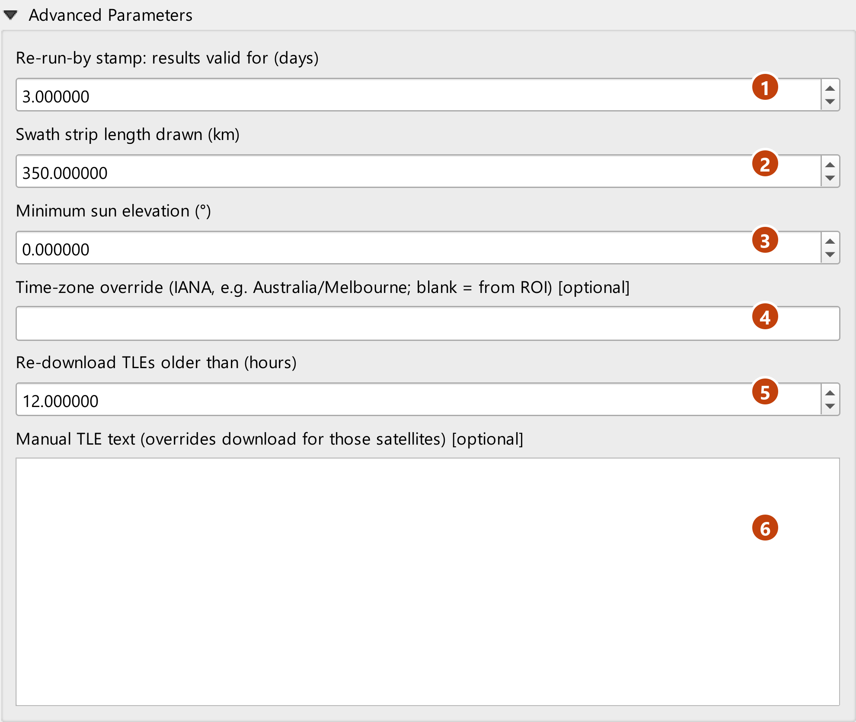
Figure 3 — Advanced parameters.
1 | Re-run-by stamp: how many days the results count as valid.
2 | Length of each swath strip drawn on the map.
3 | Minimum sun elevation for “imaging expected”.
4 | Time-zone override; blank uses the ROI’s own zone.
5 | Re-download orbital elements (TLEs) older than this many hours.
6 | Paste your own TLEs here to override the download.

Parameter | Default | What it does
Re-run-by stamp (days) | 3 | How long results are marked valid (0.5–30). Sets the RE-RUN BY date on every output and the expiry of the web page.
Swath strip length drawn (km) | 350 | Length of each pass polygon along the track (50–5000). Longer strips help when viewing passes regionally.
Minimum sun elevation (°) | 0 | Passes with the sun lower than this are not 'expected'. Raise to 15–20° for well-lit imagery at high latitudes in winter.
Time-zone override | from ROI | IANA name, e.g. Australia/Melbourne. Use it when an ROI spans several zones or you work in another zone.
Re-download TLEs older than (hours) | 12 | Orbital elements are cached; older caches are refreshed from CelesTrak.
Manual TLE text | empty | Paste two- or three-line element sets to override the download for those satellites (e.g. offline work, historical analysis).

How a pass is predicted
- Orbits are propagated with SGP4 from CelesTrak TLEs and converted to Earth-fixed WGS 84 coordinates.
- Each instrument's swath (MSI 290 km, OLI 185 km) is built with WGS 84 geodesics either side of the ground track, so its width is true at every latitude.
- Swath and ROI are intersected in an equal-area projection centred on the ROI, giving ROI % and the entry/exit times.
- Imaging expected means a descending (daytime) pass with the sun above the minimum elevation, inside the mission's latitude limits.
- Local time uses an offline time-zone grid and the IANA database, so daylight saving is applied for each date.

5 Outputs in QGIS

Overpasses layer
One polygon per pass: the swath strip around the time it crosses the ROI, coloured by satellite and labelled with local time. All attributes listed in section 6.5 are on the layer. The layer is time-enabled: open View ▸ Panels ▸ Temporal Controller to step through the passes.
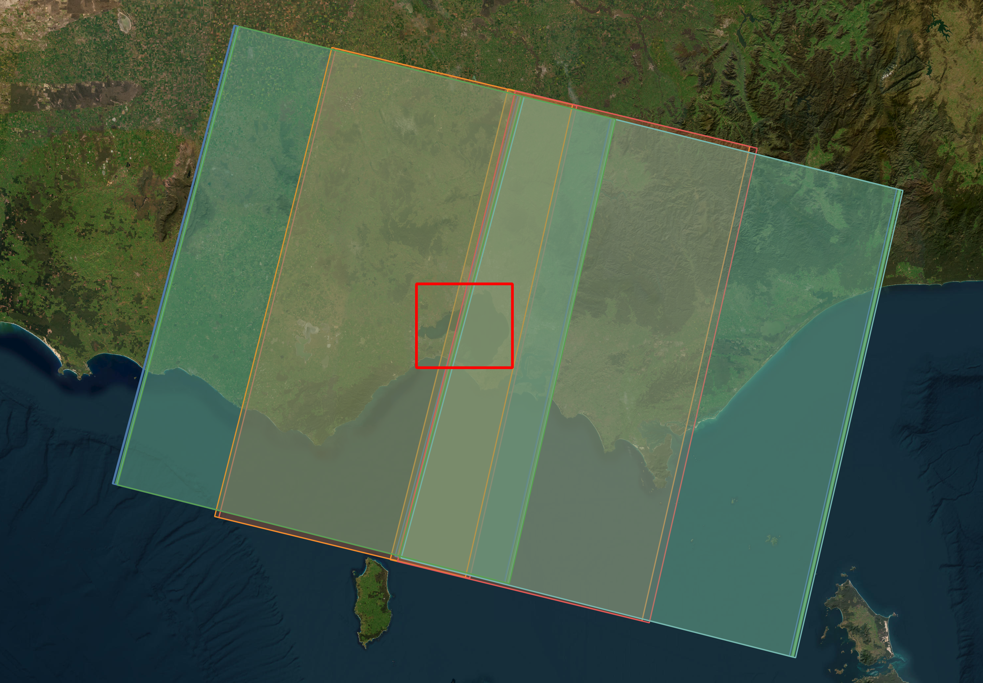
Figure 4 — The 14 predicted passes over the Port Phillip Bay ROI (red), coloured by satellite.

Products layer
Footprints of the products each pass delivers over the ROI: Sentinel-2 MGRS tiles (e.g. T55HCU) and Landsat WRS-2 scenes (path/row, e.g. 093/086), drawn as dashed outlines in the satellite's colour and labelled with the product ID. Filter by pass_no to see one pass.
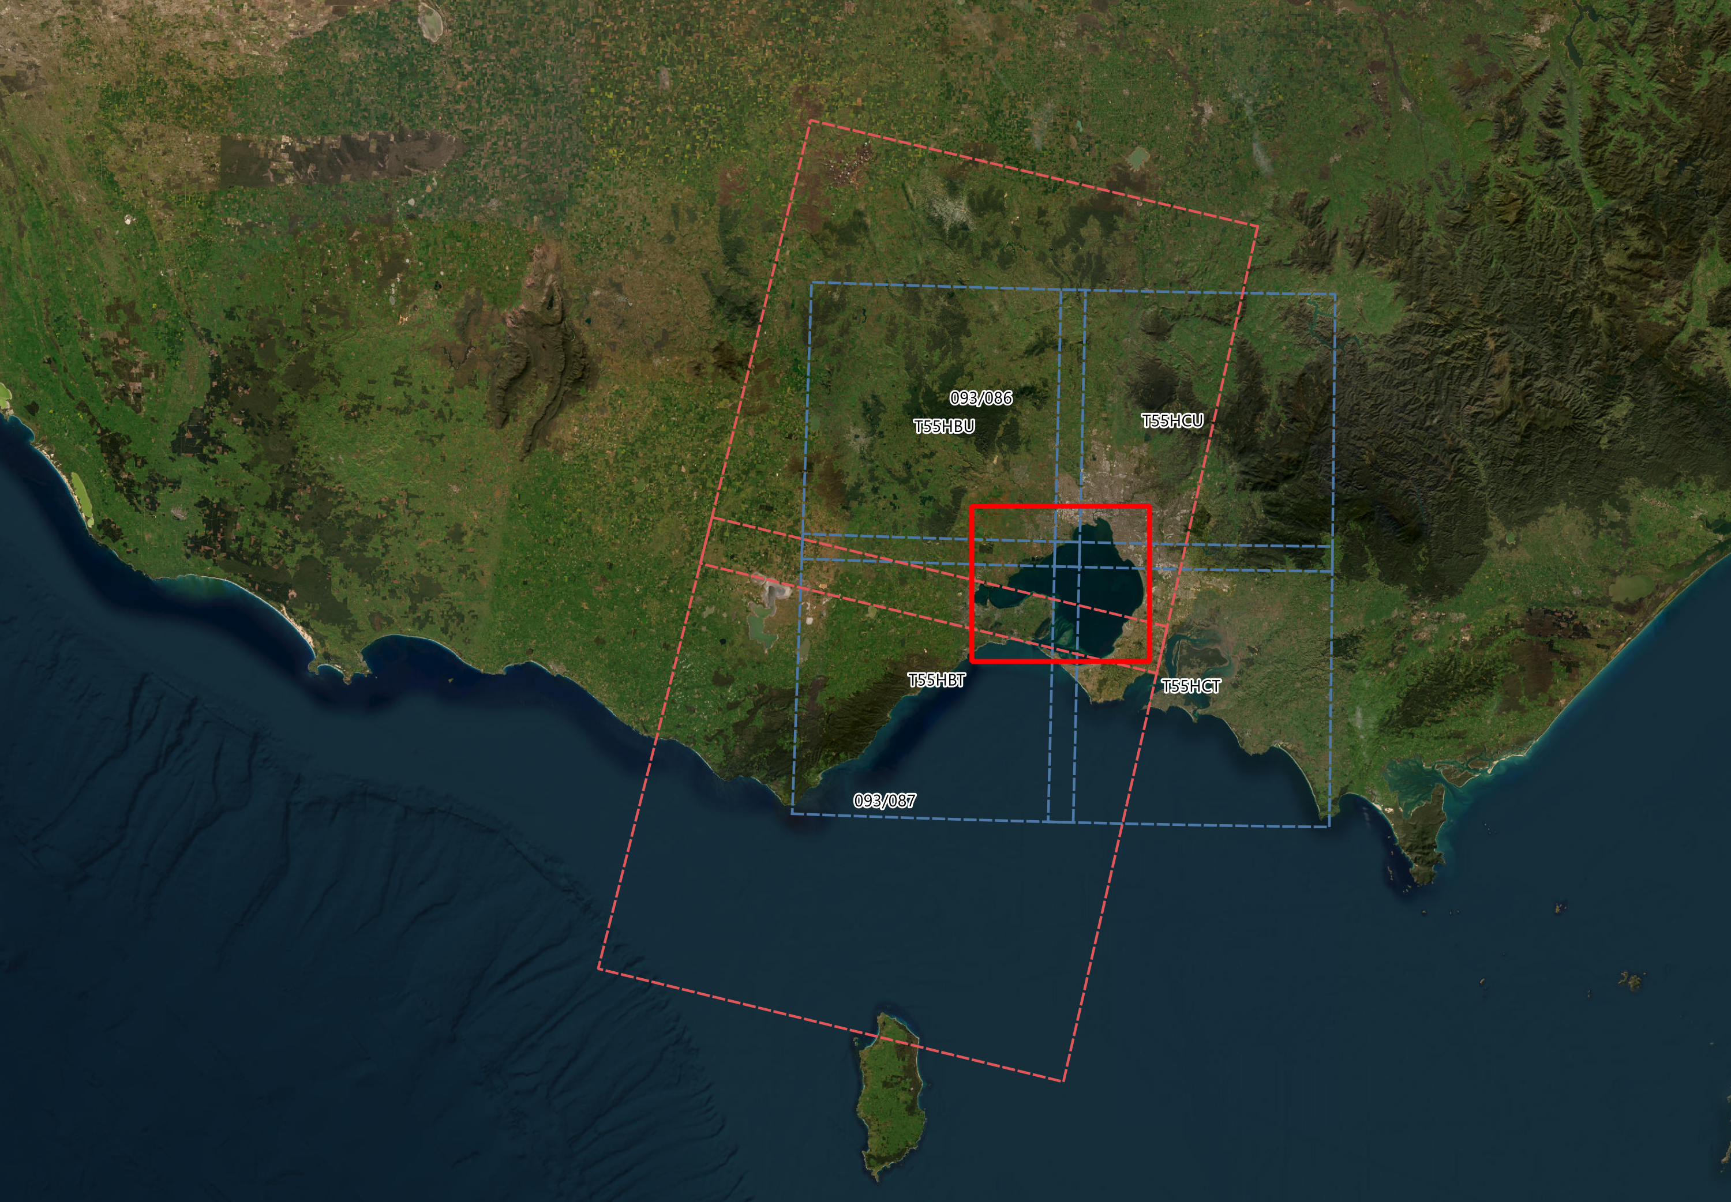
Figure 5 — Products for pass 1 (Sentinel-2B: tiles T55HBT, T55HBU, T55HCT, T55HCU) and pass 3 (Landsat 9: 093/086, 093/087).
Field | Meaning
pass_no | Pass number, matching the pass layer and field sheet.
product | MGRS tile (T55HCU) or Landsat path/row (093/086).
kind | Product type and the footprint drawn.
relative_orbit, wrs_path, wrs_row | Orbit / grid identifiers.
valid_until_utc | Re-run-by time of the prediction.

ℹ Footprints are nominal
Sentinel-2 tiles are drawn as 109.8 km squares anchored at the MGRS 100 km square's upper-left corner; Landsat scenes as 185 × 180 km rectangles along the track. They are close to, but not identical with, the official grids. The IDs themselves were checked against delivered scenes.

6 The field pack
When a field pack folder is set, the tool writes one sub-folder per ROI:
File | Contents
field_sheet_<site>.pdf | Printable A4 PDF: page 1 map and pass table, page 2 the pass timeline, then pages explaining the symbols, columns and satellites.
overpasses_<site>.csv | One row per pass, all attributes, UTC and local times.
live_tracker_<site>.html | Standalone live tracker web page with validity banner.

6.1 Field sheet — page 1: map and pass table
An A4 sheet (300 dpi) to print and take into the field. The map shows the next expected passes: the dashed line is the satellite's ground track, the shaded strip with solid edges is the area imaged, and the numbered circle matches the table. The table gives local date and time window, UTC, ROI %, orbit, products and ESA plan status.
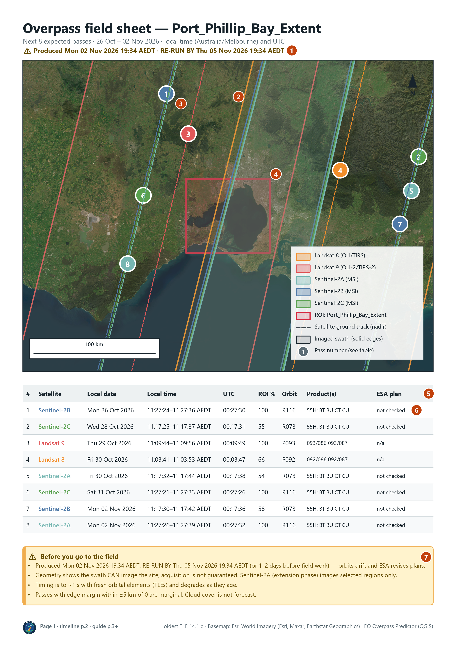
Figure 6 — Field sheet page 1, with the Esri World Imagery basemap.
1 | Produced / RE-RUN BY stamp: the sheet’s shelf life.
2 | Satellite ground tracks (dashed) and imaged swaths (solid edges), coloured by satellite.
3 | Numbered circle: the pass number, matching the # column.
4 | Your ROI (red outline).
5 | Pass table: local date and time window, UTC, ROI %, orbit and products.
6 | ESA plan: planned, not planned, no plan loaded, not checked, or n/a for Landsat.
7 | Caution box: expiry and the limits of the prediction.

6.2 Field sheet — pages 3 and 4: how to read it
The following pages of the PDF explain every map symbol and table column, give the satellites’ swath, pixel size and repeat cycle, list practical field tips, and describe every column of the CSV (section 6.5). They travel with the sheet, so someone who has never used the plugin can read it. The same reference is reproduced here.
Map symbols
Symbol | Meaning
Satellite ground track (dashed) | The line directly beneath the satellite (nadir). Its colour is the satellite's colour.
Imaged swath (shaded, solid edges) | The strip of ground the instrument images on this pass: 290 km wide for Sentinel-2, 185 km for Landsat. Anything inside the solid edges can be in the image.
Your area of interest (red outline) | The ROI from your input layer. ROI % in the table is the share of this area inside the swath.
Pass number (numbered circle) | Sits on the pass's ground track and matches the # column of the table.

Pass-table columns
Column | Meaning
# | Pass number. Matches the numbered circle on the map.
Satellite | Satellite name, in the same colour as its swath on the map.
Local date | Date at the site, in the site's own time zone (found from its location).
Local time | When the swath first reaches the site → when it leaves it, in local time with daylight saving applied. A point site has a single instant.
UTC | Closest approach to the centre of the site, in UTC (≈ the image's scene-centre time in the product metadata).
ROI % | Share of the site's area inside the imaged swath on this pass. 100 = the whole site.
Orbit | R### = Sentinel-2 relative orbit (1–143; repeats every 10 days per satellite). P### = Landsat WRS-2 path (1–233; repeats every 16 days). Use it to search image catalogues.
Product(s) | The products that will contain the site. Sentinel-2 MGRS tiles are grouped by UTM zone and latitude band: '55H: BT CU' means tiles T55HBT and T55HCU. Landsat scenes are path/row, e.g. 093/086.
ESA plan | Sentinel-2 only. planned = in ESA's published acquisition plan; not planned = ESA's plan for that date does not cover the site; no plan loaded = ESA has not published a plan that far ahead yet (about 2 weeks) — unknown, not negative; not checked = cross-check switched off; n/a = Landsat.

The satellites
Satellite | Sensor | Swath | Pixel size | Repeat cycle
Landsat 8 | OLI / TIRS | 185 km | 30 m (15 m pan, 100 m thermal) | 16 days (8 with Landsat 9)
Landsat 9 | OLI-2 / TIRS-2 | 185 km | 30 m (15 m pan, 100 m thermal) | 16 days (8 with Landsat 8)
Sentinel-2A | MSI | 290 km | 10 / 20 / 60 m | 10 days; extension phase: selected regions only
Sentinel-2B | MSI | 290 km | 10 / 20 / 60 m | 10 days (5 with Sentinel-2C)
Sentinel-2C | MSI | 290 km | 10 / 20 / 60 m | 10 days (5 with Sentinel-2B)

Field tips
- Be on site and ready a few minutes before the Local time window; the satellite crosses a typical site in seconds.
- Prefer passes with ROI % near 100. Low ROI % means the site sits near the swath edge.
- For Sentinel-2, a 'planned' ESA status is the strongest evidence the image will be taken.
- Check the cloud forecast the day before — this sheet does not forecast cloud.
- Re-run the prediction 1–2 days before going out, and by the RE-RUN BY date at the latest.

6.3 Timeline
A calendar of the window with one row per satellite. The number in each circle is the % of the ROI covered (the circle grows with it); the label above is the local time. Filled circles are expected acquisitions; hollow circles are not expected (night or ascending pass) or, for Sentinel-2, not in ESA's acquisition plan. The same page is the second page of the field-sheet PDF.
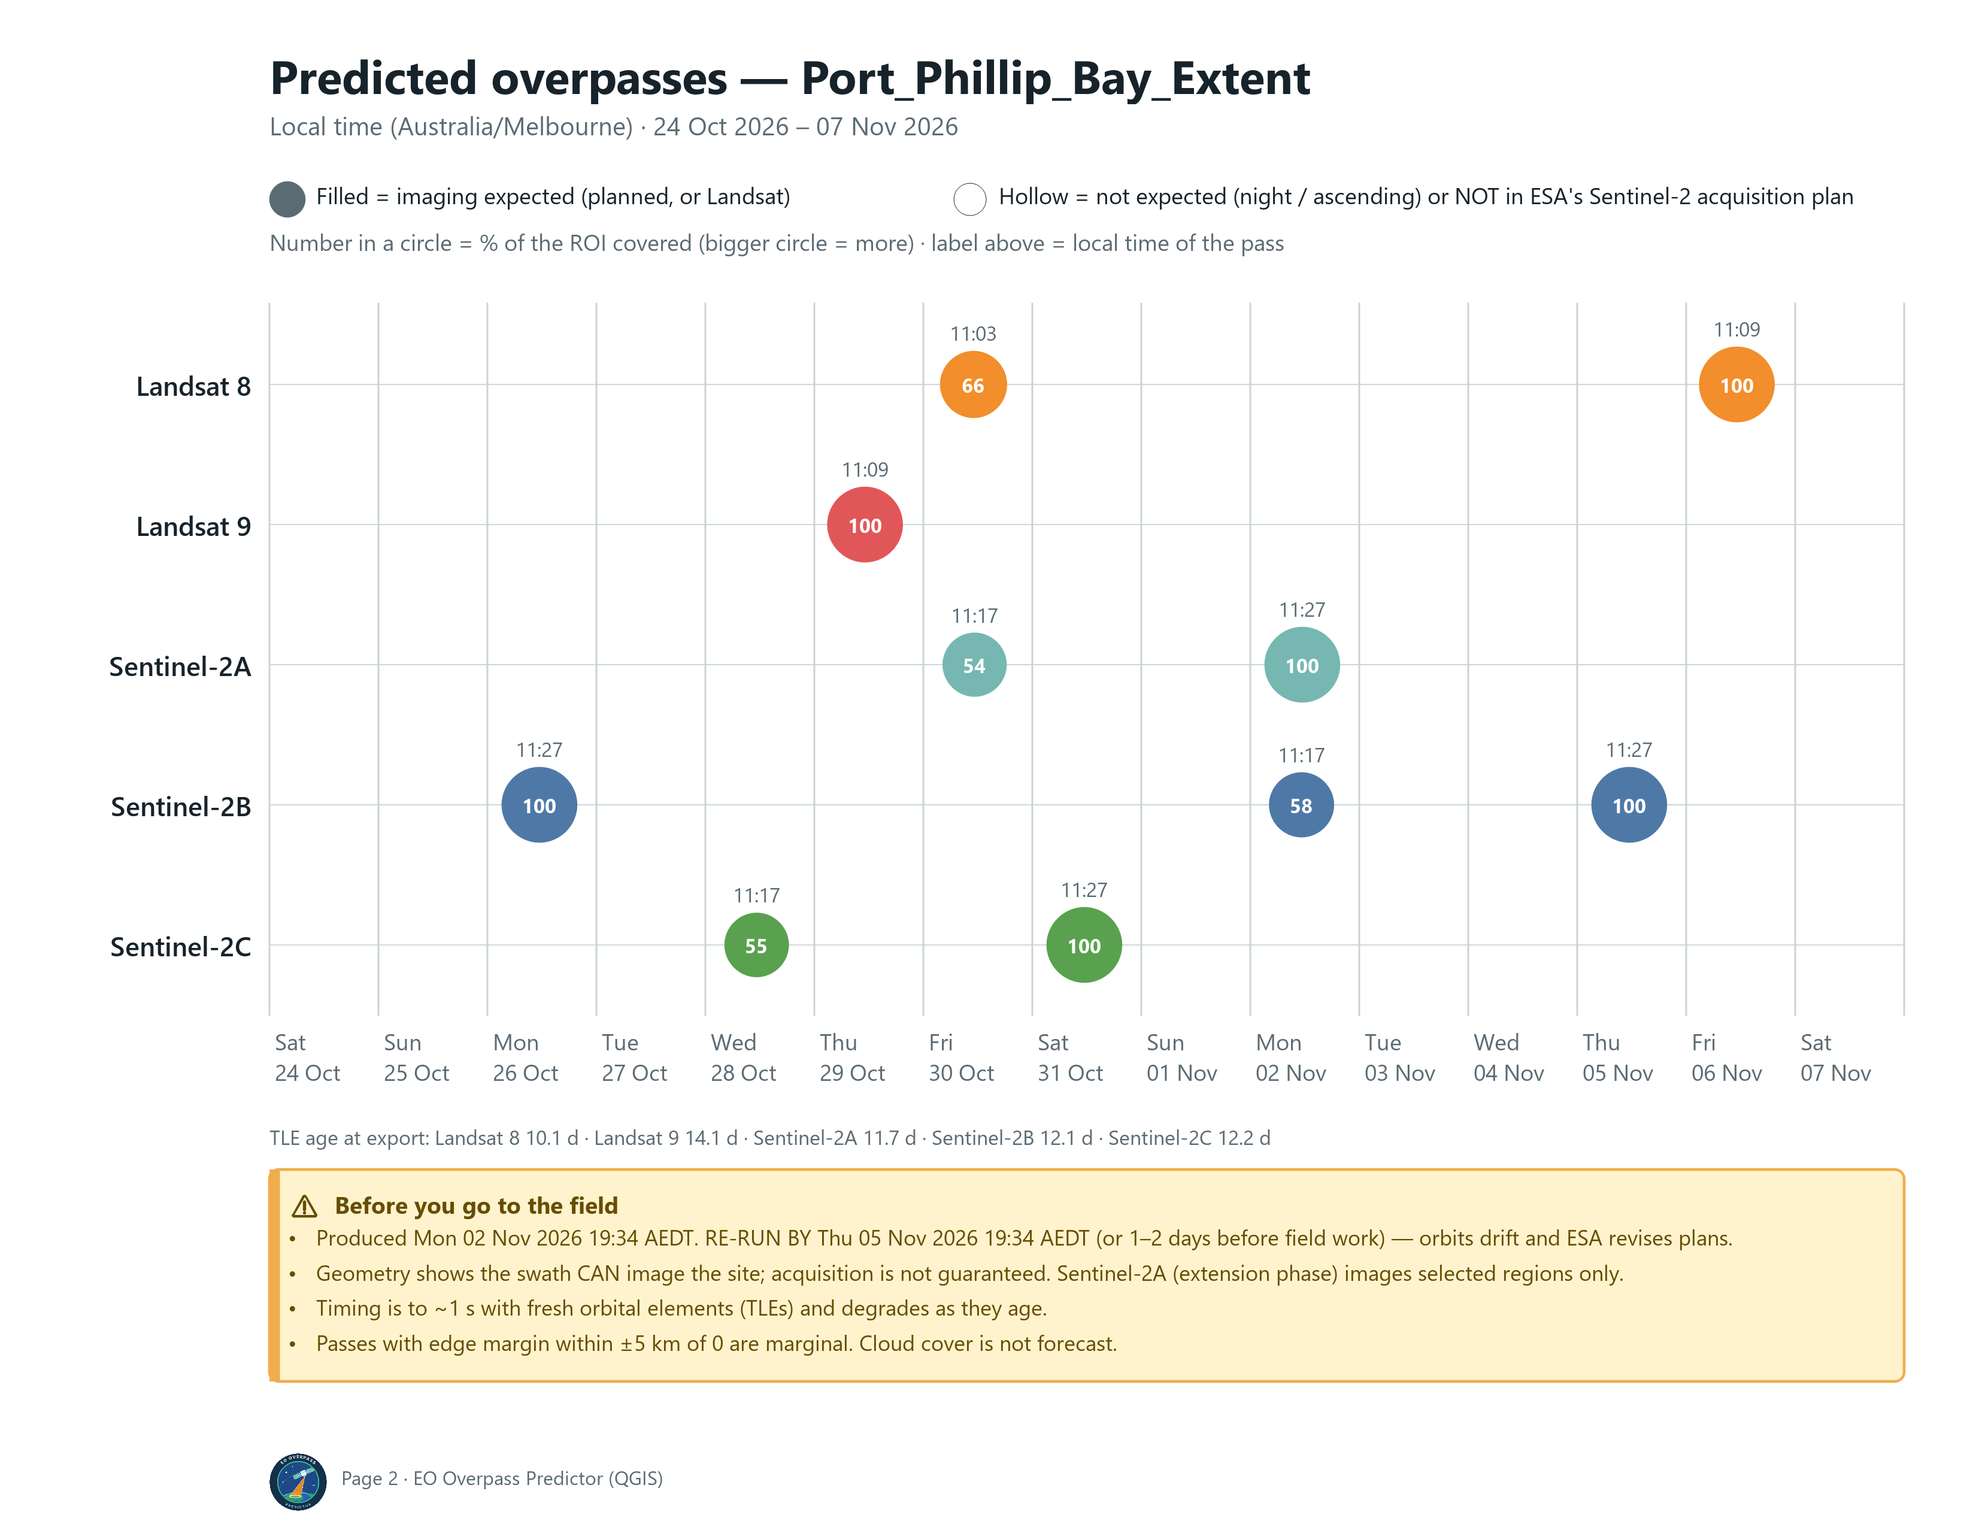
Figure 7 — Timeline for Port Phillip Bay.

6.4 Live tracker web page
A single HTML file that opens in any browser and can be emailed or put on a phone. It works offline: the satellite.js library is built into the page. It propagates the embedded orbital elements in real time, showing positions, past and future ground tracks, current swaths, the night side, and a countdown to the next ROI passes. Sentinel-2 passes that ESA has not planned are flagged.
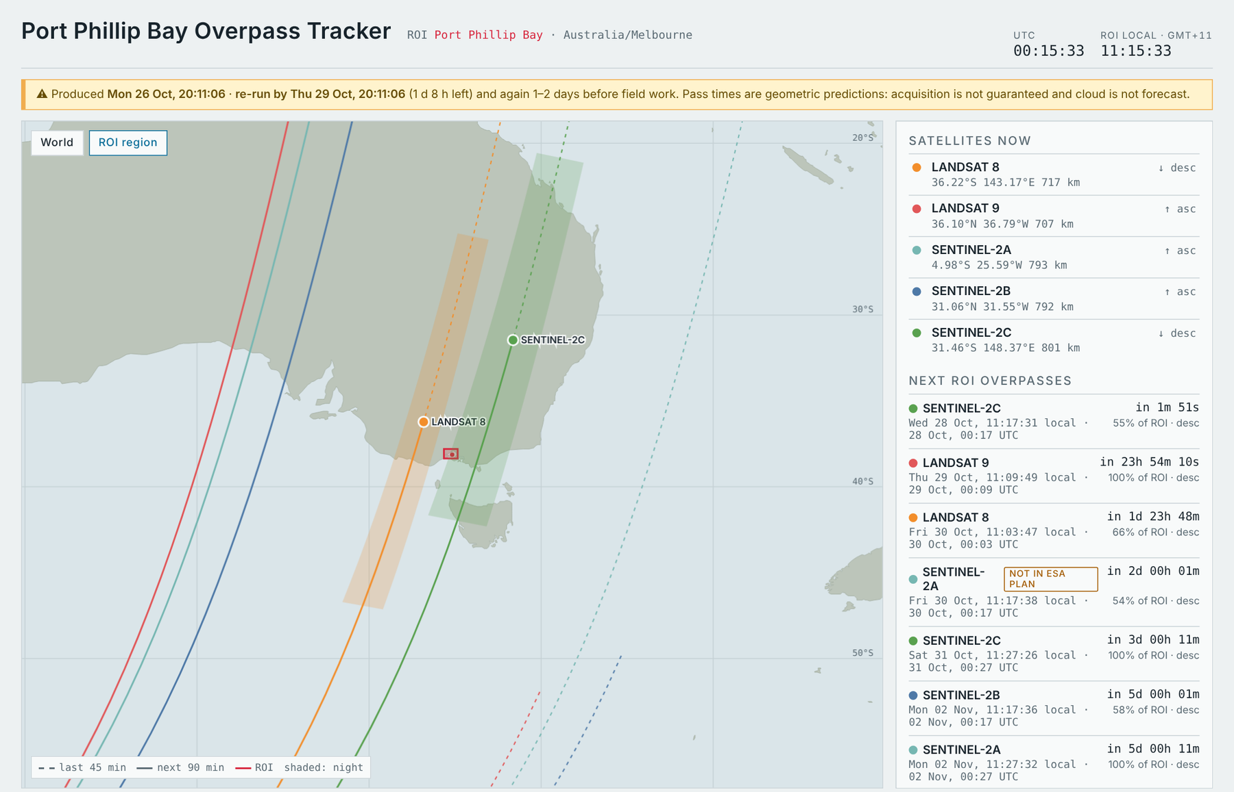
Figure 8 — Live tracker web page two minutes before Sentinel-2C's pass on 28 October.
A banner under the title shows how long the predictions remain valid. After the re-run-by time it turns red:
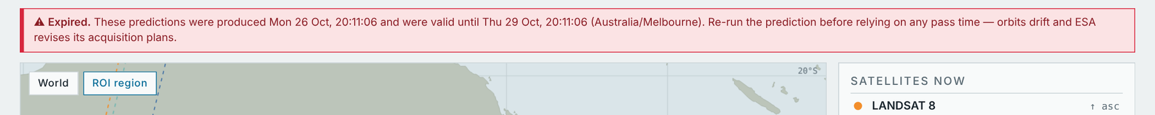
Figure 9 — Validity banner: valid (top) and expired (bottom).

6.5 CSV columns
overpasses_<site>.csv has one row per pass. UTC times end in Z; local times carry an explicit offset (e.g. +11:00), so they import unambiguously into Excel, R or pandas.
Column(s) | Meaning
roi_name | Name of the site (from your name field, or the layer name).
satellite, mission, sensor, norad_id | Which satellite and instrument; norad_id is its catalogue number.
direction | Ascending (northbound) or Descending (southbound). Both missions image in daylight on descending passes.
imaging_expected | True when the pass is descending, the sun is high enough and the site is within the mission's latitude limits.
roi_coverage_pct | Share of the site's area inside the swath on this pass.
roi_entry_utc, overpass_utc, roi_exit_utc | Swath first touches the site / closest approach to the site's centre (≈ scene centre) / swath leaves the site. UTC.
duration_s | Seconds from entry to exit.
roi_entry_local, overpass_local, roi_exit_local | The same instants in local time with an explicit UTC offset, e.g. 2026-10-26T11:27:30+11:00.
local_date, local_time, local_weekday, timezone, utc_offset | Spreadsheet-friendly local fields.
nadir_offset_km, roi_side_of_track | Distance of the site's centre from the ground track, and which side (E / W / nadir).
edge_margin_km | Distance from the site's centre to the nearest swath edge. Within ±5 km of 0 is marginal.
view_angle_deg | Angle off nadir at which the instrument sees the site's centre.
max_elevation_deg | Satellite's elevation above the horizon seen from the site.
sun_elevation_deg, sat_altitude_km | Sun height above the horizon and satellite altitude at overpass.
tle_epoch_utc, tle_age_days | Orbital elements (TLE) used and how old they are at the pass. Older = less accurate timing.
relative_orbit | Sentinel-2 relative orbit, or Landsat WRS-2 path.
products | Sentinel-2 MGRS tiles (T55HCU …) or Landsat path/rows (093/086 …) containing the site.
esa_plan_status, esa_datatake_id, esa_relative_orbit | Result of the Sentinel-2 acquisition plan cross-check, and ESA's data-take ID and orbit.
note | Mission note, e.g. Sentinel-2A's limited acquisition.
generated_utc, valid_until_utc | When the prediction was made and when it should be re-run by.

7 Live tracker dock
Live tracker is not a separate tool: it opens by itself when Predict overpasses finishes, already filled with the ROI you gave Predict (a file path is enough). If you close it, reopen it from the QGIS Panels menu. It animates the satellites on the QGIS map canvas.
- It lists the passes for the ROI you just predicted, even if it is not a layer in your project. To use another ROI, choose a ROI layer (or press … to pick a file) and press Next passes. It lists the next 14 days of imaging passes with a countdown, local and UTC date/time, direction, view angle, whether the satellite will image (Sentinel-2 checked against ESA's plans, Landsat routine) and the TLE age.
- Tick the satellites to show and press ▶ Live. Layers for satellite positions, current swaths, tracks (last 45 / next 90 minutes) and the night side are added and refreshed every few seconds.
- If your project is in a projected CRS (e.g. UTM or MGA), the dock offers to switch the map to WGS 84 while tracking, because global tracks cannot be drawn in a local projection; your CRS is restored on Pause.
- Basemap ▸ Add to map adds OpenStreetMap or Esri World Imagery layers.
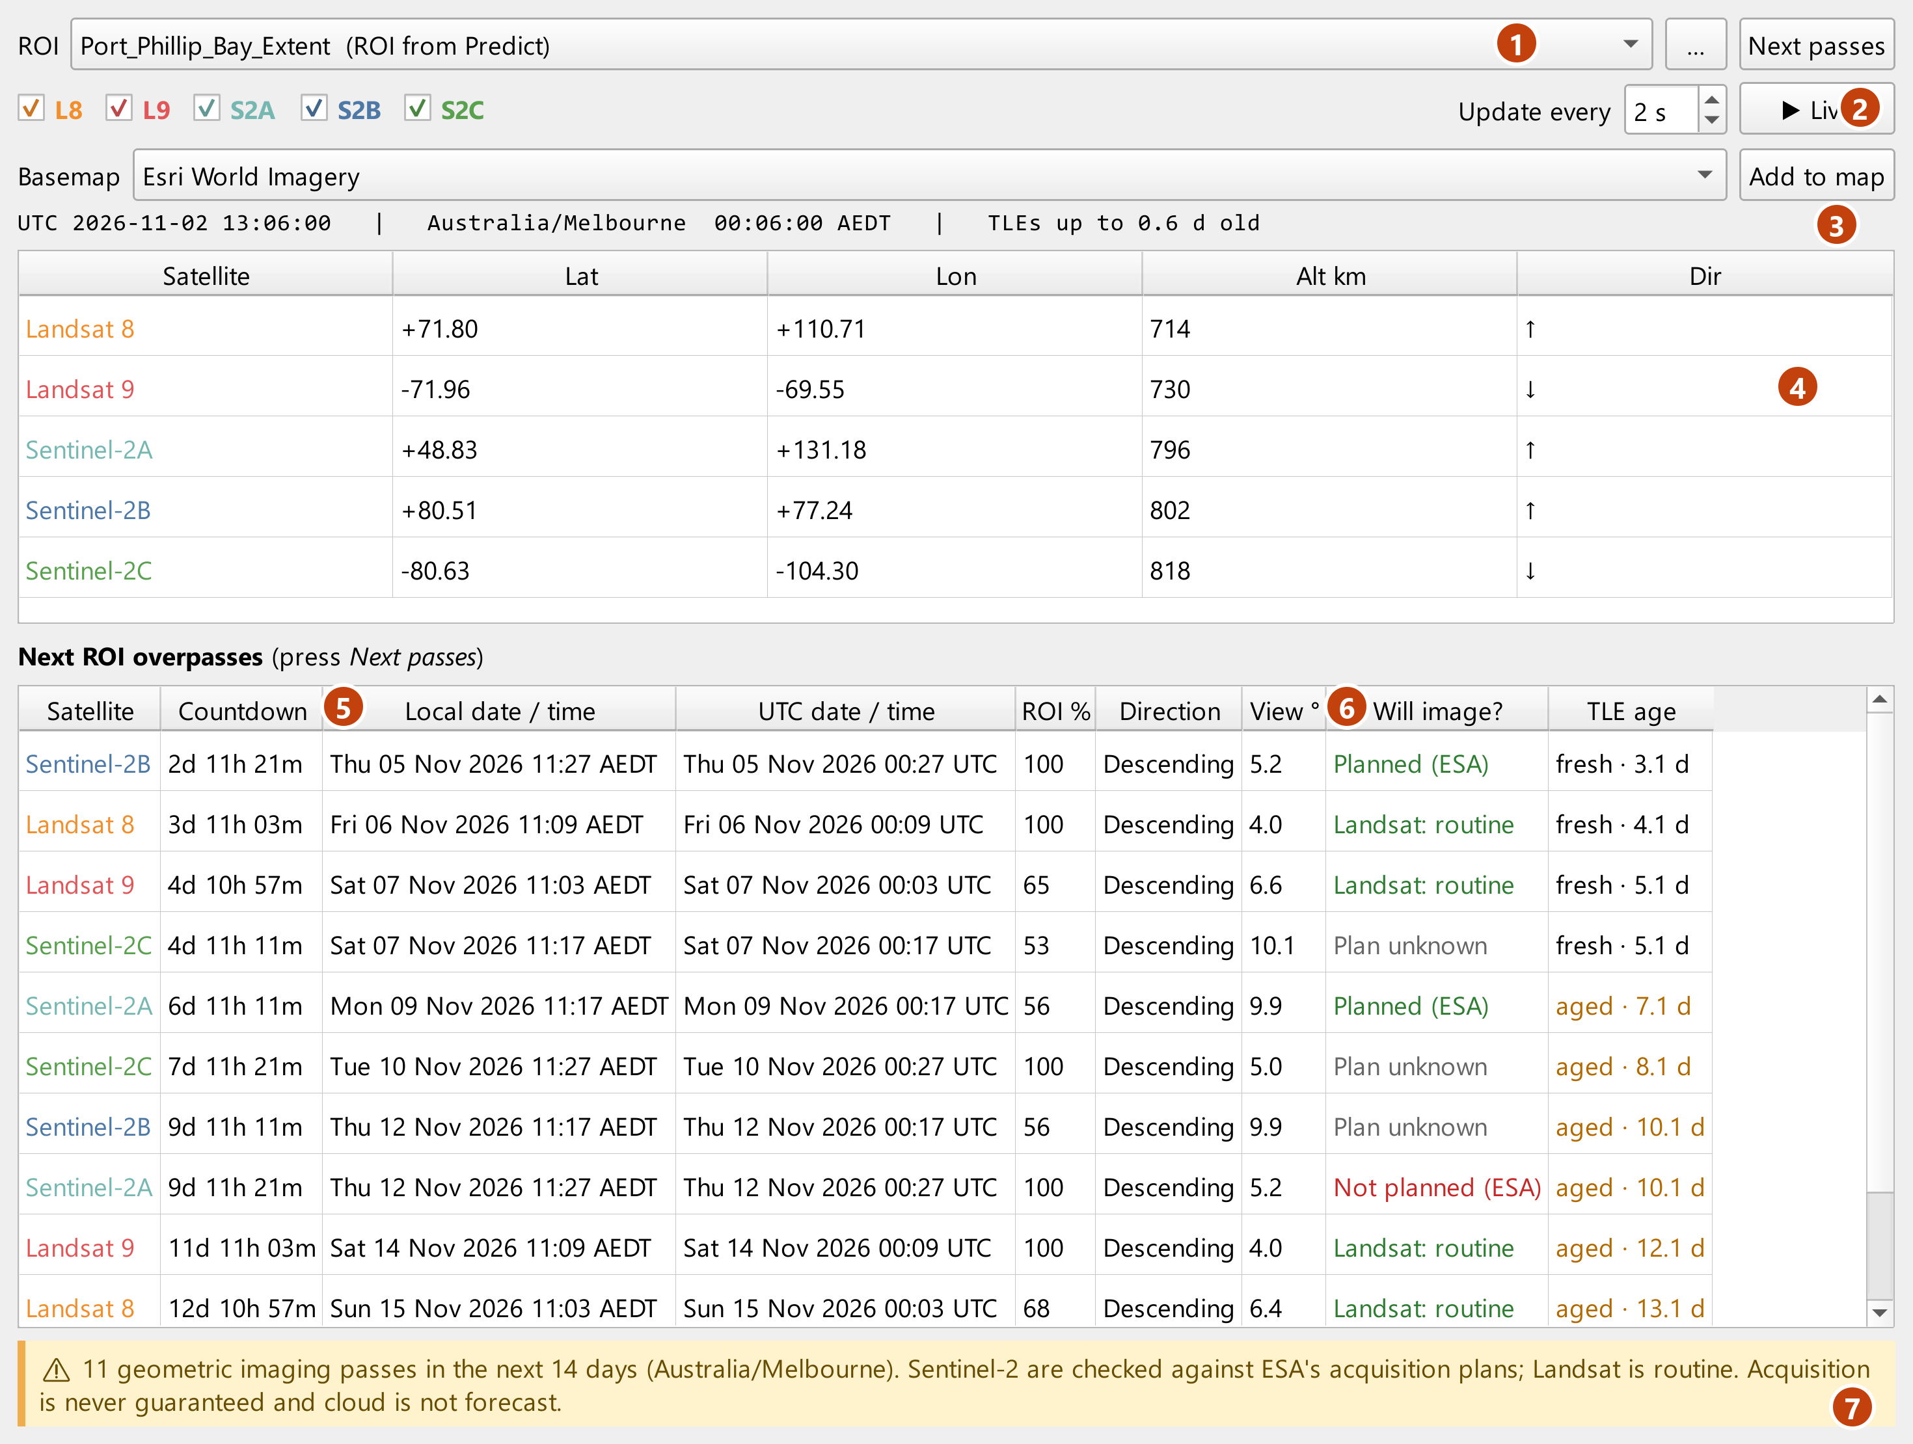
Figure 10 — Live tracker dock with the next Port Phillip Bay passes.
1 | ROI: the one you gave Predict, or pick a layer, or press … for a file.
2 | Satellites to show, and ▶ Live to animate them on the map.
3 | Clock: UTC, local time at the ROI and age of the orbital elements.
4 | Current satellite positions and direction.
5 | Next passes: countdown, local and UTC time, ROI %, direction and view angle.
6 | Will image?: ESA plan status for Sentinel-2, routine for Landsat (last column: TLE age).
7 | Reminder that acquisition is never guaranteed.

Acquisition is never guaranteed and cloud is not forecast. For product IDs, field packs and the full ESA cross-check report, use Predict overpasses.

8 Results expire: re-run before field work
Orbital elements age and ESA revises its plans, so a prediction has a shelf life. Every run is stamped with the time it was produced and a re-run-by time (Advanced ▸ Re-run-by stamp, 3 days by default):
- the help panel of the tool opens with a ⚠ Results expire warning, and the log ends with a ⚠ line giving both times;
- the field sheet heading, its caution box and its guide pages, the timeline all carry Produced … · RE-RUN BY …;
- the layer and CSV have generated_utc and valid_until_utc columns;
- the web page shows a yellow banner with the time left, which turns red once expired.
Good practice: run once when planning, again 1–2 days before going out, and print the sheet from that last run.

How timing accuracy degrades
Age of orbital elements at the pass | Typical timing error | What to do
0–3 days | ≈ 1 s | Use as is.
About a week | a few seconds | Fine for planning; re-run before the field day.
3+ weeks | ≈ 10 s or more (12.5 s observed at 23 days) | Re-run. Do not rely on old sheets.

9 Accuracy and limitations

Validation
Predicted times were compared with delivered products (USGS Landsat Collection 2 scene centres and Sentinel-2 L2A granule times):
Satellite | Product | Observed (UTC) | Predicted − observed
Landsat 9 | LC09 093/086, 13 Oct 2026 | 00:09:46.6 | +0.3 s
Landsat 9 | LC09 092/087, 6 Oct 2026 | 00:03:58.8 | +0.1 s
Landsat 9 | LC09 087/070, 18 Oct 2026 | 23:26:17.9 | < 1 s
Sentinel-2B | T55HCU, 23 Oct 2026 | 00:17:22.2 | +0.7 s
Sentinel-2B | T55HBU, 23 Oct 2026 (swath-edge sliver) | 00:17:29.6 | +0.2 s
Sentinel-2B | T55HCU, same pass, 23-day-old TLE | 00:17:22.2 | −12.5 s
Landsat 8 | LC08 092/087, 14 Oct 2026 | 00:03:53.9 | −9.0 s (9-day-old TLE)

The computed Sentinel-2 relative orbit agrees with the orbit number in ESA's plan for every planned pass in the Port Phillip Bay example (R116 and R073), and the Landsat path/row and MGRS tile IDs match delivered scenes. The automated tests in tests/test_engine.py repeat these checks.

Limitations
- Geometry, not guarantees. Landsat's LTAP schedules more than 99% of daytime land and near-shore scenes but is not cross-checked. Sentinel-2 acquires land and coastal waters, not open ocean.
- Sentinel-2A is in its extension phase and images selected regions only — check its ESA plan status.
- 'No plan loaded' means unknown, not 'not planned': ESA publishes plans about two weeks ahead. ESA's plan footprints are simplified, so a 'not planned' result for a pass that only clips the ROI's edge may be a footprint artefact.
- Swath edges are nominal. Treat passes with edge_margin_km within ±5 km of 0 as possible, not certain.
- Product footprints are nominal (see section 5). Product IDs are computed, not retrieved from a catalogue.
- Timing degrades with TLE age (section 8). Spacecraft manoeuvres can shift timing until new elements are published.
- Cloud cover is not forecast.

10 Automation
Predict overpasses is a standard Processing algorithm (eooverpass:predict_overpasses), so it works in batch mode, the Model Designer, PyQGIS and qgis_process.

PyQGIS
import processing
res = processing.run("eooverpass:predict_overpasses", {
"INPUT": "C:/data/Port_Phillip_Bay_Extent_EPSG_32755.shp",
"DAYS": 16,
"SAT_L8": True, "SAT_L9": True, "SAT_S2A": True, "SAT_S2B": True, "SAT_S2C": True,
"CROSSCHECK_ESA": True,
"MIN_COVERAGE": 50,
"OUTPUT": "C:/Fieldwork/PortPhillip/passes.gpkg",
"PRODUCTS": "C:/Fieldwork/PortPhillip/products.gpkg",
"FIELD_PACK": "C:/Fieldwork/PortPhillip/field_pack",
# BASEMAP: 0 offline land/sea, 1 OpenStreetMap, 2 Esri World Imagery
"BASEMAP": 2,
"VALID_DAYS": 3,
})
print(res["OUTPUT"], res["FIELD_PACK"])

Command line
qgis_process run eooverpass:predict_overpasses -- \
INPUT=C:/data/Port_Phillip_Bay_Extent_EPSG_32755.shp DAYS=16 \
OUTPUT=C:/Fieldwork/passes.gpkg FIELD_PACK=C:/Fieldwork/field_pack
A scheduled task (Windows Task Scheduler or cron) running this command every day keeps a field pack fresh automatically.

Parameter keys
Key | Type
INPUT | layer / path
NAME_FIELD | field name
DISSOLVE | bool
START | datetime (local)
DAYS | number
SAT_L8, SAT_L9, SAT_S2A, SAT_S2B, SAT_S2C | bool
DAYTIME_DESCENDING_ONLY | bool
MIN_COVERAGE | number (%)
CROSSCHECK_ESA | bool
BASEMAP | enum: 0 Offline land/sea, 1 OSM, 2 Esri World Imagery
ADD_BASEMAP | enum: 0 Don't add, 1 OSM, 2 Esri, 3 Offline land/sea
VALID_DAYS | number
STRIP_LENGTH_KM | number
MIN_SUN_ELEVATION | number (°)
TIMEZONE | IANA name
TLE_MAX_AGE_HOURS | number
TLE_TEXT | text
OUTPUT, PRODUCTS | vector output
FIELD_PACK | folder

11 Troubleshooting
Symptom | Cause and fix
No passes are listed | Window too short, minimum coverage too high, satellites unticked, or the ROI is outside the mission's latitude limits (Sentinel-2: 56° S to 82.8° N). Untick 'Only passes where imaging is expected' to see every geometric pass.
Every Sentinel-2 pass is 'no plan loaded' | The window is beyond ESA's published plans (about 2 weeks), or the download was blocked. Download the KMLs from ESA's Sentinel-2 acquisition plans page and save them in the folder named in the log (Windows: %APPDATA%\QGIS\QGIS3\profiles\default\eo_overpass\kml).
Orbital elements could not be downloaded | Check the proxy under Settings ▸ Options ▸ Network. The last cached elements are used if available; or paste element sets into Advanced ▸ Manual TLE text.
'ROI spans several time zones' warning | The ROI's centre zone is used. Set Advanced ▸ Time-zone override to choose another.
Live tracker tracks look distorted | The map is in a projected CRS. Accept the dock's offer to switch to WGS 84 while tracking.
Field-sheet map shows plain land/sea instead of tiles | The tiles could not be fetched (offline, proxy or blocked). The bundled Natural Earth land/sea is shown instead; the sheet is still complete. Check Settings ▸ Options ▸ Network.
Web page shows no satellites | It needs internet access once to load satellite.js from cdn.jsdelivr.net.
New version installed but nothing changed | Restart QGIS after installing from ZIP.
Times look one hour off | Check the timezone and utc_offset columns. The Start parameter is in your computer's time zone, which may differ from the ROI's.

12 Data sources, licences and citation
Data | Source | Terms
Orbital elements (TLE) | CelesTrak (US Space Force data via space-track.org) | Free; please credit CelesTrak.
Sentinel-2 acquisition plans | © ESA, Copernicus Sentinel-2 acquisition plans (KML) | Copernicus free and open data policy.
Time-zone grid | Derived from timezone-boundary-builder | © OpenStreetMap contributors, ODbL.
Coastlines, offline land/sea | Natural Earth 10 m land and minor islands | Public domain.
Basemaps | OpenStreetMap; Esri World Imagery | Each provider's terms apply.
Libraries | sgp4, geographiclib, tzdata (bundled); satellite.js (web page) | MIT; MIT; Apache-2.0; MIT.

How to cite
Manning, J. (2026). EO Overpass Predictor (QGIS plugin), version 1.0.2. https://doi.org/10.5281/zenodo.23884833
The companion notebook repository (eo-overpass-predictor) is archived on Zenodo, doi:10.5281/zenodo.23629976.
The plugin is released under the GNU General Public License v2.0 or later. Sentinel-2 is part of the EU Copernicus programme; Landsat is a USGS/NASA mission.

13 Glossary
Term | Meaning
Data-take | A continuous Sentinel-2 acquisition segment in ESA's plan, with an ID such as 50335-4.
Descending pass | Southbound pass. Both missions image in daylight on descending passes (around 10:00–10:30 local solar time).
Edge margin | Distance from the ROI's centre to the nearest swath edge; small values mean a marginal pass.
Ground track / nadir | The line on the ground directly beneath the satellite.
MGRS tile | Sentinel-2 product tile, 109.8 km square, named by UTM zone, latitude band and 100 km square (e.g. T55HCU).
Overpass / pass | One crossing of a satellite over the ROI. Here: a crossing where the instrument's swath touches the ROI.
Re-run-by | The time after which the prediction should be refreshed (default 3 days after it was produced).
Relative orbit | Sentinel-2 orbit number within its 10-day, 143-orbit repeat cycle (R001–R143).
ROI % | Share of the ROI's area inside the swath on a pass.
SGP4 | The standard model for propagating TLEs.
Swath | The strip of ground imaged by the instrument: 290 km for Sentinel-2 MSI, 185 km for Landsat OLI.
TLE | Two-line element set: the orbital elements published by CelesTrak and propagated with SGP4.
WRS-2 path / row | Landsat's Worldwide Reference System: 233 paths × 248 rows; a scene is identified by path/row.

