# **Design and Implementation of IS: Assignment Bonus**

# **UML**

**System Name:** Hagwarts Ma Program

**Semester:** B 2024

**Submitted by Group:** PowerSquad

# **Assumptions:**

This is an optional section for essential assumptions; Please provide concise information aimed at clarifying key aspects for the exercise evaluator; Ensure that the content does not replicate details already presented in the system description narrative.

# 

****to make it easier for you we add it the picture as pictures in the zip file****

** We assumed that the id for the program chair is 0 and the id for the secertart is 01

For easiness we used the id as password (it can enter other password ) applicant 1->1**

1. FIRST A NEW APPLICANT HAS TO SIGN UP FOR THE PROGRAM HE CAN PRESS THE LINE IN WHICH CASE IT TAKES HIM/ HER TO THE SIGN UP PAGE WHERE HE ENTERS HIS ID AND PASSWORD (MANDOTARY) BEFORE HE CAN ADD ANY DIPLOMAS , THEN WHEN HE IS FINISHED HE PRESSES A BUTTON AND IT TAKES HIM TO THE LOG IN PAGE (LIKE EVERY OTHER WEBSITE/PROGRAM HE MUST VALIDATE THE EMAIL/ PHONE NUMBER HE ENTERED BY A MESSAGE FROM THE SYSTEM- BUT WE ARE PUTTING AN ASSUMBTION THAT THE SYSTEM ALREADY DONE THAT) SO THE BUTTON SENDS HIM/HER TO LOG IN PAGE WHERE HE LOGS IN;
2. WHEN HE LOGS IN HE CAN UPDATE PROFILE OR ATTACH DOCUMENTS WHENEVER HE WANTS BY USING THE J bar/ when he updates the profile he can only update the info without password or id // he cant change that
3. He can also log out – he is only considered valid when he attach a transcript, a resume, and at least one certificate or recommendation.
4. If an applicant is rejected / drop out -> can never sign up again
5. We went over the whole use case diagram and the story and we implemented everything. We assumed newly application/applicants means the just applied
6. validity report- “the system checks the validity of newly submitted applications “

we made a report where the secretary can open it and see the newly applied applicants(waiting for initial decision) and which documents they provided (if there is a recommendation/resume/certificate/ transcript) and if the applicant is valid.

1. The secretary can update the applicants stages- by pressing in homepage Update applicants stages in the bar which would lead her to a page where she can see all the information about the applicants and when she presses on an applicant she can see all his/her documents -> we added it because of “Certain stages require the submission of documents” so she can see every applicants documents and decide if to update his stage.
2. One of our assumption an applicant can only move up in the stages it cant become to 2 then again 1.
3. “The program chair can generate a list of validated applications. Using this list, she determines who will be rejected, who will be automatically accepted, who will be invited to the acceptance committee, and who will be deferred for later consideration” -> we assumed this is the initial response since the applicants in this state still are waiting for initial response we made a filter that only takes applicants with state initial response and are validated (it checks if they have the required documents as in the story ) – we didn’t add any applicant with state Waiting for initial response -> so you can generate them by signing up and adding the required documents, she can change their status and when shes satisfied she presses button reset and it reset every applicant that has changed their status. We also added the diplomas table when she presses on an applicant she can see all his Background Information and make a decision.
4. Now we also made another Page for final period Decision where she can see all the applicants on the waiting list and she has the status of rejected/ invite to interview as specified in the story again we added the diploma table she can press on any applicant and see all their diplomas (we added 2 on the waiting list one with diploma another without).
5. Now for after interview we added a status “after interview “ - the interview itself is outside the program so we didn’t implement the interview but as the story requires we made a page were the program chair can press on any of the applicants with status ”after interview ” and then she sees their diplomas in the table she can edit their status which are : accepted , rejected after interview, waiting list, conditionally accepted , when she choose ->conditionally accepted and press edit it opens a panel where she can see all the remedial course are in combo box when she chooses one in the combo box she sees all their info as well as min grade to pass it if she want she can press add and it adds the remedial course to the applicant as condition with the min grade she also has the option to set the grade she wants as long as it bigger than the min required grade for the course and smaller than 100 : “For conditionally accepted applicants, the program chair further specifies the remedial courses they must undertake during their first year as condition (for acceptance)”
6. She can also delete and update the grade by pressing the row on the table and pressing the upd/delete button , when shes satisfied she presses Button reset and it resets the Table -> only after Interview applicants remain.
7. The program chair can Set Exemption for remedial courses : she can choose the remedial course she wants then press getCourses which presents the courses that does / does not give exemption also in the bottom there is a table with all courses in the system the program chair can choose a remedial course see all its exemption / non exemption courses then press on the bottom at the row(course ) she wants and it can also add the grade level if it is exemption / chooses a course that exempt/does not exempt by clicking the row its one and then add all the upd we want and then press update.
8. Import / export -> when we import the Json it checks if the conditions of the conditionally accepted applicants are checked if yes it keep them else it expel them =>it supposed to keep id =15 .works fine / the export “details of accepted applicants, along with any conditions assigned to them (i.e., remedial courses), are exported in XML”
9. To sign up/ update profile :

# **Average grade must be between 55 an 100- successfully graduate**

1. We cant delete or update records without inserting new applicant id(application id -valid didn’t exist before)
2. After inserting new valid id we can update / delete the applicant – we can also delete/ update the applicant if the id already exists
3. To add an applicant must have Id – string //to add a new diploma(background education ) he must fill – valid applicant id and institution and department name / grade/ credit points and graduation date
4. The graduation date must be before or on the same day of registration .(he / she must already have a valid diploma to apply ).
5. Credit points must be bigger than 0 and smaller than 1000
6. To add an institution that isn’t in the data base the applicant must request to add it (there is a button) he must add an institution and department name – to prevent adding invalid institutions we add them right now but there is someone(secretery …) who checks validity of the department/institution exist if not it delete it
7. If the applicant is rejected he / she cannot apply again . but if she / he deletes their application before the initial response they can apply again only when they receive final decision they cannot apply again .

1.1.a. The Final Use Case Diagram:

Verify readability of the figure.

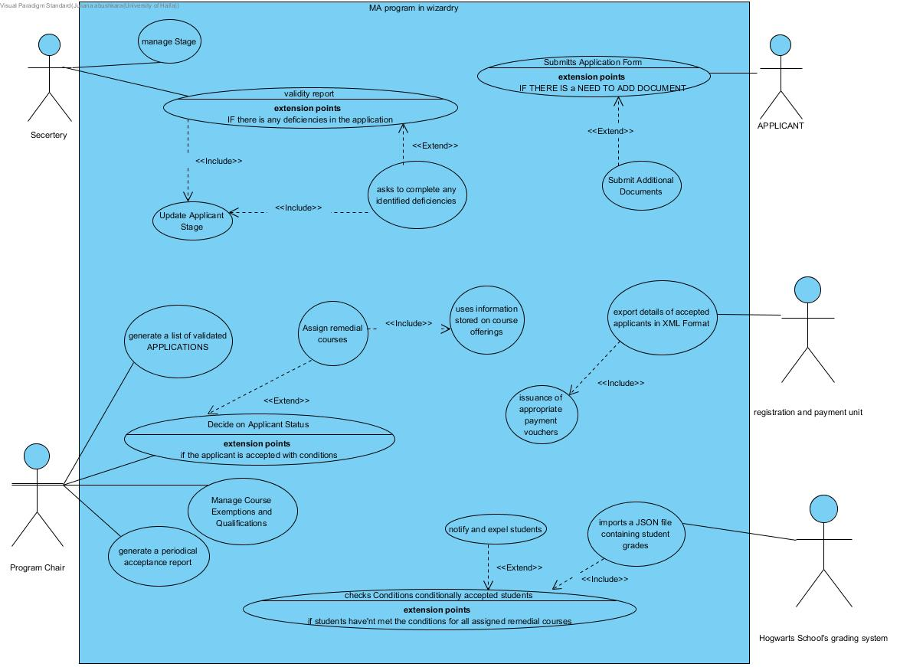

# 1.1.b. The Final Descriptions of the Use Cases:

Make sure the descriptions are short and concisely describe the responsibilities of the various use cases.

**1.Submit Application:** Applicants provide their personal and academic details through an application form**.**

* **Submit Additional Documents:** <<extend>> applicants can initially submit documents like transcripts, resumes, certificates, and recommendations. If they don't submit all the required documents at first, they can attach additional documents later.

-------------------------------------------------------

2.**manage Stage**: The secretary updates and revises the stages of the admission process.

3. **validity report** : the secretary will receive a validity report which is Regular checks are performed to ensure that applications meet the necessary criteria, particularly concerning required documents.

* **Asks to complete any identified deficiencies : <<extend>>** Based on this report if any deficiencies are found ,the program's secretary reaches out to the relevant applicants, via phone or personal email, and asks them to complete any identified deficiencies.
* **Update Applicant's stage**:**<<include>>** Based on the validity report results, the Secretary updates the stages for each applicant accordingly.

4. **Generate List of Validated Applications:** The program chair generates a list to review which applications are accepted, rejected, or require further consideration.

5. **Decide on Applicant Status**: Post-Interview The program chair reviews each applicant and decides whether they will be accepted as a regular student, accepted with conditions , rejected, or placed on a waiting list.

* **Assign Remedial Courses: <<Extend>>** For conditionally accepted applicants, remedial courses are assigned based on the program requirements and the applicant's background.
* **uses information stored on course offerings:** **<<include>>** included in Assign Remedial Courses, The program chair uses information stored in the system about course offerings.

6. **Manage Course Exemptions and Qualifications**: The program chair records which courses can exempt remedial Courses and at which grade levels and document which courses do NOT qualify for exemptions from particular remedial courses.

7. **generate a periodical acceptance report:** generate a periodical acceptance report , that categorizes the applicants by institution it presents the percentages of applicants who graduated from that institution in each status: accepted, conditionally accepted, rejected without interview, rejected after interview, succeeded conditions, failed conditions.

8. **export details of accepted applicants in XML Format :** once final decision is made details of accepted applicants, along with any conditions assigned to them (i.e., remedial courses )are exportedto the registration and payment unit.

* **issuance of appropriate payment vouchers**:<<include>>after details of accepted applicants are exported in XML format to the registration and payment unit it issuance of appropriate payment vouchers for every accepted applicant.

9. **import a JSON file containing student grades:** at the end of the year , a JSON file containing student grades is imported into the system from Hogwarts School's grading system.

* **checks Conditions conditionally accepted students :<<included**>> the system checks if the conditionally accepted studentshave met the conditions for all assigned remedial courses.
* **notify and expel students:** <<extend>> extended from checks Conditions conditionally accepted students , **if the students have failed to meet the** conditions for all assigned remedial courses then they are notified and expelled from the program.

# 

# **1.1.c. UML Class Diagram:**

This section will not be checked again and is intended to understand the context.

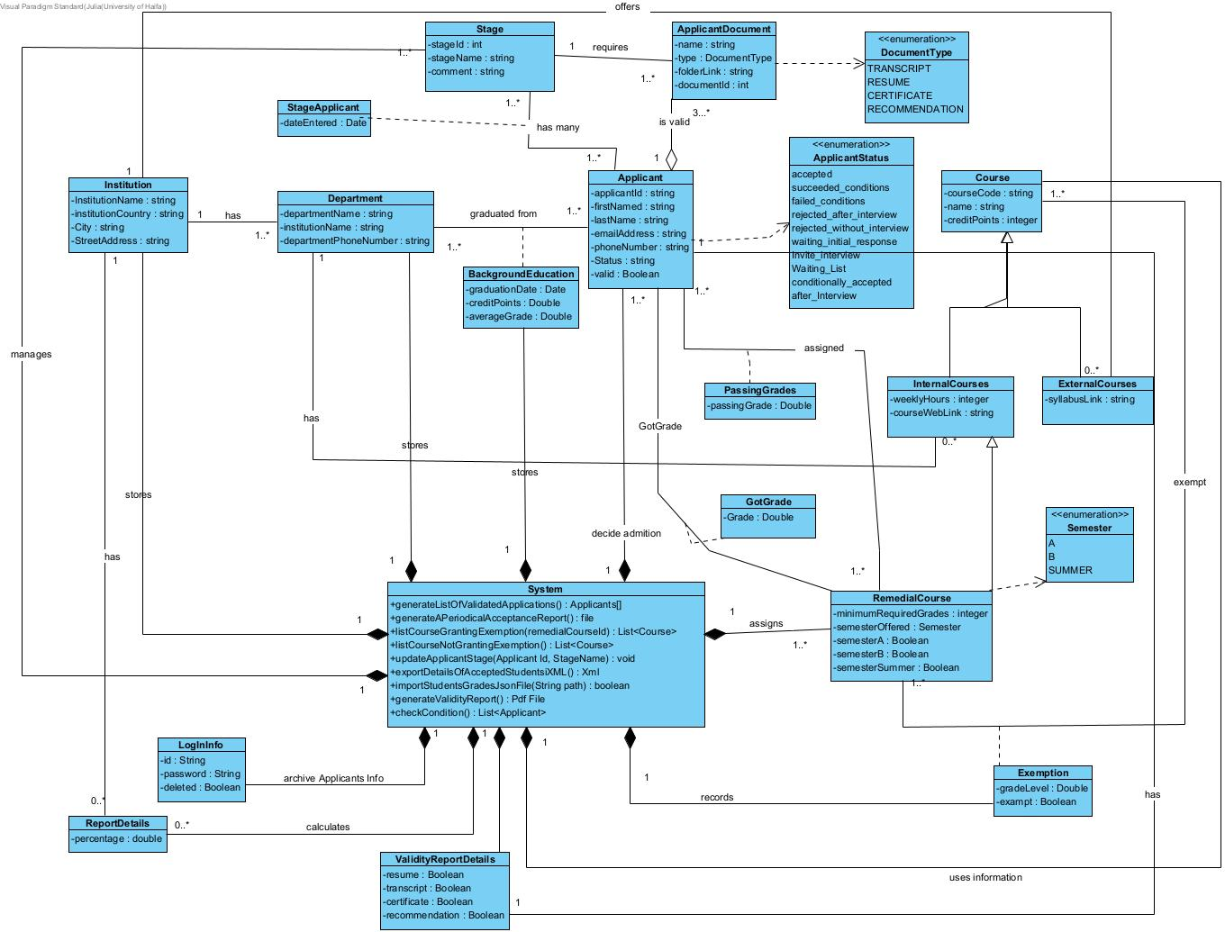

**2.1 The Final Statechart Diagram:**

Verify readability of the figure.

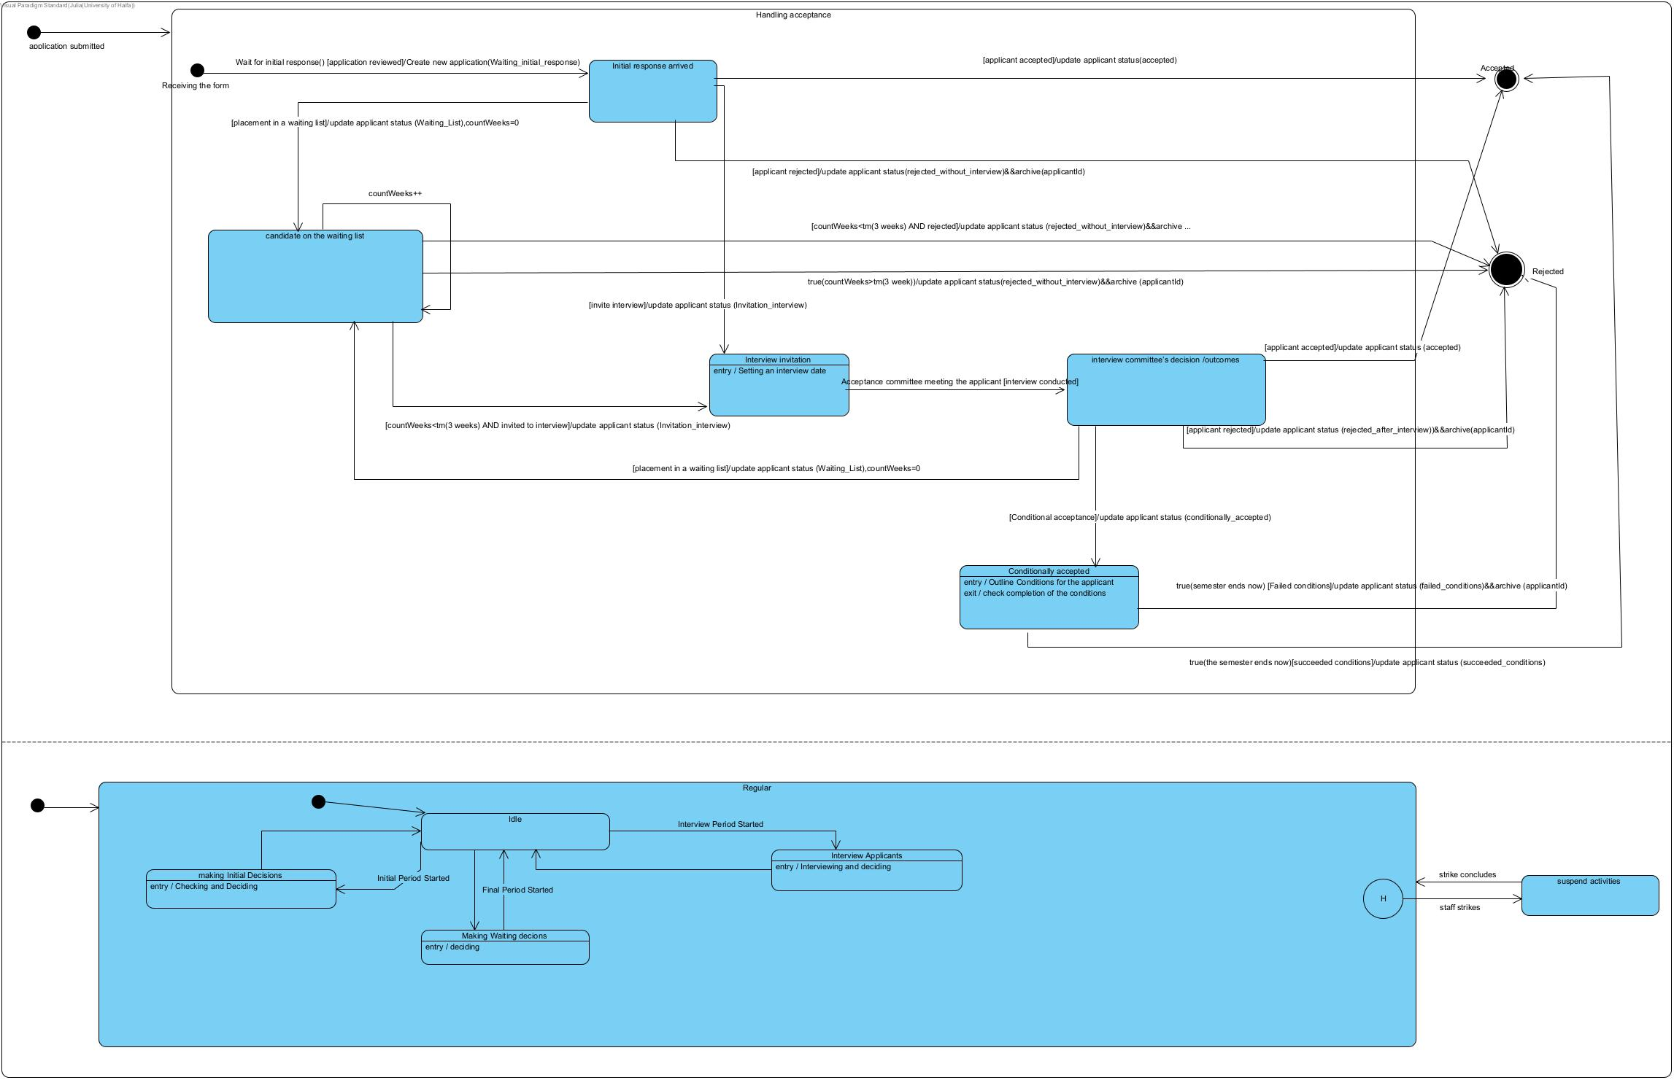

**Model:**

**Description of the model:**

|  |  |
| --- | --- |
| **Event / Variable** | **Description** |
| Wait for initial response() [application reviewed]/Create new application(Waiting_initial_response) | the event :the applicant waits for the initial decision while ->  -----------------------------------  the application is being reviewed -that’s the condition  ----------------------------------  the transition triggers the action: system creates a new applicant and initialize it in the beginning with state: Waiting_initial_response - variable |
| [placement in a waiting list]/update applicant status (Waiting_List),countWeeks=0 | After the initial response arrives :the applicant transition to being placed on the waiting list (If no immediate decision is possible, the applicant is placed on a waiting list)-> that’s the condition.  -----------------------------------  As a result of the transition to state candidate on the waiting list it triggers the action : updates the status of the applicant to Waiting_List -variable  Also initialize the countWeeks=0 -variable that counts how many weeks go by |
| [applicant accepted]/update applicant status(accepted) | After the initial response arrives :the applicant transition to being accecpted if [accepted] -> that’s the condition.  -----------------------------------  As a result of the transition to state accepted it triggers the action : updates the status of the applicant to accepted -variable |
| [invite interview]/update applicant status (Invitation_interview) | If after the initial response the applicant is invited to an interview it transition to state invitation to interview-> that’s the condition  ---------------------------------  As a result of the transition to state invitation to interview it triggers the action : updates the status of the applicant to Invitation_interview -variable |
| [applicant rejected]/update applicant status(rejected_without_interview)&&archive(applicantId) | If after the initial response the applicant is rejected it transition to state rejected -> that’s the condition  -------------------------------------  As a result of the transition to state rejected it triggers the action : updates the status of the applicant to rejected_without_interview -variable to specify that he was rejected without being invited to an interview ,  also it archives the applicant id-variable , in the database so he /she can never apply again . |
| Acceptance committee meeting the applicant [interview conducted] | Transition from interview invitation to interview committee’s decision /outcomes.  The action : Acceptance committee meeting the applicant  ----------------------------------  if the interview conducted -condition |
| [placement in a waiting list]/update applicant status (Waiting_List) | Transition interview committee’s decision /outcomes to candidate on the waiting list  If the applicant is placed on the waiting list -condition  As a result of the transition to state candidate on the waiting list it triggers the action : updates the status of the applicant to Waiting_List -variable  Also initialize the countWeeks=0 -variable that counts how many weeks go by |
| [applicant rejected]/update applicant status (rejected_after_interview)&&archive(applicantId) | After the interview is conducted applicant can be rejected  -condition  As a result of the transition to state rejected it triggers the action : updates the status of the applicant to rejected_after_interview -variable  also it archives the applicant id-variable , in the database so he /she can never apply again . |
| [applicant accepted]/update applicant status (accepted) | After the interview is conducted applicant can be accepted  -condition  As a result of the transition to state accepted it triggers the action : updates the status of the applicant to accepted -variable |
| [Conditional acceptance]/update applicant status (conditionally accepted) | After the interview is conducted applicant can be conditionally accepted  -condition  As a result of the transition to state Conditionally accepted it triggers the action : updates the status of the applicant to conditionally accepted -variable. |
| true(the semester ends now)[succeeded conditions]/update applicant status (succeeded_conditions) | Event: When the semester ends –  checks the conditions of the applicant ,  if the applicant completed the conditions successfully- condition - as they transition to accepted  -----------------------------------  As a result of the transition to state accepted it triggers the action : updates the status of the applicant to succeeded conditions -variable. |
| true(semester ends now) [Failed conditions]/update applicant status (failed_conditions)&&archive (applicantId) | Event: When the semester ends –  checks the conditions of the applicant ,  if the applicant failed to complete the conditions successfully- condition  - as they transition to rejected  -----------------------------------  As a result of the transition to state rejected it triggers the action : updates the status of the applicant to failed_conditions -variable.  also it archives the applicant id-variable , in the database so he /she can never apply again . |
| true(countWeeks>tm(3 week))/update applicant status(rejected_without_interview) )&&archive (applicantId) | It transition from candidate on the waiting list to rejected automatically if he is on the waiting list for more than 3 weeks without a decision  true(countWeeks>tm(3 week))-> event  As a result of the transition to state rejected it triggers the action : updates the status of the applicant to rejected_without_interview -variable.  also it archives the applicant id-variable , in the database so he /she can never apply again . |
| [countWeeks<tm(3 weeks) AND invited to interview]/update applicant status (Invitation_interview) | the transition from candidate on the waiting list to Interview invitation  if he is on the waiting list for less than 3 weeks and was invited to an interview  condition  As a result of the transition to state invited to an interview it triggers the action : updates the status of the applicant to Invitation_interview -variable. |
| [countWeeks<tm(3 weeks) AND rejected]/update applicant status (rejected_without_interview)&&archive (applicantId) | the transition from candidate on the waiting list to rejected  if he is on the waiting list for less than 3 weeks and he is rejected  condition  As a result of the transition to state invited to an interview it triggers the action : updates the status of the applicant to rejected_without_interview variable.  also it archives the applicant id-variable , in the database so he /she can never apply again . |
| Final Period Started | the program chair makes decision for the waiting list |
| Interview Period | Program chair interview applicants |
| Initial Period Started | The program chair evaluates newly validated applicants ( |
| staff strikes | Academic staff strikes |
| strike concludes | The strike concludes |

**2.2 Design Class Diagram of** UPDATE APPLICANT INFO/UPDATE PROFILE

Verify readability of the figure. For each diagram, the relevant screenshots must be presented (the titles can be reproduced if needed).

**Screenshot:**

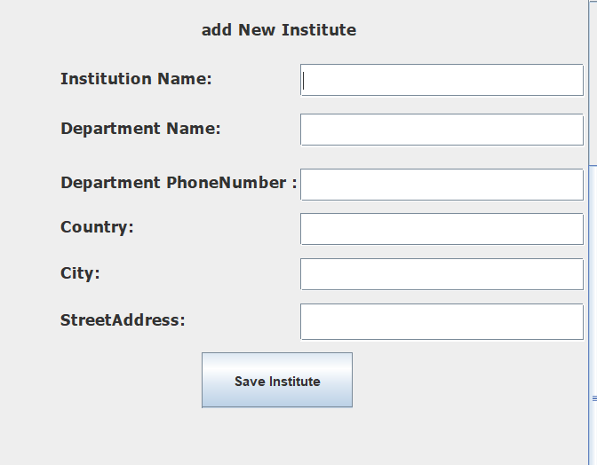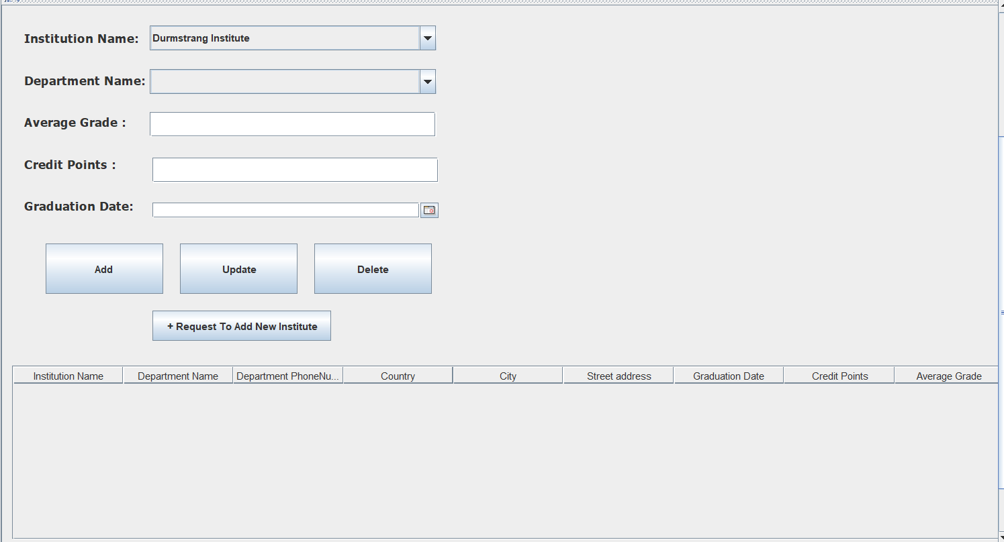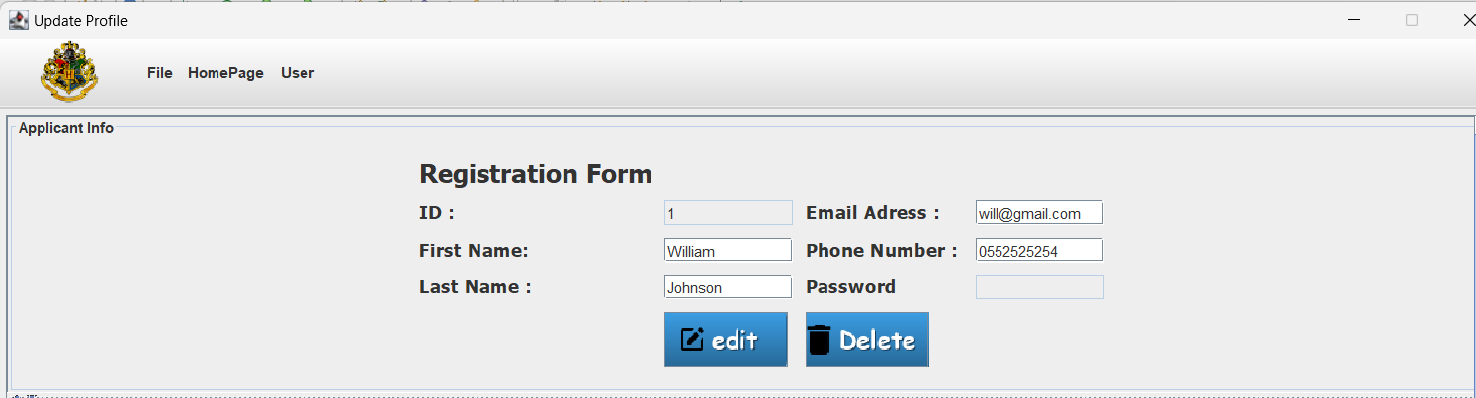

**Diagram:**

**3.1.a Design Class Diagram of Periodical Acceptance Report**

Verify readability of the figure. For each diagram, the relevant screenshots must be presented (the titles can be reproduced if needed).

**Screenshot:**

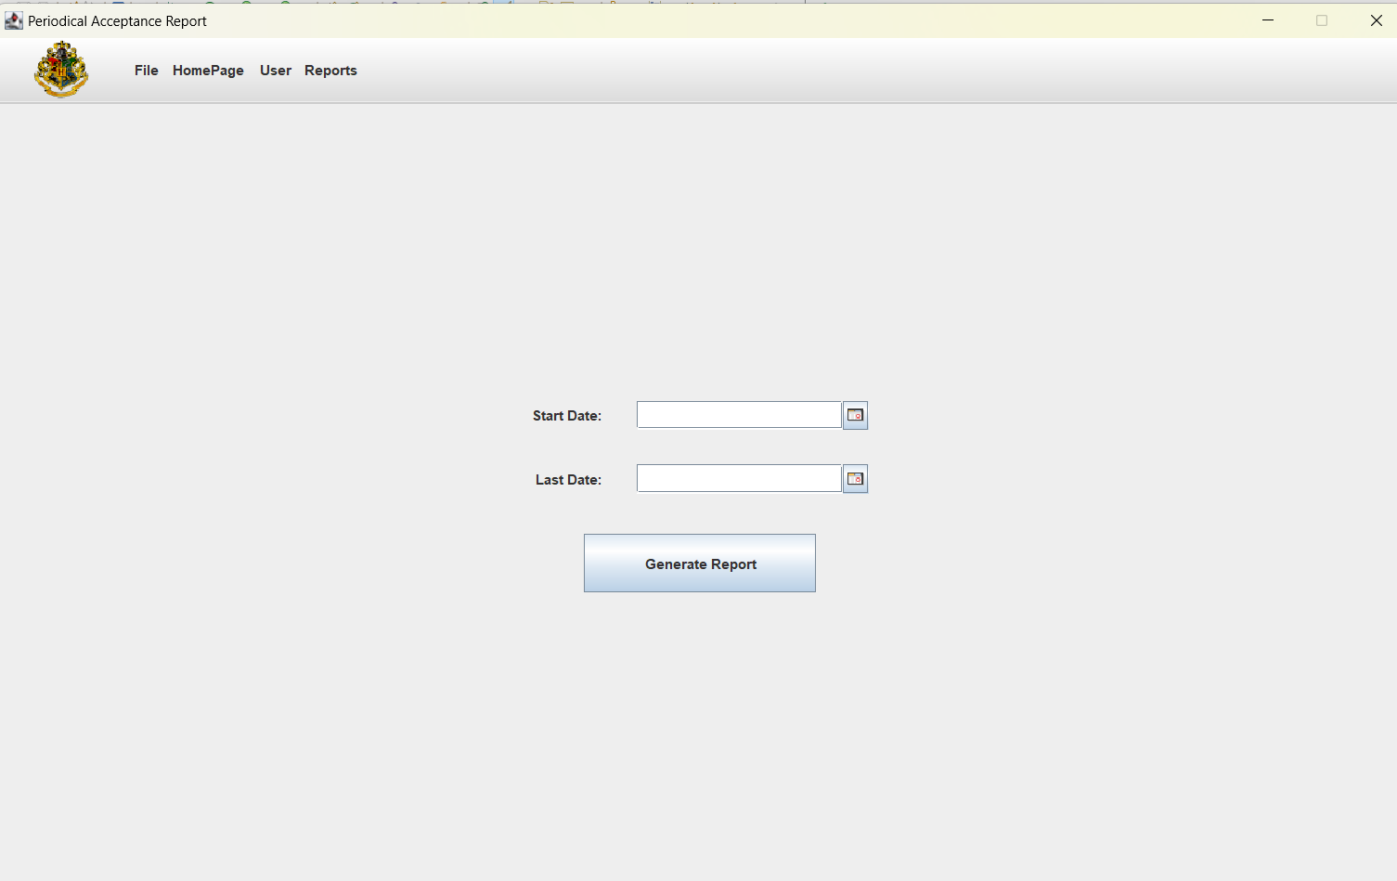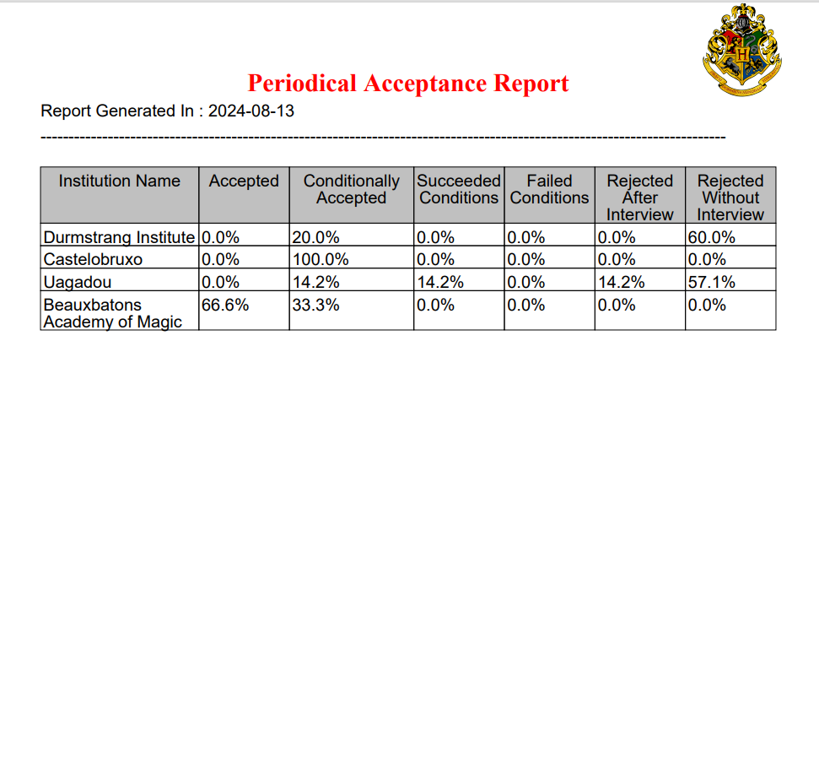

**Diagram:**

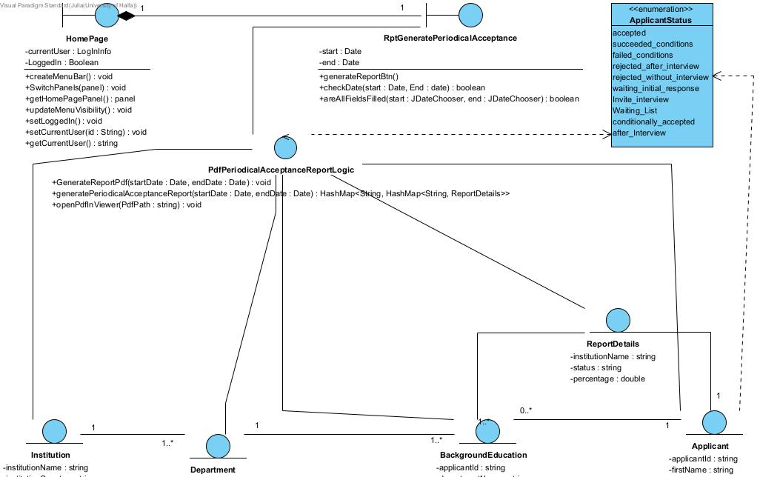

**3.1.b Sequence Diagram of :** **Periodical Acceptance Report**

Verify readability of the figure.

