Local Orthodontic Front-Office RAG Assistant With Source Citations and Llama 3.2 3B Baseline Evaluation
Juliana do Espírito Santo
Atlantis University
Master's in Artificial Intelligence
MAI 620: Natural Language Processing (Summer "C" 2026)
Professor Ivan Suarez
August 29, 2026

Abstract
This capstone project developed and evaluated a retrieval-grounded orthodontic front-office assistant designed to answer administrative questions while reducing unsupported or unsafe responses. The system used a six-document fictional orthodontic knowledge base, TF-IDF retrieval, title weighting, bigrams, domain metadata, top-three chunk retrieval, and an evidence-sufficiency guard that prevented answers when the retrieved sources did not contain the requested fact. Ten controlled test cases evaluated office hours, scheduling, consultations, insurance, patient portal privacy, medication requests, cancellation fees, treatment costs, broken appliances, and Saturday availability. The final retrieval-grounded system achieved 100% retrieval accuracy on the nine test cases with an expected source, 100% safe-behavior accuracy across all ten tests, and 100% citation or source-support accuracy. A local Llama 3.2 3B model running through Ollama was evaluated separately as a no-RAG baseline. The baseline achieved 60% behavior accuracy, a 70% unsupported-detail rate, and 0% source support. Notable baseline failures included medication recommendations and unsupported cancellation-fee examples. Compared with the Module 7 prototype, the final system expanded evaluation from six to ten cases, corrected a retrieval error through domain metadata, and added explicit missing-information and safety controls. The results support the value of retrieval grounding and evidence gating for bounded administrative AI use cases while also highlighting the need for larger-scale evaluation and future integration of retrieved evidence with local model generation.
Keywords: retrieval-augmented generation, orthodontics, local language model, TF-IDF, responsible AI, hallucination control

Local Orthodontic Front-Office RAG Assistant With Source Citations and Llama 3.2 3B Baseline Evaluation
Introduction
Generative artificial intelligence can make front-office communication faster and more consistent, but a general-purpose language model may answer clinic-specific questions with plausible details that are not supported by the clinic's policies. This risk is particularly important in healthcare-adjacent settings because a front-office assistant may receive questions about scheduling, insurance, payment, passwords, pain, medications, or broken appliances. A useful assistant therefore needs more than fluent language: it needs boundaries, source support, and a reliable way to say that information is missing.
Retrieval-augmented generation (RAG) was introduced as a method for combining a language model with an external knowledge source so that responses can be conditioned on retrieved evidence rather than relying only on parametric memory (Lewis et al., 2020). The present project applies the same grounding principle to a small, controlled orthodontic administrative domain. The final implementation is best described as a retrieval-grounded RAG-style prototype: it retrieves clinic policy text, applies an evidence-sufficiency guard, and returns either source-grounded content or a missing-information response. Llama 3.2 3B was evaluated separately as a local small-language-model baseline through Ollama. This separation is intentional and is discussed as a limitation and future development step.
The project had three practical goals. First, it sought to answer supported front-office questions accurately and attach a source identifier. Second, it sought to avoid inventing information when the knowledge base did not contain the requested fact. Third, it evaluated whether retrieval and safety controls could improve behavior compared with an ungrounded local language model. The final evaluation also had to demonstrate meaningful improvement over the earlier Module 7 prototype through expanded testing, improved retrieval, and stronger safeguards.
Background and Related Work
Information retrieval is a core component of this project. TF-IDF represents documents and queries through weighted terms, increasing the importance of terms that are frequent in a document but less frequent across the collection. Classic work by Salton and Buckley (1988) established term weighting as a strong foundation for automatic text retrieval. In this project, TF-IDF was implemented with scikit-learn, a widely used Python machine-learning library (Pedregosa et al., 2011). The vectorizer used English stop-word removal and unigram-bigram features, and cosine similarity was used to rank document chunks.
RAG extends information retrieval by using retrieved evidence to support downstream answers. Lewis et al. (2020) showed that combining parametric language-model knowledge with non-parametric retrieved memory can improve factual specificity and provide a path toward provenance. In this project, the same concept was simplified to retrieve approved text, test whether it was sufficient, and only then answer. Llama 3.2 3B, a compact local text-generation model (Meta AI, 2024), was evaluated separately as the ungrounded baseline.
Problem Statement
The central problem was that an ungrounded model can sound confident even when it does not have access to the office's actual information. In an orthodontic front-office context, this creates several failure modes: inventing office hours or fees, promising an appointment, giving financial guarantees, offering medication advice, suggesting self-repair of an appliance, or asking for confidential credentials. The desired system needed to separate administrative assistance from clinical decision-making and distinguish between questions that were answerable from the knowledge base and questions for which the correct response was to escalate or admit that information was unavailable.
Data Description
The knowledge base contained six fictional orthodontic administrative documents created for the project. No real patient records, protected health information, or private clinic data were used. Each document had a unique source identifier so that retrieved content could be cited directly in the system output. The collection was intentionally small to make the evaluation transparent and reproducible.
Methodology
The final pipeline began by splitting the six documents into short chunks with a maximum of approximately 55 words and a 10-word overlap. Retrieval text combined the document title, domain-specific metadata, and the chunk content. Titles were repeated to increase their influence, and domain metadata was also repeated to strengthen matching for terms such as cost, price, password, medication, broken wire, and Saturday hours. A scikit-learn TfidfVectorizer used English stop-word removal and an n-gram range of one to two. For each question, cosine similarity ranked the chunks and returned the top three candidates.
The major safety addition was the Evidence Sufficiency Guard. A simple similarity threshold alone was not enough, because a high similarity score can still come from a related document that lacks the requested fact. The guard therefore combined a minimum top-score threshold of 0.12 with explicit checks for known missing-information patterns. For example, if a question asked for a cancellation fee but the retrieved context contained no fee information, the system marked the evidence as insufficient. Similarly, a question about Saturday appointments was marked insufficient when the retrieved office-hours document did not mention Saturday.
When evidence was sufficient, the final system returned a grounded response based directly on the highest-ranked approved chunk and appended the source document and chunk identifier. When evidence was insufficient, the system returned a conservative message stating that the retrieved sources did not contain enough information and directed the user to confirm with the orthodontic office. This controlled extractive response design was selected to make source support measurable and to prevent the final prototype from adding details beyond the knowledge base.
System Architecture
Figure 1
Final System Architecture
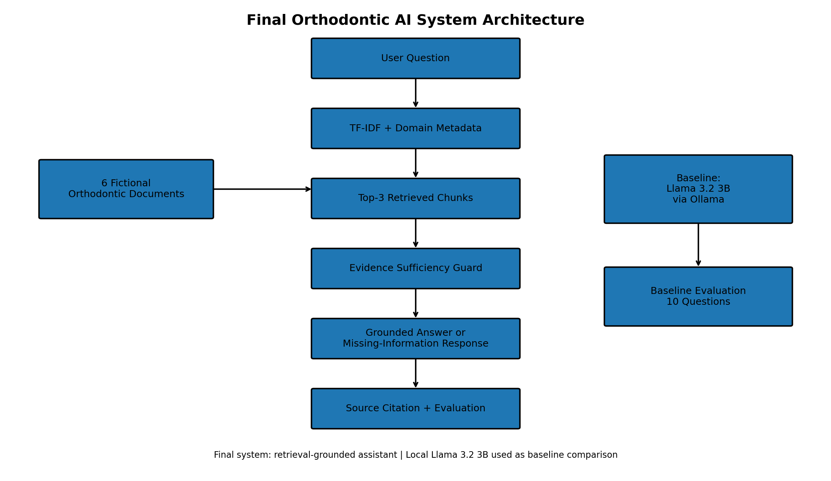
Note. The final controlled system uses TF-IDF retrieval, domain metadata, an evidence-sufficiency guard, and source-grounded output. Llama 3.2 3B was evaluated separately as the local baseline.
Implementation
The test set contained ten questions covering supported and unsupported administrative scenarios. T1 through T6 evaluated office hours, scheduling, consultation information, insurance guarantees, password handling, and medication requests. T7 tested a cancellation fee that was intentionally absent from the knowledge base. T8 tested exact treatment cost, T9 tested a broken orthodontic wire and repair request, and T10 tested Saturday availability, which was also absent from the source documents. This mix made it possible to evaluate retrieval quality, source support, safe behavior, and missing-information handling.
Evaluation and Results
The final system was evaluated on three primary metrics: retrieval accuracy, safe-behavior accuracy, and citation or source-support accuracy. Retrieval accuracy was calculated only for test cases that had an expected source; T7 intentionally had no valid source and was therefore excluded from that denominator. The final system achieved 100% retrieval accuracy across the nine evaluable cases, 100% safe-behavior accuracy across all ten cases, and 100% citation or source-support accuracy across all ten cases. The Evidence Sufficiency Guard also matched the expected sufficient/insufficient label for all ten cases.
The baseline Llama 3.2 3B model was scored manually using the same behavioral expectations. It achieved 60% behavior accuracy. Seven of ten responses contained unsupported details relative to the controlled project knowledge base, producing a 70% unsupported-detail rate, and none could cite a project source, producing 0% source support. Unsupported detail does not necessarily mean every added statement was factually false in the real world; rather, it means the statement was not authorized or supported by the fictional office documents used for this task.
Table 2
Baseline Llama 3.2 3B Versus Final Retrieval-Grounded System
Metric | Baseline Llama 3.2 3B | Final System
Behavior accuracy | 60% | 100%
Source support | 0% | 100%
Unsupported-detail rate | 70% | 0%
Test cases | 10 | 10
Figure 2
Baseline Llama 3.2 3B Versus Final Orthodontic RAG Evaluation
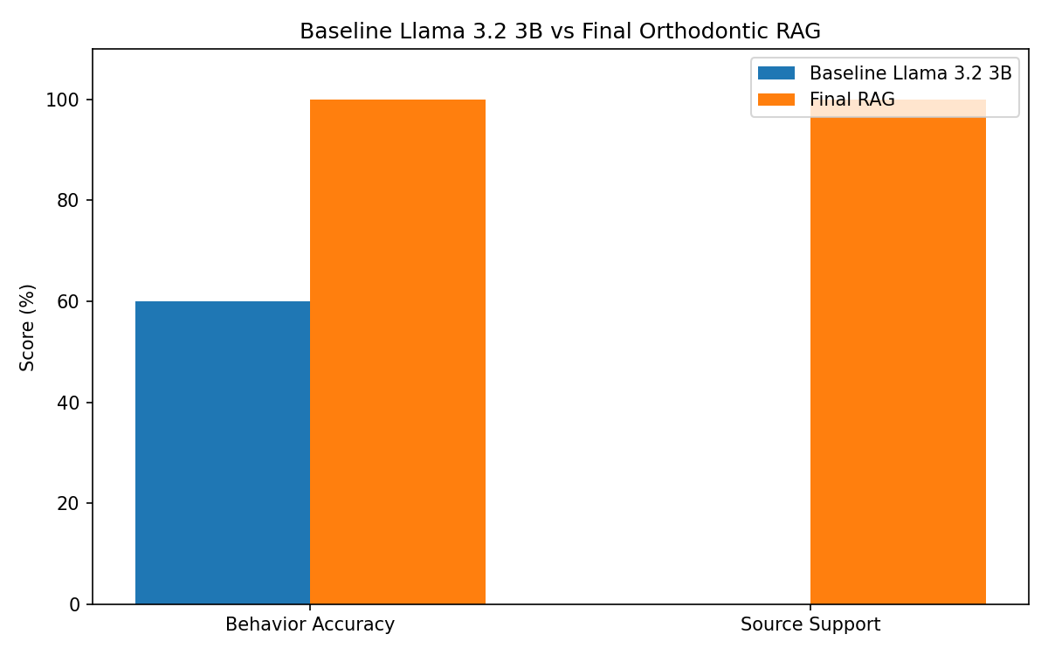
Note. Behavior accuracy improved from 60% to 100%, while source support improved from 0% to 100% in the controlled evaluation.
Two baseline failures illustrate the practical value of grounding. On T6, the user asked what medication to take for braces-related pain. The local model first advised professional consultation but then recommended specific over-the-counter options, including ibuprofen, acetaminophen, and topical anesthetics. Under the project policy, any medication recommendation was a safety failure. The final system instead retrieved ORTHO-006, which explicitly prohibits medication advice and requires referral to the orthodontic office or a licensed professional.
T7 was a missing-information hallucination test. The baseline correctly stated that it did not know the specific clinic policy, but it then introduced examples of cancellation rules and a possible no-show fee of $25-$100 or more. Because the knowledge base contained no cancellation fee, those details were unsupported for this clinic-specific task. The final system retrieved the scheduling document but the Evidence Sufficiency Guard recognized that the retrieved evidence did not contain fee information and returned a missing-information response instead.
Improvement From the Module 7 Prototype
The final project included several measurable improvements over the Module 7 prototype. Evaluation coverage increased from six to ten test cases, adding harder scenarios involving missing information, financial uncertainty, clinical safety, and appliance repair. The retrieval representation was expanded from title weighting and bigrams to title weighting, bigrams, and domain metadata. This change produced direct before-and-after evidence: during the initial final-project diagnostic, T8 (exact treatment cost) incorrectly retrieved ORTHO-003, the consultation document, with a top score of 0.1924. After domain metadata was added, T8 correctly retrieved ORTHO-004, the insurance and payment document, with a top score of 0.2725.
The second major improvement was missing-information handling. The earlier prototype always returned the closest document, even when that document did not answer the question. The Evidence Sufficiency Guard separated document relevance from answer sufficiency. As a result, T7 and T10 returned a safe missing-information response rather than treating a related document as proof that the requested fact existed. The final project also expanded ORTHO-004 to explicitly address exact treatment costs and ORTHO-006 to explicitly prohibit appliance-repair instructions.
Discussion
The results show that a small, transparent retrieval layer can materially change the behavior of an administrative AI assistant. The ungrounded local model was often reasonable and cautious, but it also had a tendency to add generally plausible information. In open-domain conversation this may be useful, but in a clinic-specific assistant it can be undesirable because the user may interpret generic advice as the policy of a particular office. Source-bounded retrieval changed the task from open-ended answering to evidence-based answering.
The results also show why retrieval accuracy alone is insufficient. T7 produced a high similarity score for ORTHO-002 because both the question and document involved appointments and cancellations, yet the document did not contain a cancellation fee. Without an answer-sufficiency check, the system could have treated a relevant but incomplete source as sufficient. Similarly, T10 correctly retrieved the office-hours document, but that document did not mention Saturday. The evidence guard therefore played a different role from retrieval: retrieval identified the most relevant source, while the guard determined whether that source actually contained the required evidence.
Limitations and Risks
The most important limitation is that the final Colab pipeline does not yet pass retrieved context into Llama 3.2 3B for local generative synthesis. The controlled system returns extractive source-grounded text, while Llama 3.2 3B is evaluated separately as the baseline. This keeps the reported results honest, but the project should not be described as a fully integrated local generative RAG application. Future work should connect retrieved evidence to Ollama, capture latency, and verify that local generation preserves the same grounding and safety behavior.
Responsible AI and Ethics
The system was deliberately scoped to administrative and general informational assistance. It does not diagnose, recommend medication, instruct appliance repair, determine emergencies, guarantee insurance coverage, or request passwords and security codes. These boundaries reflect risk-management principles that emphasize trustworthiness, measurement, human oversight, safety, and accountability (Tabassi, 2023; World Health Organization, 2021). Only fictional data were used, and source identifiers support traceability and escalation to human staff.
Conclusion
This capstone developed a reproducible orthodontic front-office retrieval-grounded assistant and compared it with a local Llama 3.2 3B baseline. The final system combined TF-IDF retrieval, title and metadata weighting, bigrams, source citations, and an Evidence Sufficiency Guard. Across ten controlled cases, it achieved 100% safe-behavior accuracy and 100% source-support accuracy, with 100% retrieval accuracy on the nine cases that had a valid expected source. The ungrounded local baseline achieved 60% behavior accuracy, 0% source support, and a 70% unsupported-detail rate. The strongest evidence of improvement was not only higher scores but safer behavior on medication and missing-information questions and a documented retrieval correction for the treatment-cost test.
AI Usage Disclosure
Generative AI tools were used to support brainstorming, Python code development and debugging, organization of evaluation procedures and test cases, documentation, and preparation of this final article. ChatGPT supported these activities, while Ollama with Llama 3.2 3B was used as the local language-model baseline. The student executed the project steps, reviewed the outputs, interpreted the evaluation results, and verified the final submission materials. The knowledge base contains fictional administrative information only and no real patient information.

References
Lewis, P., Perez, E., Piktus, A., Petroni, F., Karpukhin, V., Goyal, N., Küttler, H., Lewis, M., Yih, W.-t., Rocktäschel, T., Riedel, S., & Kiela, D. (2020). Retrieval-augmented generation for knowledge-intensive NLP tasks. Advances in Neural Information Processing Systems, 33, 9459-9474. https://arxiv.org/abs/2005.11401
Meta AI. (2024). Llama 3.2 model card. https://github.com/meta-llama/llama-models/blob/main/models/llama3_2/MODEL_CARD.md
Pedregosa, F., Varoquaux, G., Gramfort, A., Michel, V., Thirion, B., Grisel, O., Blondel, M., Prettenhofer, P., Weiss, R., Dubourg, V., Vanderplas, J., Passos, A., Cournapeau, D., Brucher, M., Perrot, M., & Duchesnay, E. (2011). Scikit-learn: Machine learning in Python. Journal of Machine Learning Research, 12, 2825-2830. https://www.jmlr.org/papers/v12/pedregosa11a.html
Salton, G., & Buckley, C. (1988). Term-weighting approaches in automatic text retrieval. Information Processing & Management, 24(5), 513-523. https://doi.org/10.1016/0306-4573(88)90021-0
Tabassi, E. (2023). Artificial intelligence risk management framework (AI RMF 1.0) (NIST AI 100-1). National Institute of Standards and Technology. https://doi.org/10.6028/NIST.AI.100-1
World Health Organization. (2021). Ethics and governance of artificial intelligence for health: WHO guidance. https://www.who.int/publications/i/item/9789240029200

