Laboratory practice No. 1: Recursion

Juliana Lalinde  Universidad Eafit  Medellín, Colombia  correoinegrante1@eafit.edu.co | Isabel Urrego Gomez  Universidad Eafit  Medellín, Colombia  iurregog@eafit.edu.co

3) Practice for final project defense presentation

- Recursion 1

_triangle:

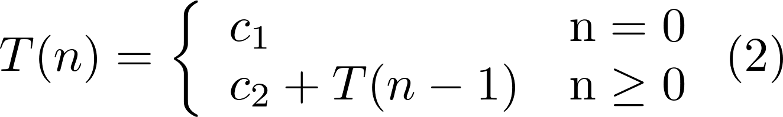

Solution:

O(n)

_sumDigits:

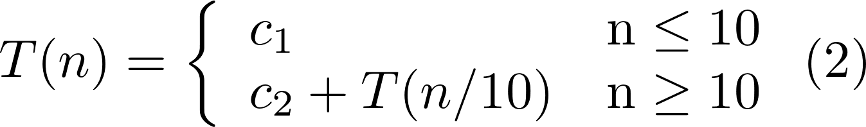

Solution:

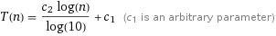
O(log(n))

_powerN:

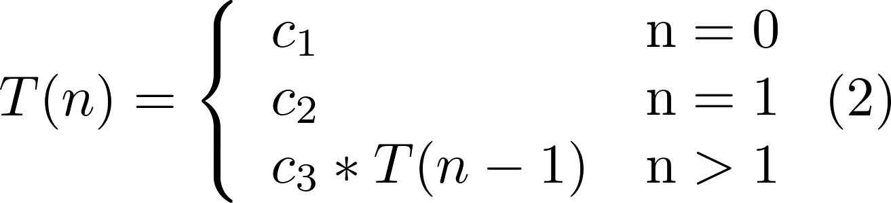

Solution:

O(a^n)

_changePi

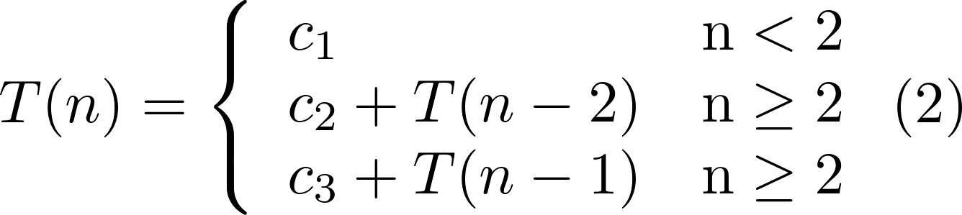

Solution:

O(n)

_noX

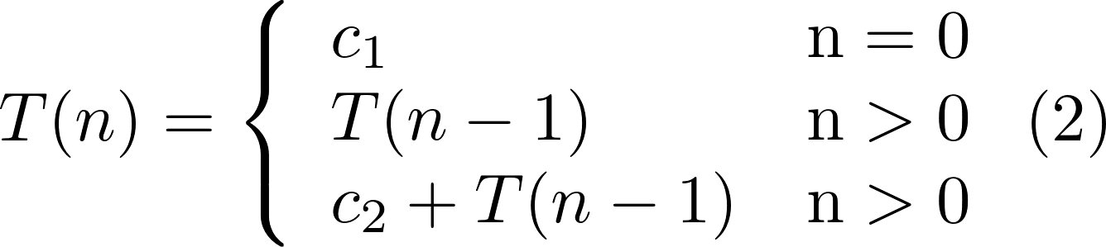
Solution:

O(n)

- Recursion 1

triangle is O(n), where n is the number of rows
sumDigits is O(log(n)), where n is the number whose digits are going to be summed
powerN is O(a^n), where a is an arbitrary constant constant and n the exponent
changePi is O(), where n is the length of the String
noX is O(n), where n is the length of the String

- About Stack Overflow
The main difference between an iteration and recursion lies in the creation of new memory. Recursive functions never lead to infinite loops since they collect information on the stack pile with each recursive call. The amount of recursive calls is limited by the capacity of the stack pile and that is the reason why the program throws an error when the stack is full, called Stack Overflow.

4) Practice for midterms

- (start+1, nums, target)

- Line 2: return n
Line 3: n-1
Line 4: n-2

5.2 b
- Line 10: sumaAux(n, i+2)
Line 12: sumaAux(n, i+1)

5) Recommended reading (optional)

- Recursion and Backtracking
- The term recursión is mainly used refering to a technique which solves a problem by calling itself and comes to a solution by reducing the problem into smaller parts. Additionally, a recursive function is made of two important things, the base case and the recursive case.

It’s also important to notice that recursive calls need extra space on the memory and not reaching a base case leads to an error called Stack Overflow.

One example of a recursion form is Backtracking, an improvement of the brute force approach. It consist in looking for a solution by trying every single possibility till it finds one that solves the problem. If the option tried doesn’t work, the function will backtrack and choose another possibility. That’s where the name backtracking comes from.

- Concept map
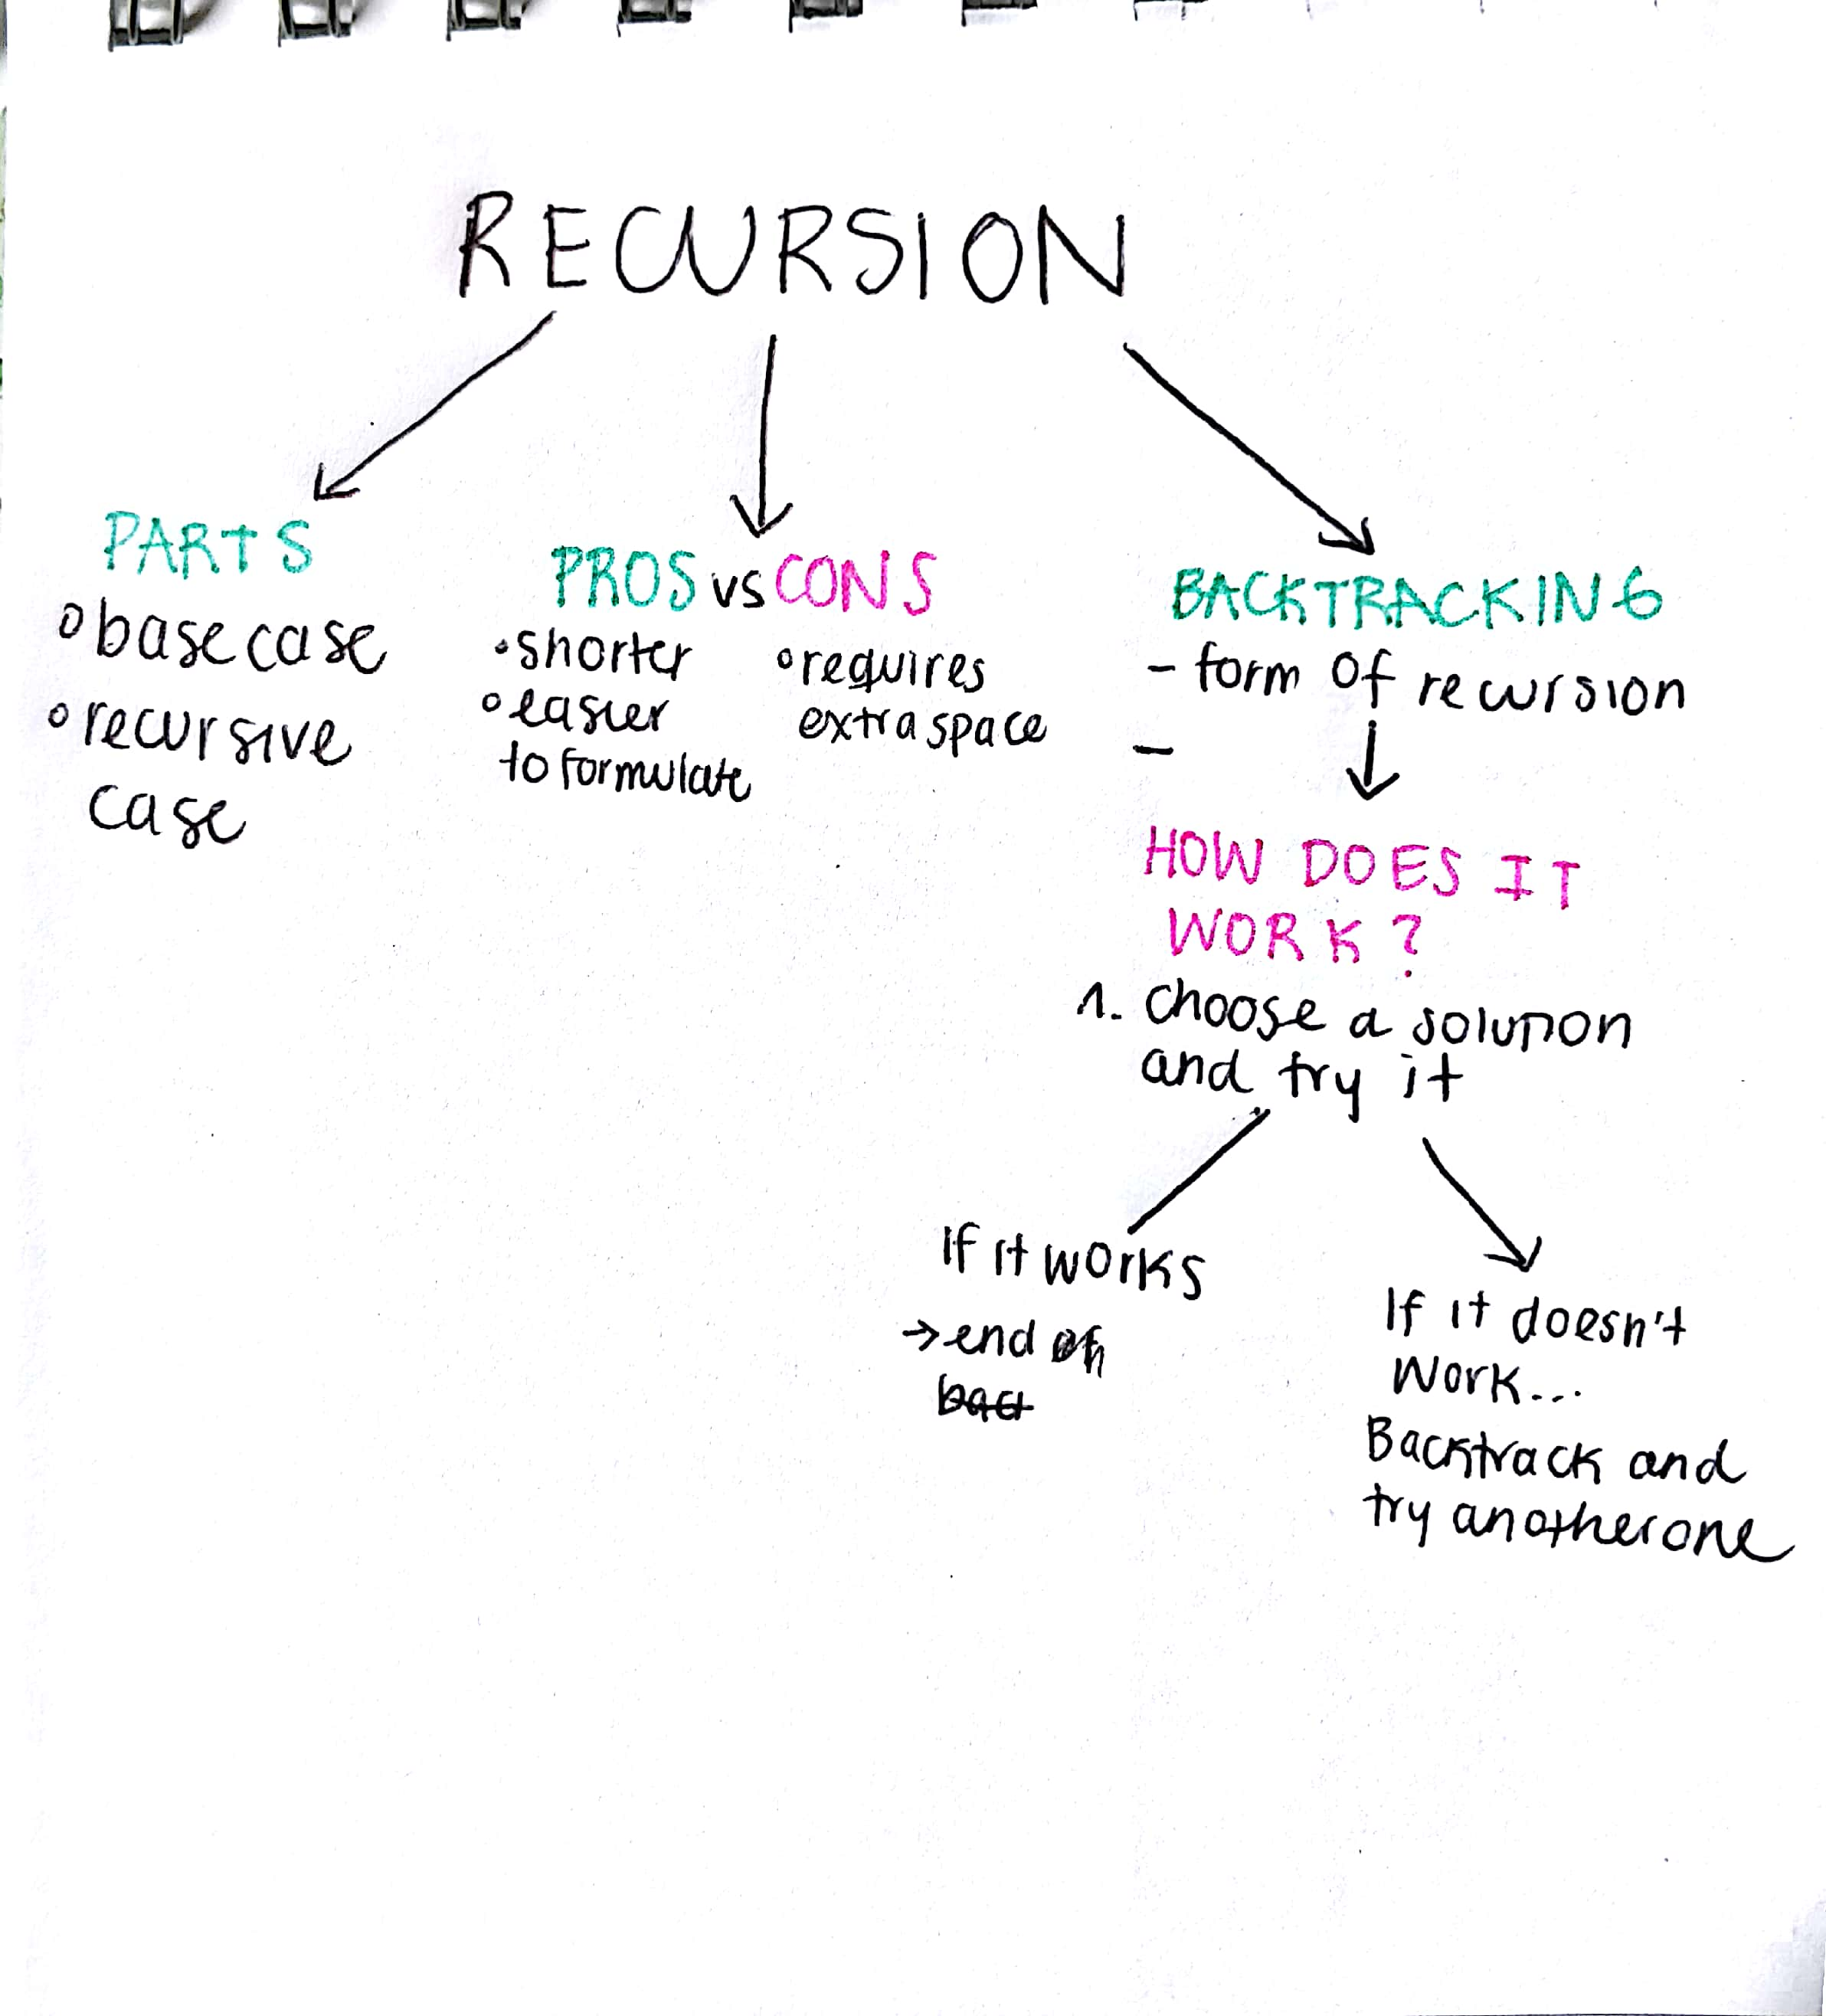

6) Team work and gradual progress (optional)

  - Meeting minutes
  - History of changes of the code
  - History of changes of the report

