Laboratory practice No. 3: Linked List and Array List

Juliana Lalinde Velásquez  Universidad Eafit  Medellín, Colombia  correoinegrante1@eafit.edu.co | Isabel Urrego Gómez  Universidad Eafit  Medellín, Colombia  iurregog@eafit.edu.co

3) Practice for final project defense presentation

- Time Complexity
 | ArrayList | LinkedList
1.1 | O(n) | O(n)
1.2
1.3
1.4

- Exercise 2.1
This algorithm reads a text written by a user with a Scanner object and enters to a loop making the following for each line read:
A linked list of characters will be created collecting the ordered information of the line read. This algorithm evaluates each character of the line and adds it to the list but if a [ is detected, the program starts adding the elements at the beginning of the list and if it finds a ], it starts adding the elements at the end of the list. The integer index indicates the program in which place it should add the characters and this index changes depending on the character detected.

After that it uses an auxiliary list that has the same information as the list but in the opposite order so that the characters will be removed and printed in the right order.

- 1.1 : The complexity is O(n), where n is the size of the List

4) Practice for midterms

- a

- a. q!= null
b. <=
c. q,remove()
d. q.remove()

- a. auxiliar1.size() > 0, auxiliar2.size() > 0
b. personas.offer(edad)

- C

- A. a
b. 12
c. O(1)
5) Recommended reading (optional)

- Chapter 3: Linked Lists
- This is one of the most known data structures used to store collections of data. The elements inside a Linked List are connected by pointers and the last element always points to NULL. This way to link elements leads to one of the most important properties of a Linked List, the possibility to be expanded in constant time.
However, there are other aspects in which using a Linked List might not be the better option. For example, when you have to access to elements using Arraylists is O(1) while using LinkedLists is O(n). Both data structures are very similar but the disadvantages of one of them are de advantages of the other and knowing that might improve the proper use of these data structures.

- Concept map

Linked Lists
What is a Linked List?
-Data Structure
-Elements connected by pointers
-Can grow and shrink even during execution
Advantages
-Expand in constant time
-Add elements without doing copies or reallocating
Disadvantages
-O(n) for access to an element
-Waste of Memory
Types
-Singly
-Doubly
-Circular
-Unrolled
-Skip

6) Team work and gradual progress (optional)

  - Meeting minutes
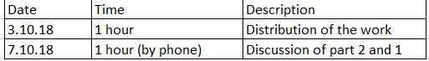

  - History of changes of the code

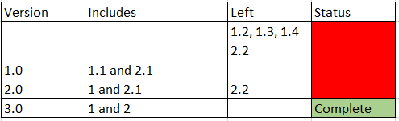

  - History of changes of the report
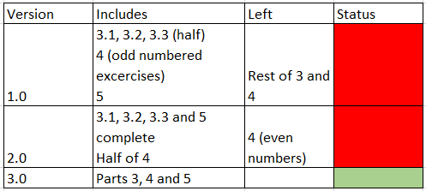

d. Individual work

