Laboratory practice No. 4: Trees

Juliana Lalinde Velásquez  Universidad Eafit  Medellín, Colombia  correoinegrante1@eafit.edu.co | Isabel Urrego Gómez  Universidad Eafit  Medellín, Colombia  iurregog@eafit.edu.co

3) Practice for final project defense presentation

- Can a family tree be implemented so that insertion and search can be made in a logarithmic time? Why?

The answer is yes. If we build a family tree as a binary search tree, it would be capable of doing this functions in O(logN) time.
The reason we can rebuild our family tree as a binary search tree is because it would fulfill the aspects needed to tag it as that type of data structure. For example, each node has at most two children, in this case father and mother and it would be perfectly balanced because the left root are the female members and the right one the male members.

- Exercise 2.2

This algorithm works recursively and stops when it detects a leaf node returning true if there is a path which sum equals the number wanted. While that statement isn’t true it keeps calling itself recursively and takes the left and right children as the new nodes that is why there are two recursive calls, one for each child. Besides, on each new call the data of the actual node will be rested to the sum since it will always be included on the path. This way the algorithm verifies every single path and returns true if it finds the one that sums the number on the parameter. Otherwise it returns false. The other possibility is that we have an empty tree and in that case the algorithm also returns false.

4) Practice for midterms

- a. altura(raiz.izq)

b. altura(raiz.der)

- a.false
b. a.dato
c. a.izq, suma - a.dato
d. a.der, suma - a.dato

- a. p.data== toInsert
b. p.data> toInserr

- 1. 1
2. 2

- a

5) Recommended reading (optional)

- Chapter 8: Binary Trees
- A tree is a tree made of nodes and edges that represent the way how the nodes are related. What differences a binary tree from the others is the maximum number of children of each node, two and that is why they are called the right child and left child. Additionally, this data structure combines the two main advantages of an array and a linked list searching, adding and deleting very fast.

There is also an specific case of a binary tree commonly known as binary search tree, which separates the data between bigger than and less than. Therefore, what is in the left o a node are the values that are smaller than the data contained in that node and the right values are the ones bigger, this repartition of the data makes it easier to search, insert and add.
- Concept map

Binary tree

Elements

Functions
Nodes(two children)
Edges
Leaf: Node with no children
Insert
O(log N) time
Follow a path and find the place where it should be located
Delete
O(log N) time
Follow the path to find the element and after deleting relate the nodes replacing the edges removed
Search
O(log N) time
Binary search trees have lower values on one side and upper on the other
Traversing
Visiting all nodes in an specific order

Types
Preorder
Inorder
postorder

6) Team work and gradual progress (optional)

  - Meeting minutes

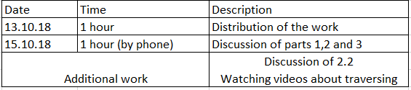

  - History of changes of the code

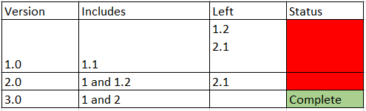

  - History of changes of the report
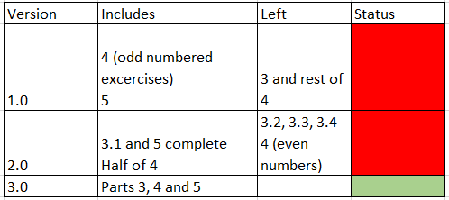

d. Individual work

