Laboratory practice No. 2: Complete the title of the laboratory practice

Juliana Lalinde Velásquez  Universidad Eafit  Medellín, Colombia  correoinegrante1@eafit.edu.co | Isabel Urrego Gómez  Universidad Eafit  Medellín, Colombia  iurregog@eafit.edu.co

3) Practice for final project defense presentation

- Insertion Sort

Size of the Array | Time
1 | 0
2 | 2002
3 | 7003
4 | 16007
5 | 30013
6 | 50025
7 | 77031
8 | 112054
9 | 156070
10 | 210089
11 | 275119
12 | 352169
13 | 442223
14 | 546233
15 | 665338
16 | 800387
17 | 903983
18 | 1039851
19 | 1185222
20 | 1340099
Merge Sort

Size of the Array | Time
1 | 0
2 | 2003
3 | 5002
4 | 8003
5 | 12004
6 | 16006
7 | 20009
8 | 24010
9 | 29014
10 | 34016
11 | 39020
12 | 44036
13 | 49018
14 | 54022
15 | 59047
16 | 64035
17 | 70030
18 | 76029
19 | 82040
20 | 88043

- Graphics
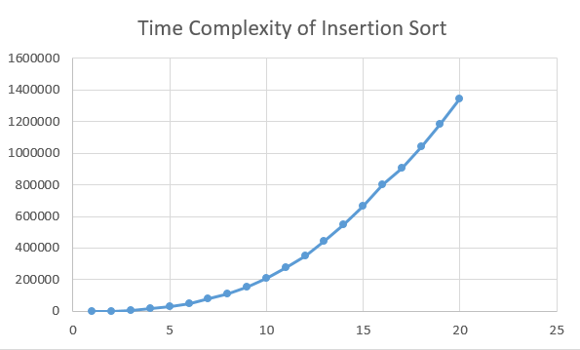
Graphic 1: О(n²)
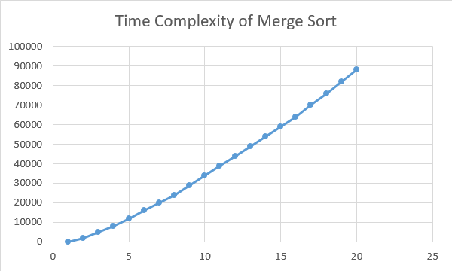
Graphic 2: O(n log n)

- From the graphics and the tables we see that both algorithms have different time complexities. At the beginning sorting small arrays result equally difficult for both algorithms, but as the size of the array gets bigger we notice that the time of the Insertion Sort algorithm grows much faster in comparison to the Merge Sort algorithm. Therefore, we can conclude that the second solution is more efficient when we have to work with a million elements data base and working with Insertion Sort leads to a waste of time in those cases.

4) Practice for midterms

- c
- d
- b
- b
- d
- a

7.1. T(n)= c+ T(n-1)
7.2. O(n)
- b
- d
- a
- c
- b
- a

5) Recommended reading (optional)

- Introduction to design and analysis of algorithms. Chapter 2

- When people talk about an efficient algorithm, they mainly take into account the time complexity. This aspect is based on the number of steps that the algorithm does while running. That is how programmers are able to compare algorithms without worrying about the velocity of the machine and other aspects.

The big O notation is used to represent the complexity of an algorithm in the worst cases. Therefore, in some cases, the program might do less steps than the ones described by the notation but never more. Besides, time complexity can also be seen as a warning to look for simpler solutions or choose the most efficient one when we have more than one solution for the problem.

- Concept map

Chapter 2: Complexity of an algorithm
Efficiency
Difficulty
Optimization

6) Team work and gradual progress (optional)

  - Individual Work

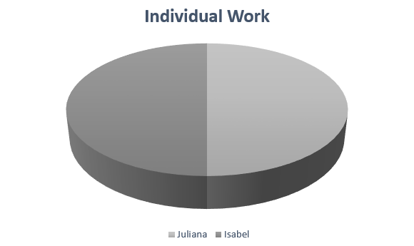
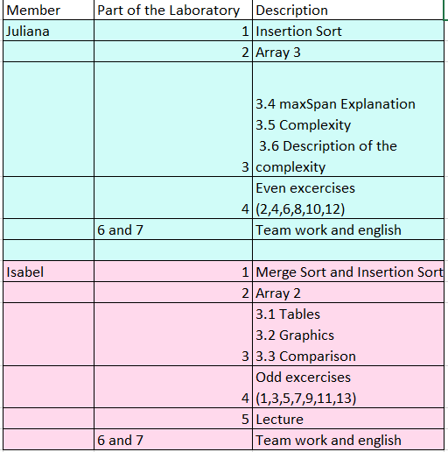

Team work(Meeting Minutes):
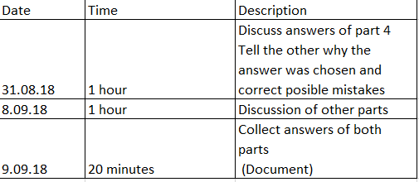

  - History of changes of the code
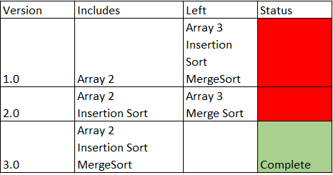

  - History of changes of the report
