# 

# Automatic photo capture Raspberry Pi and MapIR camera from an unmanned aerial vehicle

Author[1] **BOLAÑOS**, **Julian**

#### Abstract

#### Image capture is essential when collecting information in photogrammetry. One of the aspects to be addressed in this document is the optimization of image capture by autonomous flights using unmanned aircraft and a Raspberry Pi camera. This work establishes the process to achieve an automatic capture starting from the mission planning to the collection of images in a centralized server.

#### key words

#### Photogrammetry, UAV, Raspberry PI, MapIR.

#### Resumen

#### La captura de imágenes es esencial cuando se recopila información en fotogrametría. Uno de los aspectos que se abordarán en este documento es la optimización de la captura de imágenes mediante vuelos autónomos utilizando drones y una cámara Raspberry Pi. Este trabajo establece el proceso para lograr una captura automática desde la planificación de la misión hasta la recopilación de imágenes en un servidor centralizado.

#### Palabras clave Fotogrametría, UAV, Raspberry Pi, MapIR

## 1. Introduction

The Raspberry Pi card is a versatile tool when it comes to carrying out different kinds of development, in this case, it is used as a camera module carried by an unmanned aircraft to achieve efficient photo capture. This efficiency has been achieved, in this case, by attaching the Raspberry card to the unmanned aircraft using an activation pin that allows capturing when determined by the UAV. Initially, the place to be mapped and photographed is determined, followed by the adaptation and assembly of the camera system to the aircraft, ending with the realization of image capture by executing the initially planned mission. This document details the structure of the proposed system describing its components.

* 1. **Context**

This work is the basis for optimal image capture in the context of precision agriculture (Bolaños, Campo, & Corrales, 2017). Through the use of unmanned quadrocopters aircraft, it is possible to obtain fast and reliable information of a wide range, which in turn improves efficiency and economy within an agricultural process. It is important to make improvements in the capture process because this allows to improve the results and also optimizes limited resources such as battery and flight time of UAVs (Zhang & Kovacs, 2012).

## 2. Methodology

**2.1. Architecture**

The architecture is based on an unmanned aircraft module, a server dedicated to storing images and a Raspberry Pi as a camera module.

Fig 1. General Architecture

Unmanned Aerial Vehícle(UAV)

Raspberry Camera

Server

Control

**2.1.1. Control:** It refers to the module that carries out the mission planning and subsequent execution in the aircraft, for this section the free Mission planner software is used, which allows configuration and monitoring of the UAV.

**2.1.2. UAV:** It refers specifically to the aircraft module that carries the camera and actuates the trigger of the same. In this case, 2 types of aircraft were handled, the first based on APM 2.6 and the 3DR Solo.

**2.1.3. Raspberry Pi Cámara:** It is the module for capturing and subsequent storage of images. The current camera module has 5 megapixels and is attached to the UAV through a battery bank.

Automatic capture is performed using an algorithm implemented in Python that is presented in the figure 2:

Fig 2.Capture Process

Input 25Gpio Active

Is High?

No

Yes

Capture Images

Send To Server

**2.1.4. Server:** Image storage module obtained from the camera. This module is based on the Spring Boot framework and is responsible for receiving images and saving them in memory for further processing (Spring, s.f.).

**2.2 Initial System Configuration:**

Taking into account that the unmanned aircraft allows the configuration so that from a digital pin, a signal can be sent to the camera to activate image capture, it is necessary to make a configuration so that such action is possible. Below are the necessary steps to configure the UAV using the Mission Planne software (ArduPilot, s.f.):

Step 1: On the full parameter list, change **CAM_TRIGG_TYPE** to 1 on relay mode.

Step 2: Configure the **CAM_TRIGG_DIST** parameter by the capture by distance configuration.

**2.2. General System Coupling:**

The system has been configured using a signal pin and a ground pin. The APM directly connects the output pins to the raspberry Pi because the nominal operating voltage is 5V, and the 3DR connects directly to the PWM signal to the HDMI input of the Survey 3 MapIR camera with a nominal voltage of 3.3V. The system coupling can to be seen on the Figure 3

Fig 3. General System Coupling

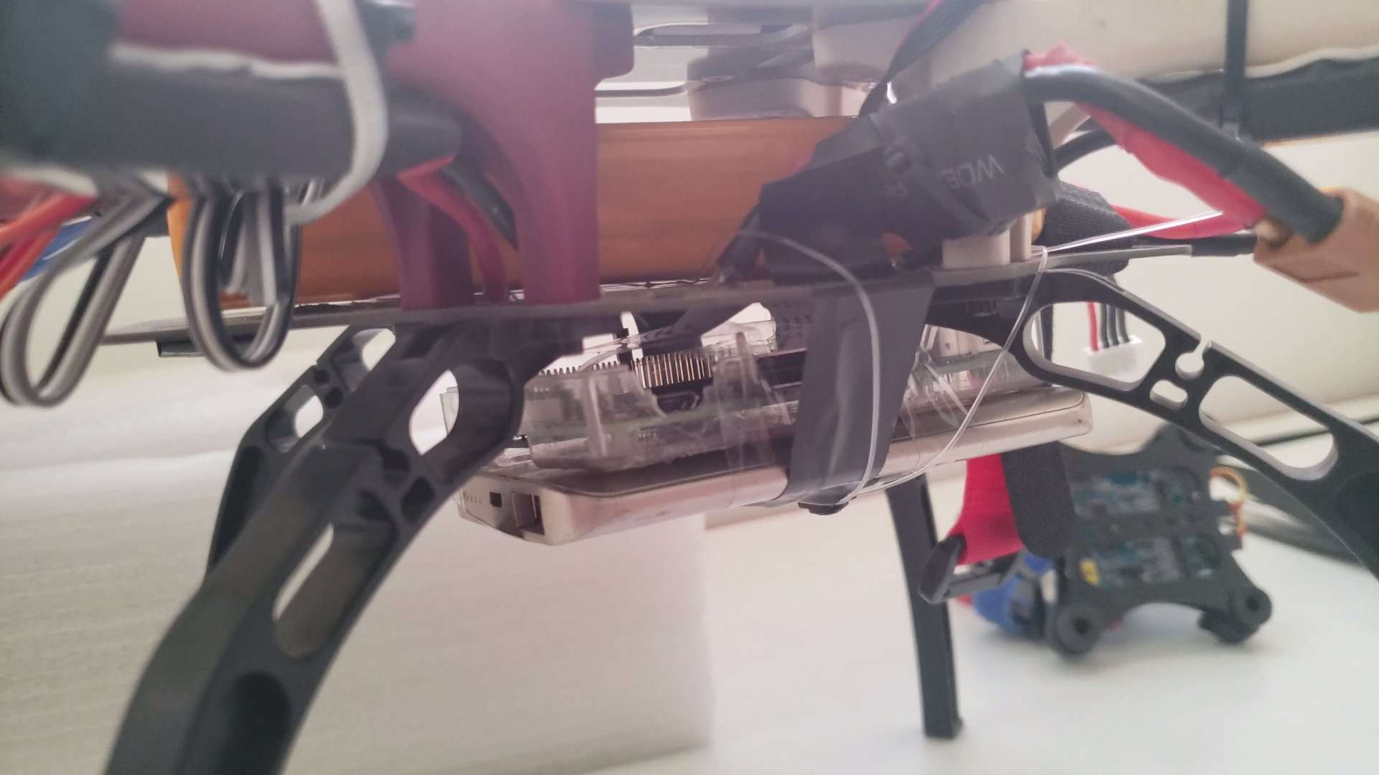 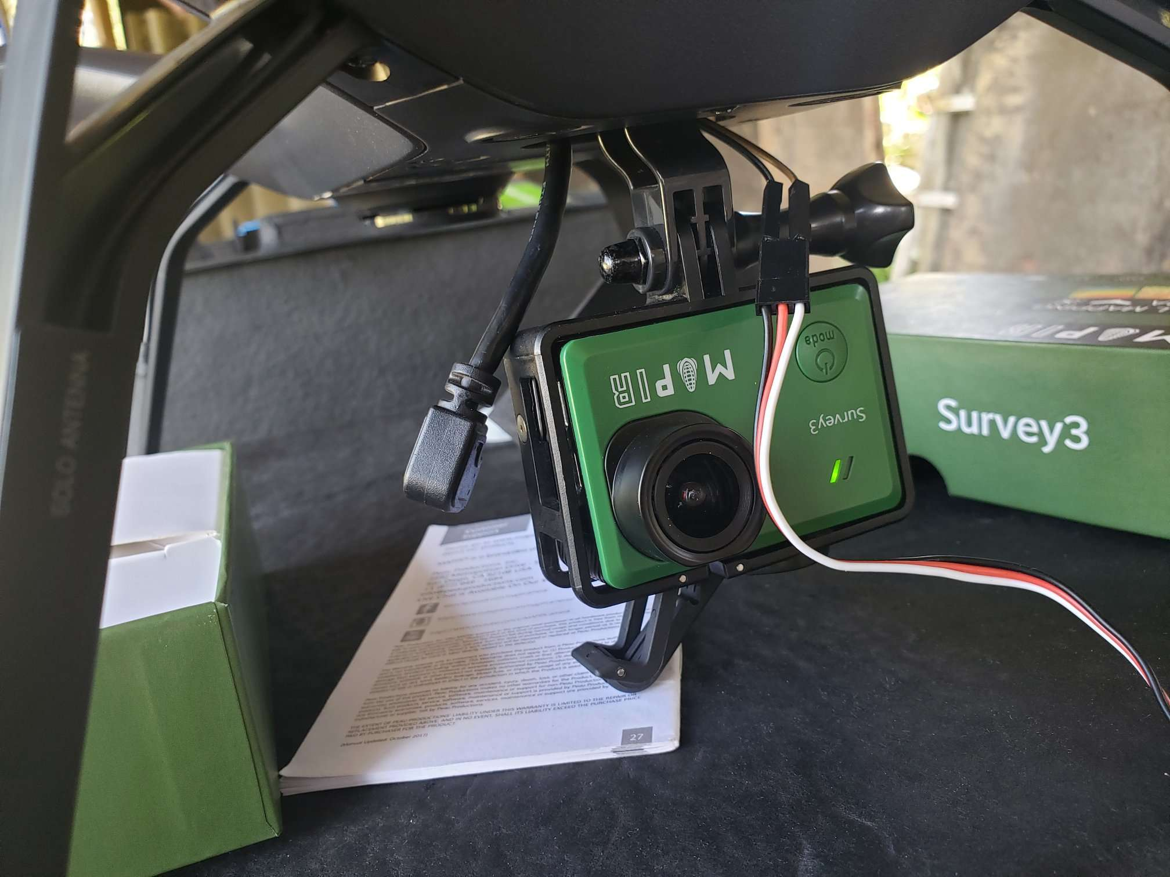

## 3. Results

**3.1 Mission Planning.**

The software Mission planner is take in account, this is compatible with the aircraft 3DR solo and APM. The full documentation is available in (Oborne, s.f.), the steps necessary to configure a mission and their respective commands are detailed. For the case of this study, figure 4 shows a capture that represents the area to be covered. Image capture takes into account flight height, camera focal length, camera sensor size and resolution, this process is detailed in (Humboldt State University, s.f.)

Fig 4.Area To Cover

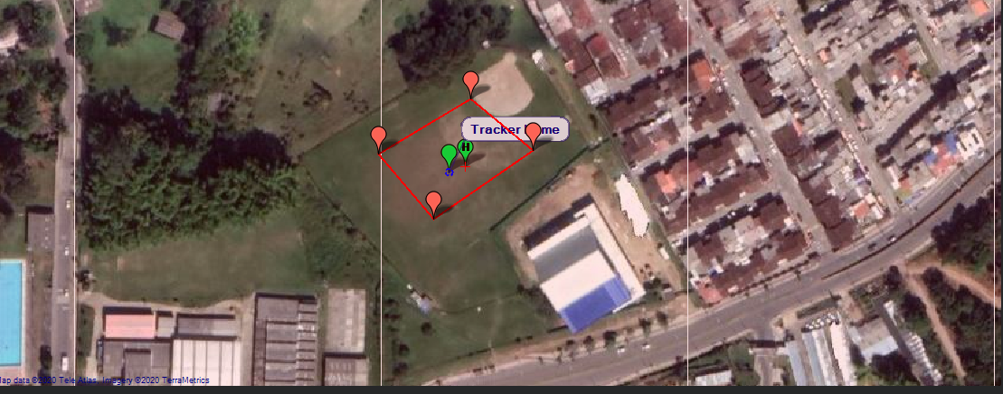

Subsequently, according to the capture requirements, flight heights and camera overlap can be specified.

Fig 5.Mission Representation

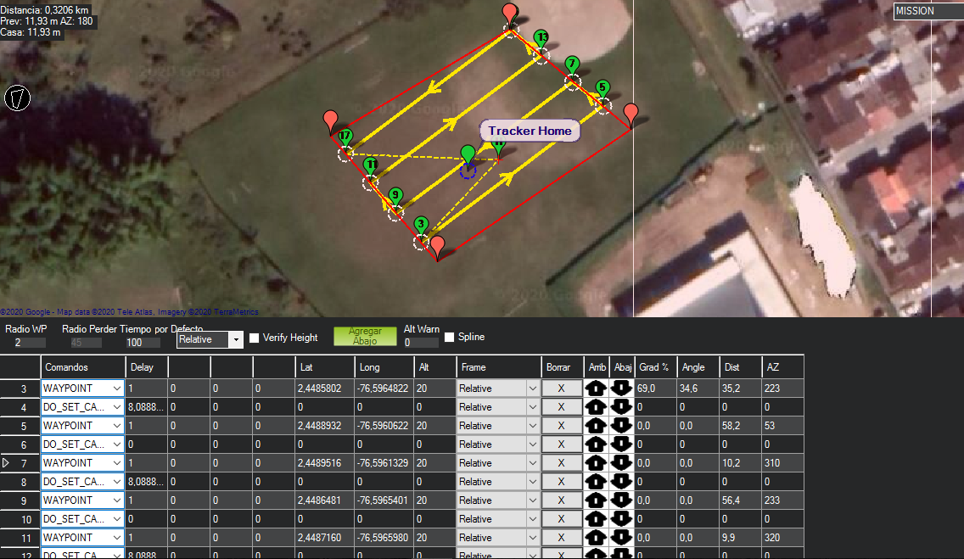

A representation after flying can to be see on Figure 6

Fig 6. Mission Executed

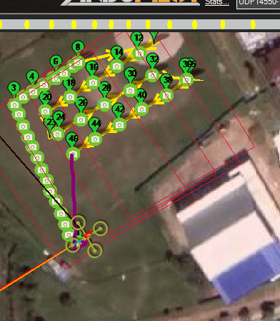

Finaly, the result can to be see on the Figure 7.

Fig 7.Image Results

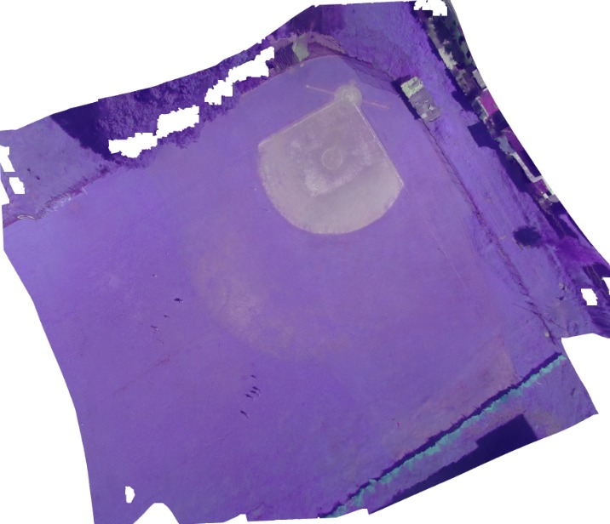

Figure 3 is achieved by Agisoft Photoscan software after capturing the images and processing them (Nolan, s.f.)..

## 4. Conclusions

This work allowed to determine the possibility of automatic and efficient capturing by means of the Ardupilot module and the Mission Planner software. It is important to highlight that each camera has fundamental characteristics that establish parameters to be activated remotely. In this case, the MapIr Survey camera cannot be activated directly by the APM module due to its voltage characteristics, and the Raspberry Pi camera cannot be sealed by the 3DR Only due to the difficulty of accessing the shutter pins.

## Bibliographic references

ArduPilot. (s.f.). *Common MavLing Mission Commands*. Obtenido de https://ardupilot.org/plane/docs/common-mavlink-mission-command-messages-mav_cmd.html

Bolaños, J. A., Campo, L., & Corrales, J. C. (2017). Characterization in the Visible and Infrared Spectrum of Agricultural Crops from a Multirotor Air Vehicle. En Springer, *International Conference of ICT for Adapting Agriculture to Climate Change* (págs. 29--43). Springer.

Humboldt State University. (s.f.). *Scale and Aerial Photography*. Obtenido de Scale and Aerial Photography: http://gsp.humboldt.edu/OLM/Courses/GSP_216_Online/lesson2-2/scale.html

Nolan, R. (s.f.). *Processing Imagenes Survey Agisoft Photoscan*. Obtenido de https://www.mapir.camera/blogs/guide/processing-survey-camera-images-in-agisoft-photoscan

Oborne, M. (s.f.). *Mission Planner*. Obtenido de https://ardupilot.org/planner/docs/mission-planner-overview.html

Spring. (s.f.). *Building an Application with Spring Boot*. Obtenido de https://spring.io/guides/gs/spring-boot/

Zhang, C., & Kovacs, J. M. (2012). The application of small unmanned aerial systems for precision agriculture: a review. *Springer*, 693--712.

1. Main Investigator. Telematics Department. University of Cauca. Contact julianbolanos@unicauca.edu.co