Julian Barnes
11/16/2017
Computer Networking
Project 3 Report

Introduction: Python 2.7, Ubuntu OS
Libraries: socket, sys, io, argparse, os, string, thread

Block Diagram

This main method first prompts the user for the port number he or she wants to establish the proxy on. Then it initializes the proxy with the given port number. A while loop is then started to continually receive requests from the client.

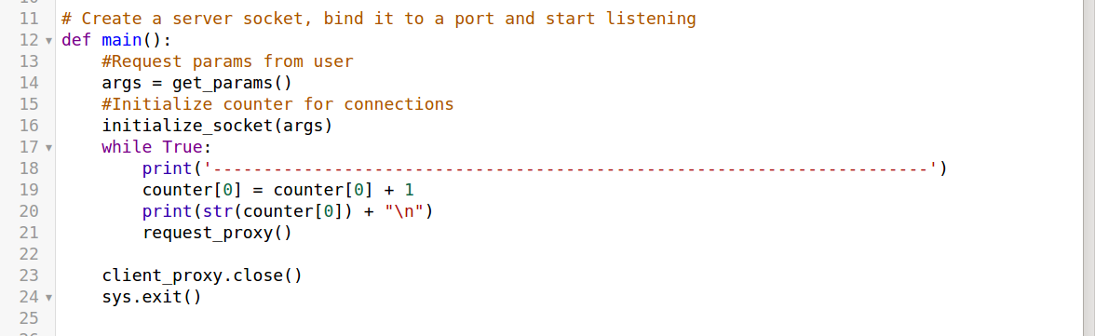

This method simply asks the user for a port number.
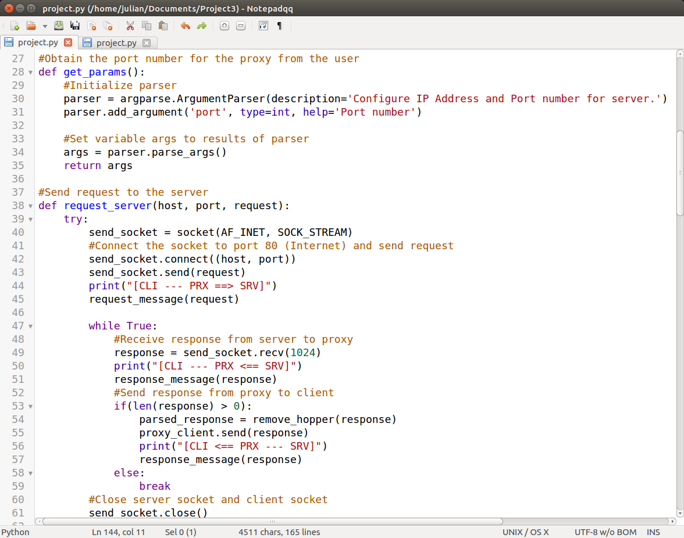

This method forwards the request from the proxy to the server. It also starts a while loop that receives the server’s response. Once the response is received by the proxy, the response is forwarded to the client

This method allows th proxy to receive requests from the client after the proxy accepts the client’s connection request. A new thread for the request_server method is created every time this method runs. This allow the machine to handle multiple requests simultaneously. Thus, speeding up rendering time
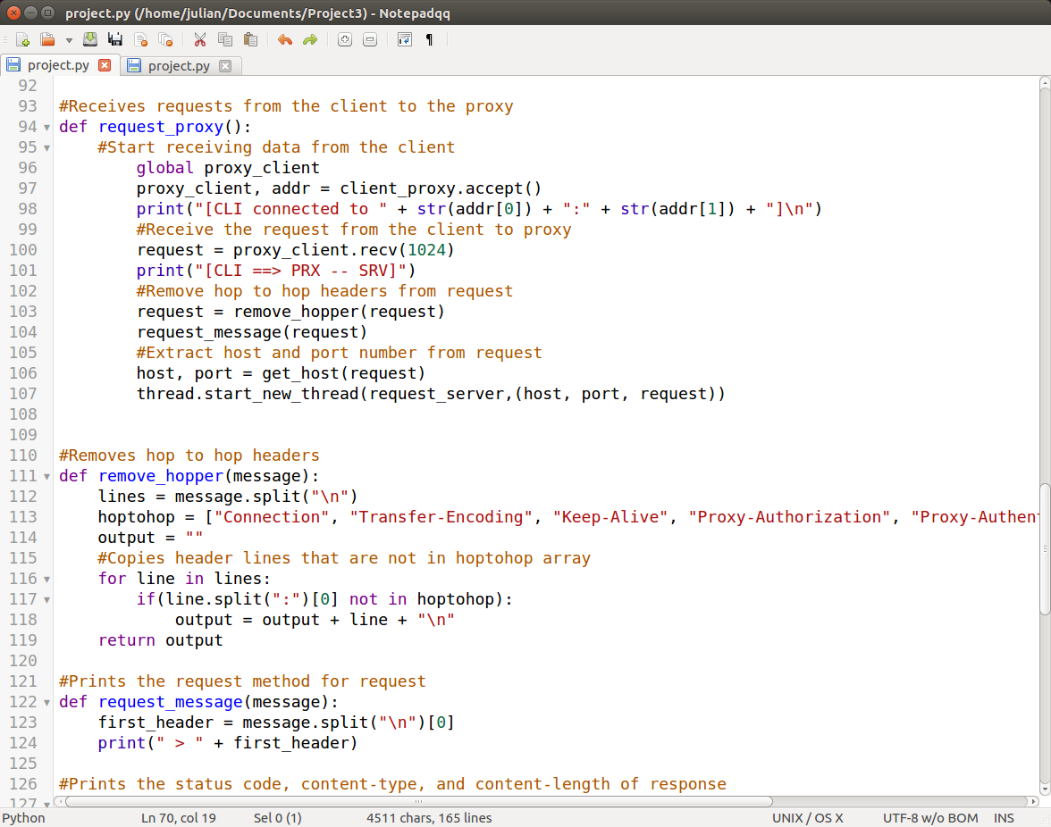

When transferring requests from client to proxy to server, “hop to hop” headers must be removed. This method accomplishes that task.

The request_message method parses an http request and prints out the first header of the message for logging.

The response_message parses the http response and prints out the status code, the content type, and the content length for logging.

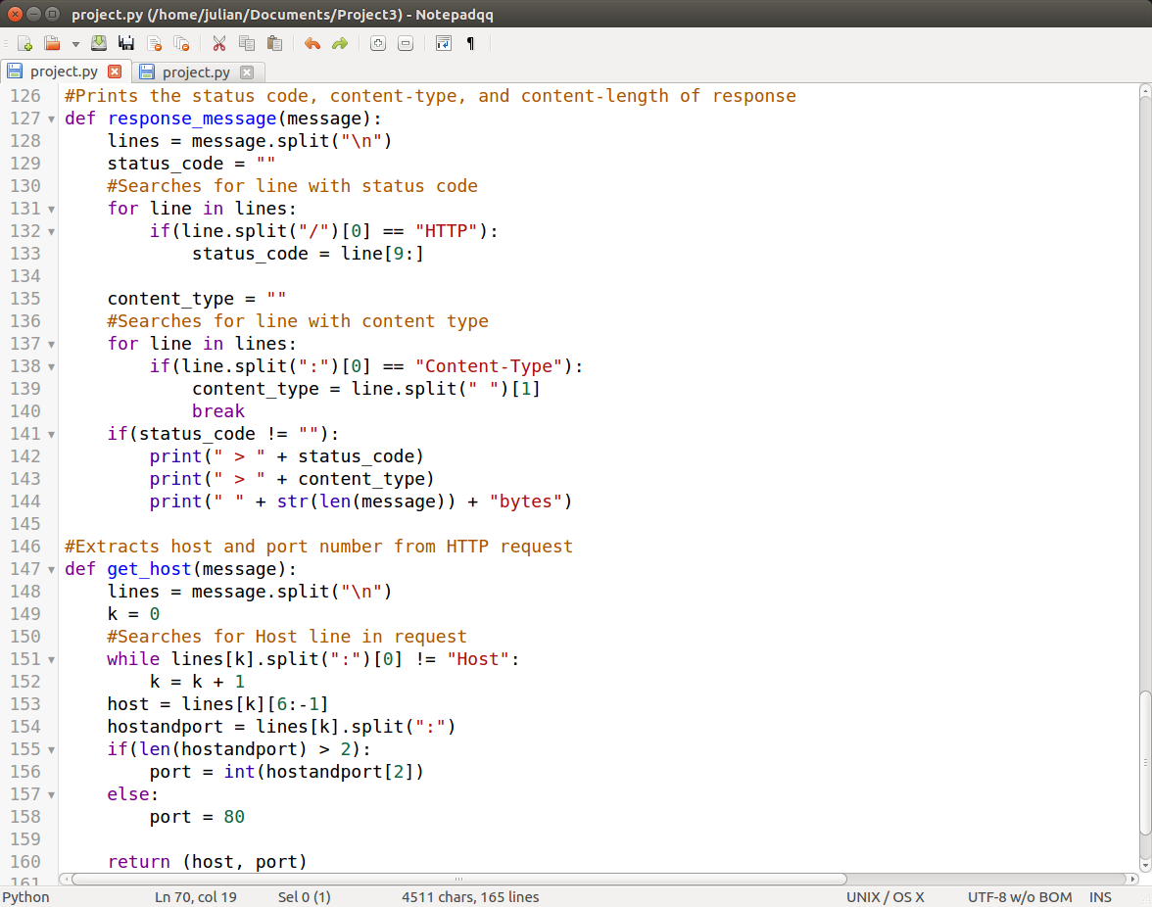

This is a convenient method that extracts the host and port number from a http request. The results of this method are used in the request_server method.

Flow Chart

Main
Initialize Proxy-client
socket
Client sends request to proxy
Proxy accepts

Threaded Action

Proxy sends request to server
Server accepts

Server sends response to proxy
Proxy forwards response to client

Proxy-client socket is closed
Proxy-server socket is closed

Examples

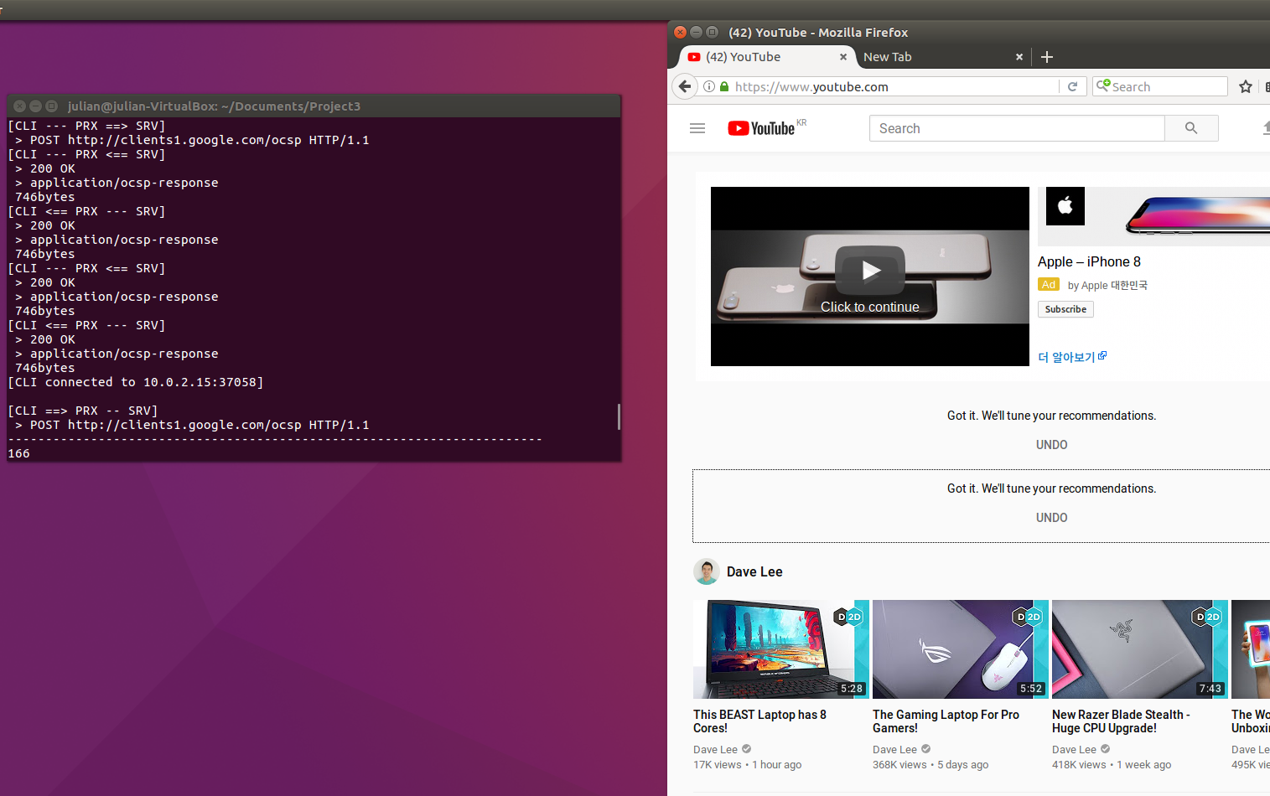
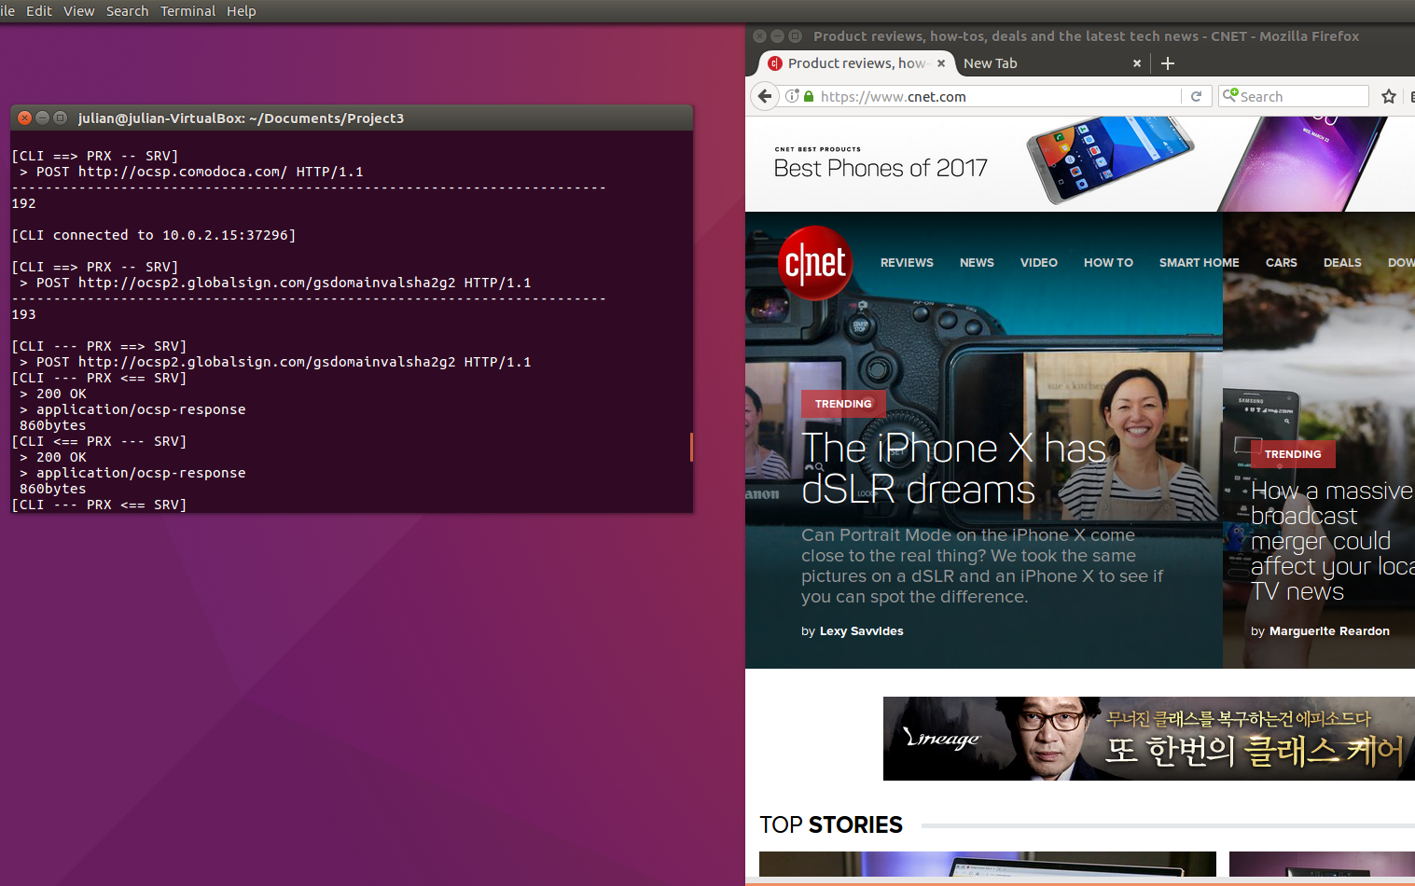
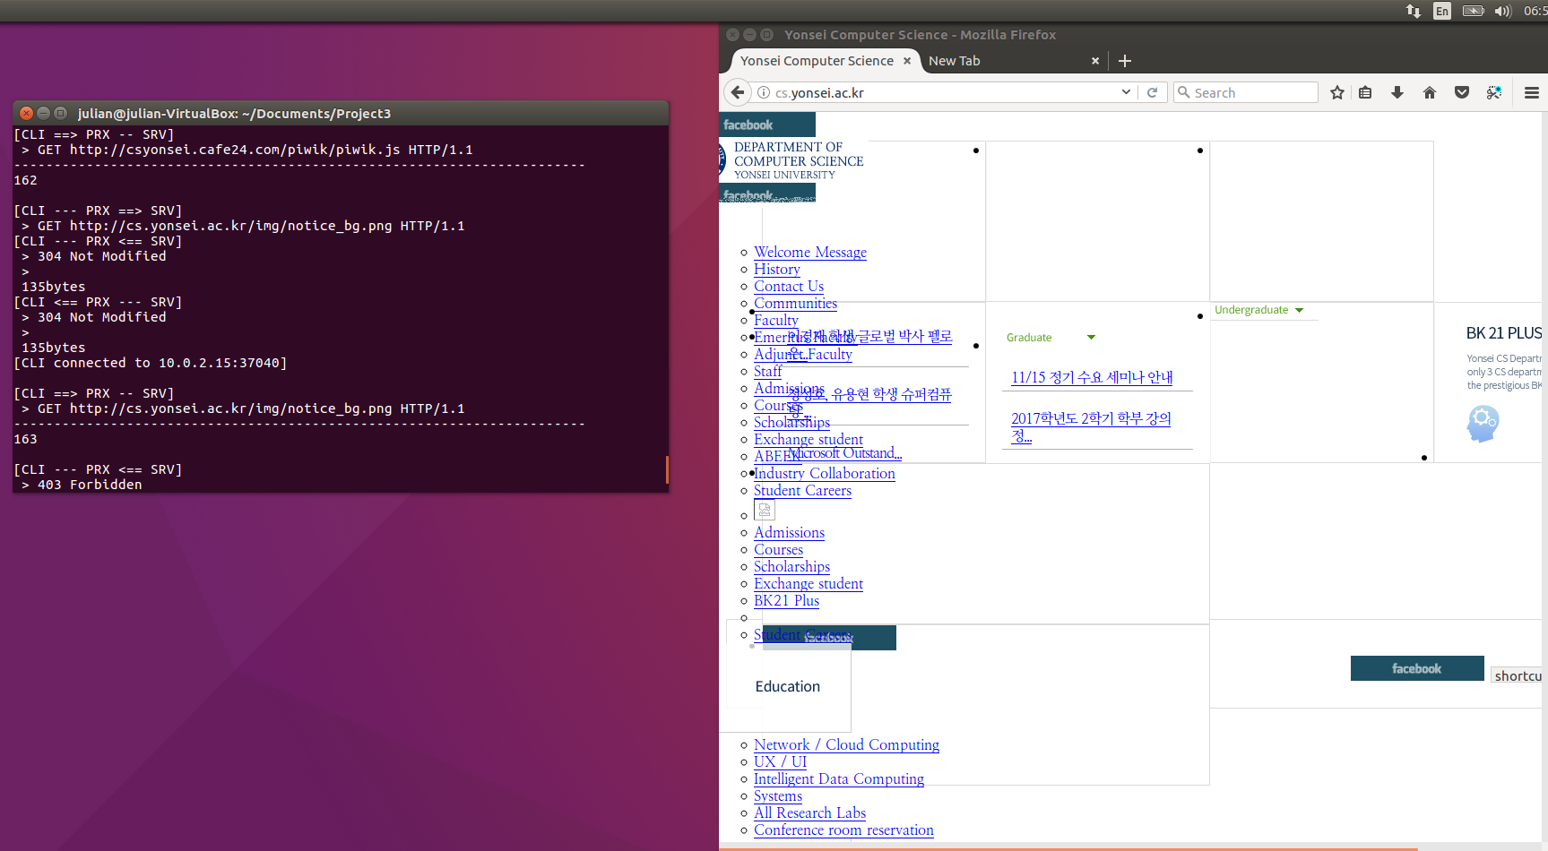
Reference:
https://media.pearsoncmg.com/intl/ge/2017/cws/ema_ge_kurose_compnetwork_7/cw/index.php
http://www.freesoft.org/CIE/RFC/2068/143.html
https://www.mnot.net/blog/2011/07/11/what_proxies_must_do
https://www.tutorialspoint.com/python/python_multithreading.htm
https://null-byte.wonderhowto.com/how-to/sploit-make-proxy-server-python-0161232/
https://stackoverflow.com/questions/3475251/split-a-string-by-a-delimiter-in-python
https://www.ntu.edu.sg/home/ehchua/programming/webprogramming/HTTP_Basics.html

