NUCLEO-F746ZG
CN12 HEADER

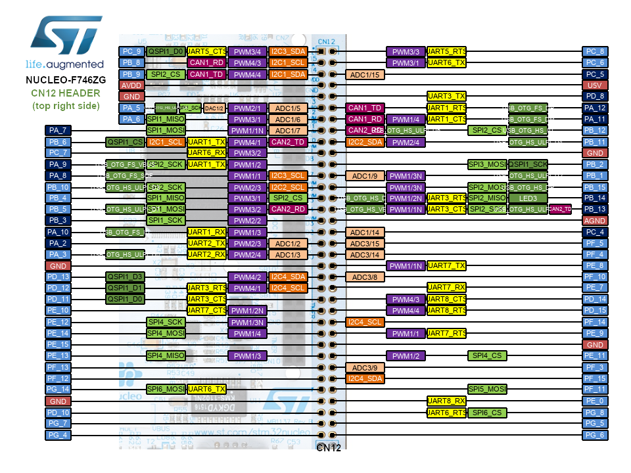
PWM_COIL1_U+ (TIM4-CH3)
PWM_COIL1_U- (TIM4-CH4)
ADC1_CH5_COIL1 (ADC1-CH5)
ADC2_CH5_COIL2 (ADC2-CH5)
PWM_COIL2_V- (TIM3-CH2)
PWM_COIL2_V+ (TIM3-CH1)
ADC3_CH14_COIL3 (ADC3-CH14)
PWM_COIL3_W+ (TIM2-CH3)
PWM_COIL3_W- (TIM2-CH4)

