Meanbee_SmartAddress

Version 1.0.1

Contents

Module Introduction 1

Installation 2

Modifying checkout/onepage.phtml 2

Modifying checkout/onepage/billing.phtml and Shipping.phtml 2

How To Use 3

UK 3

US 4

International 5

Administration configuration 6

License Options 6

Professional Installation 6

About Meanbee 6

# Module Introduction

Meanbee_SmartAddress offers UK, US and International Magento store owners the ability to enable customers to have their address auto-completed on the checkout page for their shipping and billing addresses.

Auto-completing the address for customers, store owners can:

* Speed up checkouts
* Reduce customer effort
* Improve delivery accuracy
* Increase conversation rate.

Information about Meanbee_SmartAddress, including purchase instructions and our other Magento modules, can be found at <http://www.meanbee.com/products>.

For more information contact Meanbee Internet Solutions at [support@meanbee.com](mailto:support@meanbee.com).

# Installation

**Note**: It’s advisable to have this module installed by a Magento Professional. Meanbee can offer this service. Please refer to the “Professional Installation” section for more details.

This section assumes that you have successfully purchased a license from Meanbee and have the archive file at hand.

The archive has folders in a specific structure. You simply need to extract the archive as it is, at the root of the Magento installation.

The archive places some important file changes into default/default of the frontend design directory. Assuming that you have a custom theme, you need to move these files to your theme directory.

* layout/postcode.xml
* template/checkout/onepage_postcode_updates.phtml
* template/checkout/onepage/billing_postcode_updates.phtml
* template/checkout/onepage/shipping_postcode_updates.phtml

These files need to be moved into your skin theme directory:

* css/meanbee/autocomplete.css
* images/meanbee-address-loader.gif

## Modifying checkout/onepage.phtml

We need to add the code in onepage_postcode_updates.phtml after the accordion and checkout declarations at the bottom of the file:

Optionally, you can adjust the default billing/shipping country by replacing ‘GB’ as appropriate with the 2 character country code in the following:

$('billing:country_id').value = 'GB';

billingRegionUpdater.update();

$('shipping:country_id').value = 'GB';

shippingRegionUpdater.update();

## Modifying checkout/onepage/billing.phtml and Shipping.phtml

If you have the default theme, you can copy the billing_postcode_update.phtml and shipping_postcode_update.phtml over the top of billing.phtml and shipping.phtml respectively.

If, however, you have a custom theme, we recommend the Professional Installation Service. For more information, please get in touch.

In terms of layout, we recommend the following order of items:

1. Country
2. Zipcode/Postcode (with button)
3. Select Address Box (normally hidden)
4. Street Auto-complete text box
5. Building Auto-complete text box

# How To Use

The input fields will change depending on the country selected. Try this, you will notice fields becoming visible/invisible.

## UK

If necessary, select United Kingdom as Country.

Enter postcode, click ‘Find Address’ button. A dropdown box will become visible to select building.

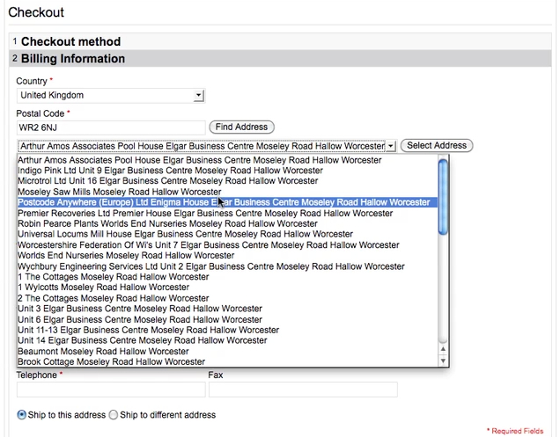

Once the *Select Address* button is clicked the fields in the form will be populated and the select box will be removed.

As you can see from the example, we decided to move the *Postal Code* and *Country* fields to the top of the address entry form to increase the usability of the system.

This uses one Postcode Anywhere credit per address selected.

## US

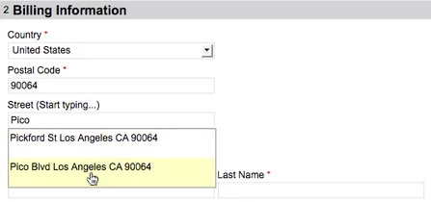For the US, once the zipcode has been entered, you can begin typing in the street text box. This conducts a wildcarded query on the Postcode Anywhere database in order to determine possible streets. A dropdown box appears where you can click on the correct street.

Then, we move on to the building auto complete box. Begin typing building name/number and a further wildcarded search produces a list of results to choose from. Once one of these has been selected, the rest of the form’s fields will automatically be filled in.

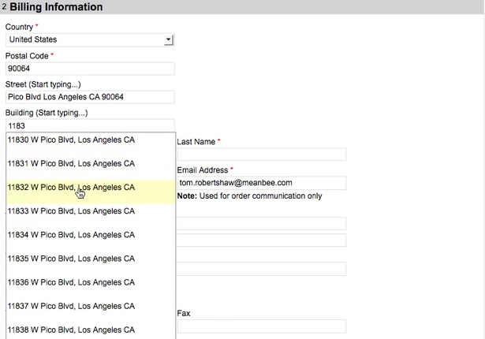

A USA lookup uses one Postcode Anywhere credit. This is charged once a building is selected.

## International

The International works in much the same way as US, however only goes to street level. The customer is then required to fill in their building on the first line of the address.

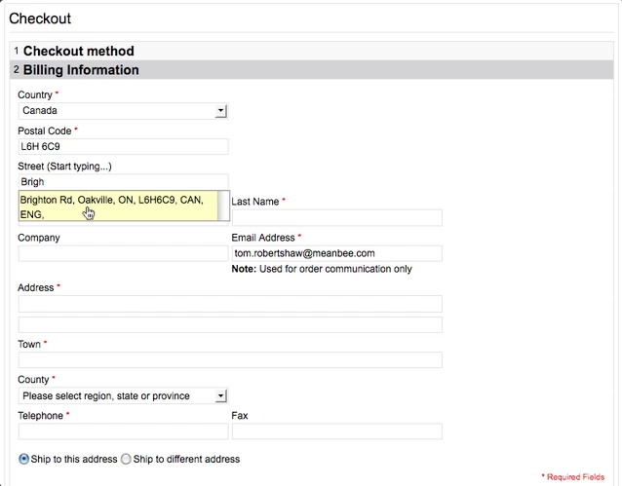

A credit is used every time the street auto complete box queries the Postcode Anywhere service. Each query is charged at 2 credits.

# Administration configuration

The configuration section for the module lives under the *Services* tab on the left hand side of the configuration screen called *Address Finder*.

You need to provide your *Account Code* and *License Code* from [postcodeanywhere.co.uk](http://www.postcodeanywhere.co.uk/partners/indiv52356.aspx) here, then save the configuration.

The *Security* option is an experimental feature which imposes referrer checks on the requesting script. This should be enabled in order to provide some minor security and it by no means fool proof.

# License Options

**Magento Partners** are eligible for a 10% discount on all license fees.

# Professional Installation

If you don’t have the expertise to install the Meanbee_SmartAddress module yourself then why not get the guys that made it to do it for you?

# About Meanbee

Meanbee Internet Solutions Limited are a small Web Design and Development company based in Bath, United Kingdom. Since the launch of Magento we’ve been Partners, supporting Magento every step of the way.

[www.meanbee.com](http://www.meanbee.com)