BLOG POST | SEO CONTENT
The Complete Guide to Polished Concrete Floors: Cost, Levels, Maintenance & Why Las Vegas Properties Are Making the Switch
Target Keywords: polished concrete floors, concrete polishing Las Vegas, polished concrete cost, polished concrete maintenance, polished concrete vs epoxy
Word Count: ~2,400 words | Read Time: 10 min | Author: ProShield Epoxy Team

If you manage a commercial property, run a warehouse, or are building out a retail space in Las Vegas, you have probably heard the buzz around polished concrete floors. What used to be considered an unfinished look reserved for industrial back-of-house areas has become one of the most sought-after flooring solutions in commercial and residential construction.
But here is what most articles will not tell you: not all polished concrete is the same. There are defined levels of polish, different classes of aggregate exposure, and two fundamentally different service types. Understanding these distinctions is the difference between getting the floor you actually want and ending up with an expensive mistake.
This guide breaks down everything you need to know about polished concrete in Las Vegas — from the mechanical process and finish levels to real-world costs, maintenance schedules, and how it stacks up against epoxy, VCT, and other flooring options.

What Is Polished Concrete, Exactly?
Polished concrete is not a coating. That distinction matters. Unlike epoxy, polyaspartic, or urethane systems that add material on top of the slab, concrete polishing is a mechanical refinement process. Diamond-impregnated tooling is used to progressively grind the concrete surface through finer and finer abrasive steps — similar to sanding wood — until the desired sheen and smoothness is achieved.
The process typically involves:
- Coarse grinding to flatten the slab, remove imperfections, and open the surface
- Densifier application — a chemical hardener (lithium silicate or sodium silicate) that reacts with calcium hydroxide in the concrete to create calcium silicate hydrate, making the surface harder and more resistant to wear
- Progressive diamond honing through increasingly fine grits (50, 100, 200, 400, 800, 1500, 3000)
- Optional guard or sealer to enhance stain resistance
- Burnishing for the final gloss level
The result is a floor that is part of the slab itself — not sitting on top of it. This means there is nothing to peel, delaminate, or chip off, which is why polished concrete routinely outlasts every other commercial flooring option.

Grind & Seal vs. Mechanically Polished: Know the Difference
One of the biggest sources of confusion in the industry is the difference between these two services. They look similar at first glance, but the process, durability, and long-term cost are very different.

Grind & Seal
The concrete is ground to a flat, consistent surface (typically only a few diamond steps), then a topical sealer — usually acrylic, polyurethane, or epoxy — is applied. The sheen comes from the sealer, not the concrete itself. It is more affordable upfront and works well for residential garages, basements, and light-traffic spaces. However, the sealer will wear and require reapplication every 2–5 years.

Mechanically Polished Concrete
The concrete is processed through the full multi-step diamond sequence, densified, and polished to a true mechanical sheen. The gloss comes from the concrete itself, not a topical film. This process is more labor-intensive and takes longer (this is not a one-day service), but the result lasts decades with minimal maintenance. It is the standard for retail, commercial, and institutional environments.
 | Grind & Seal | Mechanically Polished
Sheen Source | Topical sealer | The concrete itself
Durability | Sealer wears — recoat every 2–5 yrs | Decades with burnishing only
Typical Cost | $3–$5 / sq ft | $5–$8 / sq ft
Best For | Garages, basements, light traffic | Retail, warehouses, commercial
Timeline | 1–2 days | 3–7 days (varies by area)

Understanding the Four Polish Levels
The Concrete Polishing Association of America (CPAA) and CSDA define four levels of polish based on the final grit and gloss reading. This is a critical specification to understand when requesting quotes or writing project specs.
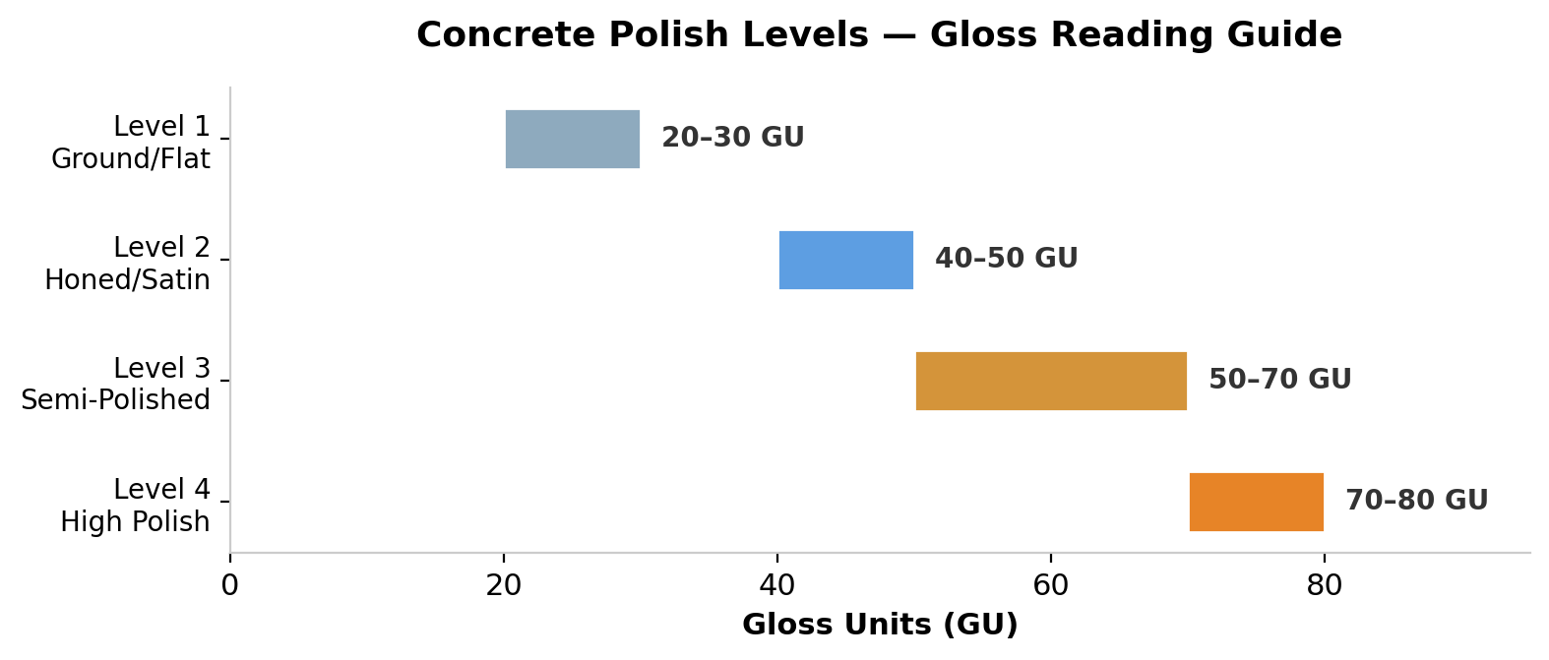
Figure 1: Concrete polish levels mapped to gloss unit (GU) readings
Level | Name | Grit Range | Gloss (GU) | Ideal Application
1 | Ground / Flat | < 100 | 20–30 | Industrial, back-of-house, utility areas
2 | Honed / Satin | 100–400 | 40–50 | Offices, warehouses, restaurants
3 | Semi-Polished | 400–800 | 50–70 | Retail, lobbies, mixed commercial
4 | High Polish / Mirror | 800–3,000 | 70–80+ | Showrooms, auto dealers, upscale spaces

Pro Tip: Level 2 (Honed/Satin) is the most popular choice for commercial spaces in Las Vegas. It balances aesthetics with practical maintenance and offers excellent light reflectivity — which can reduce artificial lighting costs in large facilities.

Aggregate Exposure Classes: The Design Variable Most People Miss
Polish level determines how shiny the floor is. Aggregate exposure class determines how it looks. These two specs together define the final aesthetic.
Class | Name | What You See | Best Aesthetic Match
A | Cream | Smooth cement paste, minimal aggregate | Modern, minimalist, uniform
B | Fine / Salt & Pepper | Fine sand particles visible | Contemporary, subtle texture
C | Medium Aggregate | Small to medium stone visible | Terrazzo-like, stone character
D | Large Aggregate | Large stone prominently exposed | Bold, natural stone statement

When specifying a polished concrete project, you should call out both: for example, "Level 3, Class B" gives you a semi-polished floor with a salt-and-pepper look. That specificity ensures you get what you are envisioning.

How Much Does Polished Concrete Cost?
Cost is the number one search query for polished concrete, and for good reason. Here is a realistic breakdown for the Las Vegas market:
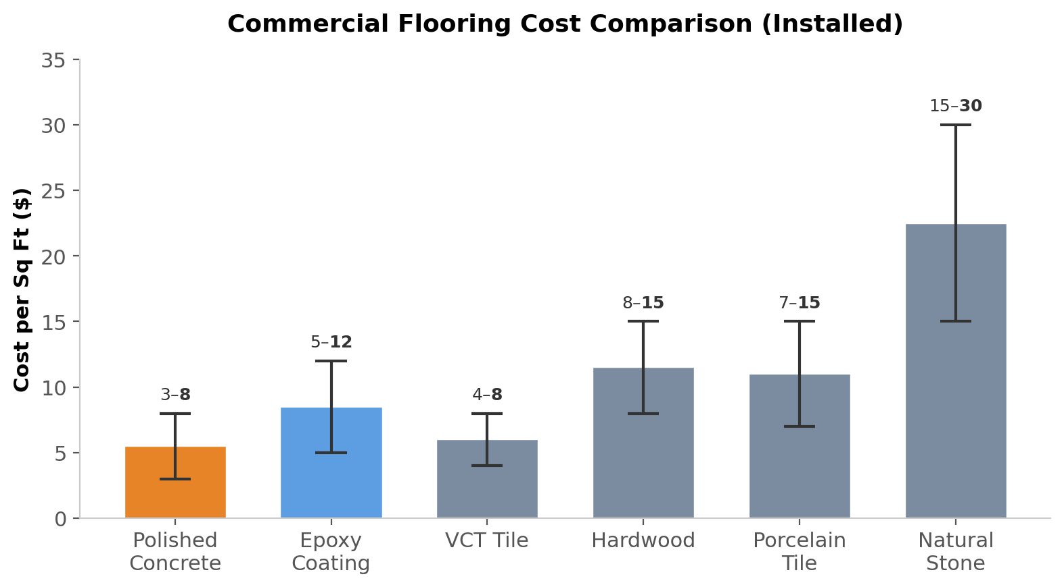
Figure 2: Installed cost per square foot across common commercial flooring types
- Grind & Seal: $3–$5 per sq ft
- Mechanically Polished (Level 1–2): $4–$6 per sq ft
- Mechanically Polished (Level 3–4): $6–$8+ per sq ft
- Decorative options (dye, scoring): Add $1–$3 per sq ft
Cost factors include: slab condition (cracks, coatings to remove, flatness), square footage (larger areas = lower per-sqft cost), polish level and aggregate exposure class, decorative enhancements, and access/scheduling constraints.

The Real ROI: Lifespan & Maintenance
This is where polished concrete pulls away from the competition. The upfront cost is competitive, but the long-term value is unmatched.
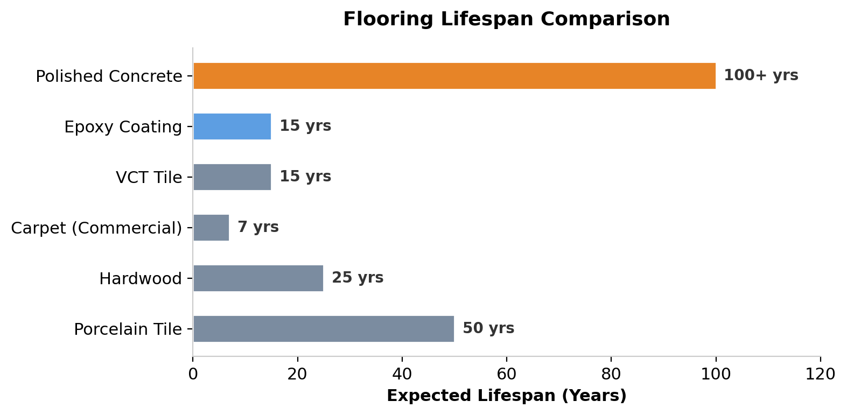
Figure 3: Expected lifespan comparison of common commercial flooring types
A mechanically polished concrete floor, properly maintained, can last the lifetime of the building itself. There is no coating to reapply, no wax to strip, and no tiles to replace.

Maintenance Schedule
- Daily: Dust mop or auto-scrub with a neutral pH cleaner
- Weekly: Damp mop or auto-scrub high-traffic zones
- Quarterly: Inspect for any staining, apply guard product if needed
- Annually: Professional burnish to restore gloss (for high-traffic commercial spaces)
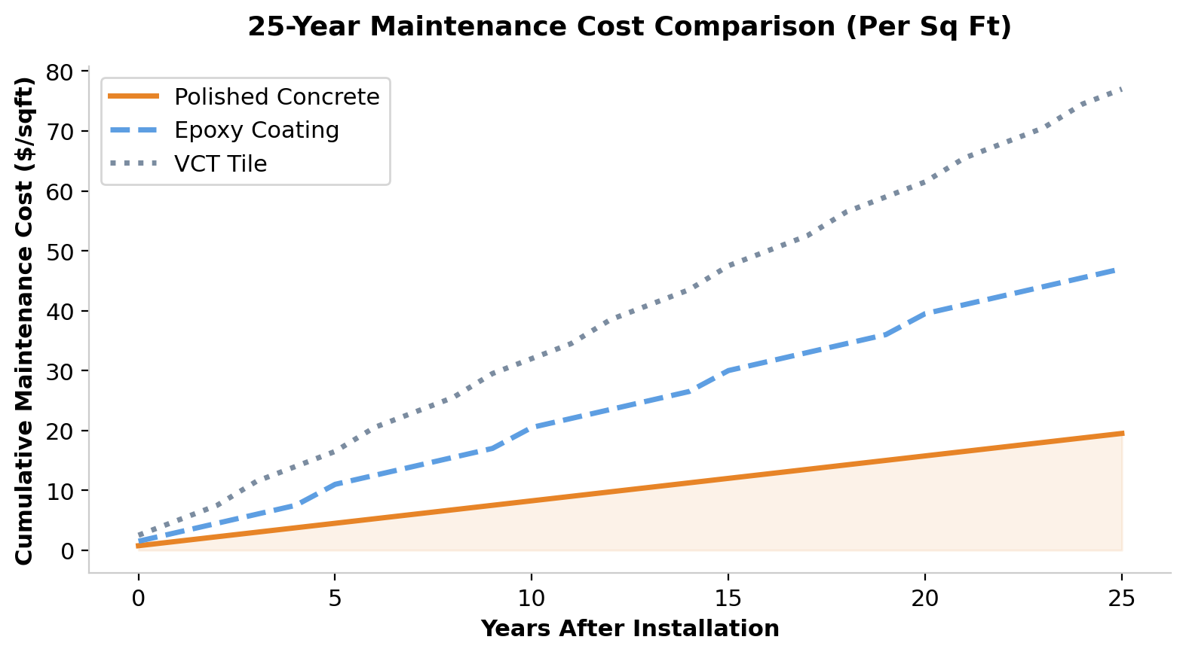
Figure 4: Cumulative maintenance cost per sq ft over 25 years
Over a 25-year period, polished concrete maintenance costs are typically 60–70% lower than VCT tile and 40–50% lower than epoxy coatings — primarily because there is no strip-and-recoat cycle.

Where Polished Concrete Works Best
Polished concrete is not the right answer for every space, but it excels in:
- Warehouses & Distribution Centers — Forklift-rated durability, reduced tire dust, improved light reflectivity
- Retail & Showrooms — High-gloss finishes that make products pop, low maintenance between customers
- Restaurants & Hospitality — Easy to clean, stain-resistant with proper guard, slip-resistant textures available
- Office Buildings — Professional look, reduced ambient noise with proper acoustic treatments
- Auto Dealerships — Mirror-finish Level 4 polish is the industry standard for showroom floors
- Residential (Garages, Living Areas) — Grind & seal or low-level polish for a clean, modern look

Why Las Vegas Properties Are Switching to Polished Concrete
Las Vegas presents unique conditions that make polished concrete an especially strong fit:
- Extreme Heat — Polished concrete stays cool underfoot compared to tile or dark coatings. No adhesive to soften or fail in 115°F+ garage temperatures.
- UV Exposure — Because the finish is the concrete itself (not a topical coating), there is no yellowing or UV degradation over time.
- Dust & Sand — The densification process hardens the surface and eliminates concrete dusting, which is a major issue in desert construction.
- Water Conservation — Maintenance requires minimal water compared to VCT or natural stone.
- Light Reflectivity — A Level 3–4 polish can increase ambient light by up to 30%, reducing energy costs in large commercial spaces.

Frequently Asked Questions

Is polished concrete slippery?
Polished concrete has a DCOF (Dynamic Coefficient of Friction) that meets or exceeds OSHA and ADA guidelines when properly processed. It is comparable to common commercial tile and actually performs better than most when wet because there is no glaze or topical film. For areas requiring extra traction, anti-slip guards can be applied.

Can you polish old or damaged concrete?
In most cases, yes. Existing coatings, paint, glue, or thin overlays can be removed during the grinding process. Cracks can be filled with color-matched epoxy. However, severely damaged, heaving, or structurally compromised slabs may not be candidates for polishing. A professional assessment is always recommended.

How long does the process take?
This is not a one-day service. A typical commercial polishing project takes 3–7 days depending on square footage, slab condition, desired polish level, and scheduling constraints. Larger facilities may be phased to keep portions operational.

Does polished concrete crack?
Concrete can develop hairline cracks due to settling, thermal movement, or subgrade issues — this is a property of the slab, not the polish. Polishing does not prevent or cause cracking. Any professional warranty should cover workmanship and the polishing process itself, not guarantee that the underlying slab will never move.

Is polished concrete eco-friendly?
It is one of the most sustainable flooring options available. You are refining an existing material rather than manufacturing and installing new product. There are no VOC emissions (unlike coatings), no adhesives, no replacement waste stream, and the reflective surface reduces lighting energy consumption. Many LEED projects specify polished concrete for these reasons.

How does it compare to epoxy?
Epoxy is a coating system applied on top of concrete. Polished concrete is the concrete itself, refined mechanically. Epoxy offers more color and design flexibility (flake systems, metallics, solid colors), while polished concrete offers superior longevity and lower lifetime maintenance cost. The right choice depends on the environment — a warehouse benefits from polished concrete; a residential garage may benefit from a flake epoxy system. They solve different problems.

Ready to Explore Polished Concrete for Your Property?
ProShield Epoxy serves the Las Vegas metro area with professional concrete polishing for commercial, industrial, and residential properties. Whether you need a Level 1 grind for a warehouse or a mirror-finish Level 4 for a showroom, we will walk you through the options and give you a straightforward quote.
Call (702) 728-5484 or visit ProShieldEpoxy.com to schedule a free on-site estimate.

