Project Handover
Anjali Jain | 2026-02-06

Files on the HPF
Main working directory:
/hpf/projects/ddissanayake/GRIID/Chantel_foldseek/foldseek_AJ
Main data sources:
- AFDB Cluster: https://afdb-cluster.steineggerlab.workers.dev/
- Uniprot: For ID mapping, annotation: https://www.uniprot.org/help/downloads
- Defense Finder: https://defensefinder.mdmlab.fr/wiki/refseq
Docs on data download: ./docs/documentation.nb.html
OneDrive Files: Located in Chantel’s OneDrive: Anjali

Workflow
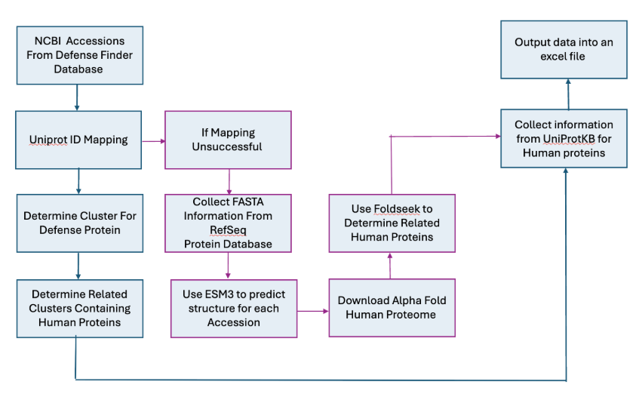
The results are ready for the workflow highlighted in blue; pink needs to be worked on

Step 1: Uniprot ID mapping
Scripts:
- scripts/00_get_unique_accessions.ipynb
- scripts/01_get_uniprot_accessions.py
- scripts/01_submit _get_uniprot_accessions.sh
- scripts/02_compare_sequences.py
- scripts/03_get_uniparc_ids.ipynb
Summary: README.docx
OneDrive Files: 01_RefSeq2Uniprot_mapping

Step 2: Query AFDB cluster files to find human matches and run foldseek
Scripts:
- 00_run_pipeline.sh
- 01_run_foldseek_pipeline.sh
- scripts/05_generate_slurm_file.py
- scripts/06_find_human_foldseek_matches.py
- scripts/07_run_foldseek.py
- scripts/07_submit_run_foldseek.py
Outputs:
- results/acc_batch_{num}/{date}_batch_{num}.no_annot.combined.csv
- results/acc_batch_{num}/{date}_batch_{num}.no_annot.combined.foldseek.csv
OneDrive Files:
- 01_RefSeq2Uniprot_mapping
- 02_FoldSeek_Results_w_Uniprot_matches

Step 3: Annotate results
Scripts:
- 02_run_annot_pipeline.sh
- scripts/08_add_annotations-optimized-new_metrics.py
- scripts/08_submit_add_annotations.sh
Results:
- results/acc_batch_{num}/{date}_batch_{num}_human_domain_annotated.xlsx
- results/acc_batch_{num}/{date}_batch_{num}_annotated.xlsx

Downstream analyses

GRIID genes:
Subset the foldseek output for matches with genes used in the GRIID study: README.docx. Note that only 12 batches were queried to generate these results.
Relevant HPF directory:
- ./priorities/griid_gene_list
OneDrive:
- GRIID_gene_list_matches

Generating results for Gasdermin, Zorya and Viperin defense systems
Relevant directories:
- ./priorities/viperin
- ./priorities/zorya
- ./priorities/gasdermin
OneDrive:
- Validated_bacterial_systems
- Zorya_System

