IEI-BISSH project
2026-10-16 gene list supplementary report
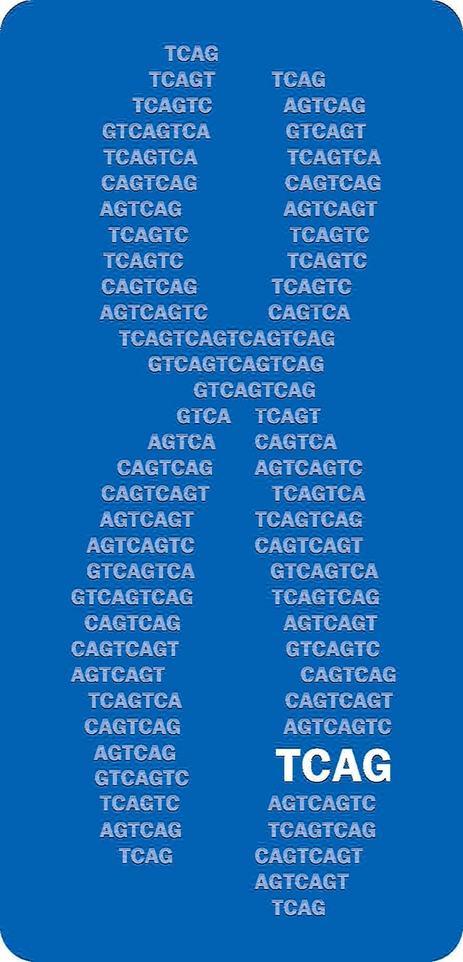

Julian Moran, Vinicius Furlan, Anjali Jain,
Chantel Trost, Christian Marshall, Steven Scherer

Data overview

The IEI-BISSH (IEI: inborn errors of immunity; BISSH: bacterial immune system structural homology) data associated with this report are stored in 2026-10-07_for_c_marshal.tsv. Each row gives a single bacterial-to-human protein pair, where the proteins in each pair exhibit structural homology. Bacterial proteins are drawn from the DefenseFinder dataset and therefore have a documented role in the immune systems of bacteria.
Our pipeline leverages the FoldSeek all-v-all structural similarity network to identify human proteins that have structural homology with DefenseFinder proteins. Pipeline hits may play a role in the human immune system, particularly antiviral response, and may be used as evidence in a larger clinical genomics discovery workflow.
These data were generated by The Centre for Applied Genomics (TCAG) in collaboration with the Centre for Computational Medicine (CCM) at the Hospital for Sick Children. Important columns are described below:
Column name | Column description
composite_score | Overall evidence score for structural homology out of 1.0. Incorporates the FoldSeek e-value, PyMOL-super root-mean-squared deviation (RMSD), TM-scores for each protein, and AlphaFold pLDDTs for each protein
defense_uniprot_ac | UniprotKB accession for the bacterial protein
human_uniprot_ac | UniprotKB accession for the human protein
human_gene_in_griid | Boolean value indicating whether the human protein maps to a gene on the Genetic Research in Inflammatory and immune Disorders (GRIID) gene panel
human_gene_in_IUIS | Boolean value indicating whether the human protein maps to a gene on the IUIS-IEI working group's 2025 gene panel
blastp_* | BLASTp pairwise alignment results for the bacterial and human protein sequences; these annotations give evidence for sequence homology

txt
txt

