Instructions

Create a new empty sandbox and perform a full cloud migration there. You can speed up the process by deleting the large tables (be sure to use a copy of the OnPrem database if you are doing this), since the main table that is needed is Tenant Media table.

Install the PTE MSFT_MSFT Move Tenant Media on both environments – the environment that was restored from backup and the PROD environment

Follow the instructions from here to setup the OAuth app with client ID:

[Using OAuth to Authenticate Business Central Web Services (OData and SOAP) - Business Central | Microsoft Learn](https://learn.microsoft.com/en-us/dynamics365/business-central/dev-itpro/webservices/authenticate-web-services-using-oauth)

Few screenshots from my tenant setup from the Portal.Azure.com:

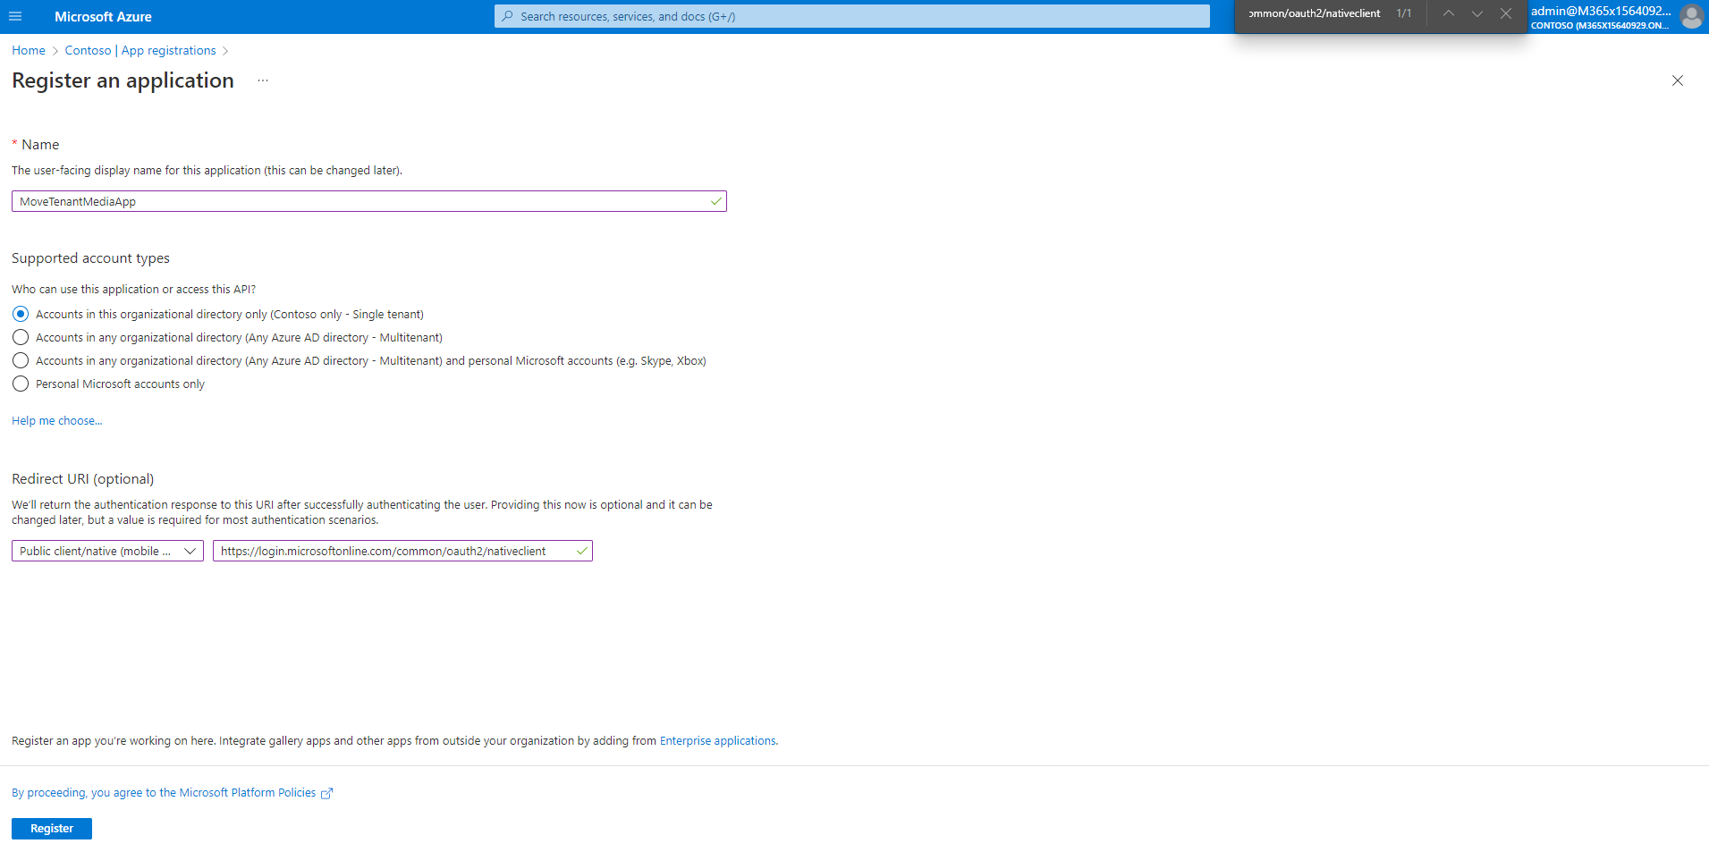

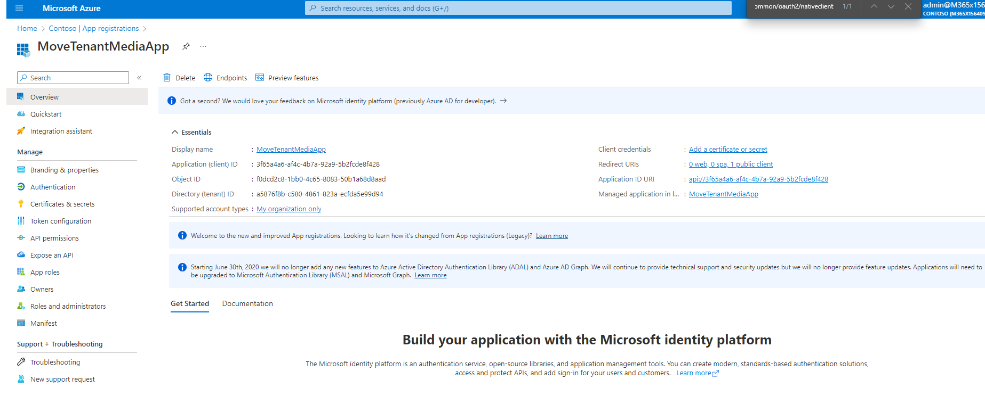

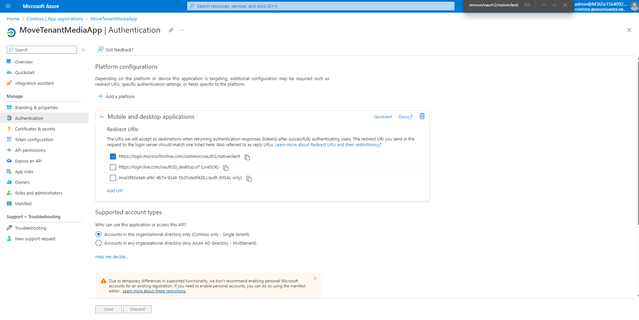

I have granted the admin consent on this page:

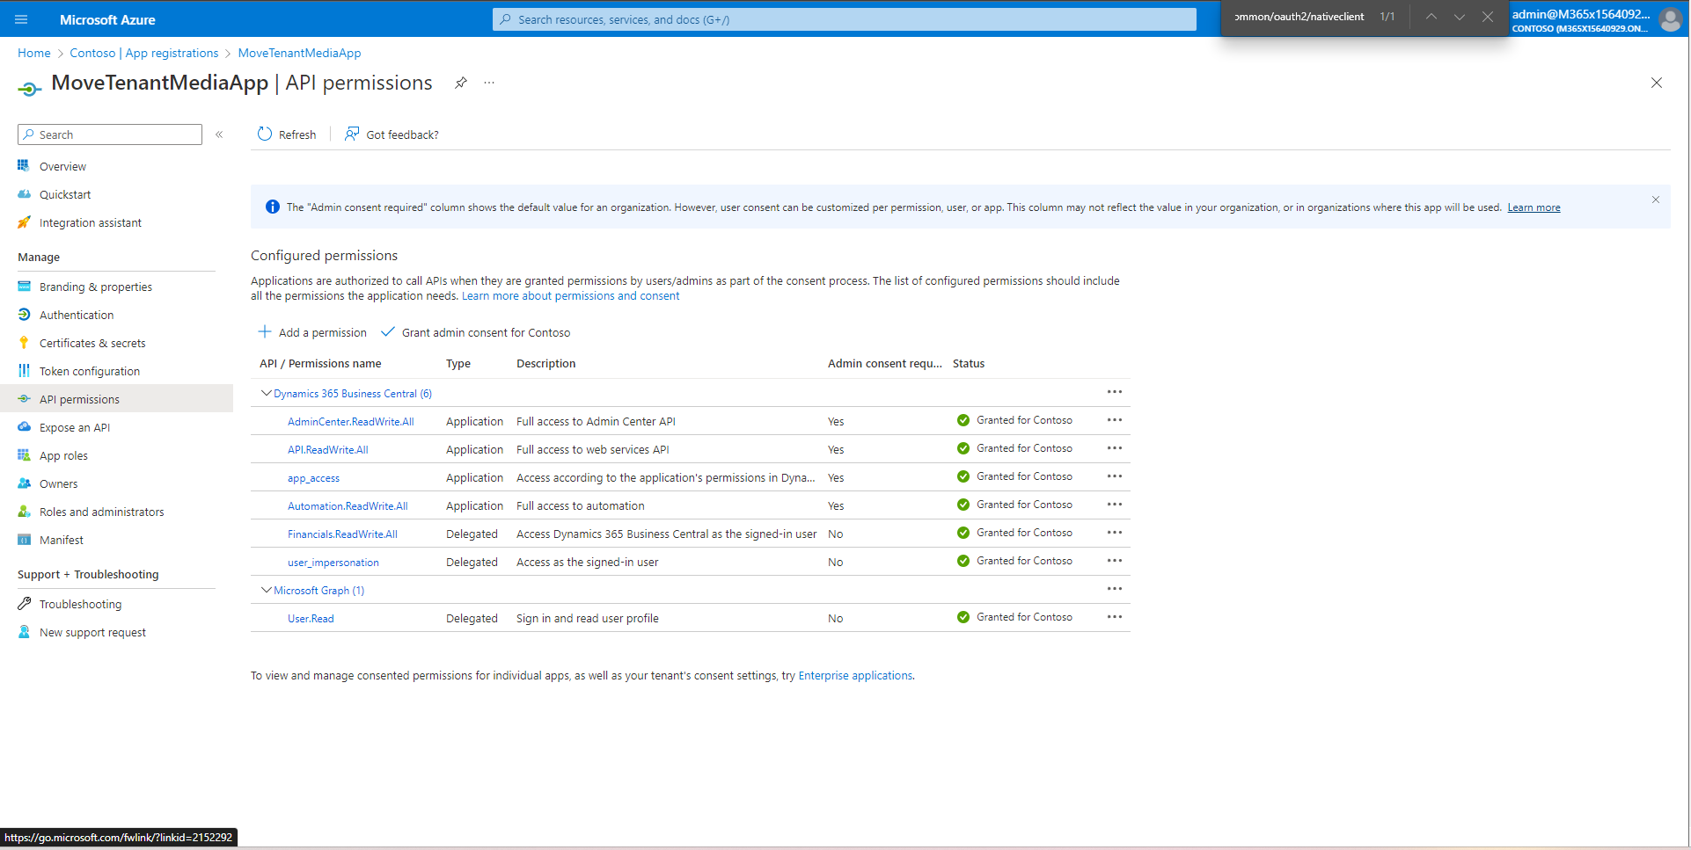

After configuring the AADApp open the PowerShell script

Update all values with provide values below with either the client URL or the values from the portal.azure.com. Be careful of the Source (Contains media) and Target (Media will be written to) environments, don’t mix these up



For the $script:SourceEnvironmentUlr and $script:TargetEnvironmentUlr you can get these values from Environment Card on the Admin Center. You should add **/api/MSFT/moveData/v1.0/companies** to the end of the link, there is the example in the comments.

Open the script in Powershell ISE, load it by running F5, then run the script by invoking Copy-TenantMedia function. If you are running the script for the first time, you need to install MSAL.PS with following commands:

Set-PSRepository PSGallery -InstallationPolicy Trusted

Install-Module MSAL.PS

Import-Module MSAL.PS

You can set a limit to e.g. 1000, by specifying $maxCount. You can run the two scripts in parallel by giving e.g. $maxCount 50000 to the first script and they can kick off a second script from the different machine by specifying $startIndex 50000. I would not recommend running more than 2 scripts in parallel.

You can create Sandbox as a copy of the Production environment to test the move first there before moving to the Production, the steps will be the same.