HAQ article framework

# Main document

## Introduction

* Amenable mortality defined as ...
* Thought to be a useful comparative measure of effectiveness and quality of healthcare
* Has been updated using GBD methodology and study data 2015
* International comparisons published [@ref]
* First time publication of English sub-national comparison
* Describes
  + Variation
  + Trends
  + Cross comparison with conventional method
  + Models variation with deprivation scores
  + Models variation with other metrics of local healthcare quality and performance

## Methods

* Calculation of HAQ described elsewhere
* In brief (to flesh out):
  + Identifies causes of death using Nolte and McKee list [@ref]
  + Recodes using 'garbage code' methodology
  + Risk adjusts
  + Calculates PCA
  + Constructs index using first 3 componenets
  + Scales index to 0-100
  + Compares index for each country against SDI using frontier analysis
  + Estimates additional gain/loss in index given countries level of socio-economic deprivation
* Obtain pre-calculated HAQ values for each UTLA from GBD
* Calculate summary metrics (tabulate)
* Plot variation and trends per LA via line charts and maps
* Obtain other metrics of healthcare performance and quality ? what
  + ONS area amenable and avoidable mortality rates (model/ correlation)
  + ?? Healthcare spend - ?is this available by LA - ? or estimation from CCGs
  + ?? SHMI - at provider level but map to LA?
  + Other??
* Simple regression model vs UTLA deprivation score and calculate predicted HAQ

## Results

* Tabular summaries
* Maps and charts
* ? Statistical analysis on trends
* Comparison with amenable mortality from ONS
* Context of other metrics
* Model vs deprivation (IMD)
* Estimates of potential improvement

## Discussion

* Novel method
* Literature about vailidty of amenable mortality as a measure of healthcare performance and quality
* What does this add?
* Paucity of indicators of population healthcare quality
* Potential as a monitoring tool?
* Other ideas?

## Conclusions

# Abstract

## Introduction

## Methods

## Loading required package: RISmed

## Your query is GBD[All Fields] AND 2000[PDAT] : 2017[PDAT]. This returns 723 abstracts. By default 1000 abstracts are downloaded. To retrieve more set 'n =' argument to the desired value

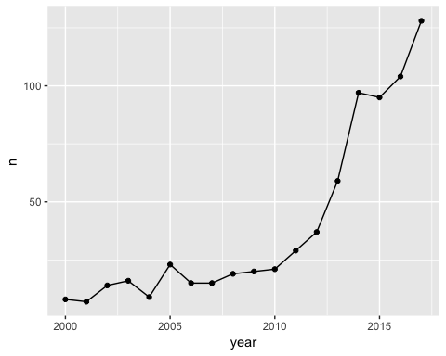

## Results

## Discussion

## Conclusions