Exercise

Analysis of Global Burden of Disease (GBD) data for Saudi Arabia

Julian Flowers

2024-04-21

Table of Contents

## Introduction

In this exercise we will use data from the Global Burden of disease to explore trends in exposures and health outcomes in Saudi Arabia

In this exercise we will be using R and Tableau Public online to analyse and visualise the data. The source data is available [here](https://github.com/julianflowers/spha/blob/main/IHME-GBD_2019_DATA-8eea0314-1.csv).

## Get started

First we need to load the R packages for analysis.

needs(tidyverse)

Now we load the data.

## Get the data

The code segment below shows how data is loaded.

gbd <- read_csv("https://github.com/julianflowers/spha/blob/main/IHME-GBD_2019_DATA-a5616352-1.csv?raw=TRUE") |>  
 filter(str_detect(rei_name, "Tobacco|Alcohol|Air|Env|Occupational|Dietary|Low"))

## Exploring the data

There are numerous ways of exploring data in R. A first step is to review the variables in the dataset.

## Rows: 94,770  
## Columns: 18  
## $ measure_id <dbl> 1, 1, 1, 1, 1, 1, 1, 1, 1, 1, 1, 1, 1, 1, 1, 1, 1, 1, 1,…  
## $ measure_name <chr> "Deaths", "Deaths", "Deaths", "Deaths", "Deaths", "Death…  
## $ location_id <dbl> 1, 1, 1, 1, 1, 1, 1, 1, 1, 1, 1, 1, 1, 1, 1, 1, 1, 1, 1,…  
## $ location_name <chr> "Global", "Global", "Global", "Global", "Global", "Globa…  
## $ sex_id <dbl> 3, 3, 3, 3, 3, 3, 3, 3, 3, 3, 3, 3, 3, 3, 3, 3, 3, 3, 3,…  
## $ sex_name <chr> "Both", "Both", "Both", "Both", "Both", "Both", "Both", …  
## $ age_id <dbl> 22, 22, 22, 22, 22, 22, 22, 22, 22, 22, 22, 22, 22, 22, …  
## $ age_name <chr> "All ages", "All ages", "All ages", "All ages", "All age…  
## $ cause_id <dbl> 297, 297, 297, 297, 297, 297, 322, 322, 322, 322, 322, 3…  
## $ cause_name <chr> "Tuberculosis", "Tuberculosis", "Tuberculosis", "Tubercu…  
## $ rei_id <dbl> 98, 102, 98, 102, 98, 102, 85, 98, 102, 202, 85, 98, 102…  
## $ rei_name <chr> "Tobacco", "Alcohol use", "Tobacco", "Alcohol use", "Tob…  
## $ metric_id <dbl> 1, 1, 2, 2, 3, 3, 1, 1, 1, 1, 2, 2, 2, 2, 3, 3, 3, 3, 1,…  
## $ metric_name <chr> "Number", "Number", "Percent", "Percent", "Rate", "Rate"…  
## $ year <dbl> 1990, 1990, 1990, 1990, 1990, 1990, 1990, 1990, 1990, 19…  
## $ val <dbl> 3.094213e+05, 2.291413e+05, 1.741761e-01, 1.290618e-01, …  
## $ upper <dbl> 3.622769e+05, 2.995508e+05, 2.039474e-01, 1.666499e-01, …  
## $ lower <dbl> 2.565213e+05, 1.507260e+05, 1.448615e-01, 8.365103e-02, …

The dataset consists a series of metrics for Saudi Arabia from the GBD Compare dataset for age ,sex, cause (level 3) and risk factor (level 3) by year. The dataset has 94770 records. The available metrics are Deaths, DALYs (Disability-Adjusted Life Years). For this analysis we will focus on Disability Adjusted Life Years (DALYs) rate, which is a summary measure of population health.

The causes included are

| id | name |
| --- | --- |
| 1 | Tuberculosis |
| 2 | Lower respiratory infections |
| 3 | Otitis media |
| 4 | Upper respiratory infections |
| 5 | Meningitis |
| 6 | Cirrhosis and other chronic liver diseases |
| 7 | Parkinson’s disease |
| 8 | Pancreatitis |
| 9 | Other pharynx cancer |
| 10 | Pancreatic cancer |
| 11 | Kidney cancer |
| 12 | Leukemia |
| 13 | Bladder cancer |
| 14 | Environmental heat and cold exposure |
| 15 | Ischemic heart disease |
| 16 | Alzheimer’s disease and other dementias |
| 17 | Idiopathic epilepsy |
| 18 | Multiple sclerosis |
| 19 | Diarrheal diseases |
| 20 | Lip and oral cavity cancer |
| 21 | Nasopharynx cancer |
| 22 | Alcohol use disorders |
| 23 | Rheumatoid arthritis |
| 24 | Esophageal cancer |
| 25 | Mesothelioma |
| 26 | Neonatal disorders |
| 27 | Cervical cancer |
| 28 | Prostate cancer |
| 29 | Stomach cancer |
| 30 | Road injuries |
| 31 | Lower extremity peripheral arterial disease |
| 32 | Falls |
| 33 | Diabetes mellitus |
| 34 | Larynx cancer |
| 35 | Colon and rectum cancer |
| 36 | Stroke |
| 37 | Rheumatic heart disease |
| 38 | Endocarditis |
| 39 | Chronic obstructive pulmonary disease |
| 40 | Encephalitis |
| 41 | Fire, heat, and hot substances |
| 42 | Poisonings |
| 43 | Animal contact |
| 44 | Upper digestive system diseases |
| 45 | Ovarian cancer |
| 46 | Aortic aneurysm |
| 47 | Exposure to forces of nature |
| 48 | Breast cancer |
| 49 | Self-harm |
| 50 | Atrial fibrillation and flutter |
| 51 | Other transport injuries |
| 52 | Other cardiovascular and circulatory diseases |
| 53 | Foreign body |
| 54 | Drowning |
| 55 | Chronic kidney disease |
| 56 | Exposure to mechanical forces |
| 57 | Asthma |
| 58 | Gallbladder and biliary diseases |
| 59 | Interpersonal violence |
| 60 | Other unintentional injuries (internal) |
| 61 | Hypertensive heart disease |
| 62 | Liver cancer |
| 63 | Cardiomyopathy and myocarditis |
| 64 | Sudden infant death syndrome |
| 65 | Non-rheumatic valvular heart disease |
| 66 | Pneumoconiosis |
| 67 | Tracheal, bronchus, and lung cancer |
| 68 | Blindness and vision loss |
| 69 | Idiopathic developmental intellectual disability |
| 70 | Low back pain |
| 71 | Age-related and other hearing loss |

.

The risk factors (exposures) included are

| id | name |
| --- | --- |
| 1 | Tobacco |
| 2 | Alcohol use |
| 3 | Air pollution |
| 4 | Environmental/occupational risks |
| 5 | Occupational risks |
| 6 | Dietary risks |
| 7 | Low physical activity |

.

The data is all age, persons values.

## 5 number summaries

We can create 5-number summaries of for each cause and exposure.

| cause_name | rei_name | age_name | sex_name | mean | 0% | 25% | 50% | 75% | 100% |
| --- | --- | --- | --- | --- | --- | --- | --- | --- | --- |
| Age-related and other hearing loss | Environmental/occupational risks | All ages | Both | 38.1 | 35.8 | 36.4 | 38.0 | 39.5 | 41.6 |
| Age-related and other hearing loss | Occupational risks | All ages | Both | 38.1 | 35.8 | 36.4 | 38.0 | 39.5 | 41.6 |
| Alcohol use disorders | Alcohol use | All ages | Both | 57.0 | 48.0 | 51.2 | 55.2 | 62.5 | 69.5 |
| Alzheimer’s disease and other dementias | Tobacco | All ages | Both | 10.9 | 10.6 | 10.6 | 10.7 | 10.8 | 12.3 |
| Animal contact | Alcohol use | All ages | Both | 0.0 | 0.0 | 0.0 | 0.0 | 0.0 | 0.0 |
| Animal contact | Environmental/occupational risks | All ages | Both | 0.2 | 0.1 | 0.2 | 0.2 | 0.3 | 0.4 |

## Visualisation

One way of presenting mutlidimensional data is to present each dimension separatly. In visualisation, this is known as **faceting**. This is shown in the code below.

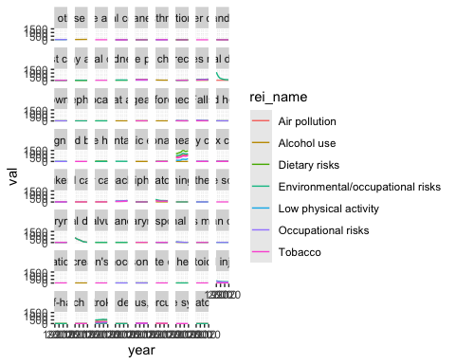

Qn: How can this chart be improved?

There are a number of problems with this initial visualsation.

* The different scales of the data masks trends in mamy of the cause.
* The cause names are too long

We can modify the scaling so each chart is scaled separately as below.

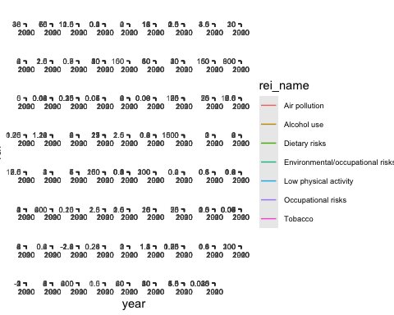

We can simplify further by filtering out causes where DALYs exceed a threshold - lets use DALYs > 50.

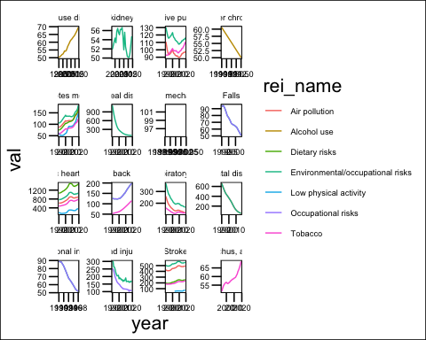

This provides greater clarity of trends in burden of disease by cause, stratified by underlying risk factors.

Qn:What trends do you see?

## Risk factors

Rather than stratifying by risk, we can plot risk stratified by disease. This only requires a minor change in the code.

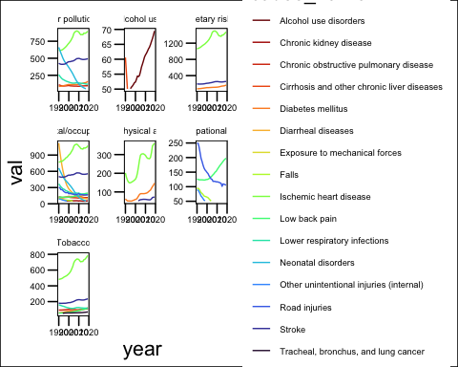

This is a more complex picture but highlights the pattern of attributable risk of exposures. For example, a growing contribution of air pollution to ischaemic heart disease.

Qn: What other trends emerge?

## Further improvements

One disadvantage of scaling each cause separately is that we cannot generate inter-cause comparison.

Qn: Why might this be useful? How might it be achieved?

## Advanced

