Tiny forest project plan

Julian Flowers SID: 2050507

8/23/04

Table of contents

## Introduction

### Biodiversity in UK

* Britain has been described as one of the most nature depleted countries(“Why We Need Green Spaces in Cities,” n.d.)
* Climate change
* Air quality
* Urbanisation

### Urban restoration and nature-based solutions

* Urban restoration / nature based solutions

### Tiny forests

* Tiny forest definition
* Tiny forest philosophy

### Tiny forest development in UK

### Putative TF impacts

## Hypotheses

1. Can TF growth be detected using satellite imagery?
2. Can TFs be classified e.g. urban/rural, landcover, age, location?
3. What is the impact of TFs on biodiversity?
4. ? Impact of TFs on pollution
5. Other outcomes?

## Proposed methods

### Literature review

* Search strategy
  + Urban forest / tiny forest
  + Biodiversity
  + Climate change / carbon
* Search
  + Pubmed
  + Semantic scholar
  + WoS
  + Grey literature
* PICO

### Design

Before and after control impact (BACI) design (Christie et al. 2019)

* Time series
* Control groups
* Summary measures of diversity (as dependent variable?)
  + Richness
  + Diversity
  + Communities (permutations)
* Modelling with mixed-models (GLMMs)
* Issues
  + Data
  + Biases in occurrence data
  + Small size of TFs

|  |
| --- |
| Figure (Christie et al. 2019) |

### Analysis plan

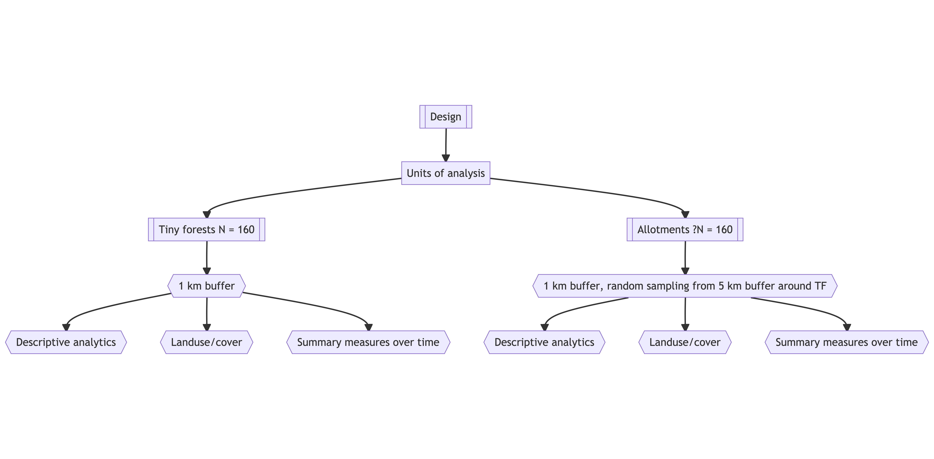

### Data

* TF data
  + From TF website
    - Planting dates
    - Location
    - Tree mix
    - Size
    - Who is involved
  + Citizen science data
    - Insects / butterflies / pollinators
    - Tree tagging / tree density
    - Soil health
    - Flood risk
    - Carbon
* Spatial data from Google Earth Engine
  + Sentintel2 satellite generates near real-time (NRT) multispectral images at 10m resolution
  + These can be used to generate vegetation indices e.g. NDVI, which can be tracked over time
  + Sentinel2 images have been modelled to generate Dynamic World - a 10m resolution NRT land-use dataset
* Control groups
  + I propose to use 2 control groups:
    - allotments (from OS Greenspace datasets) ? random sample from location (NB overlap)
* Biodiversity
  + Primary BD dataset will by NBN atlas occurrence data which is available by taxa, time and location
  + If necessary use
  + Earth Watch has provided examples of citizen science data collected for a number of existing

### Analytical methods

#### Descriptive analysis

* Characteristics of TF areas
* Summary of biodiversity
* Trends

#### Biodiversity

* Species richness and diversity estimates by area and time in study and control groups

### Modelling

TBD

## Project plan

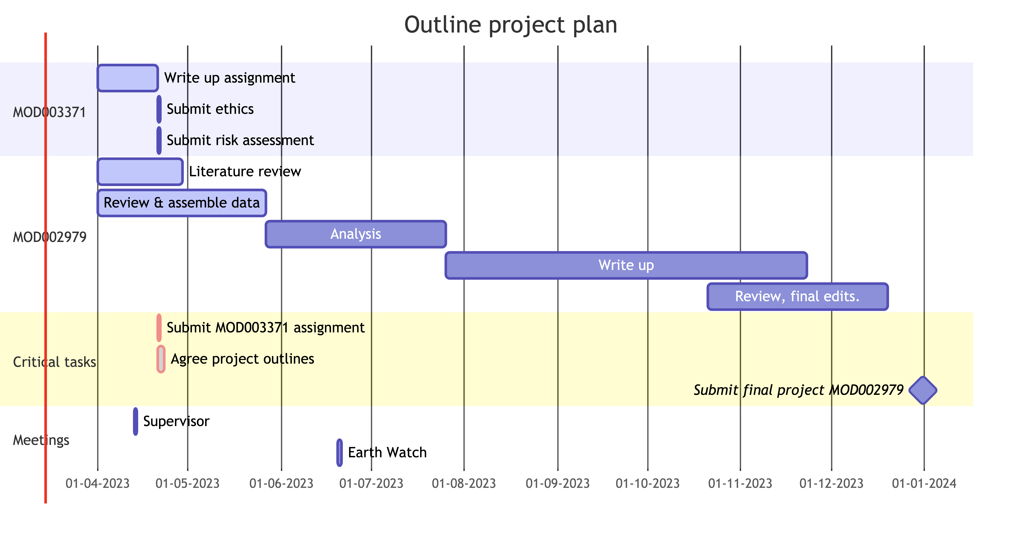

## References

Christie, Alec P., Tatsuya Amano, Philip A. Martin, Gorm E. Shackelford, Benno I. Simmons, and William J. Sutherland. 2019. “Simple Study Designs in Ecology Produce Inaccurate Estimates of Biodiversity Responses.” *Journal of Applied Ecology* 56 (12): 2742–54. <https://doi.org/10.1111/1365-2664.13499>.

“Why We Need Green Spaces in Cities.” n.d. <https://www.nhm.ac.uk/discover/why-we-need-green-spaces-in-cities.html>.