Submission for MOD005246

Assignment E010

SID: 205707

2021-10-31

# Popular science articles

## Build it … or not, and they will come

Discussion of open-ended vs ‘conventional’ species targeted conservation - old wine in new bottles?

Nature in Britain is in trouble. We have lost half our biodiversity over the last few hundred years according to recent analysis led by the [Natural History Museum](https://www.theguardian.com/p/j72x7), making Britain one of the most nature-depleted regions in Europe (see figure).

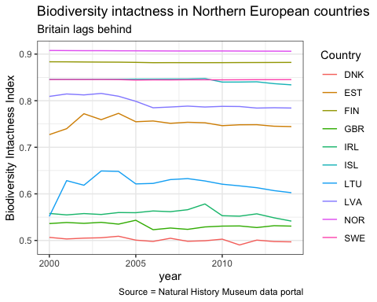

Using an indicator called the [Biodiversity Intactness Index (BII)](https://www.nhm.ac.uk/our-science/data/biodiversity-indicators/about-the-biodiversity-intactness-index.html) which calculates the percentage of species remaining and their frequency pre- and post- human impact in a given area, Britain is estimated to have only 50% of its pre-agrarian and industrial revolution biodiversity and continues a slow decline.

This loss is largely attributable to urbanisation and agricultural practices. The latter is nowhere more visible than in the Fens - a vast wetland in the East of England - where only about 0.2% of the original undrained fen exists. Over the centuries the Fens have been systematically drained for agricultural land, which has degraded as top soil and peat have been lost.

At Wicken Fen - a remnant of undrained fen in a sea of agricultural land - the impact is clear to see. The fen is some 2-3 metres higher than than the surrounding area and is a mixture of pasture, grassland and woodland which sustains enormous biodiversty - over 9000 species at last count.

The loss is attributed to change in farming practices

Wicken Fen and vision - oldest National Trust Minsmere - oldest RSPB Rewilding - Ken Hill Are they different sides of the same coin Divided by a common language

## Evidence based ecology

If the recent coronavirus pandemic has taught us anything it is that there is an unprecendented public interest in data and science in public life, as well as growing .