**Week 1: Introduction to QGIS**

During this session, you will learn how to use QGIS and explore a provided GIS project. You will get familiar with the spatial data files (shapefiles, rasters…) and the way the information is displayed in a GIS software. You will then learn how to add raw data into a new empty project and defines symbologies for each data layer.

**0. Install QGIS on your own computer**

Go to [www.qgis.org](http://www.qgis.org) and click on the Download Now button. The version used during this lecture is the Long Term Release version 3.16.9 LTR. Select the download file for the appropriate operating system on your computer (PC Windows, MacOS, Linux).

Note: the instructions are based on a MS Windows version of QGIS. There might be some variations.

**A. Download the dataset for this week’s practical**

1. On the canvas, go the Week 01 Practical page follow the link to the dataset. Save the zip file (don’t open it!) in an easy location to find.
2. Extract the archive: right-click on it and select “Extract here”. Delete the now unnecessary zip file to avoid any confusion.

**B. Explore the files and look at their extensions and sizes**

1. Look how the files are stored in different folders (Baa atoll and Whole archipelago). At the moment the number of files is low, but when you are doing GIS, you will create lots of files. It is therefore important to be organised and store your files by grouping them in different subfolders, as it will be easier to find them. It is also important to name them carefully, so you know which file has been generated by which step (avoid “test2”…).
2. Look at the size of the QGIS Project file (.qgz). What kind of information do you think this file contains? Raw data?
3. Explore the Baa atoll and Whole archipelago folders. Look at the different file names and extensions. Do you recognize some of them? Look at their sizes. Why do some have the same name and different extensions?

Here is a short description of the different datasets:

* BathymetryGrid: this data contains the bathymetry (depth of the sea) around the Maldives archipelago
* MaldivesMPA: this data locates the different marine protected areas (MPA) for the Maldives archipelago
* MeanSST1997: this data contains the mean sea surface temperature (SST) for 1997 around the Maldives archipelago
* Baa_image: this is a satellite image for the Baa atoll
* Baa_Reefs: this data contains all the coral reefs for the Baa atoll

**C. Open QGIS, the project document and explore the layers**

1. Open the start menu and find the QGIS Destop 3.16.9 application.
2. When QGIS is ready, go to Project>Open, browse to the folder containing the files for the practical and select the Maldives.qgz.
3. Look at the list of layers on the Layers box on the left-hand side of the screen (if you cannot see it, you can enable it in the View>Panels>Layers menu). Do you see any correspondence between these layers and the files (note: if you hover the cursor over the layer’s name, a bubble with the link to the raw file appears)? Look at the symbol left to the layer’s name; what does it indicate?

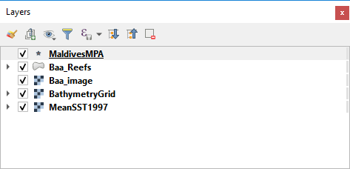

1. Untick all the layers and then tick them individually. What do you see in the main map view part of the screen?
2. Explore the Map navigation toolbar (if not visible, right click on an empty space and select it in the list; if not fully visible, drag it with the left handle somewhere else):



Select one layer in the Layers panel and click on the very useful Zoom to layer button (, also available when right-click on the layer name). Play also with the zoom history buttons ().

1. Explore each layer and try to figure out if it is a raster or a vector layer.
2. In the Layers Panel, drag some layers up and down and see the effect on the map view.

**D. Thematic maps: linking the Geography with the Information through the symbology**

1. Locate the attribute tool bar and use the identify feature button () to interrogate each layer: select the layer in the Layers Panel list and then click on one object (for vector layers) or one cell (for raster layers) to find the information associated with the feature. Try to do that for a raster and a vector layer. What is the main difference when interrogating these two types of data?



1. Zoom to the Baa_Reefs layer (you can also right-click on the layer name and select Zoom to Layer) and hide all other layers. Expend the layer legend (or symbology) by clicking on the little triangle in front of the layer tick box. What are the different colours of the polygons? What do they represent?
2. Open the attribute table for this layer (, also available when right-click on the layer name). This is all the information stored in the raw shapefile for this layer. How many objects (row) and how many attributes (columns) does this layer contain?
3. You can sort the table by attribute by clicking in the corresponding column header. Try to find which attribute is used to code for the colour (or symbology) for the layer.
4. Select one object (one row, also called feature) by clicking on the row number and have a look at the map view to see the selected object highlighted. If it’s not visible (sometimes it’s a very small portion of the reef), use the zoom to selection button ().
5. Open the properties of the Baa_Reefs layer (right-click>Properties or double-click on the layer name) and look at the Symbology tab. Note which column is selected to retrieve the information to colour the thematic map.

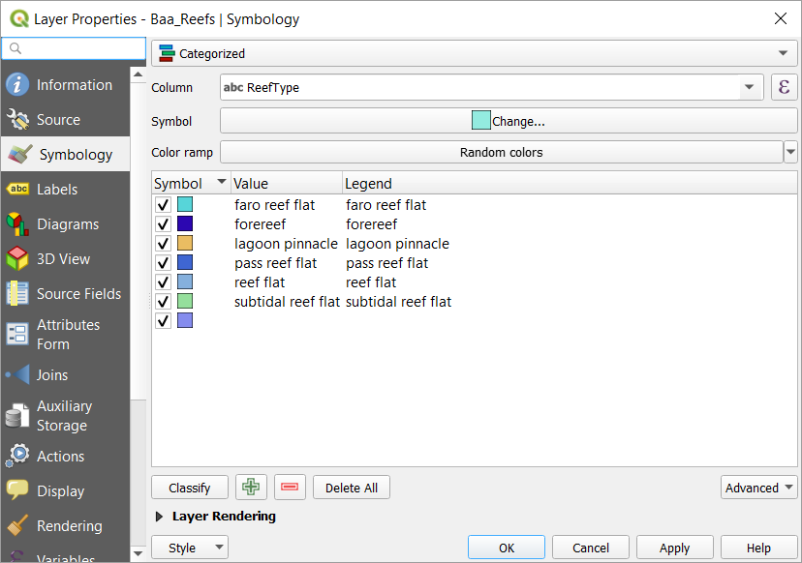

1. Change the Column field from Depth to Reef Type and click on the Classify button (click on Yes on the warning message). How many classes? Click on OK and have a look at the new thematic map for this layer.

You just changed the way information can be displayed on a map. The information is stored in the Baa_Reefs shapefile. It contains multiple attributes (including reef type and depth category). From this raw data file, you can create multiple thematic maps with different symbology, based on the different information stored in the file. The symbology choices are stored in the QGIS project document. Save the project () with your modified thematic layer.

**E. Add data to a project**

1. Create a new empty project ().
2. To add data into a QGIS project, there are three options:
   1. You can use the Browser panel to browse to your data files and double-click on them.
   2. You can drag a data file in QGIS (make sure you drag the .shp for a shapefile, the .tif for a raster, etc…) from the File explorer.
   3. You can use the Open Data Source Manager button (), browse to your data files and add them with the Add selected Layers button (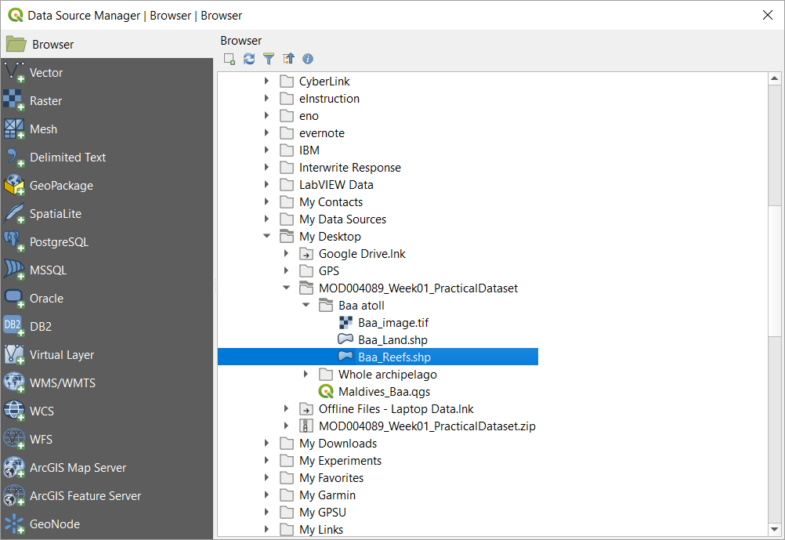).

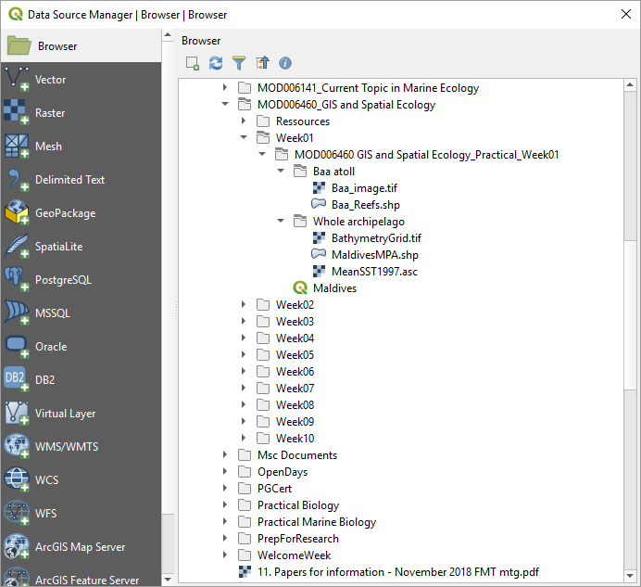

Practice these different options to add the same 5 layers as previously (MaldivesMPA, Baa_Reefs, Baa_image, BathymetryGrid and MeanSST1997).

The layers do not appear as in the Maldives.qgz project as there is no symbology defined (you started with an empty project). In the next section, you will create an appropriate symbology for each layer.

Drag the layers in the Layers panel up and down to decide which ones should be visible. A general rule is to put raster layers at the bottom and vector layers on top of them.

**F. Define the symbology for each layer**

Tip: Use colours that are easy to distinguish and intuitive to read (e.g. vegetation is green, water is blue, hot is red, cold is blue, deep is dark, shallow is light, etc…). Bear in mind colour blindness and how your colours might look if printed in greyscale when choosing colours.

1. You can start with one of the raster layers (BathymetryGrid or MeanSST1997). Right-click on the layer’s name and open its Properties. Go to the Symbology tab. Change the Render type to Singleband pseudocolor. Click on the down-arrow button next to the Color ramp and find a colour gradient that matches your data. You might have to use the Invert Color Ramp function for a better match. Once happy, click on OK. Repeat for the other raster layer (leave the Baa_image layer for now).

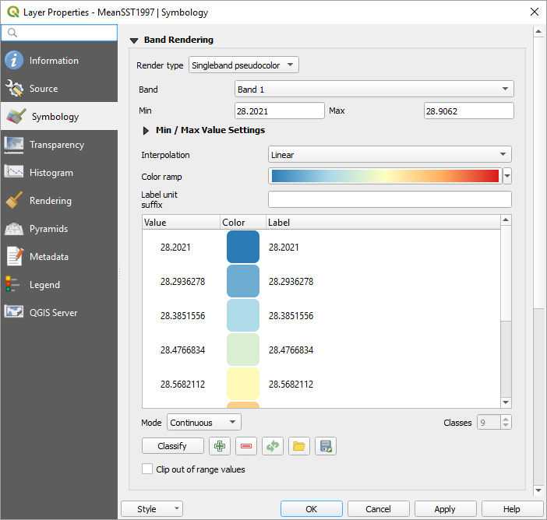

1. Open the attribute table of the MaldivesMPA layer (right-click Open Attribute Table or ) and explore its content. The information in this layer is pretty generic (except the name of the protected area) and we are not going to draw different symbols based on the content of the attribute table. Close the attribute table and open the layer Properties (right-click or double-click on the layer’s name). In the Symbology tab, keep the top option as Single symbol. You can then explore list of symbols to find one that you think is suitable.

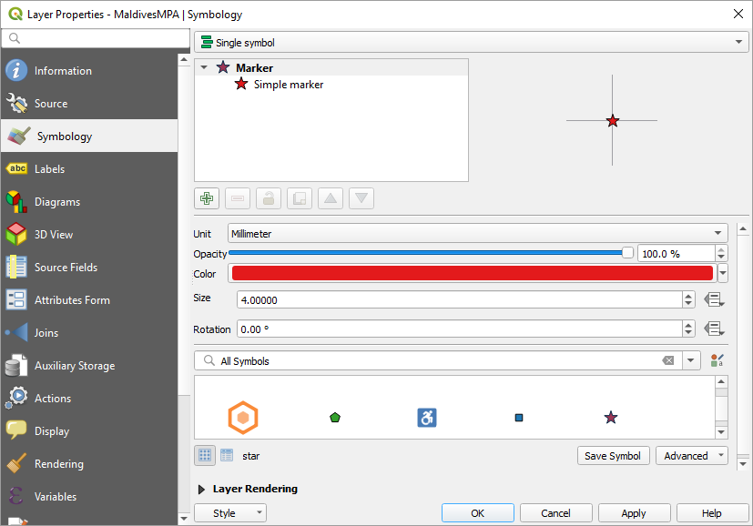

1. For the Baa_Reefs, try to recreate a symbology indicating the type of reef. Open its attribute table and check which column contains the data you need. Then open its Properties and under the Symbology tab, select Categorized. Under Columm, select the column from the attribute table that contain the information you want. Then click on the Classify button. You should have something like this:

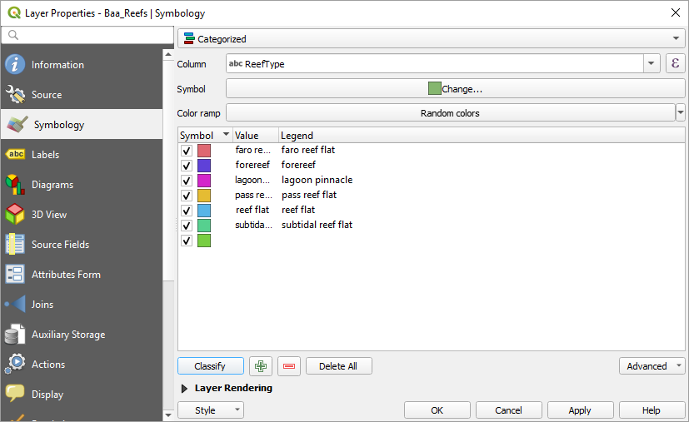

For each type of reef, you can double-click on its Symbol entry to change the colour, pattern, etc…

1. Finally, have a look at the Baa_image layer. Hide all the other layers and zoom to it (right-click Zoom to Layer). Use the Identify Features tool () to interrogate the value of its pixels. You should have 3 values (band 1, band 2 and band 3), which seems to contradict what you saw in the lecture about raster layers (each pixel contains a single value). This layer is a multiband satellite image (3 bands). We will explore these in more details in week 8 (Remote sensing). You can check the Properties > Symbology for this layer and you will see that it is based on a Mutliband color rendering, with each band being associated with a primary colour (red, green and blue).

Now that you defined the symbology for each layer, you can save your QGIS project (Project > Save) so your symbology is stored for future use.

This is the end of this first practical. You can go to Canvas and try to answer the quiz. Good luck!