**Week 3 Wednesday Workshop: Using GPS**

**IMPORTANT: For this exercise, you will need a smartphone (Android or iPhone) with localisation capabilities.**

**A. Design the task**

For this exercise you will use your smartphone to collect data using GPS (similar to Practical 3 for the MSc Applied Wildlife Conservation students). You will set up a map and then we will head to Mill Road cemetery to collect location data. Have a think of what you might want to plot the locations of, for example it could be a particular species of plant or Gordon Young’s seven bird sculptures (http://millroadcemetery.org.uk/art-in-the-cemetery/).

**B. Prepare a QGIS project**

1. Open QGIS with a blank project.
2. One of the powerful advantages of QGIS is that there is a large community of users and some of them are contributing to the software by creating a sharing plugins. To synchronise the data you will be collecting with your phone and your QGIS project, you will need a plugin called Mergin. In the Plugins menu, select Manage and Install plugins… In the search box, search for “Mergin”. Select it in the list and click on the Install Plugin button. Once the plugin is installed, you will have to restart QGIS.
3. To add some context to your project, you are going to download a basemap. This will be a raster layer representing some contextual data that will be downloaded from various sources as you zoom in and out and change the location of the map view. For that, you are going to install another plugin called QuickMapServices. Use the same procedure as before to install that plugin. Once installed, you should have a QuickMapServices entry in the Web menu. Open that menu and go to Google and select Google Satellite. Zoom in to Mill Road Cemetery (using the Google Road basemap might help you locate it if you’re having problems finding using the just the satellite layer).

You can also try to add an OSM basemap. In the QuickMapServices menu, click on OSM and investigate some of the OSM basemap options. Once ready, you can close the Search QMS panel.

1. You can now create an empty point vector layer that will be populated with the data you will be collected in the field. Click on the New Shapefile Layer button (). In the New Shapefile Layer window, under File name, click on the 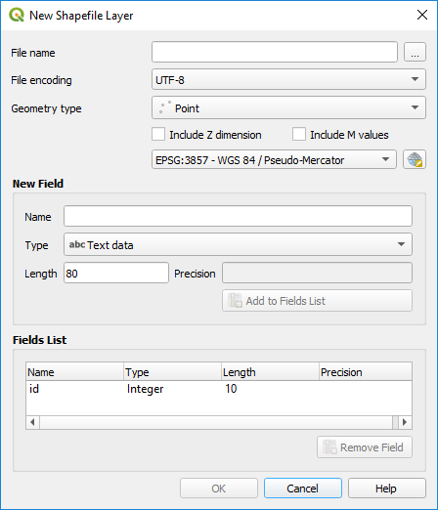 button and browse to a convenient location and, with the New folder button, create a new folder that represent your data (e.g. MillRoadCemetery) and within that folder, enter a filename that represents your data collection (e.g. BirdSculptures.shp). Under Geometry type, make sure Point is selected.

In the CRS menu (you should have EPSG: 4326 – WGS 84), click on the CRS selector button (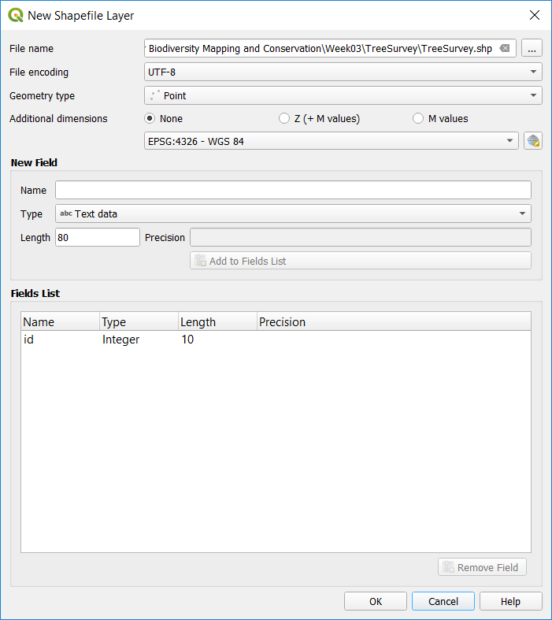) and in the Filter box, type “British National Grid”, you should have “OSGB 1936 / British National Grid EPSG: 27700” in the Predefined Coordinate Reference Systems list. Click on it, check the coverage of the CRS (the UK) and click on OK.

Create a new field for your nominal variable. Enter a Name and set the Type as Text data (e.g. Species); click on the Add to Fields List button. You should now have two fields in the Fields List: an id of type Integer and the field corresponding to the variable you will be collecting. Click on the OK button (if you have a message windows about Transformations, just click on OK).

1. Save your QGIS project in the same folder where you saved the point shapefile.

**C. Upload your project to Mergin**

1. To upload your project to your phone, you will need a Mergin account. In your Browser panel, you should have a Mergin entry (if the Browser panel is not visible, go to View > Panels and tick Browser Panel). Right-click on the Mergin entry and select Configure. On the login window, click on the Sign up now link to create a Mergin account. Once created, you can go back to QGIS and login using the credentials you just set.
2. Right-click on the My projects entry within Mergin and select Create new project. Click on Package current QGIS project (i.e. it’s using the QGIS project you’ve just created), keep the selected layers for the new project and click Next. Enter a meaningful name for the Mergin project. Click on OK.

**D. Collect the data with your phone**

1. On your smartphone go to the Google Play or App Store to install Input from Lutra Consulting. Once the app is installed on your phone, you can run it. You will have to sign in to your Mergin account. Under My projects, you should see the project you just created. Click on the download button (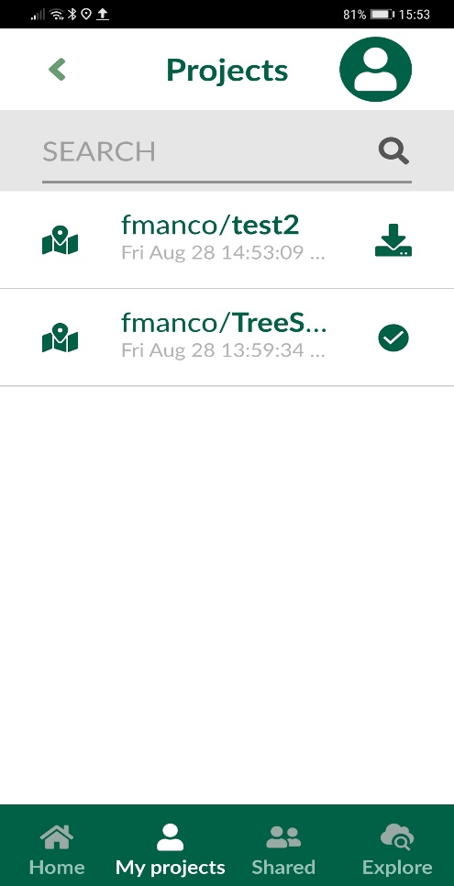) to add it into your phone.
2. Now you’re ready to go to Mill Road Cemetery and start recording location data.
3. Go to the Home screen and click on the project to open it. You can go to your location by clicking on the GPS button. To record a location, press the Record button. You can move the target to the exact location you want to record. Once happy, press the Add point button and then fill the fields with the Information. Click on Save when done.

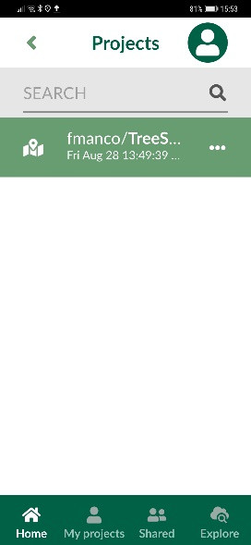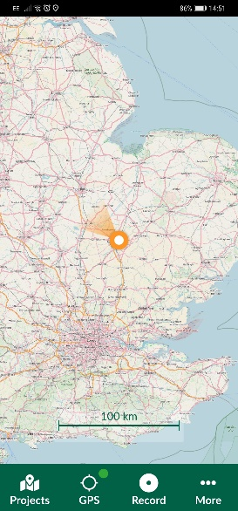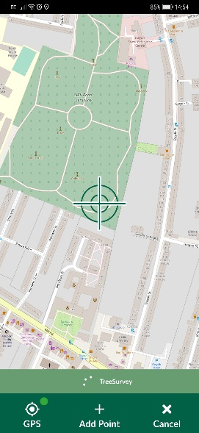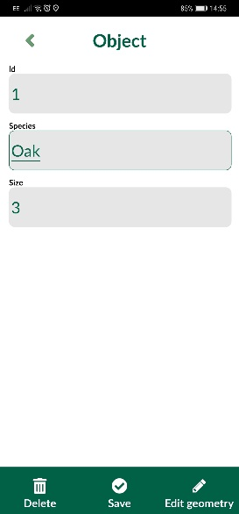

You can add more points until you have all the locations you need (e.g. there are 7 bird sculptures). Once finished, go to Projects, then to My projects and click on the synchronize button (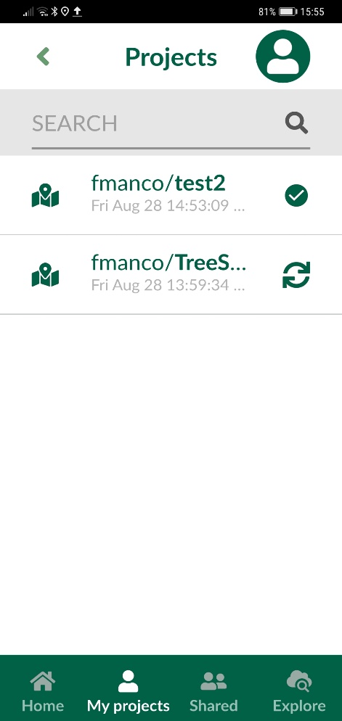).

**E. Synchronize your QGIS project.**

Back at your desk, in QGIS under Mergin > My projects, right-click click on your project and select Synchronize. Your map and the content of your point layer should now be updated with the data you collected in the field. You can check the Geography (on the map view) and the Information (in the attribute table of the layer).

Now try changing the basemap again to OSM Standard using QuickMapServices as before. How close are your records of the bird sculptures to the ones on the basemap? Why might they be different?