LABORATORY

GPIO IP Cores – PS Rd/Wr

Prepared by
C. Sisterna & L. Crespo
ICTP-MLAB

Adding IP cores in Zynq PL
Introduction
This lab guides you through the process of creating a system with two GPIOs IP Cores in the PL part of the Zynq. These GPIOs will be controlled by the ‘C’ application that will run in the PS. One of the GPIOs, the GPIO, configured as an input, will be connected to the switches available in the ZedBoard, and the other GPIO IP, will be configured as an output, and will be connected to LEDs. There also will be a reading from an external push-button that is connected to one of the PL I/O pin. This signal will be routed from the PL to the PS through the EMIO. The reading of the switches and the push-button and the writing to the LEDs will be done by a ‘C’ user-written application and the result will be displayed on the Host PC’s monitor through a serial communication between the Host and the ZedBoard.
Objectives
After completing this lab, you will be able to:
- Configure the GP0 Master port
- Add GPIO IP Core in the Programmable Logic (PL) section
- Route the GPIO signal from the PL to the PS by using EMIO
- Write a ‘C’ application program in the SDK environment
- Configure the FPGA from the SDK software
- Test in hardware the design
Procedure
This lab comprises eight primary steps: You will create a top-level project using Vivado Development Suite, create a processor based system, add two instances of GPIO IPs, validate the design, generate the bitstream, export the design to the SDK, create an application in the SDK and test the design in hardware (ZedBoard).
Design Description
The following block diagram represents the design to be created in this laboratory.
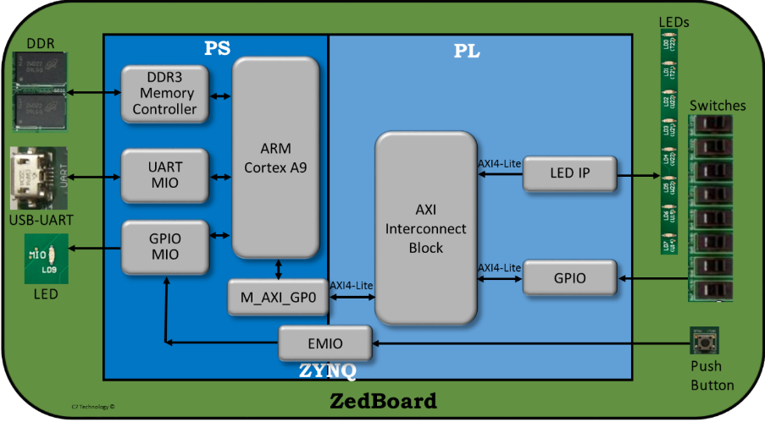
Design Flow
According to the presentation in class the flow detailed below should be followed in this laboratory:
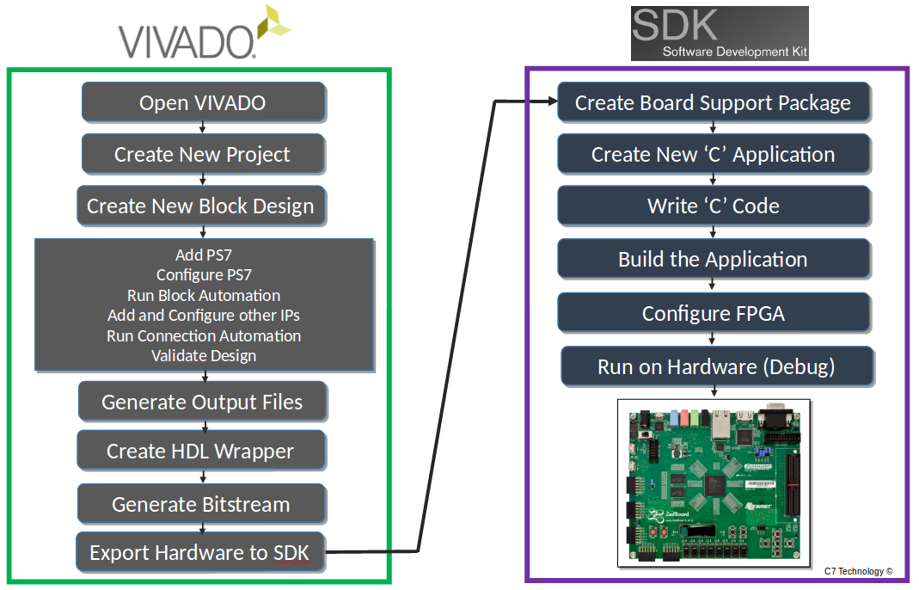
Following is a resume about each of the processes in the above flow towards this Lab:
- The design and implementation flow begins with launching Vivado. Within Vivado the entire design, from creating a block diagram to generate the bitstream, is carried out.
- Open the Create New Project Vivado option.
- From Vivado GUI, select Create Block Design to launch IP Integrator. Add the ZYNQ7 Processing System IP to include the ARM Cortex-A9 PS in the project.
- Double click on the ZYNQ7 Processing System block to configure the PS settings to make the appropriate design decisions such as selection/de-selection of dedicated PS I/O peripherals, memory configurations, clock speeds, etc.
- At this point, you may also optionally add IP from the IP catalog or create and add your own customized IP. Connect the different blocks together by dragging signals / nets from one port of an IP to another. You can also use the design automation capability of the IP Integrator to automatically connect blocks together.
- When finished, generate a top-level HDL wrapper for the system.
- When a project is created by defining a board, e.g. ZedBoard, a default constraint file is added to the project. This .xdc file defines the association between the FPGA I/Os and the peripherals existing in the ZedBoard. In case of using an FPGA I/O that is not associated to any peripherals, e.g. the JA1 PMOD connector, a customized .xdc file has to be added to the project. If there is any signal coming from the PL section to an I/O pin that is not defined in the .xdc file, then the tools will generate an error during the bitstream generation. Hence, in case of needed add a Xilinx Design Constraints (XDC) file to the Vivado project.
- Generate the bitstream for configuring the logic in the PL, if soft peripherals or other HDL are included in the design, or if any hard peripheral IO (PS peripheral) were routed through the PL. The PL part of the FPGA can be configured from either from SDK. The configuration form the SDK is the most commonly used.
- Once, the hardware portion of the embedded system design has been built, export the design to the SDK to create the software design. A convenient method to ensure that the hardware for this design is automatically integrated with the software portion is achieved by Exporting the Hardware. File -> Export -> Export Hardware. Assure to check the “Include Bitstream” option.
- Lunch SDK. File -> Lunch SDK.
- Within the SDK, for a standalone application (no operating system) create a Board Support Package (BSP) based on the hardware platform and then develop your user application. Once compiled, a *.ELF file is generated.
- Create a new ‘C’ application (usually from the available templates).
- Write your own ‘C’ code according to the requirements of the project.
- In case there is logic in the PL part of the Zynq, it is needed to configure the FPGA with the respective .bit file.
- Execute the Run As -> Launch on Hardware (GDB)process to program the PS part of the Zynq with the respective *.elf file, and automatically execute the ‘C’ code in the processor.

Section I

Create a Vivado Project
Part 1- Objective | Execute Vivado and create a PS7 based project targeting the ZedBoard.

- Open Vivado Design Suite.
- Click Create Project to start the wizard. You will see Create A New Vivado Project dialog box. Click Next. Use the information in the table below to configure the different wizard option:
Wizard Option | System Property | Settings
Project Name | Project Name | gpio_in_out
Project Name | Project Location | C:/....../../labs/lab_gpio_inout
Project Name | Create Project Subdirectory | Check this option.
Click Next
Project Type | Specify RTL | Select RTL. Keep do not specify sources at this time box unchecked
Click Next
Add Sources | Do nothing
Click Next
Add Existing IP | Do Nothing
Click Next
Add Constraints | Do Nothing
Default Part | Specify | Select Boards
 | Board | Select ZedBoard Zynq Evaluation and Development Kit, Rev. D.
Click Next
New Project Summary | Project Summary | Review the project summary
Click Finish
After clicking Finish, the New Project wizard closes and the project just created opens in the Vivado main GUI.
The board selected during the project creation, in this case the ZedBoard, has a direct impact on how the IP Integrator, within the Vivado, executes. IP Integrator is board aware and it will automatically assigns dedicated PS IO ports to physical pin locations mapped to the specific board peripherals when the Run Connection wizard is used. Besides of doing a pin constraint, IP Integrator also defines the I/O standard (LVCMOS 3.3, LVCMOS 2.5, etc) to each IO pin; saving time to the designer in doing so. Therefore, the XDC file (the Xilinx Constrain File) associated to the pre-defined IO locations is not required from user when the design uses only the defined ZedBoard peripherals.

Adding and Configuring PS7
Part 2 - Objective | Create a block design using IP Integrator. Add and configure the PS7 block.
- Next step is to use the IP Integrator to create an embedded processor project.
  - Click Create Block Design in the Flow Navigator pane under the IP Integrator.
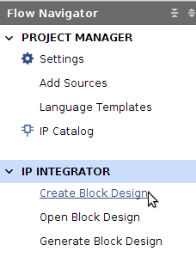
  - Type in lab_gpio_in_out as Design Name in the Create Block Design window.
  - A new blank Block Diagram canvas will be presented. This canvas will be used to create the design to be implemented into the Zynq device.
- Let’s begin creating a new embedded system in by first adding a ZYNQ7 Processing System block.
  - To insert a Processing System (PS) block either click the Add IP icon or right click on the canvas blank space and select Add IP from the available options.
  - An small window will come up showing the available IPs (they are the Intellectual Property cores that are already available; we will see later, in other lab, how to create and add our own IP). To search for the PS7 IP core, we can either scroll down to the very bottom of the IP list or search the PS7 IP using the keyword zynq. Double click on the ZYNQ7 Processing System to select it and add it to the canvas.
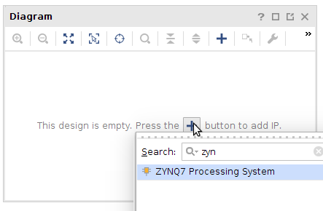
  - Then the Zynq7 PS IP block is placed in the block diagram canvas. The I/O ports shown in the Zynq block are defined by the default settings for this block.
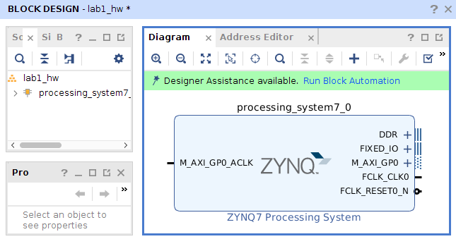
- Click Run Block Automation, available in the green information bar.
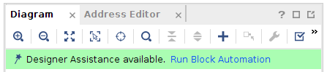
- Then, in the Run Block Automation window, select /processing_system7_0. Make sure Apply Board Presets is checked, leave everything else as default. Click OK.
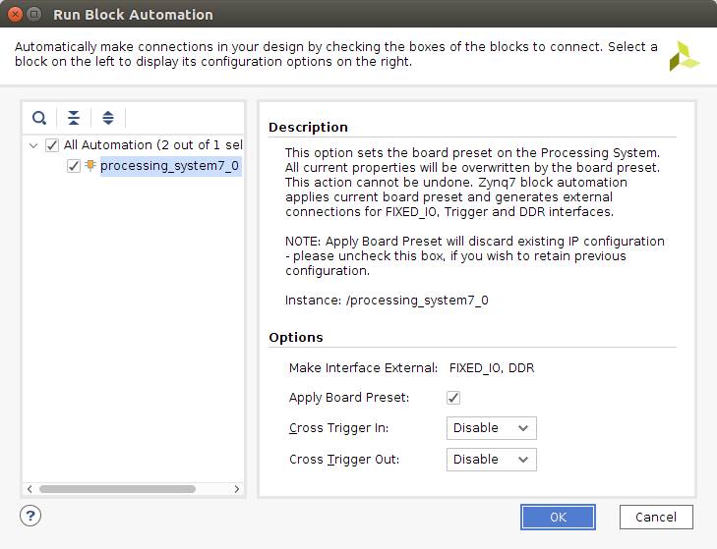
- After finishing previous step, the block diagram should look like the following:
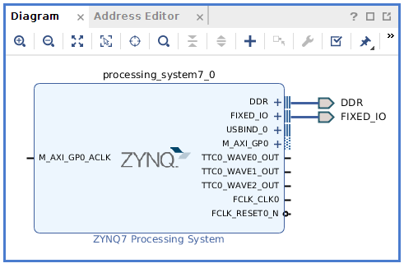

PS 7 Customization – Adding GPIO IP Cores
Part 4- Objective | Customizing the Zynq Processing System settings. For this particular lab we will enable the AXI_M_GP0 interface, the FCLK_RESET0_N, and the FCLK_CLK0 ports. We will also add two instances of a GPIO IP Peripheral from the IP catalog.
- Double click in the Zynq7 PS block to open the Zynq 7 Processing System Re-Customize IP window.
A block diagram of the Zynq PS should now be open, detailing the various configurable blocks of the Processing System (remember that the green block are the configurable ones).
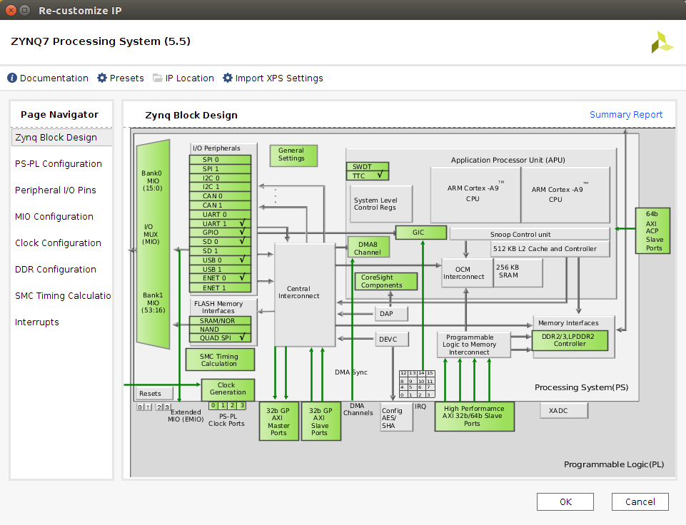
- Click on the MIO Configuration option under the Page Navigator pane. Expand I/O Peripherals, unselect all the peripherals but the UART1. The PS UART1 will be used to communicate the Zynq device with the PC. This communication will be carried out by using a serial terminal software like Putty or TeraTerm.
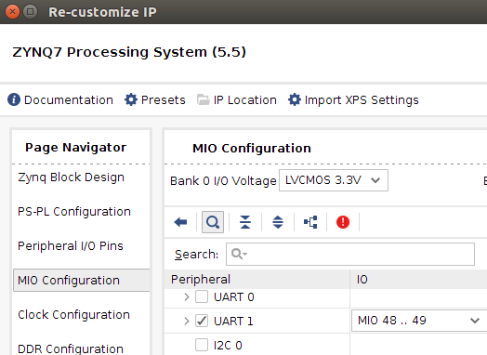
- In the same MIO Configuration section, it is necessary to enable the EMIO GPIO to be able to route the signal coming from the PL to the PS just using the EMIO GPIO.
  - Find the GPIO peripheral and expand it.
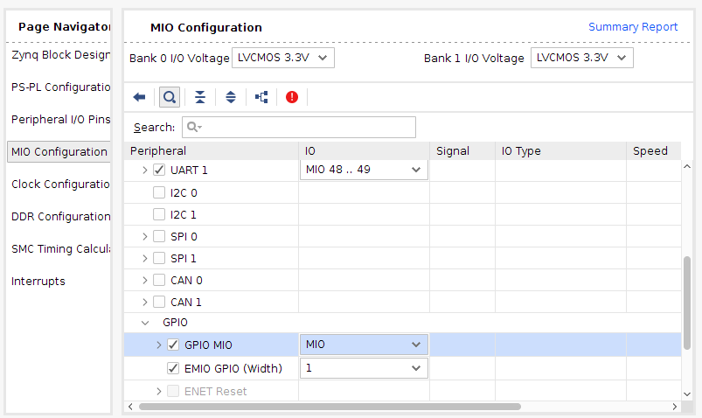
  - Check the EMIO GPIO (Width) box. Then click in the right side of the column and from the pull down menu, select 1 (as the width of the ‘bus’ going from the PS to the PL). This is the input pin from the PL (push-button) that will go into the PS.
  - Do check the GPIO MIO option, and leave the default value MIO. This is the output coming from the PS that will go through the GPIO(PS) peripheral to turn on or off the LED9.
- We can go to the Peripherals I/O Pins to see the Zynq I/O pins associated with the UART (this information is irrelevant in this lab, but it could be useful in some other cases) .
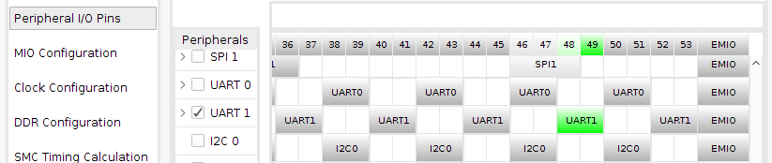
- In the DDR Configuration option, be sure that the Enable DDR configuration is selected.
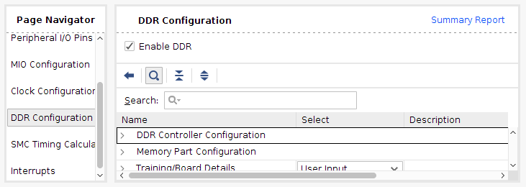
- Finish with the Zynq (processing_system7_0) configuration by clicking the OK button in the Re-Customize IP window.
- Back in the block design canvas of the project, you will notice the additional M_AXI_GPO interface, the GPIO_0, the M_AXI_GPO_ACLK, FCLK_CLK0, and FCLK_RESET0_N ports are now included on the Zynq7 PS block.
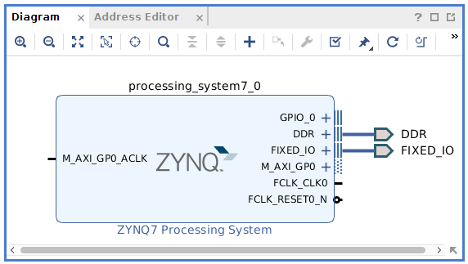

Part 5 - Objective | Add a GPIO IP Core. Connect it to automatically to the others blocks.
- In the next steps, we are going to add the GPIO IP core to handle the LEDs and the switches. Click the Add IP icon and search for AXI GPIO in the catalog.
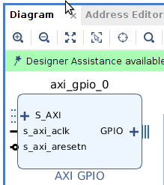
- Double-click the AXI GPIO to add the IP core to the design. Single click on the AXI GPIO block to select it, and in the Block Properties pane (in the middle of the Vivado main window), change the default name from axi_gpio_0 to board_sw_8b.
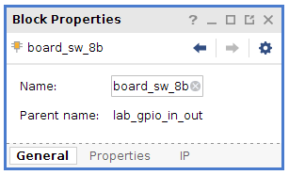 | 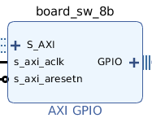
- Double click on the AXI GPIO switches block to open the customization window.
- Select the Board tab and then use the pull down menu to select the sws 8bits (ZedBoard 8 bits switches) for GPIO.
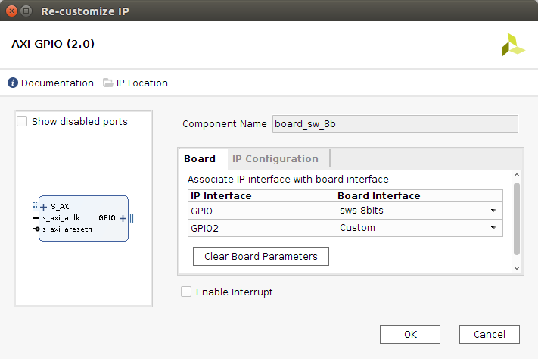
- Click the IP Configuration tab. In the GPIO Width box, by default the 8 bits wide are showed (since it was selected the 8 bits switch interface for the GPIO, and Vivado is board aware due to the fact that this project was setup for the ZedBaord).
Notice that the GPIO peripheral can be configured for two channels, but, since in this project it is needed only one channel and without interrupt, leave the Enable Interrupts and Enable Dual Channel boxes unchecked.
- Click OK to save and close the GPIO customization window, and get back to the block design pane.
- Notice that design assistance is now available on the green bar above the block design canvas. Click on Run Connection Automation.
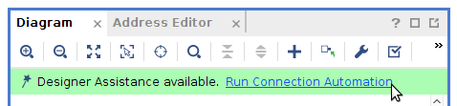
- First select /board_sw_8b/S_AXI, and left the other options unchecked. This will connect the slave part of the GPIO IP to the master part of the PS (actually it will be connected to the master port of the interconnect block as it will be seen soon).
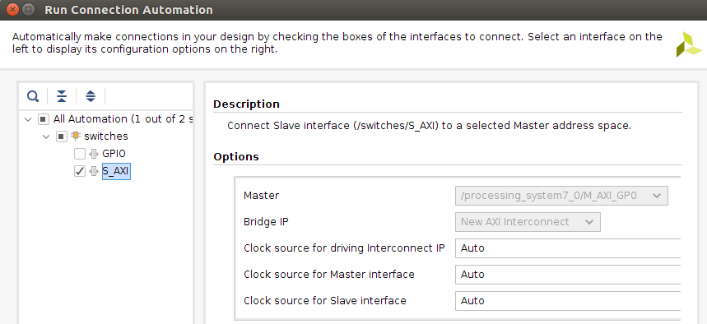
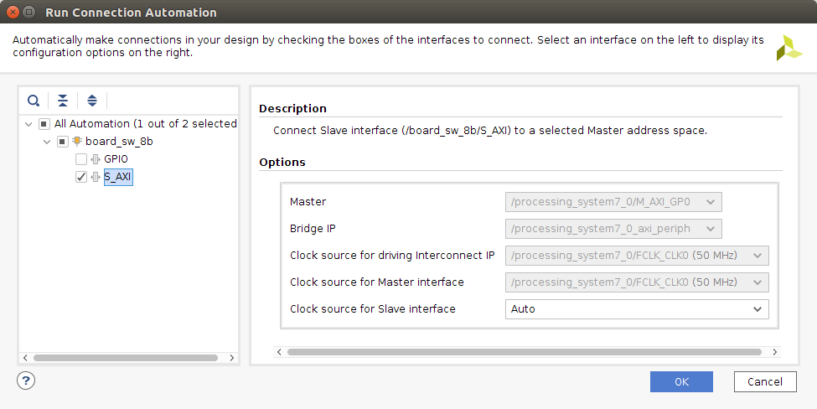
- Then, select /board_sw_8b/GPIO and in the pull down menu for Select Board Part Interface, select sws_8bits. This will create an output port for the design (for the Zynq) that will go to the switches on the board.
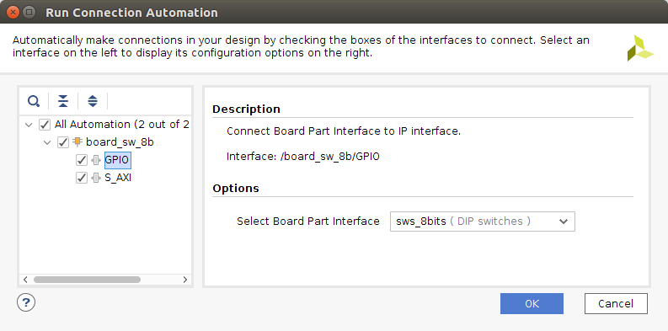
- Click OK to finish this process.
- The updated block design is now showed in the Diagram editor tab.
- Click the regenerate icon to redraw the diagram.
- Notice two additional blocks, Processor System Reset, and AXI Interconnect have automatically been added to the design.
Part 6- Objective | Add another GPIO IP core and connect it manually to the other blocks.
- Following the steps just explained and add another instance of an AXI_GPIO peripheral. Change the name to board_leds_8b.
- Double click on the board_leds_8b block. Select the Board tab and then use the pull down menu to select the Custom for this GPIO.
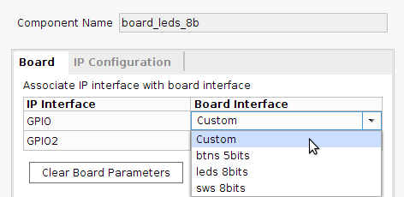
  - Select the IP Configuration tab :
    - Set GPIO Width to 8 bits.
    - Check the box for All Outputs.
    - Then click OK.
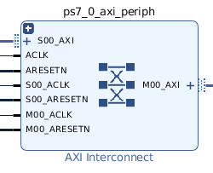
- At this point, Run Connection Automation could be executed (as it was done previously) to get the AXI GPIO board_leds_8b block connected to the PS7. The other option is to connect manually the GPIO. This time, in order to get familiar with this procedure as well, the GPIO block will be connected manually.
- Double click on the AXI Interconnect block to open the configuration window.
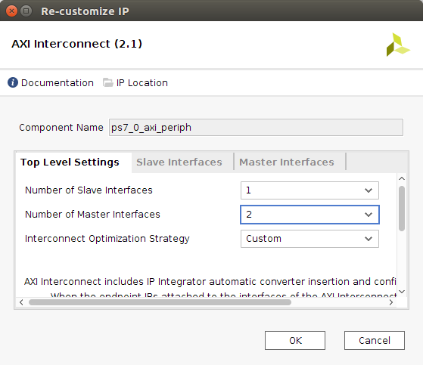
- Since we need to connect a new slave block, board_leds_8b, we need to add another master interface to this block. Change the Number of Master Interfaces from 1 to 2 and click OK.
- Back into the block design, click on the S_AXI port (slave AXI port) of the AXI GPIO board_leds_8b block, and drag the pointer towards the AXI Interconnect block. The message Found 1 Interface should appear in the canvas, and a green tick should be shown beside the M01_AXI port on the AXI Interconnect block indicating this is a valid port to connect to. Drag the pointer to this port and release the mouse button to make the connection.
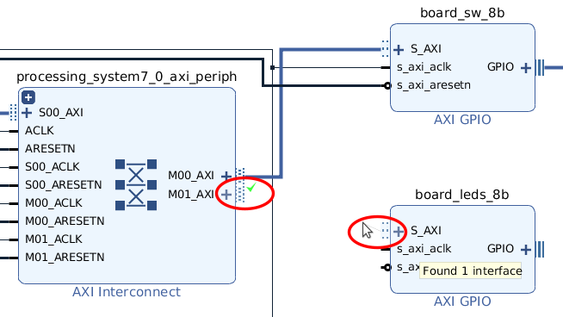
- In a similar way, connect the following ports (remember to look for the green tick mark):
  - s_axi_aclk port -> Zynq7 Processing System FCLK_CLK0 port
  - s_axi_aresetn port -> Processor System Reset peripheral_aresetn port
  - AXI Interconnect M01_ACLK port -> Zynq7 Processing System FCLK_CLK0 port
  - AXI Interconnect M01_ARESETN port -> Processor System Reset peripheral_aresetn port.
- After finishing doing the connections, the block should look like this:
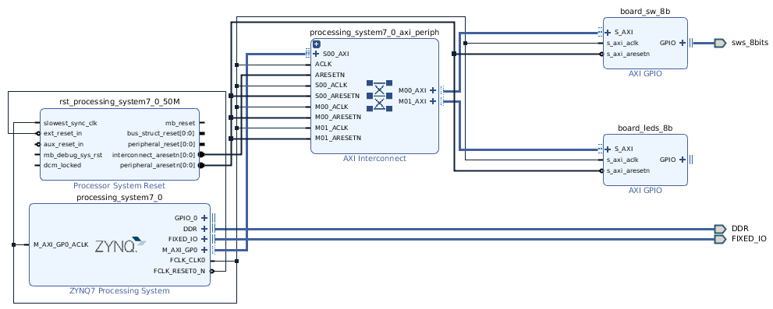
- Click on the Address Editor tab, and expand processing_system7_0 > Data > Unmapped Slaves if necessary.
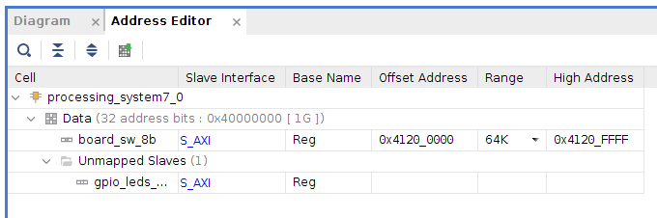
Notice that the switches GPIO block has a range of memory addresses automatically assigned (0x4120_0000 - 0x4120_FFFF).
However, gpio_leds_8b has not. This is due to the fact that we connect this GPIO block manually. So, let’s assign a range of memory addresses: right click on board_leds_8bits and select Assign Address or click on the icon. Then, a range of addresses is automatically assigned to the gpio_leds_8bits GPIO block.
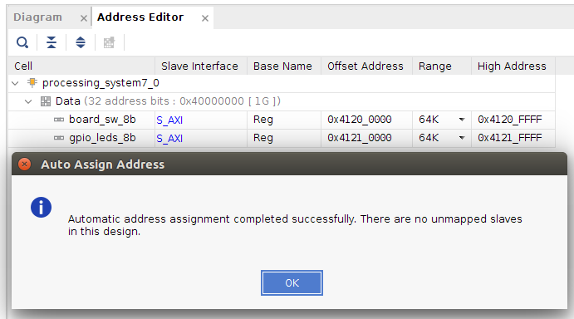

Make external the GPIO connections
Part 6 - Objective | The GPIO IPs that we add will be connected to the corresponding pins of the Zynq.
- Click on the Diagram tab to return to the block diagram. Right-Click on the GPIO port of the board_leds_8b IP block.
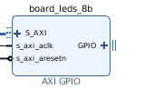
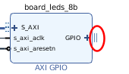
- From the menu, select Make External to create the external port. This will create the external port named (by default) GPIO_0 and will connect it to the respective peripheral (LEDs on the ZedBoard).
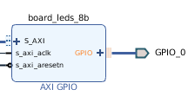
- Select the GPIO_0 port and change the name to leds_8bits in its External Interface Properties form.
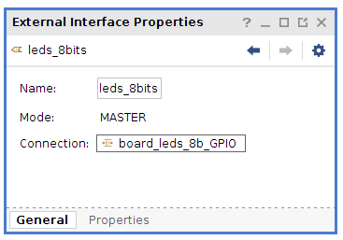
- The other GPIO IP block, the board_sw_8b, has already been assigned the external port previously, so there is no need to do anything with it (it was done automatically).
- Run Design Validation (Tools -> Validate Design) and verify there are no errors.
- The design should now look similar to the diagram below.
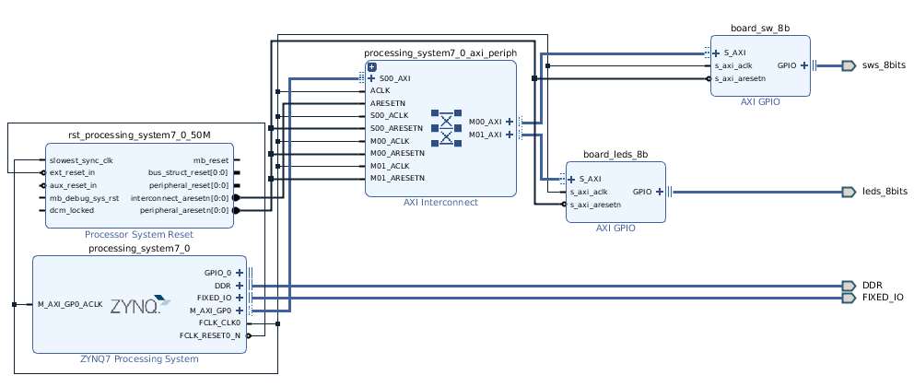

Part 7 - Objective | Create an output port for the PS7 GPIO.
- Right-click on the GPIO_0 pin of the processing_system7_1 instance, and select Make External.
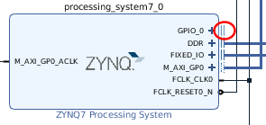
- Select the just created GPIO_0 port, and in the External Interface window change the name to BTNR.
- We have completed the hardware of our system.
- Click the Save button to save the current block diagram, which should look like the following.
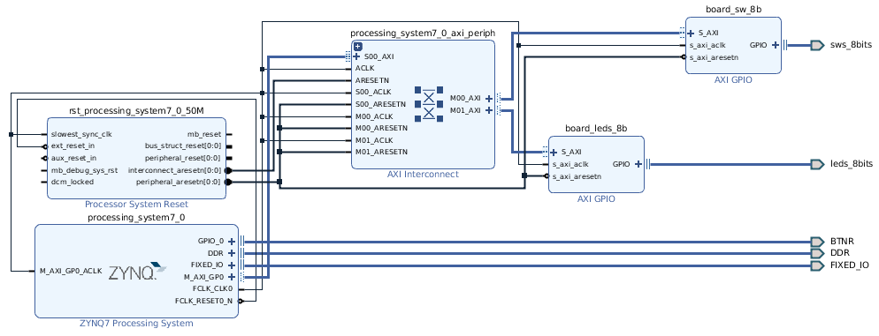

Constraint, Generate & Synthesize the design
Part 8 - Objective | Create the HDL wrapper, generate the output product, and synthesize the design. Open the I/O Planning layout, and add the necessary I/O port constraints.
- In the central pane, click on the Sources tab. The lab_gpio_in_out.bd (board design) file contains all the settings and configuration of the block diagram created in the block diagram editor window. Right click on lab_gpio_in_out.bd and select Generate Output Products. In the Generate Output Products window, leave the options as given by default, then click Generate. Click OK in the upcoming window.
- Next, right click on lab_gpio_in_out.bd and select Create HDL Wrapper to create the top level VHDL/Verilog file from the block diagram. In the Create HDL Wrapper window leave the option ‘Let Vivado manage wrapper and auto-update’ checked, and click OK.
- Next, from the Flow Navigator pane, run Synthesis.
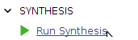
- When synthesis completes, select Open Synthesized Design and click OK.
- In the shortcut bar, select I/O Planning from the Layout drop down menu (if the option I/O Planning is not in the list, be sure that the synthesized design is open).
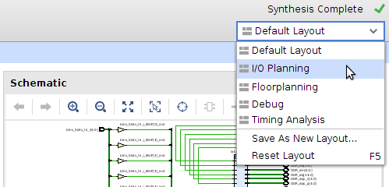
- In the I/O Ports tab, expand the two GPIO icons, and expand sw_8bits and leds_8bits. Notice that for the sws_8bits GPIO ports, FPGA pin locations have automatically been assigned, as well as an I/O Std of LVCMOS25 has been applied to each I/O port. These assignments are done automatically because Vivado software is board aware and is using the constraints related to the ZedBoard.
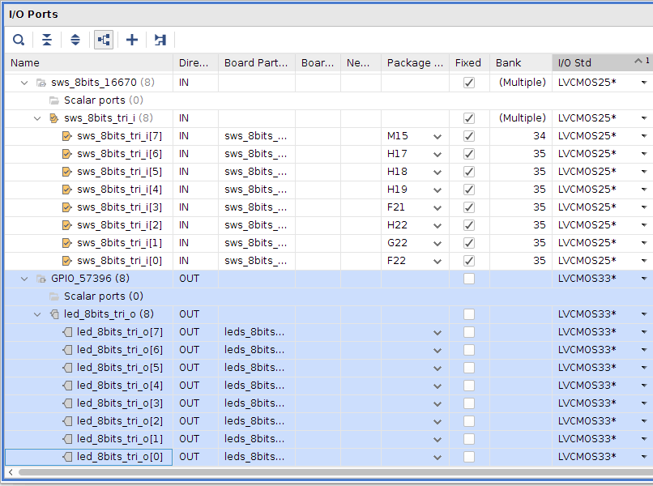
However, the I/O pins for the leds_8bits GPIO block have not been assigned, therefore we do need to do that manually. Check the ZedBoard User Guide to find the FPGA I/O pins assigned to the available LEDs on the board. You will find them in Table 14, page 21.
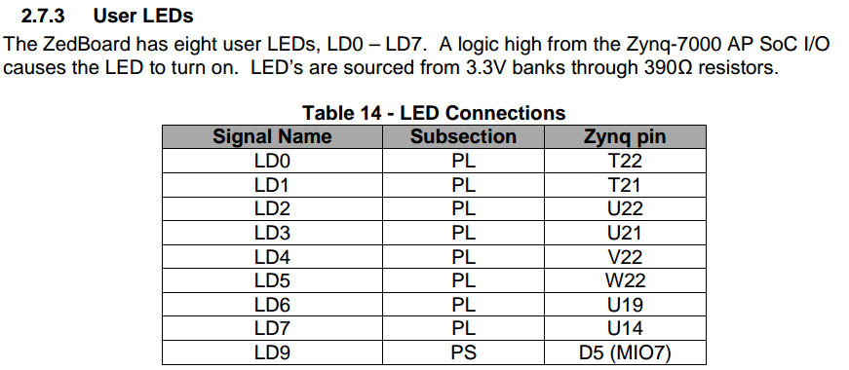
Use Table 14 to complete the I/O pin assignment for the LEDs GPIO. Also, change the default voltage to LVCMOS33.
The I/O Ports should look similar to the following:
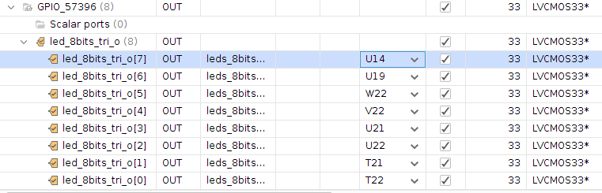
- We also need to assign the pin number to the BTNR input port. Search for the BTNR port in the I/O Ports tab.
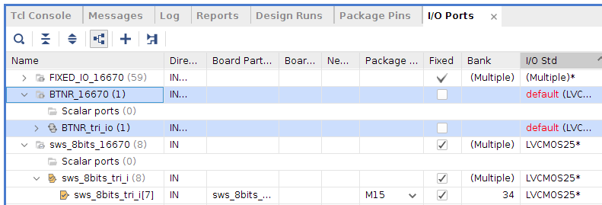
As you can see there is no pin assignment done for this port.
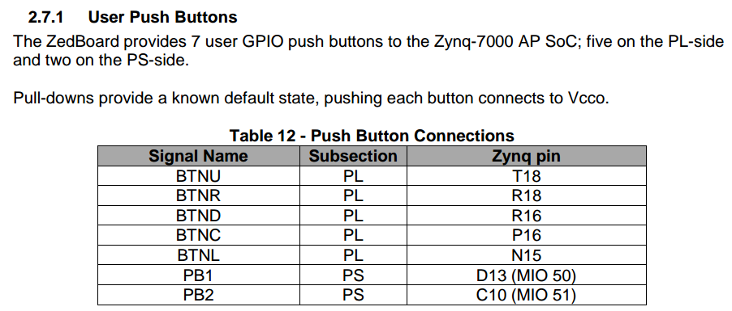
- Again, check the ZedBoard User Guide to find the FPGA I/O pins assigned to the available buttons on the board, in particular the BTNR button. You will find them in Table 12, page 2.
- Assign the R18 pin to the BTNR port, and set the I/O Std to LVCMOS25.
- Click on the save icon to save the I/O pin assignment.
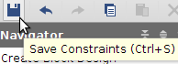
- A dialog window will come up asking the constraint file name, use lab_gpio_constr.xdc.
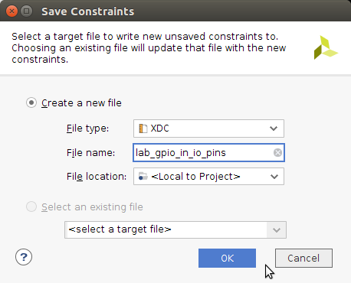
Note 1: The LVCMOS25 standard is set for these particular IOs, due to the fact that both the push buttons and the switches are buy default connected to 2.5V.
lab_gpio_constr
Note 2: The I/O Ports table presents a lot of information about each IO pin in different columns. It is possible to enable or disable each column by checking or unchecking the needed information from the options column that is obtained by click right mouse button on any of the names of the first row (Name, Direction, Bank, etc. ).
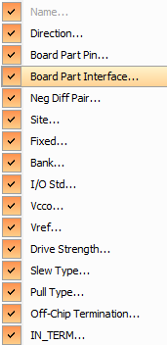
- In the Flow Navigator pane, click in Run Implementation.
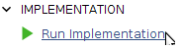
It could happens that a message window come up stating that “Synthesis is out of Data’. This is due to the fact that since we have update the I/O constraint the synthesis should be run again to get a better and optimized resultant netlist.
- Once completed the implementation task, click on the option Open Implemented Design. Then, click in the device tab. You will get a figure detailing the place and route of the current design.
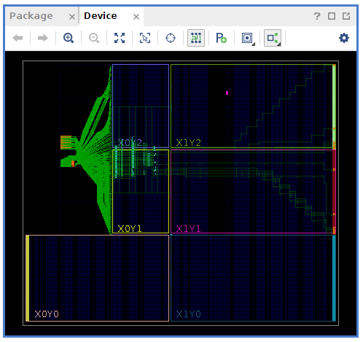

Generate Bitstream and Export Hardware
Part 9 - Objective | Generate the bistream, and export the hardware along with the generated bitstream to SDK.

- In the Flow Navigator menu, click on Generate Bitstream. Click OK after finishing the bitstream generation (leave the ‘View Report’ option checked).
- Export the hardware to the SDK environment. Do File -> Export -> Export Hardware. Since there is some logic in the PL part of the Zynq, the respective bitstream has to be included in the export task. Hence, do check the Include bitstream box. Click OK.
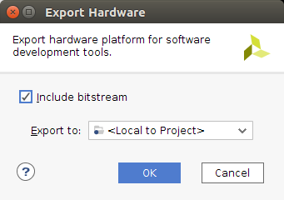
- Launch SDK by doing File -> Launch SDK and click OK.
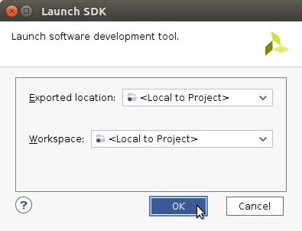

Generate ‘C’ Application in SDK
Part 10 - Objective | Generate the project in the SDK environment, and the ‘C’ application code to read from the switches and write to the LEDs.

- In SDK environment, the hardware platform related files (generated by Vivado Design Suite) are imported and showed in the folder lab_gpio_in_out_wrapper_hw_platform_0. Note: if there is any previous project open in the Project Explorer pane, close it by right clicking on the project name and select Close Project.
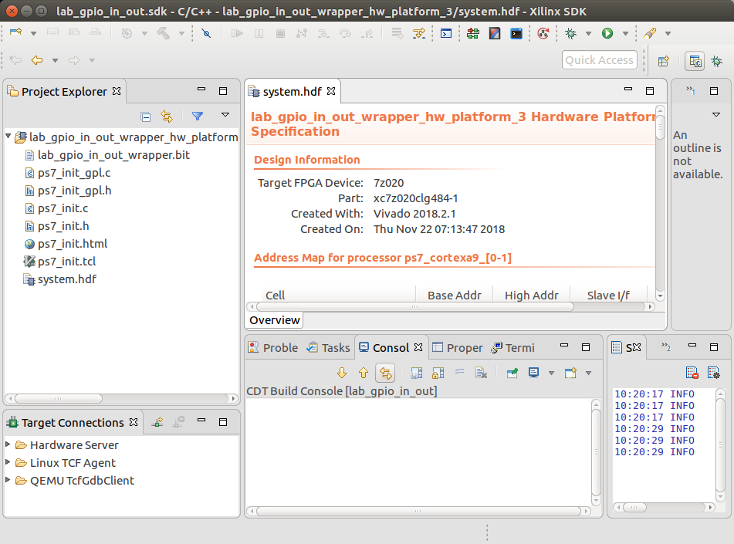
- The system.hdf file holds all the hardware information generated by Vivado Design Suite. For instance, we can see the memory map and the IP Cores used. Browse the file until you find the assigned memory map for switches and LEDs, also browse it to find the GPIO IP cores used for switches and LEDs.
- From the File menu select File -> New -> Application Project. Use as Project Name: lab_gpio_inout_sdk. Leave the other settings in its default value/name.
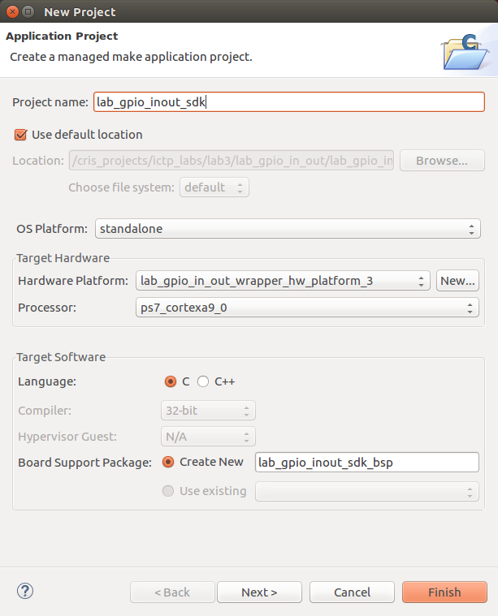
- Click Next, to open the Templates settings window. Select Empty Application and click Finish. This will create a new application project.
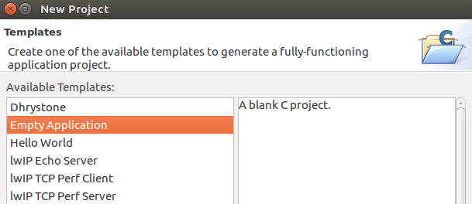
- The SDK will create the project itself as well as the BSP.
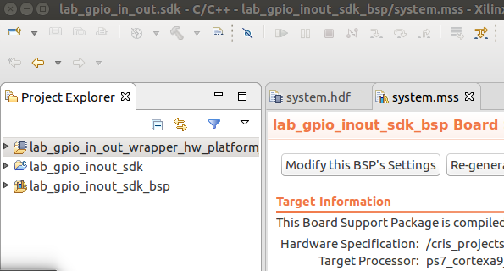
- One important file that is generated, among others, is the xparameters.h, which include all the board related definitions. The xparameters.h file is in the folder lab_gpio_inout_sdk_bsp→ps7_cortexa9_0→ include. This information will be very useful in the next steps and future labs.
Browse and try to find the file.
- In the Project Explorer view, expand lab_gpio_inout_sdk, and right-click on the src folder, and select Import.
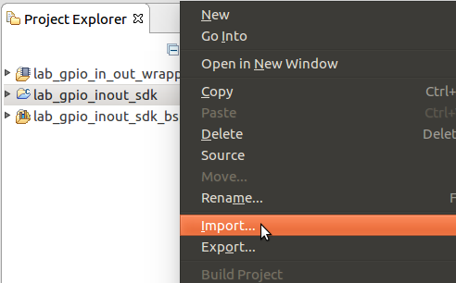
- Expand General category and double-click on File System.
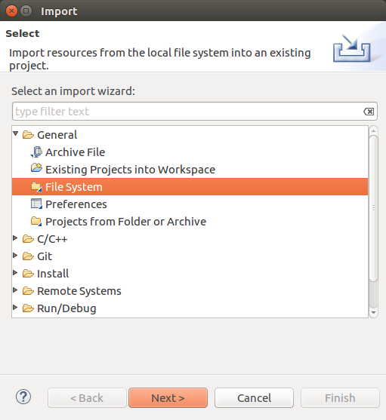
- Browse to the c:/../labs/lab_gpio_inout/c_src folder.
- Select the lab_gpio_inout.c file, to be imported into the application project and click Finish.
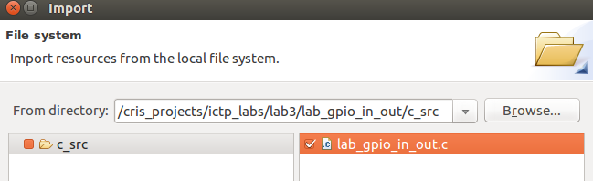
- Open to edit the lab_gpio_inout.c file, by double clicking on the file name. As you can see there are some missing functions in the code represented by ‘????’ characters. Based on what you have learned in the theoretical classes, replace the ‘????’ characters with the ‘C’ function(s) to be able to execute correctly the GPIO read from the swithces and the GPIO writes to the LEDs.
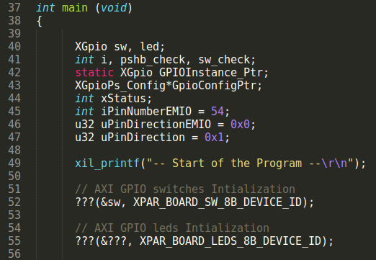

Download the design into the Zynq SoC
Part 10 - Objective | Connect the ZedBoard with the two micro-usb cables and power it ON. Establish the serial communication using a serial utility software.

- Connect a USB micro cable between the Windows/Linux Host machine and the ZedBoard JTAG J17 (on the right side of the power connector). This connection will be used to configure the PL.
- Connect a USB micro cable to the USB UART connector (J14) on the ZedBoard (on the left side of the power switch), with the Windows/Linux Host machine. This connection will be used to carry out the serial message/data transfer between the ZedBoard and the host machine.
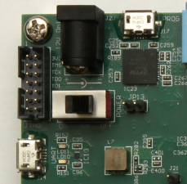
IMPORTANT 1: Ensure that jumpers JP7 to JP11 are set as shown in the figure below for the JTAG configuration mode.
J17
J14
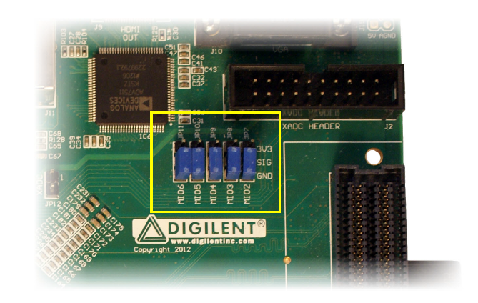
IMPORTANT 2: be sure to already have installed the Cypress device driver for the USB-UART chip on the ZedBoard.
- Check the jumper setting for J18 in the bottom right corner of the board. The jumper should be set to 2.5V, which is marked as “2V5” on the board.
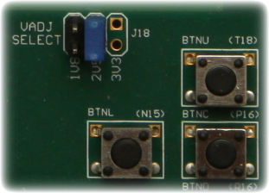
- Connect the 12V AC/DC converter power cable to the ZedBoard barrel jack.
- Power-on the board using the ZedBoard Power switch. Check that the Power LED on the board (green LED) is on. Note, in some instances the board needs to be ON before the SDK launches in order for the SDK to see which COM port is being used by the OS.
- To find out which COM port has been assigned to the UART connection, use the Control Panel->Device Manager Windows utility. An example is shown as follow.
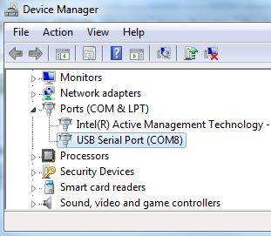
- Setting up the serial utility software:
  - Use a utility program such as Tera Term or Putty to setup a serial communication between the Host and the ZedBoard, by using the Host COM port.
For the Tera Term configuration, first select Serial as communication protocol, and from the pull down menu select the Port to be used.
Important: In case that there is no “USB Serial Port ……” option from the Port pull down menu, first check that the board is On, then check whether the serial port is detected by the operative system, e.g. in Windows use the Device Manager utility. In case that no serial port is detected, re-install the Cypress device driver for the USB-UART chip on the ZedBoard.
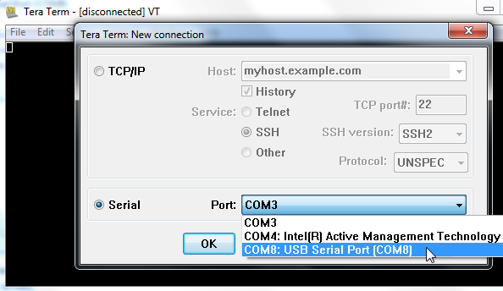
  - Do Setup → Serial Port and configure the serial port of the Tera Term or the software you are using, with the values detailed in the following figure.
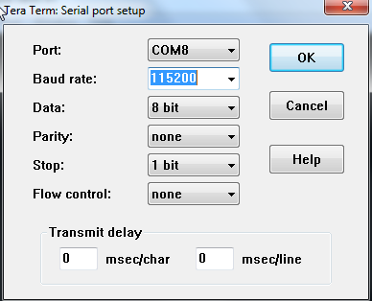
- Since in this project there is logic implemented in the PL part of the Zynq device it is needed to configure the PL. To do so, from the SDK environment you can either select Xilinx Tools -> Program FPGA or press the icon.
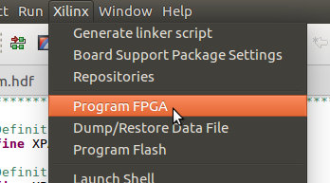 | 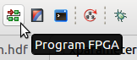
- Click the Program icon to download the hardware bitstream to the PL part (FPGA).
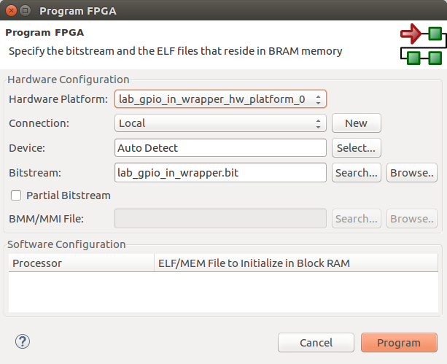
- When PL is successfully programmed, the ZedBoard DONE LED (blue LED) will light.
- Once the PL part is programmed, the next step is to execute the ‘C’ code in the PS part of the Zynq. Select lab_gpio_inout_sdk in the Project Explorer pane, right-click and select Run As -> Launch on Hardware (GDB) to download the application, execute ps7_init, and execute lab_gpio_inout_sdk.elf.
- Play with the switches, the LEDs should follow any change.
- Next, press BTNR, the LED9 should light.
- Select Console tab and click on the Terminate button () to stop the program.
- Close SDK and Vivado programs by selecting File -> Exit in each program.
- Power OFF the board.

Conclusion
GPIO peripherals were added from the Vivado IP catalog and connected to the Processing System through the 32bits Master GP0 interface. The peripherals were configured and external FPGA connections were established. Also, a PS output pin, that control an LED, was connected with a push-button associated with a PL input pin.
A ‘C’ application project was created in the SDK environment and the functionality was verified after downloading the bitstream into the ZedBaord and executing the program.

