Laboratory

SoPC Design Flow for a Simple PS Design

Prepared by:
C. Sisterna & L. Crespo
ICTP-MLAB
Section I

Vivado Design Flow for a PS Based Design
Introduction
This lab guides you through the process of using Vivado Development Suite to create a simple SoPC design targeting just the PS part of the Zynq-FPGA in the ZedBoard.
You will create a board design in the Vivado IP integrator, then you will export it to the SDK tool, generate the board support package (BSP) and modify a template to display the “Hello world” string in a console.
Objectives
After completing this lab, you will be able to:
- Create a Vivado project based in the IP Integrator
- Add and configure the PS7
- Generate HDL wrapper
- Export the design to SDK
- Create an application project in SDK, creating a board support package and ‘C’ code
- Configure the UART to communicate the PC with the ZedBoard
- Program the PS7 using the .elf file
- Execute the ‘C’ code in the processor
Description
The design consists of creating a simple project in which the PS7 will be configured to communicate with the PC to display the ‘Hello World’ string.
Design Flow
According to the presentation in class the flow detailed below should be followed in this laboratory:
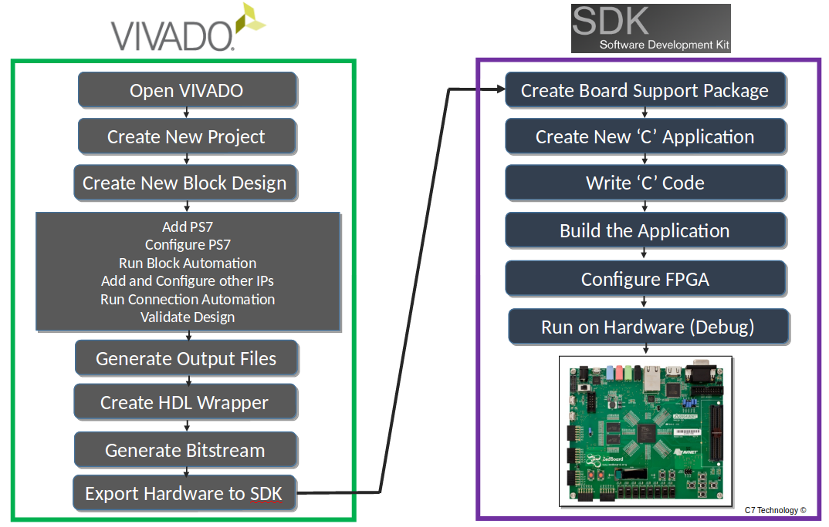
Following is a resume about each of the processes in the above flow towards this Lab:
Note: the steps of the flow design printed in light gray are steps that are not necessary in this lab, but will be used in following ones.
- The design and implementation flow begins with launching Vivado. Within Vivado the entire design, from creating a block diagram to generate the bitstream, is carried out.
- Open the Create New Project Vivado option.
- From Vivado GUI, select Create Block Design to launch IP Integrator. Add the ZYNQ7 Processing System IP to include the ARM Cortex-A9 PS in the project.
- Double click on the ZYNQ7 Processing System block to configure the PS settings to make the appropriate design decisions such as selection/de-selection of dedicated PS I/O peripherals, memory configurations, clock speeds, etc.
- At this point, you may also optionally add IP from the IP catalog or create and add your own customized IP. Connect the different blocks together by dragging signals / nets from one port of an IP to another. You can also use the design automation capability of the IP Integrator to automatically connect blocks together.
- When finished, generate a top-level HDL wrapper for the system.
- When a project is created by defining a board, e.g. ZedBoard, a default constraint file is added to the project. This .xdc file defines the association between the FPGA I/Os and the peripherals existing in the ZedBoard. In case of using an FPGA I/O that is not associated to any peripherals, e.g. the JA1 PMOD connector, a customized .xdc file has to be added to the project. If there is any signal coming from the PL section to an I/O pin that is not defined in the .xdc file, then the tools will generate an error during the bitstream generation. Hence, in case of needed add a Xilinx Design Constraints (XDC) file to the Vivado project.
- Generate the bitstream for configuring the logic in the PL, if soft peripherals or other HDL are included in the design, or if any hard peripheral IO (PS peripheral) were routed through the PL. The PL part of the FPGA can be configured from either from SDK. The configuration form the SDK is the most commonly used.
- Once, the hardware portion of the embedded system design has been built, export the design to the SDK to create the software design. A convenient method to ensure that the hardware for this design is automatically integrated with the software portion is achieved by Exporting the Hardware. File -> Export -> Export Hardware. Assure to check the “Include Bitstream” option.
- Lunch SDK. File -> Lunch SDK.
- Within the SDK, for a standalone application (no operating system) create a Board Support Package (BSP) based on the hardware platform and then develop your user application. Once compiled, a *.ELF file is generated.
- Create a new ‘C’ application (usually from the available templates).
- Write your own ‘C’ code according to the requirements of the project.
- In case there is logic in the PL part of the Zynq, it is needed to configure the FPGA with the respective .bit file.
- Execute the Run on Hardware (Debug) process to program the PS part of the Zynq with the respective *.elf file, and automatically execute the ‘C’ code in the processor.

Create a Vivado Project
Part 1 - Objective | Execute Vivado and create a PS7 based project targeting the ZedBoard.
- Open Vivado Design Suite.
- From the Quick Start menu, click Create Project to start the wizard or click File → Project → New.
You will see Create A New Vivado Project dialog box in the New Project window. Click Next. Use the information in the table below to configure the different wizard options:
Wizard Option | System Property | Settings
Project Name | Project Name | hello_world
Project Name | Project Location | C:\...\...\labs\lab_hello_world
Project Name | Create Project Subdirectory | Do not check this option.
Click Next
Project Type | Project Type | Select RTL Project.  Keep do not specify sources at this time box unchecked
Click Next
Add Sources | Do nothing
Click Next
Add Existing IP | Do Nothing
Click Next
Add Constraints | Do Nothing
Default Part | Specify | Select Boards
Default Part | Board | Select ZedBoard Zynq Evaluation and Development Kit
Click Next
New Project Summary | Project Summary | Review the project summary
Click Finish
After clicking Finish, the New Project Wizard closes and the project just created opens in the Vivado main GUI.
The board selected during the project creation, in this case the ZedBoard, has a direct impact on how the IP Integrator, within the Vivado, executes. Vivado IP Integrator is board aware and it will automatically assign dedicated Zynq IO ports to physical pin locations mapped to the specific board peripherals when the Run Connection wizard be used. Besides of doing a pin constraint, IP Integrator also defines the I/O standard (LVCMOS 3.3, LVCMOS 2.5, etc) to each IO pin; saving time to the designer in doing so. Therefore, the XDC file (the Xilinx Constrain File) associated to the pre-defined IO locations is not required from user when the design uses only the defined ZedBoard peripherals.
- The Vivado Design Suite main window should look like the following figure:
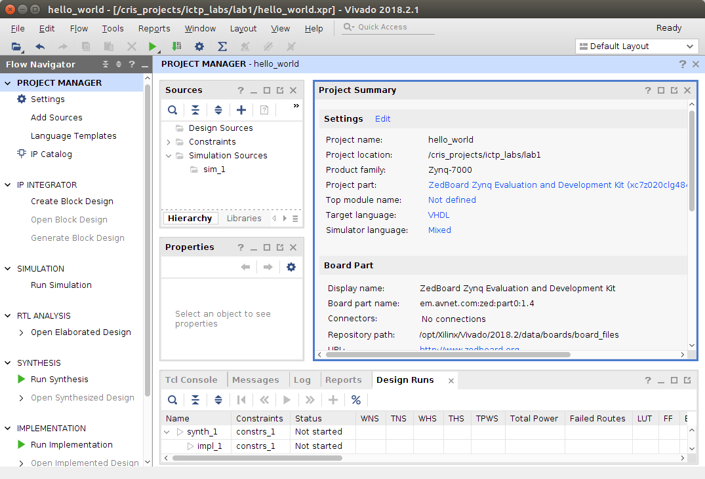
- Next step is to use the IP Integrator to create an embedded processor project.
  - Click Create Block Design under in the Flow Navigator pane in the Flow Navigator pane. Type in lab1_hw as Design Name in the Create Block Design window, and click OK.
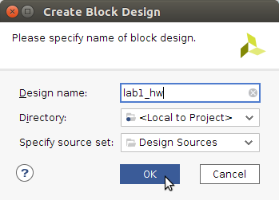
  - A new blank Block Diagram canvas will be presented. This canvas will be used to create the design to be implemented into the Zynq device.
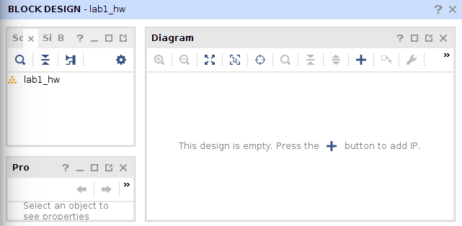
  - You can design a new embedded system in Vivado using IP Integrator by adding a ZYNQ7 Processing System block. By adding this block, you can configure one of the ARM Cortex-A9 processor cores for your application. You can also place additional IP blocks to increase the capabilities of the embedded system.
To insert a ZYNQ7 Processing System(PS7) block you can either click the Add IP icon , or, do a right click on the canvas blank space and select Add IP from the available options.
  - A small window will come up showing the available IPs (that is, they are the Intellectual Property cores, IP, that are already available. We will see later, in other lab, how to create and add our own IP. To search and add the PS IP core, we can either scroll down to the very bottom of the IP list or search the IP using the keyword zynq. Double click on the ZYNQ7 Processing System IP to select and add it to the canvas.
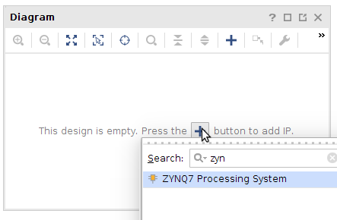
- The Zynq7 PS IP block is placed in the block diagram canvas. The I/O ports shown in the block diagram, DDR, FIXED_IO, M_AXI_GPO, etc., are defined by the default settings for this block as specified by the target development board (in this case the ZedBoard).
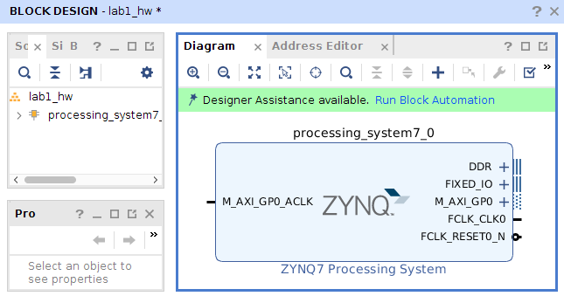
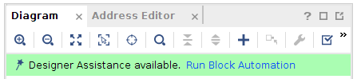
- Click Run Block Automation, available in the green information bar.
- Then, select /processing_system7_0. Make sure Apply Board Presets is checked and select OK in the Run Block Automation window (leave everything else as default).
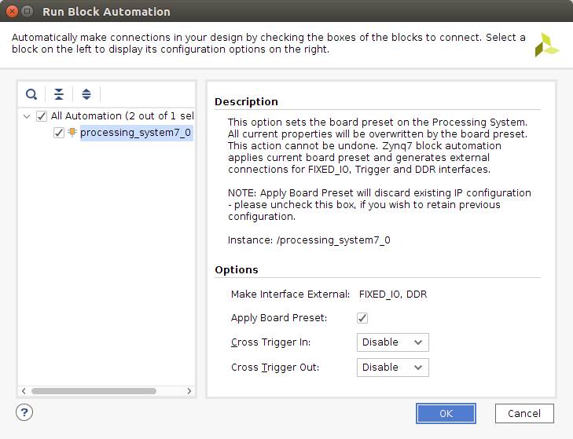
- After finishing previous step, the block diagram should look like the following:
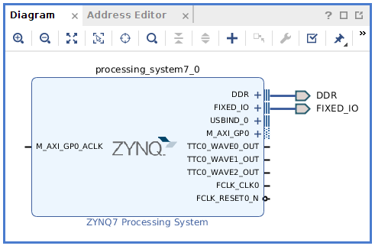

Processing System (PS) Customization
Part 2  Objective | Customizing the Zynq Processing System settings. For this particular Lab many of the defaults setting of the PS7 will not be necessary, therefore they will be modified in the following steps.
- Double click in the Zynq7 PS block to open the customization window (see figure below). In this window the Processing System part of the Zynq device can be configured.
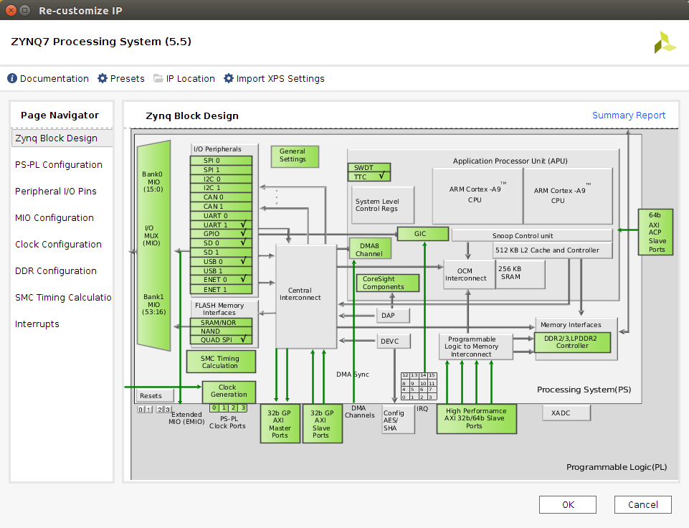
All the blocks colored in bright green can be customized. To select a block, either double click on it or select the respective configuration option on the Page Navigator pane (the column on the right).
- Let’s begin with some of the configuration. Click on the MIO Configuration option under the Page Navigator pane. Expand I/O Peripherals, and unselect all the peripherals but the UART1. The PS-UART1 will be used to communicate the Zynq device with the PC. This communication will be carried out by using a serial terminal software like Putty or TeraTerm.
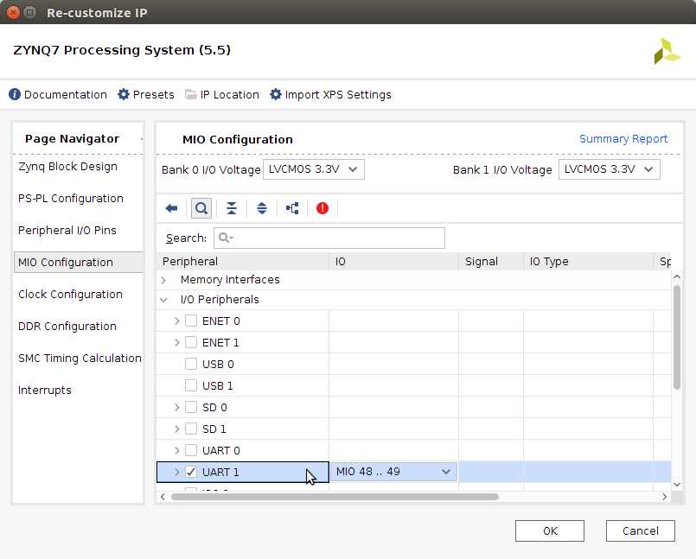
We can go to the Peripherals I/O Pins to see the Zynq I/O pins associated with the UART (this information is irrelevant in this lab, but it could be useful in some cases) .
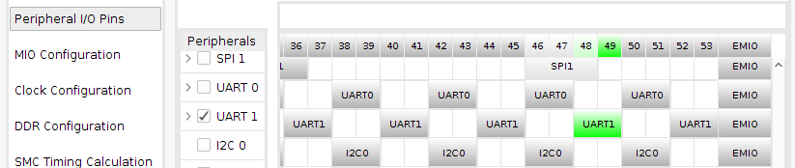
- Next, click on the Clock Configuration option, expand PL Fabric Clocks, and de-select FCLK_CLK0. Since there will not be any logic in the PL part of the Zynq it not necessary to supply any clock to the PL.
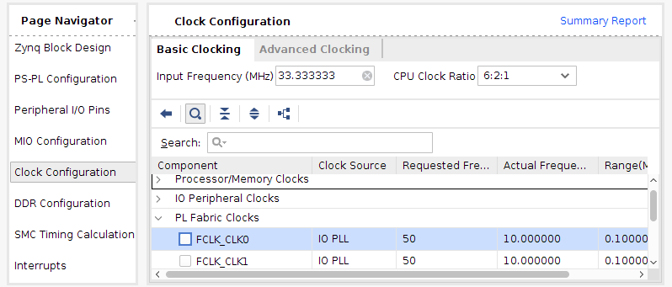
Note: There are few cases in which the FCLK_CLK0 is not used, this case is one of them. In the next labs we will be using FCLK_CLK0 and we will activate it.
- Next, click on the PS-PL Configuration option, expand General, then Enable Clock Resets, then de-select FCLK_RESET0_N.
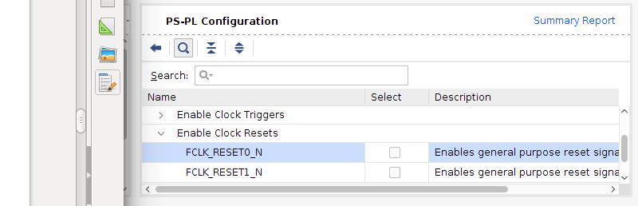
- Next, in the same PS-PL Configuration options (just below of Enable Clock Resets), expand AXI Non Secure Enablement, then expand GP Master AXI Interface and de-select M AXI GP0 Interface. Again, this is a special case where there is no logic in the PL, therefore there is no need for PS-PL interface, we will use this interface in upcoming labs.
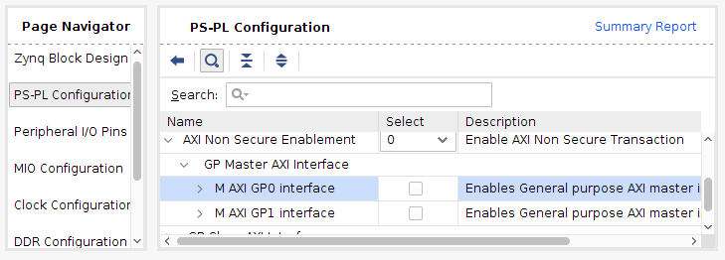
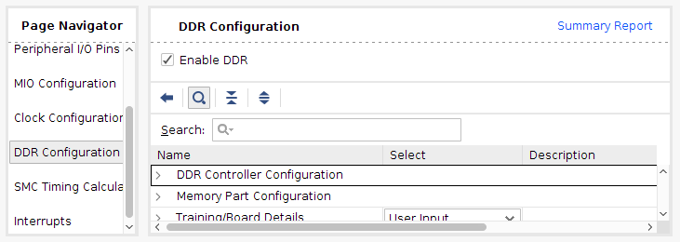
- In the DDR Configuration option, be sure that the Enable DDR configuration is selected.
- Click OK to exit the PS customization window.
- Back in the block design canvas of the project, you will notice that the ZYNQ7 Processing System block diagram has been simplified due to de-selecting the options mentioned earlier (comparing it with figure in step 9).
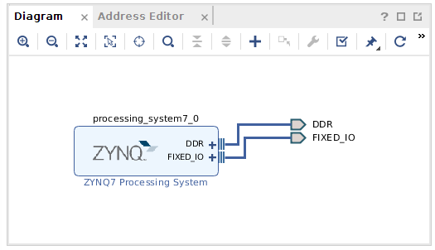
Notice that the FIXED_IO and the DDR are now connected to output ports (they are connected to the peripherals and to the DDR memory). This automatic connection is due to the fact that this project was configured initially targeting the ZedBoard, therefore Vivado Design Suite knows which are the Zynq I/O Pins connected to peripherals and memories.
- To get a nicer block diagram, you can click on the Regenerate Layout Icon
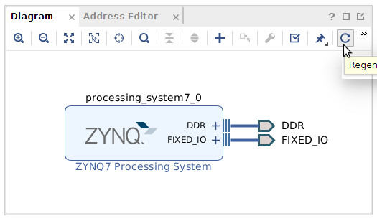
This regenerate icon will be very useful when building complicated block designs.
- Click the Save button to save the current block diagram.
- Select Tools-> Validate Design, or click in the icon, to check any possible error while creating the block diagram. There should be no warnings or errors.
- In the central pane, click on the Sources tab. The lab1_hw.bd (board design) file contains all the settings and configuration of the block diagram created in the block diagram editor window. Right click on lab1_hw.bd and select Generate Output Products. Leave the options as defaults, then click Generate. Click OK in the upcoming window.
- Right click on lab1_hw.bd and select Create HDL Wrapper to create the top level VHDL/Verilog file from the block diagram.
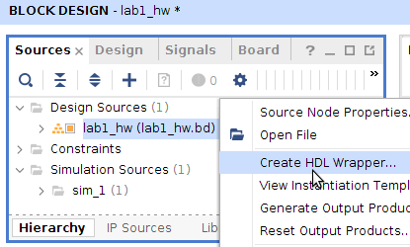
In the Create HDL Wrapper window make sure you select the “Let Vivado manage wrapper and auto-update” option to generate the VHLD/Verilog file. This will let Vivado update the HDL wrapper when you change the block diagram design. Click OK to generate the wrapper.
- Notice that lab1_hw_wrapper.vhd (or .v, depending on the HDL type selected during project definition) was created and placed at the top of the design sources hierarchy.
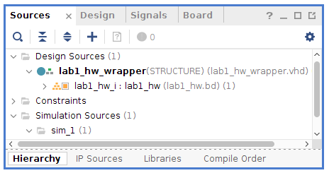
The Zynq PS Hardware has now successfully generated. Since there are no additional HDL sources to add to the design, the hardware can be exported directly to the SDK.
- Click File > Export > Export Hardware. The Export Hardware dialog box opens. Leave the Include Bitstream box unchecked since there is not logic in the PL to be configured. Click Save in case you are asked. Also, leave the Export option with the default directory that is showed. Click OK to continue.
Note: you might get an error message similar to this:
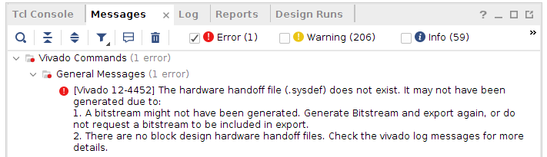
This error is to the fact we have not generated a bitstream file (file that is used to program the PL part of the Zynq), since in this particular lab we do not use the PL, we do not generate the bitstream, therefore, we can skip this error message.
- Click File > Launch SDK. The Launch SDK dialog box opens. Click OK to continue (leave the default values). If prompted, click Save to save the project. Important: keep open the block design while lunching SDK.

Create an Application Project in SDK
Part 3- Objective | Create a ‘Hello World” application in SDK.
- Let’s review what we just have done:
The Vivado design tool exported the Hardware Platform Specification of the project design (system.hdf in this case) to the SDK. In addition to system.hdf, there are four more files relevant to SDK got created and exported. They are ps7_init.c, ps7_init.h, ps7_init.tcl, and ps7_init.html.
The ps7_init.c and ps7_init.h files contain the initialization code for the Zynq Processing System and initialization settings for DDR, clocks, PLLs, and MIOs. SDK uses these files to initialize the processing system (PS) so that the applications can be run using the configured processing system peripherals.
The system.hdf file opens by default when SDK is launched. The address map of your system read from this file.
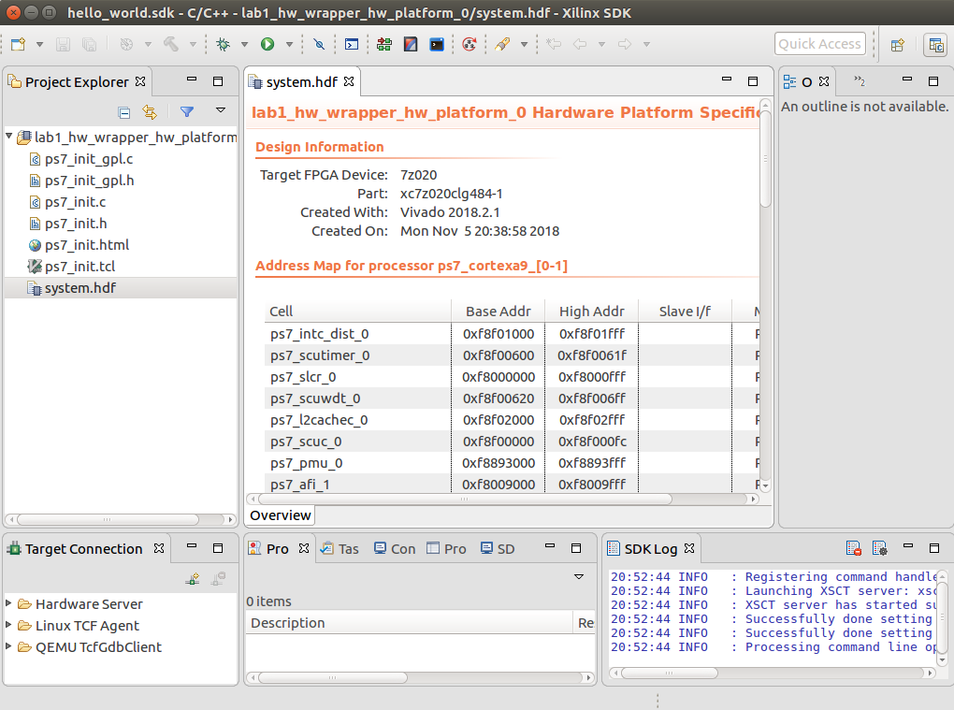
- Select File -> New -> Application Project. To create the new application use the following information:
Wizard Screen | System Property | Setting
New Application Project | Project Name | hello_word_sdk
New Application Project | Used default location | Check this option
New Application Project | OS Platform | Standalone
New Application Project | Hardware Platform | system_wrapper_hw_platform_0
New Application Project | Processor | ps7_cortexa9_0
New Application Project | Language | C
New Application Project | Board Support Package | Create New: hello_world_bsp
Click Next
Templates | Available Templates | Hello World
- The following figures details how to write the respective settings:
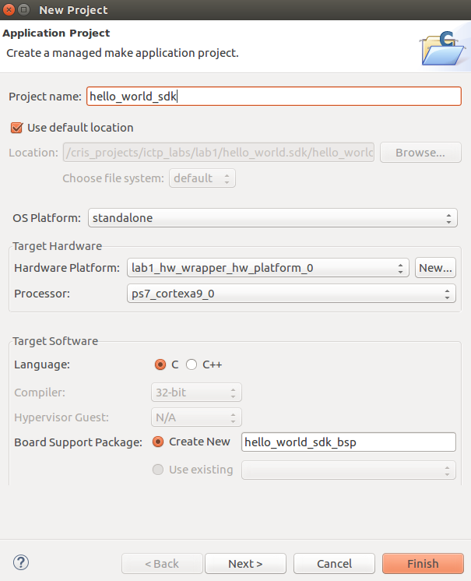
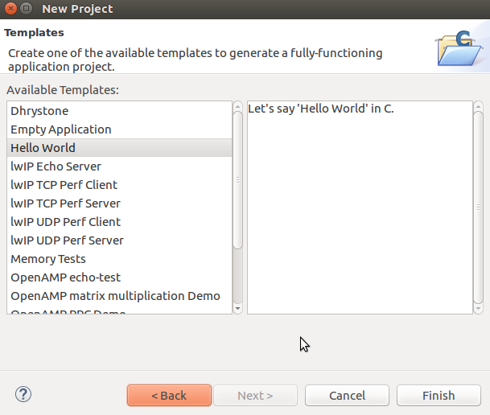
- After clicking the Finish button, SDK automatically begins building the application. On the bottom left part of the main window there is a small indicator about this process.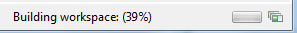
- In this step the Board Support Package (BSP) and the necessary ‘C’ code for the ‘Hello World’ has been created. BSPs contain drivers, libraries, and essentially anything else, which will allow the software applications to access features on the hardware.
- While the application is being built, watch the messages in the Console window. When the project is successfully built, the following message should be read “Build Finished”. Hence, the application and its BSP are both compiled and the *.elf is generated (*.elf is the file that will be downloaded into the PS memory to execute the ‘C’ file). The information provided by *.size gives an idea of the code size.
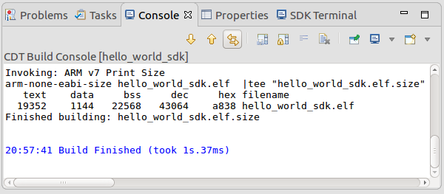
- In the Project Explorer pane, on the left side of the screen, you will now see three folders: hello_world, hello_world_bsp, and the lab1_wrapper_hw_platform. The hello_world folder contains the necessary files for the application itself. For instance, expand the folder, and find the src sub-folder, then double click on the helloworld.c file. Tthe respective ‘C’ code will be displayed in the edit window. This file contains the main( ) function. Likewise, expand the “hello_world_bsp” folder, and continue to expand the yellow folders until you see the “include” folder. Open this folder and you will see a list of header (.h) files which holds all of the drivers that you will need to develop your software application.
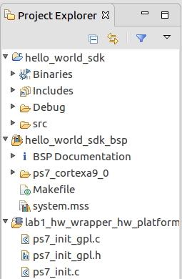

Connecting the ZedBoard
Part 4- Objective | Steps to connect the ZedBoard to run the application.
- Connect a USB micro cable between the Windows/Linux Host machine and the ZedBoard JTAG J17 (on the right side of the power connector). This connection will be used to configure the PL (in this particular Lab there is no need for this connection, since there is not PL configuration file, bitstream file, but in all the other Labs this connection will be used).
- Connect a USB micro cable to the USB UART connector (J14) on the ZedBoard (on the left side of the power switch), with the Windows/Linux Host machine. This connection will be used to carry out the serial message/data transfer between the ZedBoard and the host machine.
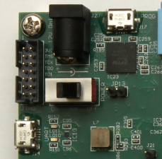
IMPORTANT 1: Ensure that jumpers JP7 to JP11 are set as shown in the figure below for the JTAG configuration mode.
J17
J14
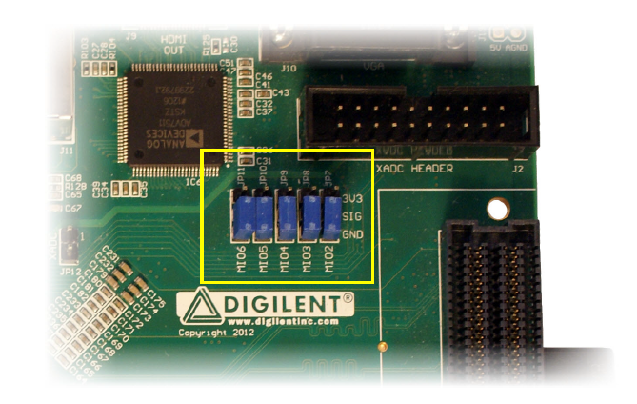
IMPORTANT 2: be sure to already have installed the Cypress device driver for the USB-UART chip on the ZedBoard.
- Check the jumper setting for J18 in the bottom right corner of the board. The jumper should be set to 2.5V, which is marked as “2V5” on the board.
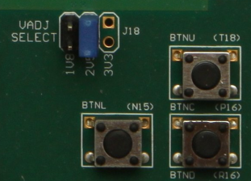
- Connect the 12V AC/DC converter power cable to the ZedBoard barrel jack.
- Power-on the board using the ZedBoard Power switch. Check that the Power LED on the board (green LED) is on. Note, in some instances the board needs to be ON before the SDK launches in order for the SDK to see which COM port is being used by the OS.
- To find out which COM port has been assigned to the UART connection, use the Control Panel->Device Manager Windows utility. An example is shown as follow.
Power Switch
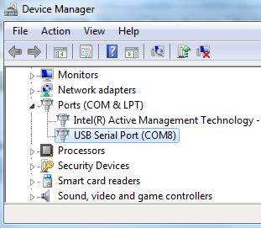
- Setting up the serial utility software:
  - Use a utility program such as Tera Term or Putty to setup a serial communication between the Host and the ZedBoard, by using the Host COM port.
For the Tera Term configuration, first select Serial as communication protocol, and from the pull down menu select the Port to be used. Then Serial
Important: In case that there is no “USB Serial Port ……” option from the Port pull down menu, first check that the board is On, then check whether the serial port is detected by the operative system, e.g. in Windows use the Device Manager utility. In case that no serial port is detected, re-install the Cypress device driver for the USB-UART chip on the ZedBoard.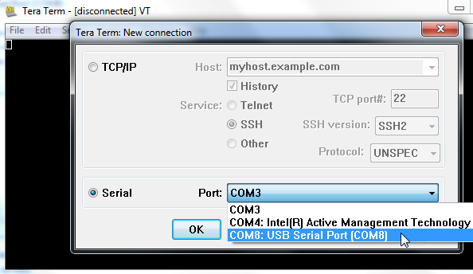
  - Select Setup → Serial Port.
  - Configure the Serial port of the Tera Term or the software you are using, with the values detailed in the following figure.
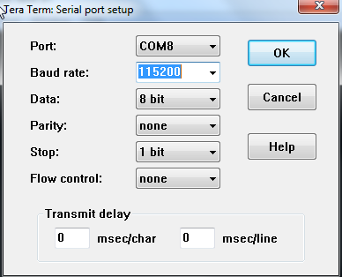

Executing the Application in the ZedBoard
Part 5- Objective | Executing the ‘C’ application in the Zynq.
- On the Project Explorer pane, select the hello_world application, and then right click mouse and select Run As -> Launch on Hardware (GDB).
- On the bottom right part of the main window there is a bar indicating that the programming file, .elf, is being downloaded into the internal memory.
- Once it is done, the program will be automatically executed. Hence, in the Tera Term window the “Hello World” message should be displayed.
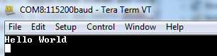

Some Points to Keep in Mind
- For this particular application, since there is no hardware in the PL, there is no need of configuring the PL. Hence, no bitstream download is required.
- All the initialization routines needed for the ARM Cortex-A9 are automatically created, there is no need for the designer to create them.
- The Board Support Package (BSP) is the support code for a given hardware platform or board. It initializes the board, ZedBoard, at power up to allow the software applications execute on the platform. It can be specific to some operating systems with bootloader and device drivers.
- Standalone applications do not utilize an Operating System (OS). They are sometimes also referred to as bare-metal applications. Standalone applications have access to basic processor features such as caches, interrupts, exceptions as well as other simple features specific to the processor. These basic features include standard input/output, profiling, abort, and exit. It is a single threaded semi-hosted environment. Almost all the Labs of this part of the Workshop will be standalone applications.

Challenges
- Modify the ‘C’ code of the main function to use the printf function instead of print. Find out how much memory bits are needed in each case.
- Modify the ‘C’ code of the main function to use the xil_printf function instead of printf. Find out how much memory is needed for the original code and how much is needed for the code with the xil_printf function.
- Use the optimization per size option of the C/C++ Build Settings. Repeat the previous two processes and find out the respective sizes.

Section II

Memory Test Application
Objective | Create a new PS7 based design in Vivado, then a ‘C’ application based in the pre-defined memory test.

- Follow the steps detailed in the Section I of this lab to build a PS7 based block design similar to the one shown in the figure below. Name the design as “lab1_mem_test.
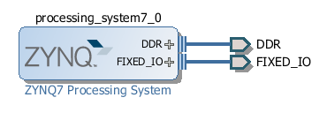
- Create the wrapper.
- Generate the block design.
- Export the hardware design.
- Lunch the SDK.
- In the SDK environment create a new application project with the name “lab1_memory_test_sdk”
- In the templates window select the “Memory Test” option.
- Follow the necessary steps to connect and power the board as it was explained before.
- Execute the ‘C’ code (as it was explained before).
- Open and configure the serial terminal (Putty, TeraTerm, etc).
- You should obtain a result window similar to this one:
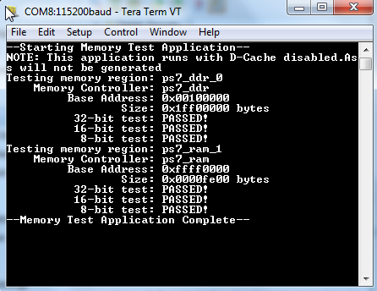
- Execute the ‘C’ code step by step. Go into the for-loop to try to understand the different functions executed inside the loop.
- Insert a print or xil_printf to print out your name and lab number in the result window.
- Try to find out the size of the ‘C’ code.

Conclusion
First steps to create a simple design of the Zynq. Only the PS part is used in this lab. The PS was added and configured according to the requirements. An SDK based application project was created and a simple ‘C’ code executed to display the ‘Hello World’ phrase on the UART terminal software.

