Modeling summary

Our model contains two types of variables: costs and rewards.

Costs … [we already say all of this in the paper. The only thing we do not explain is that the exploration cost is the expected number of actions *assuming* that the agent begins exploring the simplest hypothesis space and progressively moves on to more complex hypotheses].

We treated rewards as variable across agents. Our empirical data suggested that 80% of children (20 out of 25) determined that the light-up effect was better than the music. There are two ways to capture this difference, and our model is robust to both approaches.

The first approach consists in using different ranges of rewards for each effect. Thus, children’s preference for the light-up toy reflects that children tend to assign reward values to that effect that the music effect cannot ever reach.

The second approach consists of setting an identical range of rewards to both effects, but manipulating the distribution over these rewards such that the music effect has a higher reward than the light up effect 80% of the time.

Method 1.

[This is what we had already done].

Below we present the model predictions as a function of the probability of exploration.

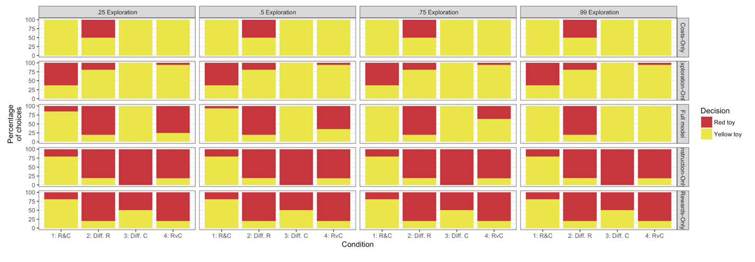

As a 50% chance of probability of exploration, we then varied the noise parameter that we used to compute likelihoods. The noise parameter allows us to compute the likelihood of models that make extreme predictions. For instance, if one model predicts that all children should choose the yellow toy, then the likelihood of even a single child choosing the red toy is 0, and thus, the likelihood would be 0 unless we introduced a small probability of distraction.

At a 1% noise level, the full model was 4 times more likely to generate the data than any alternative model.

At a 5% noise level, the full model was over 190 times more likely to generate the data than any alternative model.

At a 10% noise level, the full model was 1e4 times more likely to generate the data than any alternative model.

At a 20% noise level, the full model was 1000 times more likely likely to generate the data than any alternative model.

At a 30% noise level, the full model was 55 times more likely to generate the data than any alternative model.

At a 40% noise level, the full model was 9 times more likely to generate the data than any alternative model.

At a 50% noise level, the full model was 2.5 times more likely to generate the data than any alternative model.

That is, for all levels of noise, our full model outperformed all models. Only when we assumed that 50% of children were responding randomly did we find weak evidence that the costs-only model may better explain children’s responses.

Below we summarize this data presenting the ratio of the log-likelihoods.

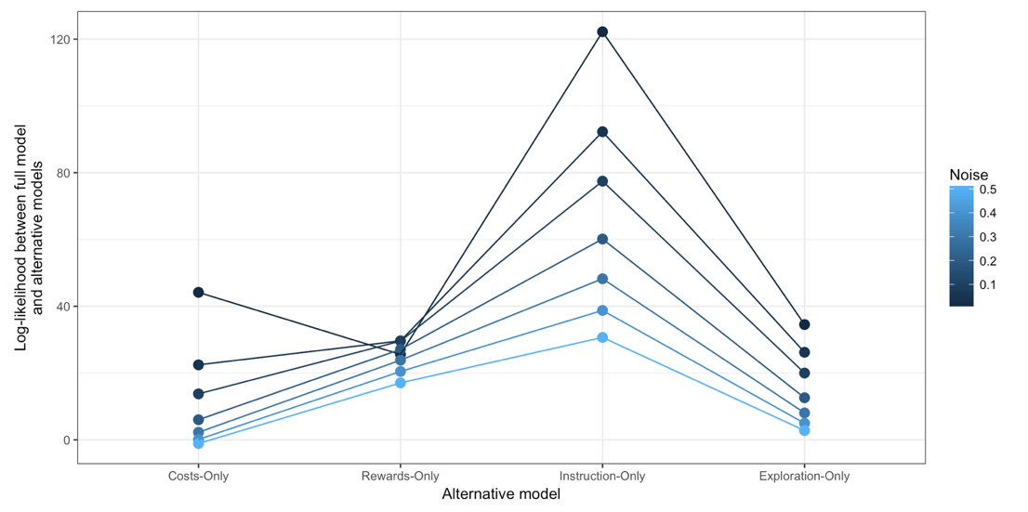

Method 2.

The second method is to assume that both effects have the same space of reward magnitudes, but that one effect in general has a higher reward than the other.

To model this, we used a Beta distribution extended over the range from 0 to 45 (for the same reason we used a limit of 45 in the reward range as above). Beta distributions are useful because they can create continuous distributions which are bounded (unlike Gaussian distributions), and these distributions can be asymmetric, with one tail falling more quickly than the other.

Beta distributions are determined by two parameters: alpha and beta. We searched for the parameters of two beta distributions such that the probability that a sample from the light-up reward space would be higher than a sample from the music reward space 80% of the time. For simplicity, we only considered distributions that were mirror images of each other. That is, we assumed that one distribution had parameters (x,y) and the second distribution had parameters (y,x). This simplifies the search over parameters. Searching over the space of alpha and beta values ranging from 1 to 10.

For any pair of parameters, we assessed the fit through Monte Carlo sampling. As such, we could not compute the exact probability that sample from the first distribution would be higher than a sample from the second distribution. Thus, any set of parameters where the Monte Carlo estimate feel between 75% and 85% was considered to fit our data. The figure below shows the results from this parameter search:

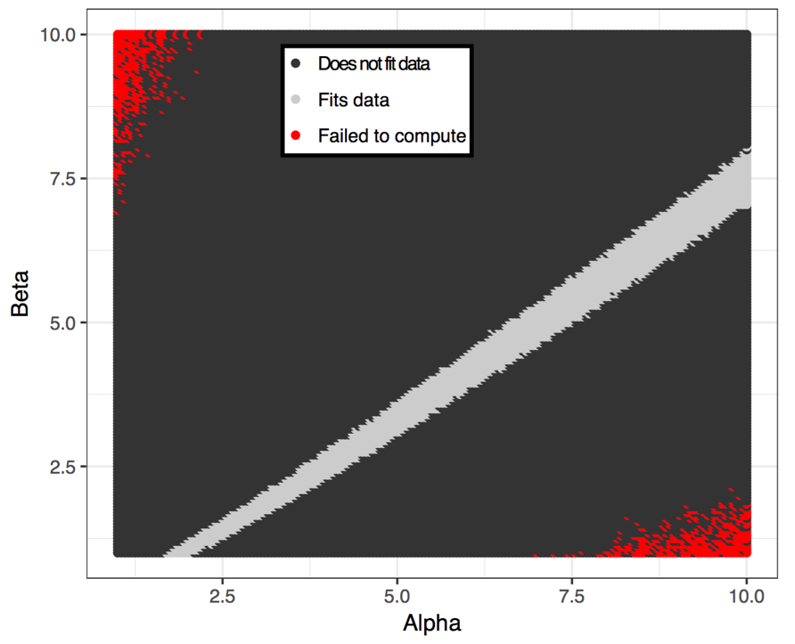

To ensure that our model results were consistent at different points of the grey strip that fits our data, we tested the model at three different points: the left end of the strip, the middle of the strip, and the right end of the strip.

On the left end we used parameters alpha=1.875, beta=1 (the middle alpha parameter when beta = 1):

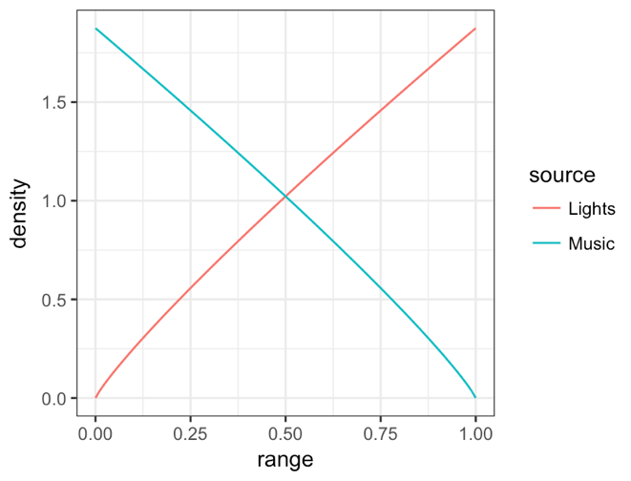

In the middle range, we tested parameters alpha=6, and beta = 4.15:

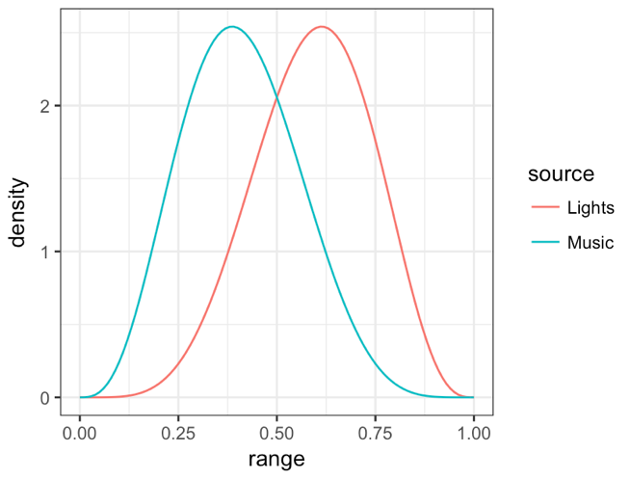

On the right range, we tested parameters alpha=10, beta=7.5274:

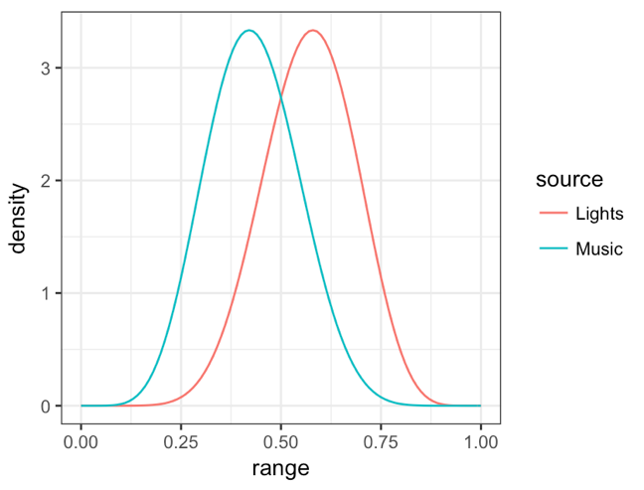

Under any of these three reward distributions, we would expect around 80% of children to prefer the light toy over the music toy. We henceforth call these models, the left, middle, and right models (because of the area where the alpha parameter is located).

Left model:

Below we present the model predictions as a function of the probability of exploration.

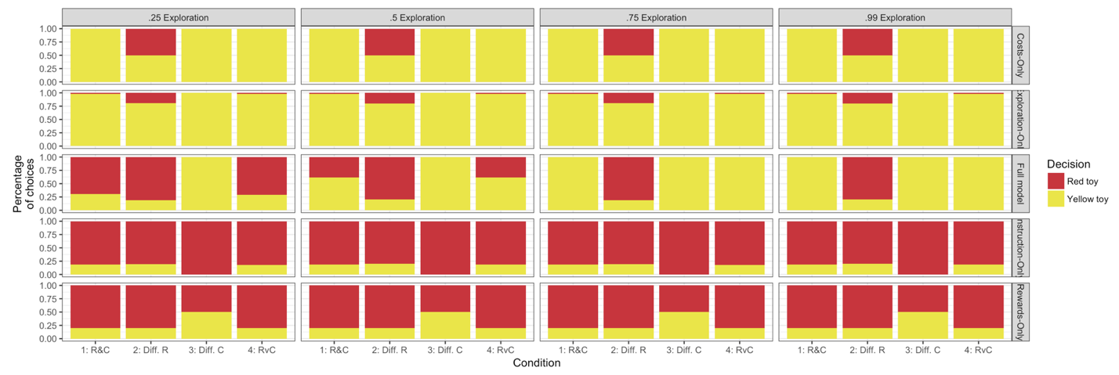

As a 50% chance of probability of exploration, we then varied the noise parameter that we used to compute likelihoods.

At a 1% noise level, the full model was over 1e11 times more likely to generate the data than any alternative model.

At a 5% noise level, the full model was over 5e9 times more likely to generate the data than any alternative model.

At a 10% noise level, the full model was 9e5 times more likely to generate the data than any alternative model.

At a 20% noise level, the full model was 400 times more likely likely to generate the data than any alternative model.

At a 30% noise level, the full model was 9 times more likely to generate the data than any alternative model.

At a 40% noise level, the full model was 1.3 times more likely to generate the data than any alternative model.

At a 50% noise level, the full model was 16 times more likely to generate the data than the rewards-only, the instruction-only, and the exploration-only model, but the costs-only model was 3 times more likely to generate the data relative to the full model.

That is, for all levels of noise, our full model outperformed all models. Only when we assumed that 50% of children were responding randomly did we find weak evidence that the costs-only model may better explain children’s responses.

Below we summarize this data presenting the ratio of the log-likelihoods.



Middle model:

The analyses are the same as presented for the left model.

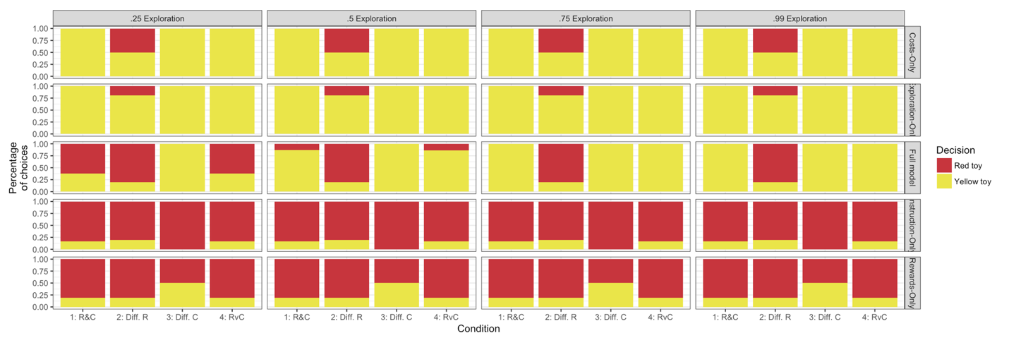

As a 50% chance of probability of exploration, we then varied the noise parameter that we used to compute likelihoods.

At a 1% noise level, the full model was over 4e10 times more likely to generate the data than any alternative model.

At a 5% noise level, the full model was over 1e9 times more likely to generate the data than any alternative model.

At a 10% noise level, the full model was 6e5 times more likely to generate the data than any alternative model.

At a 20% noise level, the full model was 1000 times more likely likely to generate the data than any alternative model.

At a 30% noise level, the full model was 69 times more likely to generate the data than any alternative model.

At a 40% noise level, the full model was 14 times more likely to generate the data than any alternative model.

At a 50% noise level, the full model was 5 times more likely to generate the data than any alternative model.

Below we summarize this data presenting the ratio of the log-likelihoods. All points above 0, showing that the full model outperforms all alternative models for a wide range of noise parameters.

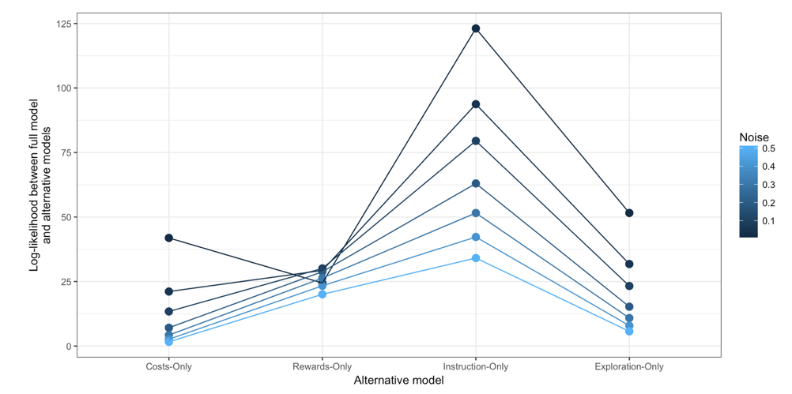

Right model:

Below we present the model predictions as a function of the probability of exploration.

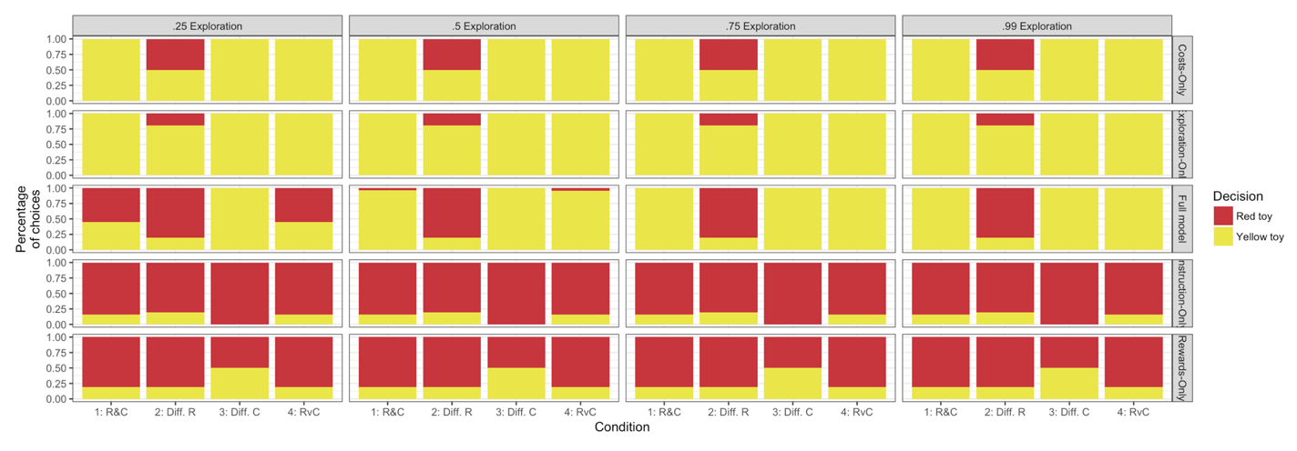

As a 50% chance of probability of exploration, we then varied the noise parameter that we used to compute likelihoods.

At a 1% noise level, the full model was over 3.42e5 times more likely to generate the data than any alternative model.

At a 5% noise level, the full model was over 3.47e5 times more likely to generate the data than any alternative model.

At a 10% noise level, the full model was 1.905e3 times more likely to generate the data than any alternative model.

At a 20% noise level, the full model was 62 times more likely likely to generate the data than any alternative model.

At a 30% noise level, the full model was 17.7 times more likely to generate the data than any alternative model.

At a 40% noise level, the full model was 9 times more likely to generate the data than any alternative model.

At a 50% noise level, the full model was 5.78 times more likely to generate the data than any alternative model.

Below we summarize this data presenting the ratio of the log-likelihoods. All points above 0, showing that the full model outperforms all alternative models for a wide range of noise parameters.

