Nama : Julian Jie

NPM : 2327250024

UTS Pemrograman Web II

* Pengujian POSTMAN GET (local)  
  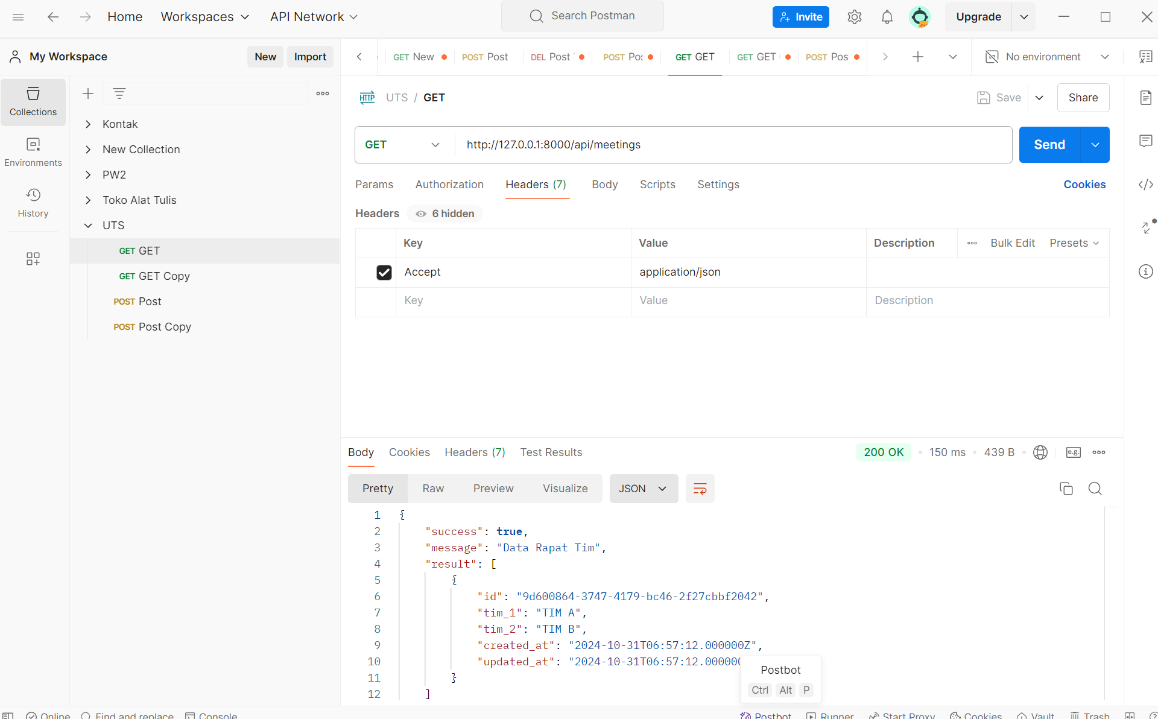
* Pengujian POSTMAN POST (local)  
  A screenshot of a computer

  Description automatically generated
* Pengujian POSTMAN GET (vercel)  
  A screenshot of a computer

  Description automatically generated
* Pengujian POSTMAN POST (vercel)  
  A screenshot of a computer

  Description automatically generated
* Table pada phpMyAdmin clever cloud  
  A screenshot of a computer

  Description automatically generated
* React Home  
  A white background with black text

  Description automatically generated
* React /meeting  
  A screenshot of a computer

  Description automatically generated
* React/meeting/create  
  A screenshot of a computer

  Description automatically generated