|  |  |  |
| --- | --- | --- |
| Christian-Albrechts-Universität zu Kiel, 24098 Kiel  Grazia Iaffaldona  **BMC Neuroscience** | | Institut für Psychologie  Biologische Psychologie  Hausanschrift:  Olshausenstraße 62 - R. 306  24118 Kiel  http://www.biopsych.uni-kiel.de/ |
| **Bearbeiter/in, Zeichen**  Prof. Dr. Julian Keil | **Mail, Telefon, Fax**  keil@psychologie.uni-kiel.de  Tel +49(0)431-880-4872  Fax +49(0)431-880-1829 | **Datum**  05.09.2022 |

**Characterization of the planarian surface electroencephalogram**

Dear Dr. Iaffaldona,

We hereby submit our recent work on the neural activity of the planarian *Schmidtea mediterranea* for publication in BMC Neuroscience. In the current manuscript, we summarize the results from experiments on the electrophysiological activity of simple nervous systems. We aimed to establish a recording protocol to record ongoing neural activity safely and securely from alive and healthy planarians under different lighting conditions. As a replication and critical extension of the results by Aoki and colleagues (2009), we hypothesized that the ongoing neural activity is characterized by a 1/fx power spectrum, and that changes in lighting will induce changes in neural activity due to the reported photophobia. We could successfully confirm these hypotheses, which paves the way to continuous recordings across longer intervals, and repeated recordings from the same animals to study cognitive processes.

We believe that the current results are of great interest to the neuroscience research community, to scientists working on animal cognition, and to researchers studying neural oscillations. All data and code to reproduce the analyses is available on GitHub (https://github.com/juliankeil/Planarian), and the manuscript is not under consideration elsewhere.

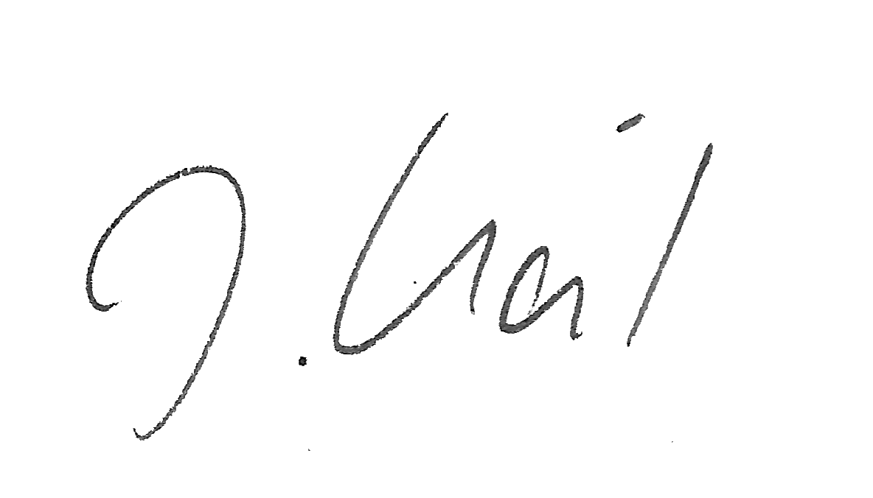Best regards, also on behalf of the co-authors,

Julian Keil