**Title**

Characterization of the planarian surface electroencephalogram

**Autors**

Jannes Freiberg, Lukas Lang, Christian Kaernbach, Julian Keil

**Affiliation**

Department of Psychology, Kiel University, Kiel, Germany

**Corresponding Author**

Julian Keil

Department of Psychology

Christian-Albrechts-University Kiel

Olshausenstrasse 62

24118 Kiel

[keil@psychologie.uni-kiel.de](mailto:keil@psychologie.uni-kiel.de)

**Declarations**

**Ethics approval**

Approval from the ethics committee of the Christian-Albrechts-University Kiel was waived by the ethics committee. No animals were harmed in the experiments described here.

**Consent for publication**

Not applicable

**Availability of data and materials**

Following acceptance, all data and analysis scripts will be uploaded to osf.io. For review purposes, they are available at https://github.com/juliankeil/Planarian

**Competing interests**

The authors declare that they have no competing interests.

**Funding**

JF has been funded by the Deutsche Forschungsgemeinschaft (DFG, German Research Foundation) – Project-ID 434434223 – CRC 1461

**Authors' contributions**

JF planned the experiments, prepared the materials and animals, conducted the recordings, analyzed the data, and prepared the manuscript. LL prepared the materials and animals, conducted the recordings, analyzed the data, and prepared the manuscript. CK planned the experiments and prepared the manuscript. JK planned the experiments, analyzed the data, and prepared the manuscript.

**Acknowledgements**

We thank Maren Eberle for her help in the preparation of the experiment.

**Abstract**

**Background:** Despite large morphological differences between the nervous systems of lower animals and humans, striking functional similarities have been reported. However, little is known about how these functional similarities translate to cognitive similarities. As a first step towards studying the cognitive abilities of simple nervous systems, we here characterize the ongoing electrophysiological activity of the planarian *Schmidtea mediterranea.* One previous report using invasive microelectrodes describes that the ongoing neural activity is characterized by a 1/fx power spectrum with the exponent ‘x’ of the power spectrum close to 1. To extend these findings, we aimed to establish a recording protocol to measure ongoing neural activity safely and securely from alive and healthy planarians under different lighting conditions using non-invasive surface electrodes.

**Results:** As a replication and extension of the previous results, we show that the ongoing neural activity is characterized by a 1/fx power spectrum, that the exponent ‘x’ in living planarians is close to 1, and that changes in lighting induce changes in neural activity likely due to the planarian photophobia.

**Conclusions:** We confirm the existence of continuous EEG activity in planarians and show that it is possible to noninvasively record this activity with surface wire electrodes. This opens up broad possibilities for continuous recordings across longer intervals, and repeated recordings from the same animals to study cognitive processes.

**Keywords**

Neural Oscillation, 1/f law, aperiodic component, planarian, animal cognition

**1. Background**

Comparative cognitive science often strives to examine peak performance in different species [1]. To successfully reproduce biological intelligence in artificial intelligence, it might be more constructive to examine the cognitive functions of lower animals [2]. This will then allow testing activity patterns related to stimulus processing and cognition, as well as the reproduction of these patterns in artificial neural networks. A first step into this direction is the characterization of the ongoing electrophysiological activity of such lower animals. Remarkably, [3] already recorded synchronized neural responses in the optic nerve of a water beetle. Despite large morphological differences between the nervous systems of lower animals and humans, striking similarities have since then become evident [4]. For example, honeybees show neural oscillations with a similar functional profile as the prominent human 10 Hz alpha oscillation [5]. Moreover, Aoki et al. [6] were able to record neural activity from the planarian flatworm *Schmidtea mediterranea.* Whereas these previous experiments were able to record a rich spectrum of neural activity, they involved decapitating the animals, opening the head capsule, or implanting invasive electrodes into the ganglia. To facilitate the recording of ongoing neural activity, ensure animal welfare and enable repeated recordings of the same animals (e.g., before and after learning), noninvasive recordings are necessary. The aim of the current experiment was to demonstrate the possibility to record neural activity safely and quickly from the planarian *Schmidtea mediterranea* without harming the animals.

The planarian *Schmidtea mediterranea*, formerly called *Dugesia mediterranea* is a small, approximately 20 mm long and 2 mm wide freshwater turbellarian of the order Tricladida, usually found around the Mediterranean Sea [7]. In research, they are often used as model organisms due to their ability to regenerate the central nervous system (CNS) even from small pieces of the body within a short period of time [8]. This planarian is one of the simplest animals with a bilateral body plan and cephalization [9]. Its CNS itself comprises two lobed cephalic ganglia connected by the anterior commissure, which can be considered the most primitive brain in animal evolution. In addition, a pair of ventral nervous cords run the length of the animal, and both cords are connected by transverse commissures [10]. The cephalic ganglia appear to be remarkably complex, and using direct recordings from electrodes implanted in the ganglia Aoki and colleagues [6] were able to record ongoing neural activity characterized by a 1/fx power spectrum with the exponent ‘x’ of the power spectrum close to 1. *Schmidtea mediterranea* can therefore be regarded as a primitive model organism for the human nervous system.

Whereas the CNS of *Schmidtea mediterranea* is comparatively simple with only approximately 50000 neurons, and resembles that of the early developmental stages of the CNS of vertebrates [11], the animal is nevertheless capable of complex behavior, learning and memory [12]. For example, the animal shows long term memory in the form of environmental familiarization, which persists across two weeks and even across regeneration of the cephalic ganglia [13]. Moreover, the planarians are mobile, avoid open spaces and are negatively phototactic [14], which promises at least basic cognitive capabilities such as sensory discrimination and decision making. While previous research showed ongoing neural activity, the cognitive ability to discriminate stimuli, and form long-term memory, it is currently unknown how these cognitive abilities are reflected in neural activity. As a first step towards shedding light on this issue, we here aimed to establish a recording protocol to record ongoing neural activity safely and securely from alive and healthy planarians under different lighting conditions. As a replication of the results by Aoki and colleagues [6], we hypothesized that the ongoing neural activity is characterized by a 1/fx power spectrum with an exponent ‘x’ close to 1, and that changes in lighting will induce changes in neural activity due to the reported photophobia.

**2. Methods**

The aim of the current experiment was to establish a recording protocol to noninvasively measure ongoing neural activity from live planarians without harming the animals. To this end, we developed a recording chamber and used a mobile electroencephalography (EEG) device to record the electrical signal from planarians in darkness, under light, and from dead mosquito larvae as a control group.

**2.1 Animal characteristics**

Overall, we collected data from 36 planarians of the asexual strain of the species *Schmidtea mediterranea*. Because we were usure how the animals would respond to the experimental setting and to limit the stress on the individual animals, we chose a between-subjects design with 17 planarians recorded during darkness, and 19 recorded under illumination. All planarians were bred for laboratory use and reared in our dedicated breeding facility at the Christian-Albrechts-University Kiel. As a control group to test how the recording setup responds to environmental noise, we recorded data from six red mosquito larvae purchased as food for our planarians.

**2.2 Recording environment**

All recordings took place in the animal laboratories of the department of psychology at the Christian-Albrechts-University Kiel and were conducted by instructed student assistants supervised by specifically trained PhD students. In the first step, we designed and built a 3D-printed recording chamber to hold the electrodes and the planarians (Figure 1). As electrodes, we used wire electroretinography electrodes. The ongoing electric activity was recorded from a mobile EEG amplifier (mBrainTrain Smarting), and each electrode was referenced to the same reference electrode (bipolar montage). The animals were enclosed in agarose gel (Roth, cooled down to 45°C) and placed on top of the wire electrodes, so that the recording electrode was close to the head, and the reference electrode was close to the tail of the animal (Figure 1). Please note that the mosquito larvae covered multiple recording electrodes, and these multiple electrodes were treated as independent recordings in the data analysis. The animals stayed on top of the electrodes for approximately 10 minutes, after which they were rinsed off to free them from the agarose gel.

**2.3 Stimulation protocol**

The current experiment comprised a between-subjects design with three groups. One group of planarians was recorded during darkness. The animals were enclosed in agarose gel and placed on the wire electrodes, afterwards the recording chamber as well as the EEG amplifier were covered with a mason tub (0 Lux) and the EEG data were recorded for 10 minutes. The second group of planarians was recorded during light stimulation. As in the first group, the animals were enclosed in agarose gel and placed on the wire electrodes under ambient lighting. In this group, a light source (35 W Grow Light Bulb) 43 cm above the animals was switched on (approx. 40000 Lux), and the EEG data were recorded for 10 minutes. The third group comprised dead mosquito larvae, which were placed on the wire electrodes without enclosing in agarose gel, and the EEG data were again recorded for 10 minutes.

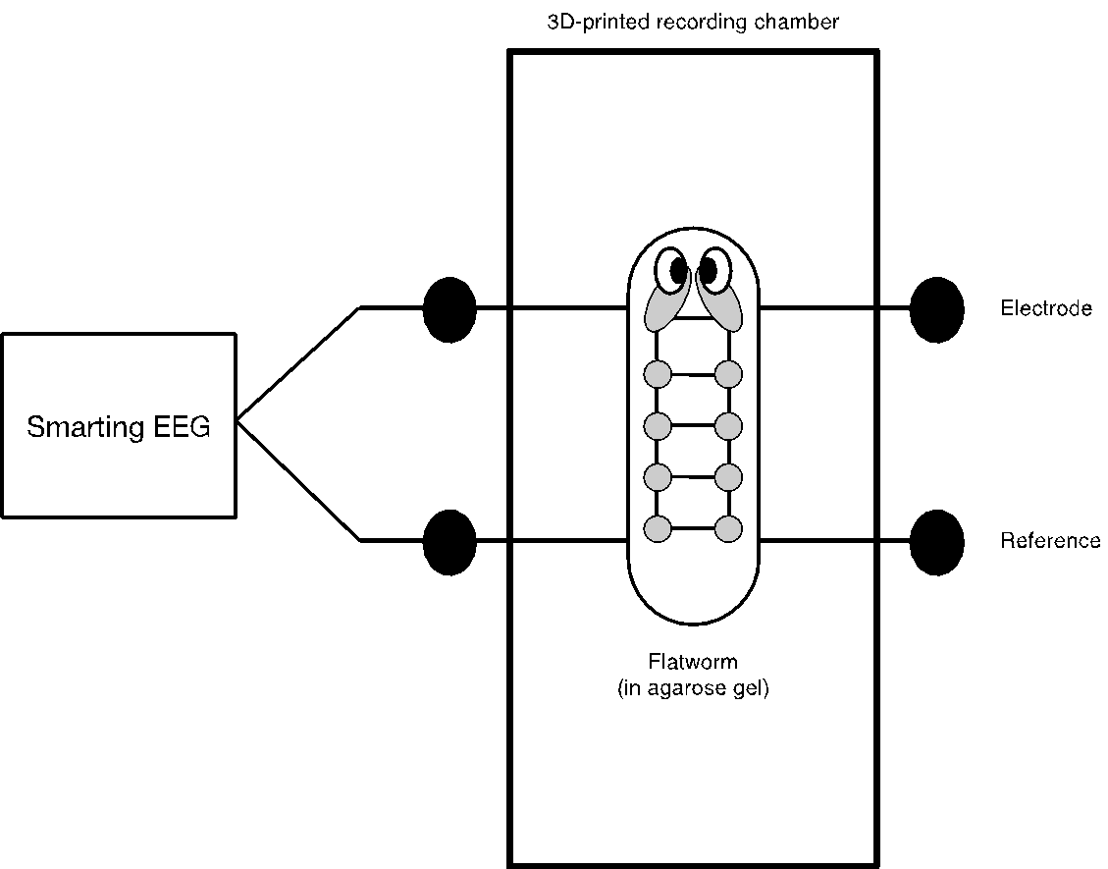

*Figure 1: Schematic overview of the recording environment. The animal is fixated in agarose gel and placed on top of wire electroretinography electrodes. The electrodes are held in place in a 3D-printed recording chamber and are connected to a mobile EEG recording device.*

**2.4 Data processing**

In the current experiment, we recorded continuous EEG at a sample rate of 500 Hz at 24 bits resolution with a bandwidth of 0-250 Hz and one common reference electrode for 10 minutes. All raw data and data analysis scripts are available on GitHub (<https://github.com/juliankeil/Planarian>). All data analyses were performed in Matlab using the Fieldtrip toolbox [15] and custom-written code (<https://github.com/juliankeil/VirtualTools>). The entire data for each recording was imported into Matlab and filtered using two-pass Hamming-windowed FIR filters, with an order of 8250, a -6 dB cutoff frequency of 0.1 Hz, and a passband edge of 0.2 Hz for the high pass and an order of 288, a -6 dB cutoff frequency of 23 Hz, and a pass- band edge of 20.1 Hz for the low pass. The 23 Hz low-pass filter was chosen due to the high contamination with environmental noise at harmonic frequencies of the power line frequency. Moreover, Aoki et al. [6] report continuous spectra across the 0.1 - 5 Hz range. Subsequently, the first and last 500 ms of each dataset were removed to avoid edge artifacts, and the entire dataset was cut into non-overlapping 6 s segments. In order to automatically and reproducibly remove artifacts from the data, we then computed the mean signal amplitude for each channel and trial and removed channels and trials with peaks 5 standard deviations above or below the mean signal amplitude. Moreover, channels and trials were removed if they exceeded a threshold of 2.5 standard deviations above the mean variance, z-value, or kurtosis across channels and trials. If at least one channel and more than 5 data segments survived the automatic artifact removal, spectral power and the exponent ‘x’ of the 1/fx power spectrum (i.e., the so-called aperiodic component, [16]) were estimated using a multitaper fast Fourier transform with discrete prolate spheroidal sequence (DPSS) tapering with a spectral smoothing of ±1 Hz. The frequency band of 0.5–20 Hz was divided into 23 steps with logarithmic spacing. Using this approach, we obtained 14 datasets for the first group of planarians recorded during darkness, 13 datasets for the second group of planarians recorded during light stimulation, and 18 datasets for the third group of dead mosquito larvae. Please note that the mosquito larvae covered multiple recording electrodes and we treated the single electrodes as independent recordings.

**2.5 Data analysis**

To differentiate neural activity between the three groups, we assessed differences in oscillatory power and the exponent of the power spectrum between the two groups of planarians, and between each group of planarians and the control group of dead mosquito larvae. To correct for multiple testing across the three comparisons, we adjusted the critical alpha-level to 0.01, and used the FDR correction for the correction for multiple comparisons across the different frequencies within each comparison. For each comparison of the power spectra, we conducted a nonparametric permutation test. The experimental test statistic was evaluated against a permutation (10000 permutations) distribution to test the null hypothesis of no difference between the neural activity of the different groups using three two-tailed independent-samples tests. For each of the three comparisons of the exponents, we conducted two-tailed independent-samples t-tests.

**3. Results**

The aim of the current experiment was to record the electrical signal from planarians in darkness, under light, and from dead mosquito larvae as a control group. As a replication of the results by Aoki and colleagues [6], we hypothesized that the ongoing neural activity is characterized by a 1/fx power spectrum, and that changes in lighting will induce changes in neural activity due to the reported photophobia.

**3.1 Power Spectrum Exponent**

In a first step, we estimated the scaling exponent ‘x’ of the individual power spectra, which should follow a 1/fx power law [17]. Larger exponents indicate steeper slopes, a value of 0 would indicate a flat slope, such as in white noise, and the exponent of human EEG is approximately 0.828 [16]. For the first group of planarians recorded during darkness, we found an average exponent of x = 1.30 (SD = 0.58), for the second group of planarians recorded during light stimulation, we found an average exponent of x = 1.17 (SD = 0.59), and for the dead mosquito larvae, we found an average exponent of x = 2.72 (SD = 0.27), as can be discerned from the comparison between power spectra in Figure 2. Whereas the exponents did not differ between the two groups of planarians (t(24.80) = 0.58, p = 0.57, CI = [-0.33, 0.59]), it was significantly smaller for the darkness group compared to the mosquito larvae (t(17.36) = -8.47, p < 0.001, CI = [-1.77 -1.07]), and significantly smaller for the light stimulation group compared to the mosquito larvae (t(15.68) = -8.87, p < 0.001, CI = [-1.92 -1.18]).

**3.2 Oscillatory Activity**

In the second step, we estimated the power of oscillatory activity between 0.5 and 20 Hz with logarithmic frequency spacing. The permutation-based comparison between groups with FDR correction for multiple comparisons indicated that the power of oscillatory activity differed between the planarians recorded during darkness and under light stimulation in a low frequency range between 0.488 and 1.098 Hz and in a higher frequency range between 2.685 and 20.019 Hz (see table 1 for details), as indicated by the green horizontal lines in figure 2. The power spectra from the planarians under light stimulation differed across the entire frequency range from the spectra recorded from the dead mosquito larvae. However, only the power above 5.249 Hz differed between the planarians recorded during darkness and the dead mosquito larvae.

*Table 1: Statistical results for the comparison of oscillatory power between 0.5 and 20 Hz for the three groups (planarians recorded during darkness and under light stimulation, and dead mosquito larvae). T- and p-values result from permutation-based between-groups comparisons, and significance thresholds are FDR corrected for multiple comparisons.*

|  |  |  |  |  |  |  |  |  |  |  |  |  |  |  |  |  |  |  |  |  |  |  |  |
| --- | --- | --- | --- | --- | --- | --- | --- | --- | --- | --- | --- | --- | --- | --- | --- | --- | --- | --- | --- | --- | --- | --- | --- |
| **Freq.** | **0.488** | **0.610** | **0.732** | **0.854** | **0.976** | **1.098** | **1.342** | **1.586** | **1.953** | **2.319** | **2.685** | **3.173** | **3.784** | **4.394** | **5.249** | **6.225** | **7.324** | **8.666** | **10.253** | **12.084** | **14.282** | **16.967** | **20.019** |
| **Dark vs. Light** | | | | | | | | | | | | | | | | | | | | | | | |
| **t-Val.** | -4.2431 | -4.1635 | -4.0608 | -4.1816 | -4.1794 | -4.1483 | -2.4820 | -1.4787 | -2.2176 | -3.1887 | -3.5108 | -3.9447 | -3.6593 | -3.2864 | -2.8099 | -2.5736 | -2.7472 | -3.0757 | -3.4602 | -3.0366 | -3.9638 | -3.8121 | -4.2515 |
| **p-Val.** | 0.0001 | 0.0001 | 0.0002 | 0.0002 | 0.0002 | 0.0004 | 0.0091 | 0.0886 | 0.0188 | 0.0019 | 0.0008 | 0.0002 | 0.0002 | 0.0002 | 0.0002 | 0.0002 | 0.0002 | 0.0002 | 0.0001 | 0.0001 | 0.0001 | 0.0001 | 0.0001 |
| **Sig.** | **true** | **true** | **true** | **true** | **true** | **true** | false | false | false | false | **true** | **true** | **true** | **true** | **true** | **true** | **true** | **true** | **true** | **true** | **true** | **true** | **true** |
| **Dark vs. mosquito** | | | | | | | | | | | | | | | | | | | | | | | |
| **t-Val.** | 1.5886 | 1.5839 | 1.5876 | 1.5711 | 1.5621 | 1.5288 | 1.4348 | 1.3782 | 1.3891 | 1.4338 | 1.4127 | 1.4943 | 1.5741 | 1.7998 | 1.7347 | 1.6957 | 1.7664 | 1.8512 | 1.9843 | 2.0548 | 2.1524 | 2.2852 | 2.4306 |
| **p-Val.** | 0.0709 | 0.0719 | 0.0742 | 0.0673 | 0.0670 | 0.0667 | 0.0327 | 0.0151 | 0.0043 | 0.0034 | 0.0032 | 0.0025 | 0.0019 | 0.0008 | 0.0004 | 0.0003 | 0.0002 | 0.0002 | 0.0002 | 0.0001 | 0.0001 | 0.0001 | 0.0001 |
| **Sig.** | false | false | false | false | false | false | false | false | false | false | false | false | false | false | **true** | **true** | **true** | **true** | **true** | **true** | **true** | **true** | **true** |
| **Light vs. mosquito** | | | | | | | | | | | | | | | | | | | | | | | |
| **t-Val.** | 5.7933 | 5.6627 | 5.5215 | 5.8555 | 5.9466 | 6.4602 | 6.4996 | 5.3211 | 5.7304 | 6.4348 | 6.4129 | 5.6299 | 4.6791 | 3.9609 | 3.3413 | 3.0290 | 3.2027 | 3.5732 | 4.0163 | 3.5122 | 4.6017 | 4.4211 | 4.9263 |
| **p-Val.** | 0.0001 | 0.0001 | 0.0001 | 0.0001 | 0.0001 | 0.0001 | 0.0001 | 0.0001 | 0.0001 | 0.0001 | 0.0001 | 0.0001 | 0.0001 | 0.0001 | 0.0001 | 0.0001 | 0.0001 | 0.0001 | 0.0001 | 0.0001 | 0.0001 | 0.0001 | 0.0001 |
| **Sig.** | **true** | **true** | **true** | **true** | **true** | **true** | **true** | **true** | **true** | **true** | **true** | **true** | **true** | **true** | **true** | **true** | **true** | **true** | **true** | **true** | **true** | **true** | **true** |

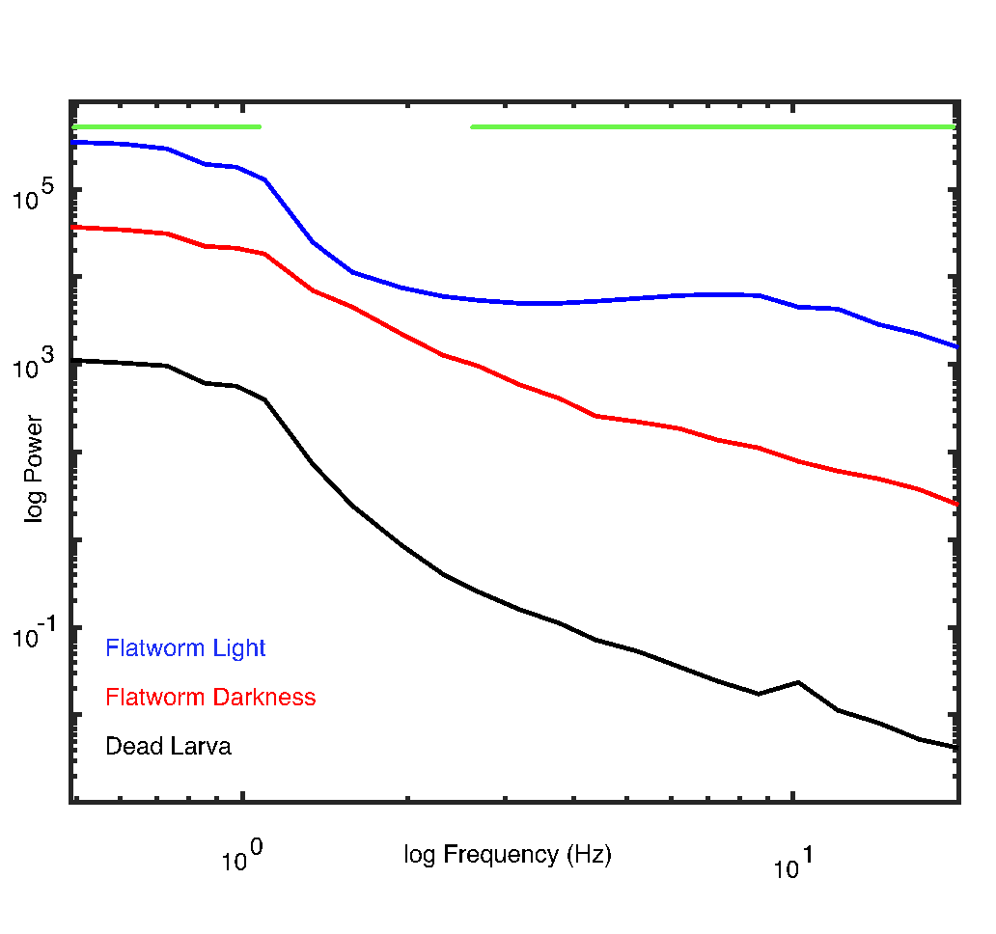

*Figure 2: Overview of the power spectra for the three groups. The red line indicates the power spectral density for the first group of planarians recorded during darkness, the blue line indicates the power spectral density for the second group of planarians recorded during light stimulation, and the black line indicates the power spectral density for the third group of dead mosquito larvae recorded as a control group. The horizontal green lines indicate the frequency range in which the power spectra significantly differed between the first and second group.*

**4. Discussion**

A large part of the field of comparative cognitive science aims to examine peak performance across different species [1]. An alternative approach is searching for the most primitive nervous system capable of a certain cognitive task such as memory or sensory discrimination. Here, we studied *Schmidtea mediterranea,* a small planarian with only 50000 neurons capable of astounding cognitive tasks, in an attempt to pin down neural activity corresponding to stimulus processing in a relatively simple nervous system. A previous study [6] used invasive monopole recordings in cooled planarians, and observed ongoing activity between 0.1 and 5 Hz with a power spectrum characterized by a 1/f1 relationship. Our main goal of this research project was establishing a recording protocol to record ongoing neural activity safely and securely from alive and healthy planarians under different lighting conditions. As a replication of the previous results, we hypothesized that the ongoing neural activity is characterized by a 1/f1 power spectrum, and that changes in lighting will induce changes in neural activity due to the reported photophobia.

**4.1 Power Spectrum Exponent**

Studying neural oscillations and their relationship to cognitive processes is a hallmark of cognitive neuroscience [18]. However, neural oscillations, defined as rhythmic activity within a narrow frequency band, are embedded in aperiodic activity [16]. This aperiodic part of the neural power spectrum has been related to the integration of excitatory and inhibitory synaptic currents [19] [17]. The power spectral density of the aperiodic component of neural data follows a 1/fx power law and the exponent ‘x’ describes how steep or flat the power spectral density is [20]. Larger values of x indicate steeper slopes, a value of 0 would indicate a flat slope, such as in white noise. The smaller the exponent the larger the excitation to inhibition ratio. Accordingly, in a vigilant state the exponent is smaller than in unconscious states which indicates more neural excitation [21]. The exponent of human EEG is approximately 0.828 [16], and the planarian EEG previously showed good correspondence with an exponent of 1 [6]. Here, we observed that the exponent of the planarian EEG is 1.30 during darkness and 1.17 during light stimulation, indicating a slightly steeper slope compared to humans and previous planarian EEG recordings, but still within the expected range of biological neural networks (c.f., Figure 5e in [16] which indicates an exponent range of approximately 1 to 1.75 for younger participants, or figure 5 in [6] with a reference line for an exponent of 1). Importantly, we observed a vastly steeper slope from the recordings of the dead mosquito larvae. We can therefore conclude that we were successful in recording neural activity from planarians with our current setup, because the exponent of the power spectrum resembles the exponents observed in recordings of neural activity from planarian and human EEG and differs significantly from the exponent extracted from recordings of dead animals. However, the steep slope extracted in the latter recordings indicates the presence of low frequency noise in our recording setup, which we will need to address in future experiments.

**4.2 Oscillatory Activity**

In addition to the aperiodic component of the spectrum of neural activity, periodic parameters like frequency and power can change with cognitive tasks or different stimulation conditions [22]. A vast amount of research across species has related different frequency bands of neural activity to different behaviors, perceptual or cognitive processes, or conscious states [23] [24]. Much of this research has focused on prominent peaks of neural activity visible in the power spectrum of neural activity, such as the 10 Hz alpha rhythm in humans related to attention [25] [26], the 6 Hz theta rhythm in rodents related to memory [27] [28], or the higher beta rhythm between 15 and 35 Hz related to perceptual decision making or motor activity [29] [30]. In planarians, the previous work by Aoki and colleagues [6] did not uncover specific peaks in the power spectrum, aside from a “plateau” between 0.1 and 0.4 Hz. Similarly, the data recorded in our experiment under darkness did not show any specific peaks aside from a plateau in lower frequencies. However, this signal was not significantly different from the signal recorded from the dead mosquito larvae, so it is possible that this plateau reflects noise in the recording setup. In contrast, in the comparison of the power spectra between the planarians recorded during darkness and under light stimulation, we found that the overall power appears to be increased. More specifically, we found a significant difference at low frequencies between approximately 0.5 and 1 Hz, indicating an elevated low-frequency plateau during light stimulation. In addition, we also found a significant difference in a broad frequency range between 2 and 20 Hz, indicating increased higher frequency power during light stimulation. The latter activity could be specifically related to the reported photophobia of the planarians. Aoki et al. [6] reported increased waveform activity when the animals were warmed to approximately 10°C, as well as large myogenic spikes. Our data processing pipeline should have excluded all myogenic spikes due to their large amplitude above the signal mean. Therefore, we can conclude that the difference in the power spectra likely reflects increased neural activity due to sensory stimulation or to an overall active state of the live, uncooled animals. The exact nature of the high-frequency power increase needs to be further examined in different stimulation contexts or in different tasks.

**4.3 Limitations**

Previous research demonstrated the possibility to record neural activity from the planarian cephalic ganglia using invasive monopole electrodes [6]. We extend this demonstration by recording ongoing electrophysiological activity from noninvasive surface electrodes at room temperature. Whereas this approach has a number of advantages over the invasive recordings, such as reducing the harm to the animals, ease and low cost of implementation of the recording procedure, and the possibility to record the same animal multiple times, it comes with a number of drawbacks. First, the recording device is not specifically designed to record from planarians, and it is imperative to carefully establish that the currently observed signal actually reflects neural activity. To this end, we recorded EEG activity with the same setup from dead mosquito larvae. Second, and related to this, our recording setup is spatially much less precise than a single electrode inserted into the cephalic ganglion. Therefore, future recording setups should include a higher number of electrodes to disentangle electrical activity arising from the ganglia from those arising from the ventral nervous cords, or muscle activity. Finally, we observed strong low-frequency noise even in the recordings from the mosquito larvae, and strong signal contamination from the power lines, even at sub-harmonic frequencies. Therefore, we need to optimize our current recording environment to shield it from environmental noise, for example with a faraday cage.

**5. Conclusion**

Overall, we can confirm the observations by Aoki and colleagues [6], that the power spectrum of continuous neural activity of planarians exhibits a broad rise in the low frequencies, and that the spectrum conforms to a 1/fx pattern with an exponent ‘x’ close to 1. Moreover, we extend this observation by showing that light stimulation induced an increase in higher frequency activity. Recording neural activity from planarians with wire electrodes allows continuous recordings across longer intervals, and repeated recordings from the same animals without harming the animals to study changes in neural activity linked to stimulus processing and cognition. The study of nervous systems with a small number of neurons is of special interest to the field of artificial intelligence. Simulations and hardware implementations of artificial neural networks strive to disentangle the neural mechanisms underlying different cognitive performances such as memory or perception. It would be highly interesting to quantify the minimal number of neurons necessary for a certain task, in biology as well as in technology.

**References**

1. Gómez J-C. Species comparative studies and cognitive development. Trends in Cognitive Sciences. 2005;9:118–25.

2. Fitch WT. Toward a computational framework for cognitive biology: unifying approaches from cognitive neuroscience and comparative cognition. Phys Life Rev. 2014;11:329–64.

3. Adrian ED. Synchronized reactions in the optic ganglion of dytiscus. The Journal of Physiology. John Wiley & Sons, Ltd; 1937;91:66–89.

4. van den Heuvel MP, Bullmore ET, Sporns O. Comparative Connectomics. Trends in Cognitive Sciences. Elsevier Ltd; 2016;20:345–61.

5. Popov T, Szyszka P. Alpha oscillations govern interhemispheric spike timing coordination in the honey bee brain. Proceedings of the Royal Society B: Biological Sciences. 2020;287:20200115.

6. Aoki R, Wake H, Sasaki H, Agata K. Recording and spectrum analysis of the planarian electroencephalogram. Neuroscience. Elsevier Inc; 2009;159:908–14.

7. Harrath AH, Charni M, Sluys R, Zghal F, Tekaya S. Ecology and distribution of the freshwater planarian Schmidtea mediterranea in Tunisia. Italian Journal of Zoology. 2004;71:233–6.

8. Agata K, Umesono Y. Brain regeneration from pluripotent stem cells in planarian. Philos. Trans. R. Soc. Lond., B, Biol. Sci. 2008;363:2071–8.

9. Sarnat HB, Netsky MG. The brain of the planarian as the ancestor of the human brain. Can J Neurol Sci. Cambridge University Press; 1985;12:296–302.

10. Fraguas S, Barberán S, Ibarra B, Stöger L, Cebri F. Regeneration of neuronal cell types in Schmidtea mediterranea: an immunohistochemical and expression study. Int. J. Dev. Biol. 2012;56:143–53.

11. Agata K, Soejima Y, Kato K, Kobayashi C, Umesono Y, Watanabe K. Structure of the planarian central nervous system (CNS) revealed by neuronal cell markers. Zoolog Sci. Zoological Society of Japan; 1998;15:433–40.

12. Deochand N, Costello MS, Deochand ME. Behavioral Research with Planaria. Perspect Behav Sci. 2nd ed. Springer International Publishing; 2018;41:447–64.

13. Shomrat T, Levin M. An automated training paradigm reveals long-term memory in planarians and its persistence through head regeneration. Journal of Experimental Biology. 2013;216:3799–810.

14. Talbot J, Schotz EM. Quantitative characterization of planarian wild-type behavior as a platform for screening locomotion phenotypes. Journal of Experimental Biology. 2011;214:1063–7.

15. Oostenveld R, Fries P, Maris E, Schoffelen J-M. FieldTrip: Open Source Software for Advanced Analysis of MEG, EEG, and Invasive Electrophysiological Data. Computational Intelligence and Neuroscience. 2011;2011:1–9.

16. Donoghue T, Haller M, Peterson EJ, Varma P, Sebastian P, Gao R, et al. Parameterizing neural power spectra into periodic and aperiodic components. Nat Neurosci. Nature Publishing Group; 2020;23:1655–65.

17. Miller KJ, Zanos S, Fetz EE, Nijs Den M, Ojemann JG. Decoupling the Cortical Power Spectrum Reveals Real-Time Representation of Individual Finger Movements in Humans. 2009;29:3132–7.

18. Buzsáki G, Anastassiou CA, Koch C. The origin of extracellular fields and currents--EEG, ECoG, LFP and spikes. Nat Rev Neurosci. 2012;13:407–20.

19. Freeman WJ, Zhai J. Simulated power spectral density (PSD) of background electrocorticogram (ECoG). Cognitive Neurodynamics. Springer Netherlands; 2009;3:97–103.

20. Gerster M, Waterstraat G, Litvak V, Lehnertz K, Schnitzler A, Florin E, et al. Separating Neural Oscillations from Aperiodic 1/f Activity: Challenges and Recommendations. Neuroinformatics. Springer US; 2022;:1–22.

21. Colombo MA, Napolitani M, Boly M, Gosseries O, Casarotto S, Rosanova M, et al. The spectral exponent of the resting EEG indexes the presence of consciousness during unresponsiveness induced by propofol, xenon, and ketamine. NeuroImage. Elsevier Ltd; 2019;189:631–44.

22. Keitel C, Ruzzoli M, Dugué L, Busch NA, Benwell CSY. Rhythms in cognition: The evidence revisited. Eur J Neurosci. John Wiley & Sons, Ltd; 2022;55:2991–3009.

23. Buzsáki G, Draguhn A. Neuronal oscillations in cortical networks. Science. American Association for the Advancement of Science; 2004;304:1926–9.

24. Kopell NJ, Gritton HJ, Whittington MA, Kramer MA. Beyond the Connectome: The Dynome. Neuron. Elsevier Inc; 2014;83:1319–28.

25. Klimesch W, Sauseng P, Hanslmayr S. EEG alpha oscillations: The inhibition–timing hypothesis. Brain Research Reviews. 2007;53:63–88.

26. Jensen O, Mazaheri A. Shaping functional architecture by oscillatory alpha activity: gating by inhibition. Frontiers in Human Neuroscience. 2010;4:186.

27. Buzsáki G. Theta rhythm of navigation: link between path integration and landmark navigation, episodic and semantic memory. Hippocampus. 2005;15:827–40.

28. Kienitz R, Schmid MC, Dugué L. Rhythmic sampling revisited: Experimental paradigms and neural mechanisms. Eur J Neurosci. John Wiley & Sons, Ltd; 2021.

29. Donner TH, Siegel M, Fries P, Engel AK. Buildup of choice-predictive activity in human motor cortex during perceptual decision making. Curr Biol. 2009;19:1581–5.

30. Keil J, Timm J, SanMiguel I, Schulz H, Obleser J, Schonwiesner M. Cortical brain states and corticospinal synchronization influence TMS-evoked motor potentials. J Neurophysiol. 2014;111:513–9.