**INTI International College Penang School of Computing**

**3+0 Bachelor of Science (Hons) in Computer Science, in collaboration with Coventry University, UK 3+0 Bachelor of Science (Hons) in Computing, in collaboration with Coventry University, UK**

# Coursework cover sheet

**Section A - To be completed by the student.**

|  |  |
| --- | --- |
| Full Name: Julian Koh Chee Yong | |
| CU Student ID Number: p22014789 | |
| Semester: Semester 3 | |
| Session:  **April 2023** | |
| Lecturer:  **Puteri Nursyawati Azzuri (puteri.azzuri@newinti.edu.my)** | |
| Module Code and Title:  **4067CEM Software Design** | |
| Assignment No. / Title:  **Continuous Assessment** | % of Module Mark:  **50** |
| Hand out Date:  **12 May 2023** | Due Date:  **Task 1: 02 June 2023, by 11.59pm.**  **Task 2: 07 July 2023, by 11.59pm**  **Task 3: 23 June 2023, by 11.59pm.**  **Task 4: 23 June 2023, by 11.59pm.**  **Task 5: 23 June 2023, by 11.59pm.** |
| Penalties: No late work will be accepted. If you are unable to submit coursework on time due  to extenuating circumstances, you may be eligible for an extension. Please consult the lecturer. | |
| Declaration: I/we the undersigned confirm that I/we have read and agree to abide by the University regulations on plagiarism and cheating and Faculty coursework policies and procedures. I/we confirm that this piece of work is my/our own. I/we consent to the appropriate storage of our work for plagiarism checking.  Signature(s): jk | |

# Section B - To be completed by the module leader

|  |  |  |
| --- | --- | --- |
| Intended learning outcomes assessed by this work:   1. Understand and apply appropriate concepts, tools, and techniques to each stage of the software development. 2. Understand and apply design patterns to software components in developing new software. 3. Demonstrate an understanding of project planning and working to agreed deadlines, along with professional, interpersonal skills and effective communication required for software production.   5. Demonstrate an awareness of, and ability to apply, social, professional, legal, and ethical standards as documented in relevant laws and professional codes of conduct such as that of  the Malaysian National Computer Confederation. | | |
| Marking scheme | Max | Mark |
| 1. User Story Mapping | 20 |  |
| 2. Setting up a GitHub |  |
| Repository | 10 |
| 3. Creating a Class diagram and |  |
| design pattern selection | 30 |
| 4. Creating a Prototype User |  |
| Interface and Usability Testing | 20 |
| 5. Discuss the ethical issue |  |
| related to the software | 20 |
| Total | 100 |  |

Task 3

**1. Class diagram for the student business system**

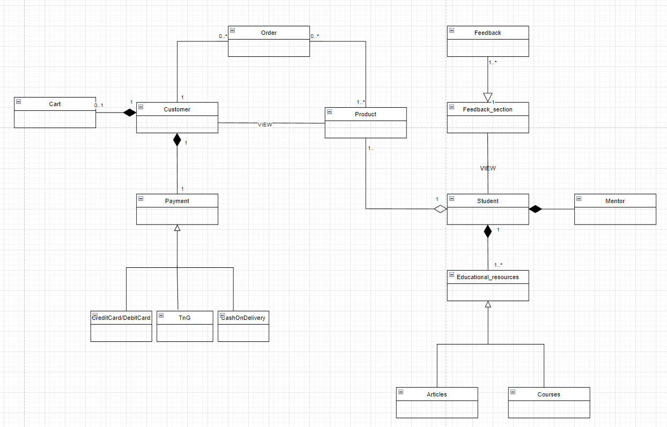

This is a class diagram for the student business system, For the ‘Student’ class has two educational resources to learn more about business, articles, and courses which are subclasses of the ‘payment’ class. and a ‘Mentor’ class to find a mentor seek business advice from. The ‘feedback section’ class stores the feedback from their customers. ‘product**’** class lists what the student is selling, it has a composite relationship with the student because it cannot exist without the student, the ‘customer’ class has three payment methods which are credit card/debit card, TnG and cash on delivery that are all subclasses of the payment class. The cart class is the container of the products the customer ordered before making payment.

**2. Design pattern**

Strategy design pattern design pattern for payment methods in the student business system

The strategy pattern is a behavioural software design pattern. It is suitable when there are multiple algorithms or strategies available for a specific task, and the client can determine the implementation to be used at runtime[(reference)](https://www.digitalocean.com/community/tutorials/strategy-design-pattern-in-java-example-tutorial). Each of the payment method is a strategy for processing payments, the system can dynamically select the appropriate payment method or based on user preferences and other factors. It also gives a way to have flexible and expandable management of the payment methods. Besides support multiple payment options, it can also easily add a new payment method in the future without changing the code too much.