## Marlon Julian Martínez Triana

## Bitácora w3schools

## DataWarehouse

-----------------------------------------------------------------------------------------------------------------------------------

**SQL SELECT Statement**

### SELECT Syntax

SELECT CustomerName, ContactName, City FROM Customers Where City = 'Berlin';

Result

|  |  |  |
| --- | --- | --- |
| **CustomerName** | **ContactName** | **City** |
| Alfreds Futterkiste | Maria Anders | Berlin |

# SQL SELECT DISTINCT Statement

### SELECT DISTINCT Syntax

SELECT distinct Country FROM Customers;

Result

|  |
| --- |
| **Country** |
| Argentina |
| Austria |
| Belgium |
| Brazil |
| Canada |
| Denmark |
| Finland |
| France |
| Germany |
| Ireland |
| Italy |
| Mexico |
| Norway |
| Poland |
| Portugal |
| Spain |
| Sweden |
| Switzerland |
| UK |
| USA |
| Venezuela |

# SQL WHERE Clause

### WHERE Syntax

SELECT * FROM Customers WHERE CustomerID=10;

Result

|  |  |  |  |  |  |  |
| --- | --- | --- | --- | --- | --- | --- |
| **CustomerID** | **CustomerName** | **ContactName** | **Address** | **City** | **PostalCode** | **Country** |
| 10 | Bottom-Dollar Marketse | Elizabeth Lincoln | 23 Tsawassen Blvd. | Tsawassen | T2F 8M4 | Canada |

# SQL AND, OR and NOT Operators

### AND Syntax

SELECT * FROM Customers WHERE Country='Mexico' AND City='México D.F.';

Result

|  |  |  |  |  |  |  |
| --- | --- | --- | --- | --- | --- | --- |
| **CustomerID** | **CustomerName** | **ContactName** | **Address** | **City** | **PostalCode** | **Country** |
| 2 | Ana Trujillo Emparedados y helados | Ana Trujillo | Avda. de la Constitución 2222 | México D.F. | 05021 | Mexico |
| 3 | Antonio Moreno Taquería | Antonio Moreno | Mataderos 2312 | México D.F. | 05023 | Mexico |
| 13 | Centro comercial Moctezuma | Francisco Chang | Sierras de Granada 9993 | México D.F. | 05022 | Mexico |
| 58 | Pericles Comidas clásicas | Guillermo Fernández | Calle Dr. Jorge Cash 321 | México D.F. | 05033 | Mexico |
| 80 | Tortuga Restaurante | Miguel Angel Paolino | Avda. Azteca 123 | México D.F. | 05033 | Mexico |

### OR Syntax

SELECT * FROM Customers WHERE City='Berlin' OR City='München';

Result

|  |  |  |  |  |  |  |
| --- | --- | --- | --- | --- | --- | --- |
| **CustomerID** | **CustomerName** | **ContactName** | **Address** | **City** | **PostalCode** | **Country** |
| 1 | Alfreds Futterkiste | Maria Anders | Obere Str. 57 | Berlin | 12209 | Germany |
| 25 | Frankenversand | Peter Franken | Berliner Platz 43 | München | 80805 | Germany |

### NOT Syntax

SELECT * FROM Customers

WHERE NOT Country='Germany' and not Country = 'Mexico' and not Country = 'USA';

|  |  |  |  |  |  |  |
| --- | --- | --- | --- | --- | --- | --- |
| **CustomerID** | **CustomerName** | **ContactName** | **Address** | **City** | **PostalCode** | **Country** |
| 4 | Around the Horn | Thomas Hardy | 120 Hanover Sq. | London | WA1 1DP | UK |
| 5 | Berglunds snabbköp | Christina Berglund | Berguvsvägen 8 | Luleå | S-958 22 | Sweden |
| 7 | Blondel père et fils | Frédérique Citeaux | 24, place Kléber | Strasbourg | 67000 | France |
| 8 | Bólido Comidas preparadas | Martín Sommer | C/ Araquil, 67 | Madrid | 28023 | Spain |
| 9 | Bon app' | Laurence Lebihans | 12, rue des Bouchers | Marseille | 13008 | France |
| 10 | Bottom-Dollar Marketse | Elizabeth Lincoln | 23 Tsawassen Blvd. | Tsawassen | T2F 8M4 | Canada |
| 11 | B's Beverages | Victoria Ashworth | Fauntleroy Circus | London | EC2 5NT | UK |
| 12 | Cactus Comidas para llevar | Patricio Simpson | Cerrito 333 | Buenos Aires | 1010 | Argentina |
| 14 | Chop-suey Chinese | Yang Wang | Hauptstr. 29 | Bern | 3012 | Switzerland |
| 15 | Comércio Mineiro | Pedro Afonso | Av. dos Lusíadas, 23 | São Paulo | 05432-043 | Brazil |
| 16 | Consolidated Holdings | Elizabeth Brown | Berkeley Gardens 12 Brewery | London | WX1 6LT | UK |
| 18 | Du monde entier | Janine Labrune | 67, rue des Cinquante Otages | Nantes | 44000 | France |
| 19 | Eastern Connection | Ann Devon | 35 King George | London | WX3 6FW | UK |
| 20 | Ernst Handel | Roland Mendel | Kirchgasse 6 | Graz | 8010 | Austria |
| 21 | Familia Arquibaldo | Aria Cruz | Rua Orós, 92 | São Paulo | 05442-030 | Brazil |
| 22 | FISSA Fabrica Inter. Salchichas S.A. | Diego Roel | C/ Moralzarzal, 86 | Madrid | 28034 | Spain |
| 23 | Folies gourmandes | Martine Rancé | 184, chaussée de Tournai | Lille | 59000 | France |
| 24 | Folk och fä HB | Maria Larsson | Åkergatan 24 | Bräcke | S-844 67 | Sweden |
| 26 | France restauration | Carine Schmitt | 54, rue Royale | Nantes | 44000 | France |
| 27 | Franchi S.p.A. | Paolo Accorti | Via Monte Bianco 34 | Torino | 10100 | Italy |
| 28 | Furia Bacalhau e Frutos do Mar | Lino Rodriguez | Jardim das rosas n. 32 | Lisboa | 1675 | Portugal |
| 29 | Galería del gastrónomo | Eduardo Saavedra | Rambla de Cataluña, 23 | Barcelona | 08022 | Spain |
| 30 | Godos Cocina Típica | José Pedro Freyre | C/ Romero, 33 | Sevilla | 41101 | Spain |
| 31 | Gourmet Lanchonetes | André Fonseca | Av. Brasil, 442 | Campinas | 04876-786 | Brazil |
| 33 | GROSELLA-Restaurante | Manuel Pereira | 5ª Ave. Los Palos Grandes | Caracas | 1081 | Venezuela |
| 34 | Hanari Carnes | Mario Pontes | Rua do Paço, 67 | Rio de Janeiro | 05454-876 | Brazil |
| 35 | HILARIÓN-Abastos | Carlos Hernández | Carrera 22 con Ave. Carlos Soublette #8-35 | San Cristóbal | 5022 | Venezuela |
| 37 | Hungry Owl All-Night Grocers | Patricia McKenna | 8 Johnstown Road | Cork |  | Ireland |
| 38 | Island Trading | Helen Bennett | Garden House Crowther Way | Cowes | PO31 7PJ | UK |
| 40 | La corne d'abondance | Daniel Tonini | 67, avenue de l'Europe | Versailles | 78000 | France |
| 41 | La maison d'Asie | Annette Roulet | 1 rue Alsace-Lorraine | Toulouse | 31000 | France |
| 42 | Laughing Bacchus Wine Cellars | Yoshi Tannamuri | 1900 Oak St. | Vancouver | V3F 2K1 | Canada |
| 46 | LILA-Supermercado | Carlos González | Carrera 52 con Ave. Bolívar #65-98 Llano Largo | Barquisimeto | 3508 | Venezuela |
| 47 | LINO-Delicateses | Felipe Izquierdo | Ave. 5 de Mayo Porlamar | I. de Margarita | 4980 | Venezuela |
| 49 | Magazzini Alimentari Riuniti | Giovanni Rovelli | Via Ludovico il Moro 22 | Bergamo | 24100 | Italy |
| 50 | Maison Dewey | Catherine Dewey | Rue Joseph-Bens 532 | Bruxelles | B-1180 | Belgium |
| 51 | Mère Paillarde | Jean Fresnière | 43 rue St. Laurent | Montréal | H1J 1C3 | Canada |
| 53 | North/South | Simon Crowther | South House 300 Queensbridge | London | SW7 1RZ | UK |
| 54 | Océano Atlántico Ltda. | Yvonne Moncada | Ing. Gustavo Moncada 8585 Piso 20-A | Buenos Aires | 1010 | Argentina |
| 57 | Paris spécialités | Marie Bertrand | 265, boulevard Charonne | Paris | 75012 | France |
| 59 | Piccolo und mehr | Georg Pipps | Geislweg 14 | Salzburg | 5020 | Austria |
| 60 | Princesa Isabel Vinhoss | Isabel de Castro | Estrada da saúde n. 58 | Lisboa | 1756 | Portugal |
| 61 | Que Delícia | Bernardo Batista | Rua da Panificadora, 12 | Rio de Janeiro | 02389-673 | Brazil |
| 62 | Queen Cozinha | Lúcia Carvalho | Alameda dos Canàrios, 891 | São Paulo | 05487-020 | Brazil |
| 64 | Rancho grande | Sergio Gutiérrez | Av. del Libertador 900 | Buenos Aires | 1010 | Argentina |
| 66 | Reggiani Caseifici | Maurizio Moroni | Strada Provinciale 124 | Reggio Emilia | 42100 | Italy |
| 67 | Ricardo Adocicados | Janete Limeira | Av. Copacabana, 267 | Rio de Janeiro | 02389-890 | Brazil |
| 68 | Richter Supermarkt | Michael Holz | Grenzacherweg 237 | Genève | 1203 | Switzerland |
| 69 | Romero y tomillo | Alejandra Camino | Gran Vía, 1 | Madrid | 28001 | Spain |
| 70 | Santé Gourmet | Jonas Bergulfsen | Erling Skakkes gate 78 | Stavern | 4110 | Norway |
| 72 | Seven Seas Imports | Hari Kumar | 90 Wadhurst Rd. | London | OX15 4NB | UK |
| 73 | Simons bistro | Jytte Petersen | Vinbæltet 34 | København | 1734 | Denmark |
| 74 | Spécialités du monde | Dominique Perrier | 25, rue Lauriston | Paris | 75016 | France |
| 76 | Suprêmes délices | Pascale Cartrain | Boulevard Tirou, 255 | Charleroi | B-6000 | Belgium |
| 81 | Tradição Hipermercados | Anabela Domingues | Av. Inês de Castro, 414 | São Paulo | 05634-030 | Brazil |
| 83 | Vaffeljernet | Palle Ibsen | Smagsløget 45 | Århus | 8200 | Denmark |
| 84 | Victuailles en stock | Mary Saveley | 2, rue du Commerce | Lyon | 69004 | France |
| 85 | Vins et alcools Chevalier | Paul Henriot | 59 rue de l'Abbaye | Reims | 51100 | France |
| 87 | Wartian Herkku | Pirkko Koskitalo | Torikatu 38 | Oulu | 90110 | Finland |
| 88 | Wellington Importadora | Paula Parente | Rua do Mercado, 12 | Resende | 08737-363 | Brazil |
| 90 | Wilman Kala | Matti Karttunen | Keskuskatu 45 | Helsinki | 21240 | Finland |
| 91 | Wolski | Zbyszek | ul. Filtrowa 68 | Walla | 01-012 | Poland |

# SQL ORDER BY Keyword

SELECT * FROM Customers

ORDER BY Country DESC, CustomerName ASC;

|  |  |  |  |  |  |  |
| --- | --- | --- | --- | --- | --- | --- |
| **CustomerID** | **CustomerName** | **ContactName** | **Address** | **City** | **PostalCode** | **Country** |
| 33 | GROSELLA-Restaurante | Manuel Pereira | 5ª Ave. Los Palos Grandes | Caracas | 1081 | Venezuela |
| 35 | HILARIÓN-Abastos | Carlos Hernández | Carrera 22 con Ave. Carlos Soublette #8-35 | San Cristóbal | 5022 | Venezuela |
| 46 | LILA-Supermercado | Carlos González | Carrera 52 con Ave. Bolívar #65-98 Llano Largo | Barquisimeto | 3508 | Venezuela |
| 47 | LINO-Delicateses | Felipe Izquierdo | Ave. 5 de Mayo Porlamar | I. de Margarita | 4980 | Venezuela |
| 32 | Great Lakes Food Market | Howard Snyder | 2732 Baker Blvd. | Eugene | 97403 | USA |
| 36 | Hungry Coyote Import Store | Yoshi Latimer | City Center Plaza 516 Main St. | Elgin | 97827 | USA |
| 43 | Lazy K Kountry Store | John Steel | 12 Orchestra Terrace | Walla Walla | 99362 | USA |
| 45 | Let's Stop N Shop | Jaime Yorres | 87 Polk St. Suite 5 | San Francisco | 94117 | USA |
| 48 | Lonesome Pine Restaurant | Fran Wilson | 89 Chiaroscuro Rd. | Portland | 97219 | USA |
| 55 | Old World Delicatessen | Rene Phillips | 2743 Bering St. | Anchorage | 99508 | USA |
| 65 | Rattlesnake Canyon Grocery | Paula Wilson | 2817 Milton Dr. | Albuquerque | 87110 | USA |
| 71 | Save-a-lot Markets | Jose Pavarotti | 187 Suffolk Ln. | Boise | 83720 | USA |
| 75 | Split Rail Beer & Ale | Art Braunschweiger | P.O. Box 555 | Lander | 82520 | USA |
| 77 | The Big Cheese | Liz Nixon | 89 Jefferson Way Suite 2 | Portland | 97201 | USA |
| 78 | The Cracker Box | Liu Wong | 55 Grizzly Peak Rd. | Butte | 59801 | USA |
| 82 | Trail's Head Gourmet Provisioners | Helvetius Nagy | 722 DaVinci Blvd. | Kirkland | 98034 | USA |
| 89 | White Clover Markets | Karl Jablonski | 305 - 14th Ave. S. Suite 3B | Seattle | 98128 | USA |
| 4 | Around the Horn | Thomas Hardy | 120 Hanover Sq. | London | WA1 1DP | UK |
| 11 | B's Beverages | Victoria Ashworth | Fauntleroy Circus | London | EC2 5NT | UK |
| 16 | Consolidated Holdings | Elizabeth Brown | Berkeley Gardens 12 Brewery | London | WX1 6LT | UK |
| 19 | Eastern Connection | Ann Devon | 35 King George | London | WX3 6FW | UK |
| 38 | Island Trading | Helen Bennett | Garden House Crowther Way | Cowes | PO31 7PJ | UK |
| 53 | North/South | Simon Crowther | South House 300 Queensbridge | London | SW7 1RZ | UK |
| 72 | Seven Seas Imports | Hari Kumar | 90 Wadhurst Rd. | London | OX15 4NB | UK |
| 14 | Chop-suey Chinese | Yang Wang | Hauptstr. 29 | Bern | 3012 | Switzerland |
| 68 | Richter Supermarkt | Michael Holz | Grenzacherweg 237 | Genève | 1203 | Switzerland |
| 5 | Berglunds snabbköp | Christina Berglund | Berguvsvägen 8 | Luleå | S-958 22 | Sweden |
| 24 | Folk och fä HB | Maria Larsson | Åkergatan 24 | Bräcke | S-844 67 | Sweden |
| 8 | Bólido Comidas preparadas | Martín Sommer | C/ Araquil, 67 | Madrid | 28023 | Spain |
| 22 | FISSA Fabrica Inter. Salchichas S.A. | Diego Roel | C/ Moralzarzal, 86 | Madrid | 28034 | Spain |
| 29 | Galería del gastrónomo | Eduardo Saavedra | Rambla de Cataluña, 23 | Barcelona | 08022 | Spain |
| 30 | Godos Cocina Típica | José Pedro Freyre | C/ Romero, 33 | Sevilla | 41101 | Spain |
| 69 | Romero y tomillo | Alejandra Camino | Gran Vía, 1 | Madrid | 28001 | Spain |
| 28 | Furia Bacalhau e Frutos do Mar | Lino Rodriguez | Jardim das rosas n. 32 | Lisboa | 1675 | Portugal |
| 60 | Princesa Isabel Vinhoss | Isabel de Castro | Estrada da saúde n. 58 | Lisboa | 1756 | Portugal |
| 91 | Wolski | Zbyszek | ul. Filtrowa 68 | Walla | 01-012 | Poland |
| 70 | Santé Gourmet | Jonas Bergulfsen | Erling Skakkes gate 78 | Stavern | 4110 | Norway |
| 2 | Ana Trujillo Emparedados y helados | Ana Trujillo | Avda. de la Constitución 2222 | México D.F. | 05021 | Mexico |
| 3 | Antonio Moreno Taquería | Antonio Moreno | Mataderos 2312 | México D.F. | 05023 | Mexico |
| 13 | Centro comercial Moctezuma | Francisco Chang | Sierras de Granada 9993 | México D.F. | 05022 | Mexico |
| 58 | Pericles Comidas clásicas | Guillermo Fernández | Calle Dr. Jorge Cash 321 | México D.F. | 05033 | Mexico |
| 80 | Tortuga Restaurante | Miguel Angel Paolino | Avda. Azteca 123 | México D.F. | 05033 | Mexico |
| 27 | Franchi S.p.A. | Paolo Accorti | Via Monte Bianco 34 | Torino | 10100 | Italy |
| 49 | Magazzini Alimentari Riuniti | Giovanni Rovelli | Via Ludovico il Moro 22 | Bergamo | 24100 | Italy |
| 66 | Reggiani Caseifici | Maurizio Moroni | Strada Provinciale 124 | Reggio Emilia | 42100 | Italy |
| 37 | Hungry Owl All-Night Grocers | Patricia McKenna | 8 Johnstown Road | Cork |  | Ireland |
| 1 | Alfreds Futterkiste | Maria Anders | Obere Str. 57 | Berlin | 12209 | Germany |
| 6 | Blauer See Delikatessen | Hanna Moos | Forsterstr. 57 | Mannheim | 68306 | Germany |
| 86 | Die Wandernde Kuh | Rita Müller | Adenauerallee 900 | Stuttgart | 70563 | Germany |
| 17 | Drachenblut Delikatessend | Sven Ottlieb | Walserweg 21 | Aachen | 52066 | Germany |
| 25 | Frankenversand | Peter Franken | Berliner Platz 43 | München | 80805 | Germany |
| 39 | Königlich Essen | Philip Cramer | Maubelstr. 90 | Brandenburg | 14776 | Germany |
| 44 | Lehmanns Marktstand | Renate Messner | Magazinweg 7 | Frankfurt a.M. | 60528 | Germany |
| 52 | Morgenstern Gesundkost | Alexander Feuer | Heerstr. 22 | Leipzig | 04179 | Germany |
| 56 | Ottilies Käseladen | Henriette Pfalzheim | Mehrheimerstr. 369 | Köln | 50739 | Germany |
| 63 | QUICK-Stop | Horst Kloss | Taucherstraße 10 | Cunewalde | 01307 | Germany |
| 79 | Toms Spezialitäten | Karin Josephs | Luisenstr. 48 | Münster | 44087 | Germany |
| 7 | Blondel père et fils | Frédérique Citeaux | 24, place Kléber | Strasbourg | 67000 | France |
| 9 | Bon app' | Laurence Lebihans | 12, rue des Bouchers | Marseille | 13008 | France |
| 18 | Du monde entier | Janine Labrune | 67, rue des Cinquante Otages | Nantes | 44000 | France |
| 23 | Folies gourmandes | Martine Rancé | 184, chaussée de Tournai | Lille | 59000 | France |
| 26 | France restauration | Carine Schmitt | 54, rue Royale | Nantes | 44000 | France |
| 40 | La corne d'abondance | Daniel Tonini | 67, avenue de l'Europe | Versailles | 78000 | France |
| 41 | La maison d'Asie | Annette Roulet | 1 rue Alsace-Lorraine | Toulouse | 31000 | France |
| 57 | Paris spécialités | Marie Bertrand | 265, boulevard Charonne | Paris | 75012 | France |
| 74 | Spécialités du monde | Dominique Perrier | 25, rue Lauriston | Paris | 75016 | France |
| 84 | Victuailles en stock | Mary Saveley | 2, rue du Commerce | Lyon | 69004 | France |
| 85 | Vins et alcools Chevalier | Paul Henriot | 59 rue de l'Abbaye | Reims | 51100 | France |
| 87 | Wartian Herkku | Pirkko Koskitalo | Torikatu 38 | Oulu | 90110 | Finland |
| 90 | Wilman Kala | Matti Karttunen | Keskuskatu 45 | Helsinki | 21240 | Finland |
| 73 | Simons bistro | Jytte Petersen | Vinbæltet 34 | København | 1734 | Denmark |
| 83 | Vaffeljernet | Palle Ibsen | Smagsløget 45 | Århus | 8200 | Denmark |
| 10 | Bottom-Dollar Marketse | Elizabeth Lincoln | 23 Tsawassen Blvd. | Tsawassen | T2F 8M4 | Canada |
| 42 | Laughing Bacchus Wine Cellars | Yoshi Tannamuri | 1900 Oak St. | Vancouver | V3F 2K1 | Canada |
| 51 | Mère Paillarde | Jean Fresnière | 43 rue St. Laurent | Montréal | H1J 1C3 | Canada |
| 15 | Comércio Mineiro | Pedro Afonso | Av. dos Lusíadas, 23 | São Paulo | 05432-043 | Brazil |
| 21 | Familia Arquibaldo | Aria Cruz | Rua Orós, 92 | São Paulo | 05442-030 | Brazil |
| 31 | Gourmet Lanchonetes | André Fonseca | Av. Brasil, 442 | Campinas | 04876-786 | Brazil |
| 34 | Hanari Carnes | Mario Pontes | Rua do Paço, 67 | Rio de Janeiro | 05454-876 | Brazil |
| 61 | Que Delícia | Bernardo Batista | Rua da Panificadora, 12 | Rio de Janeiro | 02389-673 | Brazil |
| 62 | Queen Cozinha | Lúcia Carvalho | Alameda dos Canàrios, 891 | São Paulo | 05487-020 | Brazil |
| 67 | Ricardo Adocicados | Janete Limeira | Av. Copacabana, 267 | Rio de Janeiro | 02389-890 | Brazil |
| 81 | Tradição Hipermercados | Anabela Domingues | Av. Inês de Castro, 414 | São Paulo | 05634-030 | Brazil |
| 88 | Wellington Importadora | Paula Parente | Rua do Mercado, 12 | Resende | 08737-363 | Brazil |
| 50 | Maison Dewey | Catherine Dewey | Rue Joseph-Bens 532 | Bruxelles | B-1180 | Belgium |
| 76 | Suprêmes délices | Pascale Cartrain | Boulevard Tirou, 255 | Charleroi | B-6000 | Belgium |
| 20 | Ernst Handel | Roland Mendel | Kirchgasse 6 | Graz | 8010 | Austria |
| 59 | Piccolo und mehr | Georg Pipps | Geislweg 14 | Salzburg | 5020 | Austria |
| 12 | Cactus Comidas para llevar | Patricio Simpson | Cerrito 333 | Buenos Aires | 1010 | Argentina |
| 54 | Océano Atlántico Ltda. | Yvonne Moncada | Ing. Gustavo Moncada 8585 Piso 20-A | Buenos Aires | 1010 | Argentina |
| 64 | Rancho grande | Sergio Gutiérrez | Av. del Libertador 900 | Buenos Aires | 1010 | Argentina |

# SQL INSERT INTO Statement

### INSERT INTO Syntax

INSERT INTO Customers (CustomerName, ContactName, Address, City, PostalCode, Country)

VALUES ('Blocked','Julian M','Calle 30','Chia','0041','Cundinamarca');

# SQL NULL Values

### IS NULL Syntax

SELECT CustomerName, ContactName, Address FROM Customers WHERE City IS not NULL;

|  |  |  |
| --- | --- | --- |
| **CustomerName** | **ContactName** | **Address** |
| Alfreds Futterkiste | Maria Anders | Obere Str. 57 |
| Ana Trujillo Emparedados y helados | Ana Trujillo | Avda. de la Constitución 2222 |
| Antonio Moreno Taquería | Antonio Moreno | Mataderos 2312 |
| Around the Horn | Thomas Hardy | 120 Hanover Sq. |
| Berglunds snabbköp | Christina Berglund | Berguvsvägen 8 |
| Blauer See Delikatessen | Hanna Moos | Forsterstr. 57 |

### IS NOT NULL Syntax

SELECT CustomerName, ContactName, Address FROM Customers WHERE PostalCode IS NULL;

# SQL UPDATE Statement

### UPDATE Syntax

UPDATE *table_name* SET *column1* = *value1*, *column2* = *value2*, ...  
WHERE *condition*;

UPDATE Customers SET ContactName = 'Ana Trujillo', City= 'Mexico D.F.' WHERE CustomerID = 1;

# SQL DELETE Statement

DELETE Syntax

DELETE FROM Customers WHERE CustomerName='Thomas Hardy';

# SQL TOP, LIMIT or ROWNUM Clause

**MySQL Syntax:**

SELECT *column_name(s)* FROM *table_name* WHERE *condition* LIMIT *number*;

**SQL Server / MS Access Syntax:**

SELECT TOP *number*|*percent* *column_name(s)* FROM *table_name* WHERE *condition*;

**Oracle Syntax:**

SELECT *column_name(s)* FROM *table_name* WHERE ROWNUM <= *number*;

SELECT TOP 5 City FROM Customers;

Result

|  |
| --- |
| **City** |
| Berlin |
| México D.F. |
| México D.F. |
| London |
| Luleå |

## SQL TOP PERCENT

SELECT TOP 10 PERCENT * FROM Customers;

Result

|  |  |  |  |  |  |  |
| --- | --- | --- | --- | --- | --- | --- |
| **CustomerID** | **CustomerName** | **ContactName** | **Address** | **City** | **PostalCode** | **Country** |
| 1 | Alfreds Futterkiste | Maria Anders | Obere Str. 57 | Berlin | 12209 | Germany |
| 2 | Ana Trujillo Emparedados y helados | Ana Trujillo | Avda. de la Constitución 2222 | México D.F. | 05021 | Mexico |
| 3 | Antonio Moreno Taquería | Antonio Moreno | Mataderos 2312 | México D.F. | 05023 | Mexico |
| 4 | Around the Horn | Thomas Hardy | 120 Hanover Sq. | London | WA1 1DP | UK |
| 5 | Berglunds snabbköp | Christina Berglund | Berguvsvägen 8 | Luleå | S-958 22 | Sweden |
| 6 | Blauer See Delikatessen | Hanna Moos | Forsterstr. 57 | Mannheim | 68306 | Germany |
| 7 | Blondel père et fils | Frédérique Citeaux | 24, place Kléber | Strasbourg | 67000 | France |
| 8 | Bólido Comidas preparadas | Martín Sommer | C/ Araquil, 67 | Madrid | 28023 | Spain |
| 9 | Bon app' | Laurence Lebihans | 12, rue des Bouchers | Marseille | 13008 | France |
| 10 | Bottom-Dollar Marketse | Elizabeth Lincoln | 23 Tsawassen Blvd. | Tsawassen | T2F 8M4 | Canada |

## ADD a WHERE CLAUSE

SELECT TOP 4 * FROM Customers  
WHERE Country='Germany';

|  |  |  |  |  |  |  |
| --- | --- | --- | --- | --- | --- | --- |
| **CustomerID** | **CustomerName** | **ContactName** | **Address** | **City** | **PostalCode** | **Country** |
| 1 | Alfreds Futterkiste | Maria Anders | Obere Str. 57 | Berlin | 12209 | Germany |
| 6 | Blauer See Delikatessen | Hanna Moos | Forsterstr. 57 | Mannheim | 68306 | Germany |
| 17 | Drachenblut Delikatessend | Sven Ottlieb | Walserweg 21 | Aachen | 52066 | Germany |
| 25 | Frankenversand | Peter Franken | Berliner Platz 43 | München | 80805 | Germany |

# SQL MIN() and MAX() Functions

### MIN() MAX() Syntax

SELECT MIN - MAX(*column_name*)  
FROM *table_name*  
WHERE *condition*;

SELECT MIN(Price) AS SmallestPrice FROM Products;

Result

|  |
| --- |
| **SmallestPrice** |
| 2.5 |

SELECT MAX(Price) AS LargestPrice FROM Products;

|  |
| --- |
| **LargestPrice** |
| 263.5 |

# SQL COUNT(), AVG() and SUM() Functions

**COUNT() Syntax**

SELECT COUNT(*column_name*)  
FROM *table_name*  
WHERE *condition*;

SELECT COUNT(ProductID) FROM Products;

|  |
| --- |
| **Expr1000** |
| 77 |

**AVG() Syntax**

SELECT AVG(*column_name*)  
FROM *table_name*  
WHERE *condition*;

SELECT AVG(Price) FROM Products;

|  |
| --- |
| **Expr1000** |
| 28.8664 |

**SUM() Syntax**

SELECT SUM(*column_name*)  
FROM *table_name*  
WHERE *condition*;

SELECT SUM(Quantity) FROM OrderDetails;

|  |
| --- |
| **Expr1000** |
| 12743 |

# SQL LIKE Operator

### LIKE Syntax

SELECT column1, column2, ...  
FROM table_name  
WHERE columnN LIKE pattern;

|  |  |
| --- | --- |
| **LIKE Operator** | **Description** |
| WHERE CustomerName LIKE 'a%' | Finds any values that start with "a" |
| WHERE CustomerName LIKE '%a' | Finds any values that end with "a" |
| WHERE CustomerName LIKE '%or%' | Finds any values that have "or" in any position |
| WHERE CustomerName LIKE '_r%' | Finds any values that have "r" in the second position |
| WHERE CustomerName LIKE 'a__%' | Finds any values that start with "a" and are at least 3 characters in length |
| WHERE ContactName LIKE 'a%o' | Finds any values that start with "a" and ends with "o" |

SELECT * FROM Customers WHERE CustomerName LIKE 'a%';

|  |  |  |  |  |  |  |
| --- | --- | --- | --- | --- | --- | --- |
| **CustomerID** | **CustomerName** | **ContactName** | **Address** | **City** | **PostalCode** | **Country** |
| 1 | Alfreds Futterkiste | Maria Anders | Obere Str. 57 | Berlin | 12209 | Germany |
| 2 | Ana Trujillo Emparedados y helados | Ana Trujillo | Avda. de la Constitución 2222 | México D.F. | 05021 | Mexico |
| 3 | Antonio Moreno Taquería | Antonio Moreno | Mataderos 2312 | México D.F. | 05023 | Mexico |
| 4 | Around the Horn | Thomas Hardy | 120 Hanover Sq. | London | WA1 1DP | UK |

# SQL Wildcards

SELECT * FROM Customers WHERE City LIKE 'ber%';

|  |  |  |  |  |  |  |
| --- | --- | --- | --- | --- | --- | --- |
| **CustomerID** | **CustomerName** | **ContactName** | **Address** | **City** | **PostalCode** | **Country** |
| 1 | Alfreds Futterkiste | Maria Anders | Obere Str. 57 | Berlin | 12209 | Germany |
| 14 | Chop-suey Chinese | Yang Wang | Hauptstr. 29 | Bern | 3012 | Switzerland |
| 49 | Magazzini Alimentari Riuniti | Giovanni Rovelli | Via Ludovico il Moro 22 | Bergamo | 24100 | Italy |

SELECT * FROM Customers WHERE City LIKE '%es%';

|  |  |  |  |  |  |  |
| --- | --- | --- | --- | --- | --- | --- |
| **CustomerID** | **CustomerName** | **ContactName** | **Address** | **City** | **PostalCode** | **Country** |
| 12 | Cactus Comidas para llevar | Patricio Simpson | Cerrito 333 | Buenos Aires | 1010 | Argentina |
| 18 | Du monde entier | Janine Labrune | 67, rue des Cinquante Otages | Nantes | 44000 | France |
| 26 | France restauration | Carine Schmitt | 54, rue Royale | Nantes | 44000 | France |
| 38 | Island Trading | Helen Bennett | Garden House Crowther Way | Cowes | PO31 7PJ | UK |
| 40 | La corne d'abondance | Daniel Tonini | 67, avenue de l'Europe | Versailles | 78000 | France |
| 50 | Maison Dewey | Catherine Dewey | Rue Joseph-Bens 532 | Bruxelles | B-1180 | Belgium |
| 54 | Océano Atlántico Ltda. | Yvonne Moncada | Ing. Gustavo Moncada 8585 Piso 20-A | Buenos Aires | 1010 | Argentina |
| 64 | Rancho grande | Sergio Gutiérrez | Av. del Libertador 900 | Buenos Aires | 1010 | Argentina |
| 88 | Wellington Importadora | Paula Parente | Rua do Mercado, 12 | Resende | 08737-363 | Brazil |

SELECT * FROM Customers WHERE City LIKE '_ondon';

|  |  |  |  |  |  |  |
| --- | --- | --- | --- | --- | --- | --- |
| **CustomerID** | **CustomerName** | **ContactName** | **Address** | **City** | **PostalCode** | **Country** |
| 4 | Around the Horn | Thomas Hardy | 120 Hanover Sq. | London | WA1 1DP | UK |
| 11 | B's Beverages | Victoria Ashworth | Fauntleroy Circus | London | EC2 5NT | UK |
| 16 | Consolidated Holdings | Elizabeth Brown | Berkeley Gardens 12 Brewery | London | WX1 6LT | UK |
| 19 | Eastern Connection | Ann Devon | 35 King George | London | WX3 6FW | UK |
| 53 | North/South | Simon Crowther | South House 300 Queensbridge | London | SW7 1RZ | UK |
| 72 | Seven Seas Imports | Hari Kumar | 90 Wadhurst Rd. | London | OX15 4NB | UK |

# SQL IN Operator

### IN Syntax

SELECT column_name(s) FROM table_name WHERE column_name IN (value1, value2, ...);

SELECT * FROM Customers WHERE Country IN ('Germany', 'France', 'UK');

|  |  |  |  |  |  |  |
| --- | --- | --- | --- | --- | --- | --- |
| **CustomerID** | **CustomerName** | **ContactName** | **Address** | **City** | **PostalCode** | **Country** |
| 1 | Alfreds Futterkiste | Maria Anders | Obere Str. 57 | Berlin | 12209 | Germany |
| 4 | Around the Horn | Thomas Hardy | 120 Hanover Sq. | London | WA1 1DP | UK |
| 6 | Blauer See Delikatessen | Hanna Moos | Forsterstr. 57 | Mannheim | 68306 | Germany |
| 7 | Blondel père et fils | Frédérique Citeaux | 24, place Kléber | Strasbourg | 67000 | France |
| 9 | Bon app' | Laurence Lebihans | 12, rue des Bouchers | Marseille | 13008 | France |
| 11 | B's Beverages | Victoria Ashworth | Fauntleroy Circus | London | EC2 5NT | UK |
| 16 | Consolidated Holdings | Elizabeth Brown | Berkeley Gardens 12 Brewery | London | WX1 6LT | UK |
| 17 | Drachenblut Delikatessend | Sven Ottlieb | Walserweg 21 | Aachen | 52066 | Germany |
| 18 | Du monde entier | Janine Labrune | 67, rue des Cinquante Otages | Nantes | 44000 | France |
| 19 | Eastern Connection | Ann Devon | 35 King George | London | WX3 6FW | UK |
| 23 | Folies gourmandes | Martine Rancé | 184, chaussée de Tournai | Lille | 59000 | France |
| 25 | Frankenversand | Peter Franken | Berliner Platz 43 | München | 80805 | Germany |
| 26 | France restauration | Carine Schmitt | 54, rue Royale | Nantes | 44000 | France |
| 38 | Island Trading | Helen Bennett | Garden House Crowther Way | Cowes | PO31 7PJ | UK |
| 39 | Königlich Essen | Philip Cramer | Maubelstr. 90 | Brandenburg | 14776 | Germany |
| 40 | La corne d'abondance | Daniel Tonini | 67, avenue de l'Europe | Versailles | 78000 | France |
| 41 | La maison d'Asie | Annette Roulet | 1 rue Alsace-Lorraine | Toulouse | 31000 | France |
| 44 | Lehmanns Marktstand | Renate Messner | Magazinweg 7 | Frankfurt a.M. | 60528 | Germany |
| 52 | Morgenstern Gesundkost | Alexander Feuer | Heerstr. 22 | Leipzig | 04179 | Germany |
| 53 | North/South | Simon Crowther | South House 300 Queensbridge | London | SW7 1RZ | UK |
| 56 | Ottilies Käseladen | Henriette Pfalzheim | Mehrheimerstr. 369 | Köln | 50739 | Germany |
| 57 | Paris spécialités | Marie Bertrand | 265, boulevard Charonne | Paris | 75012 | France |
| 63 | QUICK-Stop | Horst Kloss | Taucherstraße 10 | Cunewalde | 01307 | Germany |
| 72 | Seven Seas Imports | Hari Kumar | 90 Wadhurst Rd. | London | OX15 4NB | UK |
| 74 | Spécialités du monde | Dominique Perrier | 25, rue Lauriston | Paris | 75016 | France |
| 79 | Toms Spezialitäten | Karin Josephs | Luisenstr. 48 | Münster | 44087 | Germany |
| 84 | Victuailles en stock | Mary Saveley | 2, rue du Commerce | Lyon | 69004 | France |
| 85 | Vins et alcools Chevalier | Paul Henriot | 59 rue de l'Abbaye | Reims | 51100 | France |
| 86 | Die Wandernde Kuh | Rita Müller | Adenauerallee 900 | Stuttgart | 70563 | Germany |

# SQL BETWEEN Operator

### BETWEEN Syntax

SELECT column_name(s)  
FROM table_name  
WHERE column_name BETWEEN value1 AND value2;

SELECT * FROM Products  
WHERE Price BETWEEN 15 AND 20;

|  |  |  |  |  |  |
| --- | --- | --- | --- | --- | --- |
| **ProductID** | **ProductName** | **SupplierID** | **CategoryID** | **Unit** | **Price** |
| 1 | Chais | 1 | 1 | 10 boxes x 20 bags | 18 |
| 2 | Chang | 1 | 1 | 24 - 12 oz bottles | 19 |
| 15 | Genen Shouyu | 6 | 2 | 24 - 250 ml bottles | 15.5 |
| 16 | Pavlova | 7 | 3 | 32 - 500 g boxes | 17.45 |
| 35 | Steeleye Stout | 16 | 1 | 24 - 12 oz bottles | 18 |
| 36 | Inlagd Sill | 17 | 8 | 24 - 250 g jars | 19 |
| 39 | Chartreuse verte | 18 | 1 | 750 cc per bottle | 18 |
| 40 | Boston Crab Meat | 19 | 8 | 24 - 4 oz tins | 18.4 |
| 44 | Gula Malacca | 20 | 2 | 20 - 2 kg bags | 19.45 |
| 49 | Maxilaku | 23 | 3 | 24 - 50 g pkgs. | 20 |
| 50 | Valkoinen suklaa | 23 | 3 | 12 - 100 g bars | 16.25 |
| 57 | Ravioli Angelo | 26 | 5 | 24 - 250 g pkgs. | 19.5 |
| 66 | Louisiana Hot Spiced Okra | 2 | 2 | 24 - 8 oz jars | 17 |
| 70 | Outback Lager | 7 | 1 | 24 - 355 ml bottles | 15 |
| 73 | Röd Kaviar | 17 | 8 | 24 - 150 g jars | 15 |
| 76 | Lakkalikööri | 23 | 1 | 500 ml | 18 |

# SQL Aliases

### Alias Column Syntax

SELECT column_name AS alias_name  
FROM table_name;

### Alias Table Syntax

SELECT column_name(s)  
FROM table_name AS alias_name;

SELECT CustomerID AS ID, CustomerName AS Customer FROM Customers;

|  |  |
| --- | --- |
| **ID** | **Customer** |

SELECT CustomerName, Address + ', ' + PostalCode + ' ' + City + ', ' + Country AS Address FROM Customers;

|  |  |
| --- | --- |
| **CustomerName** | **Address** |
| Alfreds Futterkiste | Obere Str. 57, 12209 Berlin, Germany |

# SQL Joins

SELECT Orders.OrderID, Customers.CustomerName, Orders.OrderDate FROM Orders

INNER JOIN Customers ON Orders.CustomerID=Customers.CustomerID;

|  |  |  |
| --- | --- | --- |
| **OrderID** | **CustomerName** | **OrderDate** |
| 10308 | Ana Trujillo Emparedados y helados | 9/18/1996 |
| 10365 | Antonio Moreno Taquería | 11/27/1996 |

# SQL INNER JOIN Keyword

SELECT *column_name(s)*  
FROM *table1*  
INNER JOIN *table2*ON *table1.column_name* = *table2.column_name*;

|  |  |  |  |  |
| --- | --- | --- | --- | --- |
| **OrderID** | **CustomerID** | **EmployeeID** | **OrderDate** | **ShipperID** |
| 10308 | 2 | 7 | 1996-09-18 | 3 |
| 10309 | 37 | 3 | 1996-09-19 | 1 |
| 10310 | 77 | 8 | 1996-09-20 | 2 |

|  |  |  |  |  |  |  |
| --- | --- | --- | --- | --- | --- | --- |
| **CustomerID** | **CustomerName** | **ContactName** | **Address** | **City** | **PostalCode** | **Country** |
| 1 | Alfreds Futterkiste | Maria Anders | Obere Str. 57 | Berlin | 12209 | Germany |
| 2 | Ana Trujillo Emparedados y helados | Ana Trujillo | Avda. de la Constitución 2222 | México D.F. | 05021 | Mexico |
| 3 | Antonio Moreno Taquería | Antonio Moreno | Mataderos 2312 | México D.F. | 05023 | Mexico |

SELECT Orders.OrderID, Customers.CustomerName FROM Orders INNER JOIN Customers ON Orders.CustomerID = Customers.CustomerID;

|  |  |
| --- | --- |
| **OrderID** | **CustomerName** |
| 10308 | Ana Trujillo Emparedados y helados |
| 10365 | Antonio Moreno Taquería |

# SQL LEFT JOIN Keyword

### LEFT JOIN Syntax

SELECT column_name(s)  
FROM table1  
LEFT JOIN table2ON table1.column_name = table2.column_name;

SELECT Customers.CustomerName, Orders.OrderID FROM Customers LEFT JOIN Orders ON Customers.CustomerID=Orders.CustomerID ORDER BY Customers.CustomerName;

|  |  |
| --- | --- |
| **CustomerName** | **OrderID** |
| Alfreds Futterkiste |  |
| Ana Trujillo Emparedados y helados | 10308 |
| Antonio Moreno Taquería | 10365 |

# SQL RIGHT JOIN Keyword

**RIGHT JOIN Syntax**

SELECT *column_name(s)*  
FROM *table1*  
RIGHT JOIN *table2*ON *table1.column_name* = *table2.column_name*;

SELECT Orders.OrderID, Employees.LastName, Employees.FirstName FROM Orders RIGHT JOIN Employees ON Orders.EmployeeID = Employees.EmployeeID ORDER BY Orders.OrderID;

|  |  |  |
| --- | --- | --- |
| **OrderID** | **LastName** | **FirstName** |
|  | West | Adam |
| 10248 | Buchanan | Steven |
| 10249 | Suyama | Michael |
| 10250 | Peacock | Margaret |

# SQL FULL OUTER JOIN Keyword

**FULL OUTER JOIN Syntax**

SELECT *column_name(s)*  
FROM *table1*  
FULL OUTER JOIN *table2*ON *table1.column_name* = *table2.column_name*WHERE *condition*;

SELECT Customers.CustomerName, Orders.OrderID FROM Customers FULL OUTER JOIN Orders ON Customers.CustomerID=Orders.CustomerID ORDER BY Customers.CustomerName;

# SQL UNION Operator

**UNION Syntax**

SELECT *column_name(s)* FROM *table1*  
UNION  
SELECT *column_name(s)* FROM *table2*;

SELECT City FROM Customers UNION SELECT City FROM Suppliers ORDER BY City;

|  |
| --- |
| **City** |
| Aachen |
| Albuquerque |
| Anchorage |
| Ann Arbor |
| Annecy |

# SQL GROUP BY Statement

**GROUP BY Syntax**

SELECT *column_name(s)*  
FROM *table_name*  
WHERE *condition*  
GROUP BY *column_name(s)*ORDER BY *column_name(s);*

SELECT COUNT(CustomerID), Country FROM Customers GROUP BY Country;

|  |  |
| --- | --- |
| **Expr1000** | **Country** |
| 3 | Argentina |
| 2 | Austria |
| 2 | Belgium |
| 9 | Brazil |
| 3 | Canada |
| 2 | Denmark |
| 2 | Finland |
| 11 | France |
| 11 | Germany |
| 1 | Ireland |
| 3 | Italy |
| 5 | Mexico |
| 1 | Norway |
| 1 | Poland |
| 2 | Portugal |
| 5 | Spain |
| 2 | Sweden |
| 2 | Switzerland |
| 7 | UK |
| 13 | USA |
| 4 | Venezuela |

# SQL HAVING Clause

**HAVING Syntax**

SELECT *column_name(s)*  
FROM *table_name*  
WHERE *condition*  
GROUP BY *column_name(s)*HAVING *condition*ORDER BY *column_name(s);*

SELECT COUNT(CustomerID), City FROM Customers GROUP BY City

HAVING COUNT(CustomerID) > 3;

|  |  |
| --- | --- |
| **Expr1000** | **City** |
| 6 | London |
| 5 | México D.F. |
| 4 | São Paulo |

# SQL EXISTS Operator

**EXISTS Syntax**

SELECT *column_name(s)*  
FROM *table_name*  
WHERE EXISTS  
(SELECT *column_name* FROM *table_name* WHERE *condition*);

SELECT SupplierName,ContactName FROM Suppliers WHERE EXISTS (SELECT ProductName FROM Products WHERE Products.SupplierID = Suppliers.supplierID AND Price < 10);

|  |  |
| --- | --- |
| **SupplierName** | **ContactName** |
| Mayumi's | Mayumi Ohno |
| Specialty Biscuits, Ltd. | Peter Wilson |
| PB Knäckebröd AB | Lars Peterson |
| Refrescos Americanas LTDA | Carlos Diaz |
| Plutzer Lebensmittelgroßmärkte AG | Martin Bein |
| Norske Meierier | Beate Vileid |
| New England Seafood Cannery | Robb Merchant |
| Lyngbysild | Niels Petersen |
| Zaanse Snoepfabriek | Dirk Luchte |
| G'day, Mate | Wendy Mackenzie |
| Ma Maison | Jean-Guy Lauzon |

# SQL ANY and ALL Operators

**ANY Syntax**

SELECT *column_name(s)*  
FROM *table_name*  
WHERE *column_name operator* ANY  
(SELECT *column_name* FROM *table_name* WHERE *condition*);

SELECT ProductName, Price FROM Products WHERE ProductID = ANY (SELECT ProductID FROM OrderDetails WHERE Quantity = 1);

|  |  |
| --- | --- |
| **ProductName** | **Price** |
| Teatime Chocolate Biscuits | 9.2 |
| Gravad lax | 26 |
| Gudbrandsdalsost | 36 |

**ALL Syntax**

SELECT *column_name(s)*  
FROM *table_name*  
WHERE *column_name operator* ALL  
(SELECT *column_name* FROM *table_name* WHERE *condition*);

SELECT ProductName,Price FROM Products WHERE ProductID = ALL (SELECT ProductID FROM OrderDetails WHERE Quantity > 99);

|  |  |
| --- | --- |
| **ProductName** | **Price** |
| Steeleye Stout | 18 |
| Pâté chinois | 24 |

# SQL Comments

Any text between -- and the end of the line will be ignored (will not be executed).

--Select all:  
SELECT * FROM Customers where city = 'Berlin';

|  |  |  |  |  |  |  |
| --- | --- | --- | --- | --- | --- | --- |
| **CustomerID** | **CustomerName** | **ContactName** | **Address** | **City** | **PostalCode** | **Country** |
| 1 | Alfreds Futterkiste | Maria Anders | Obere Str. 57 | Berlin | 12209 | Germany |

# SQL CREATE DATABASE Statement

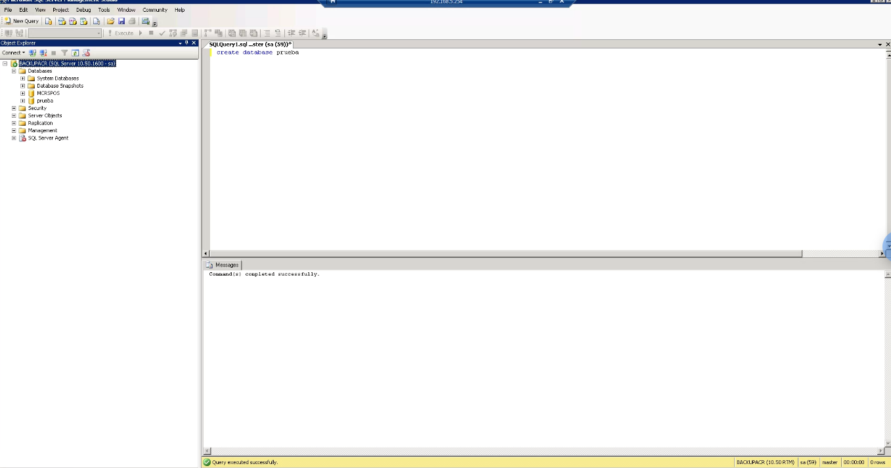

## **The SQL DROP DATABASE Statement**

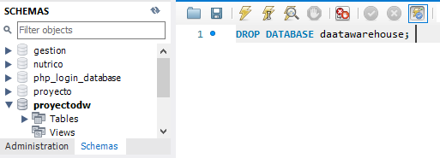

# SQL BACKUP DATABASE for SQL Server

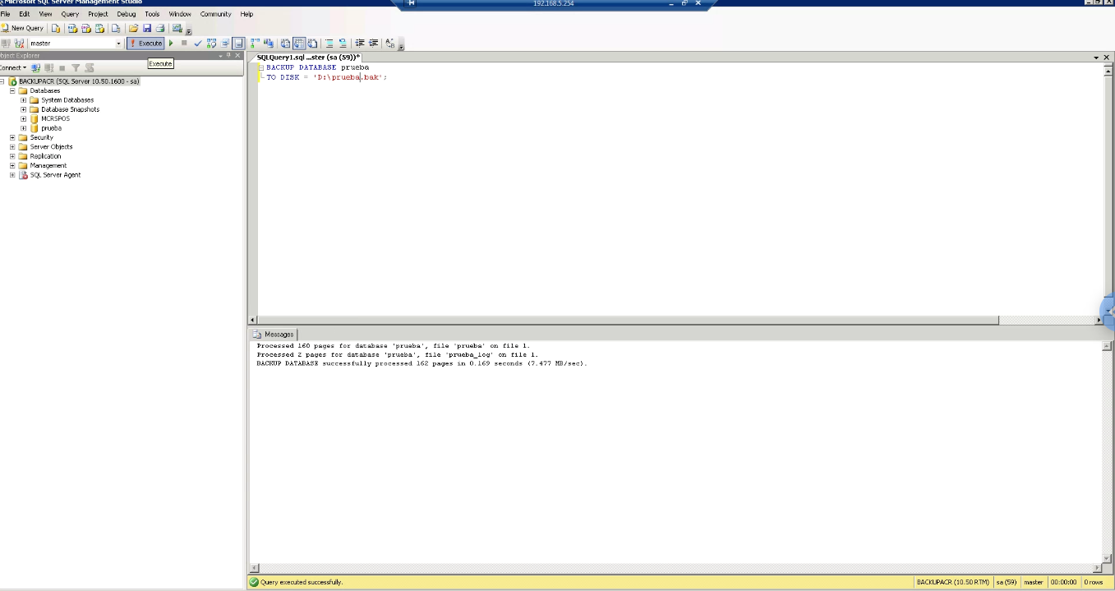

# SQL CREATE TABLE Statement

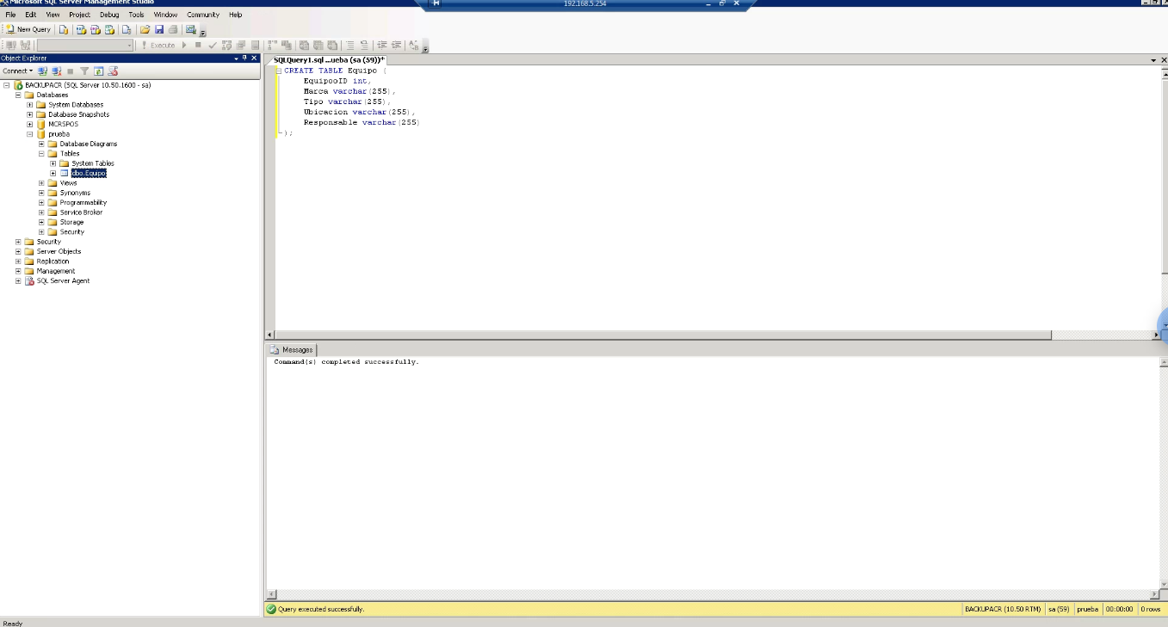

# SQL DROP TABLE Statement

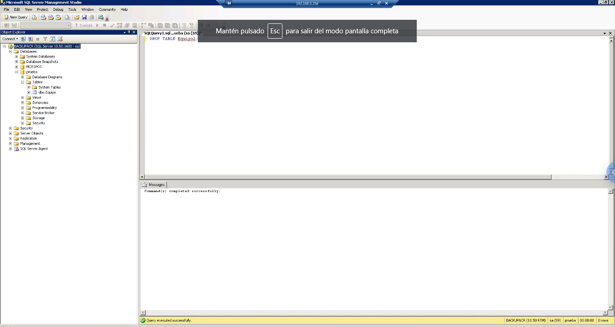

# SQL ALTER TABLE Statement

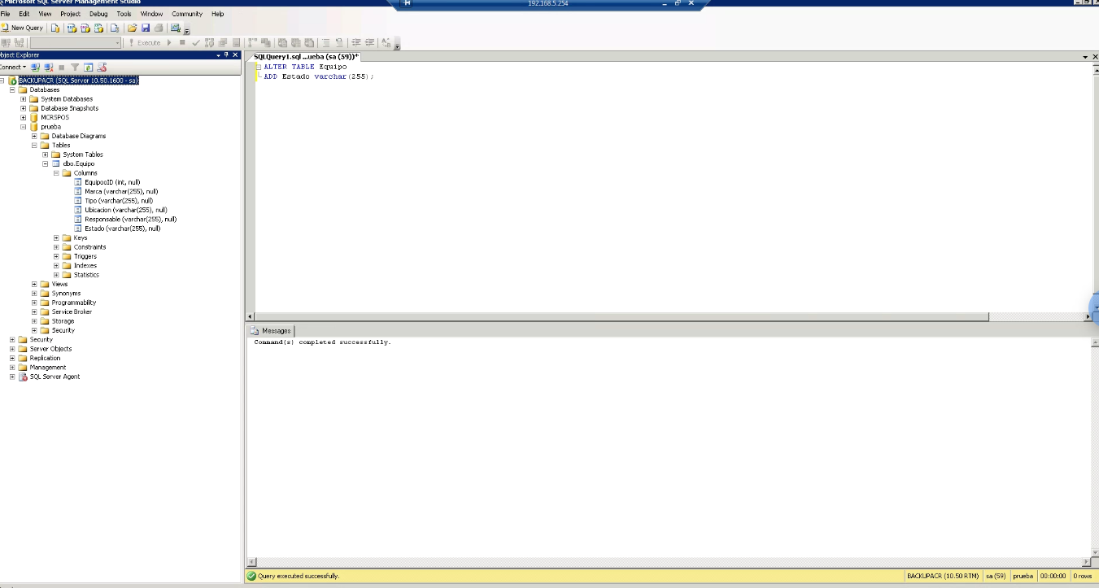

# SQL NOT NULL Constraint

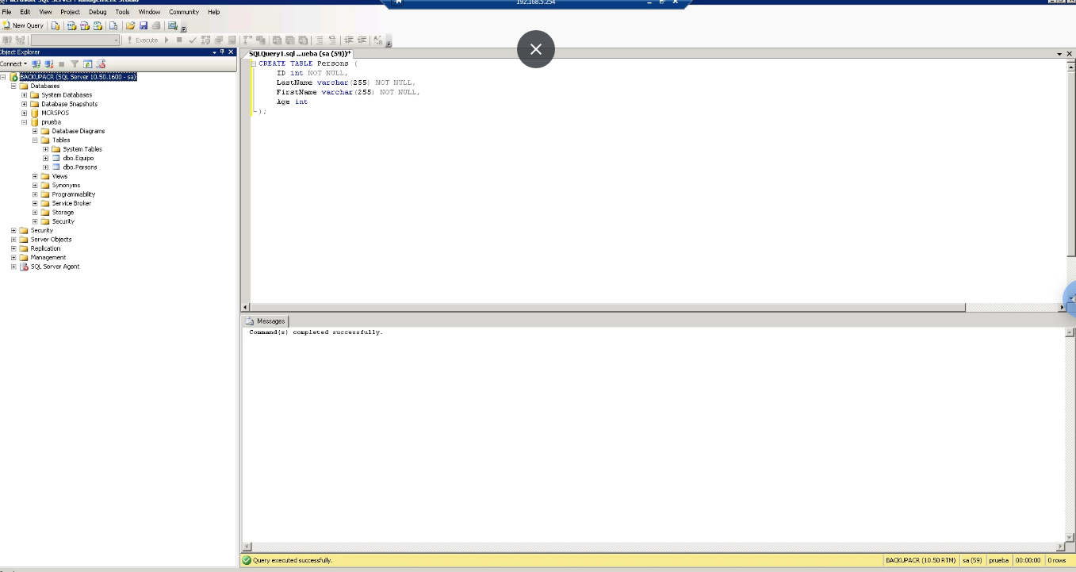

# SQL PRIMARY KEY Constraint

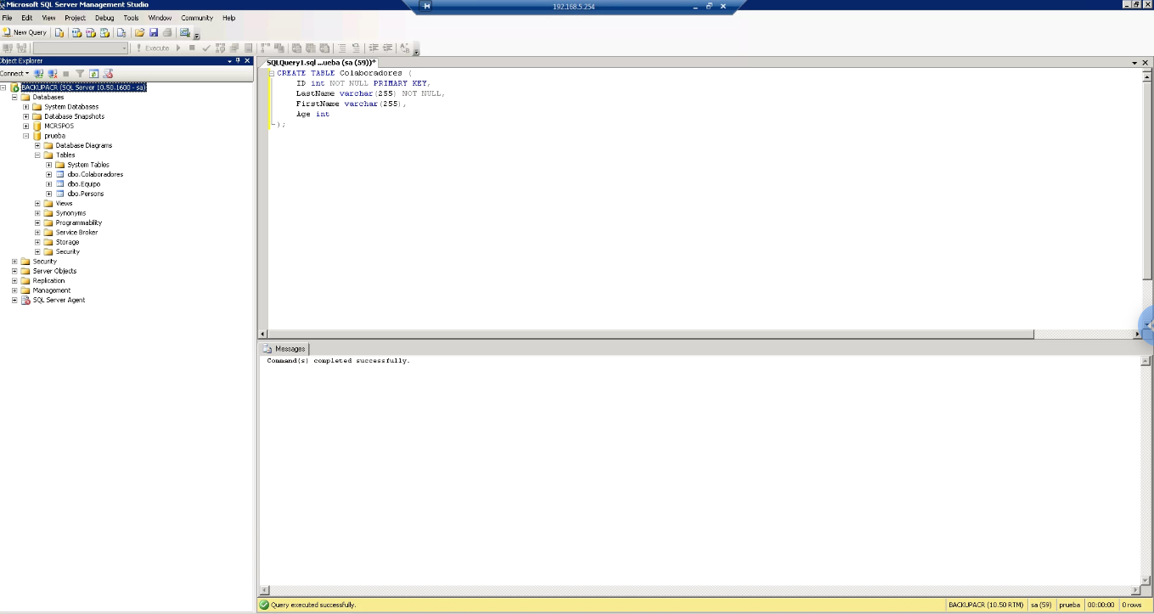

## **SQL FOREIGN KEY Constraint**



# SQL AUTO INCREMENT Field

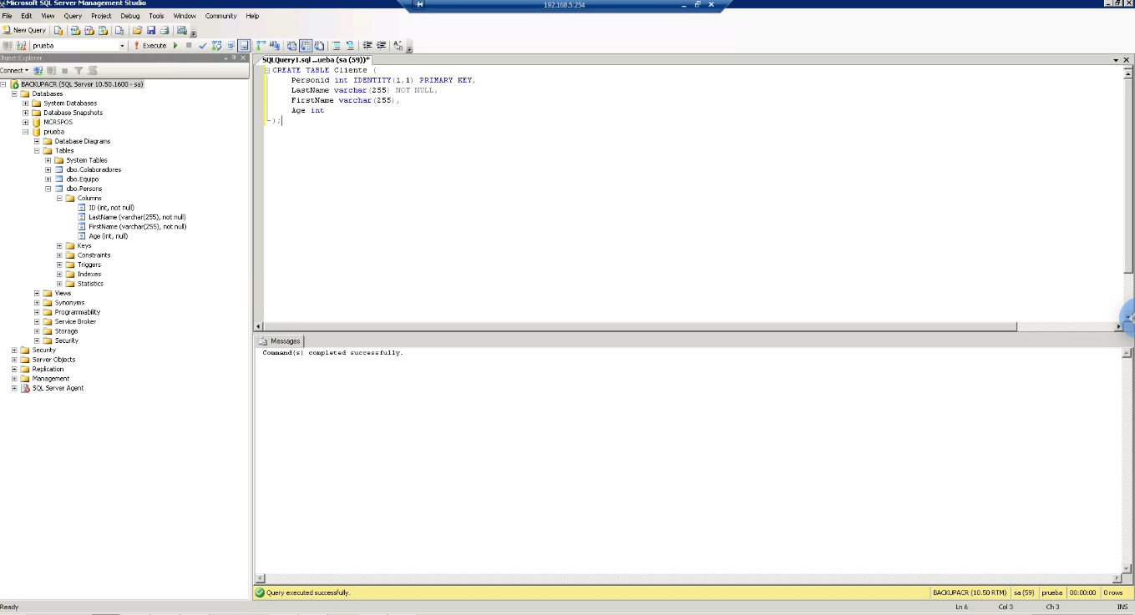

# QUIZ SQL W3SCHOOLS

# 

# Exercises w3schools

# 

# 