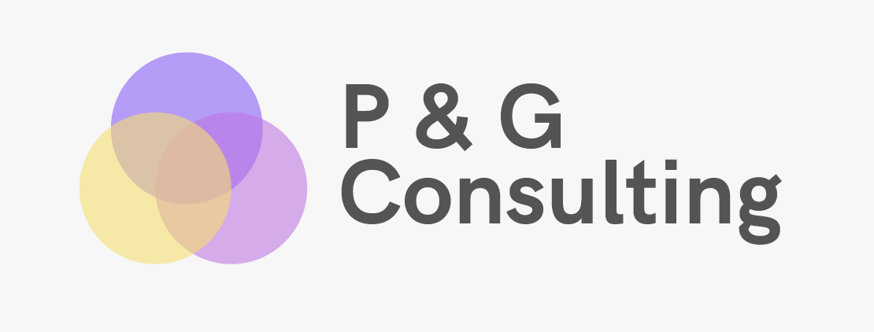

**ISDS 7510: SQL Project – Group #3**

Lundyn Harrelson, Julian Navarre, Rachel Packer, Erin Roach

**Business Statement**

Purple & Gold Consultants, specialize in enhancing businesses’ tech operations. Recently, we gained a new client, Snip’s. Snip’s is a virtual salon/barber client who has asked us to create an application platform to connect with clients so that stylists may provide mobile service(s) to customers. Snip’s is a mobile salon/barber service provider, which contracts licensed stylists who can bring their service(s) to the client, instead of the traditional business model of enforcing the client to travel to them to receive such service(s). To begin the deployment of Snip’s new application, we must create a database. Below, we have attached our working model of the new database for Snip’s.

**Entity Relationship Diagram**

Explains ERD

Paste picture of ERD underneath

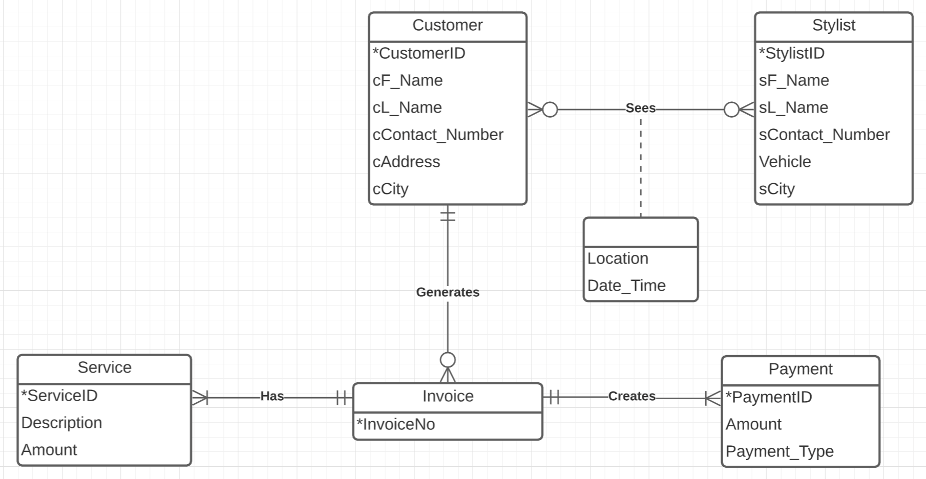

**Data Defnition**

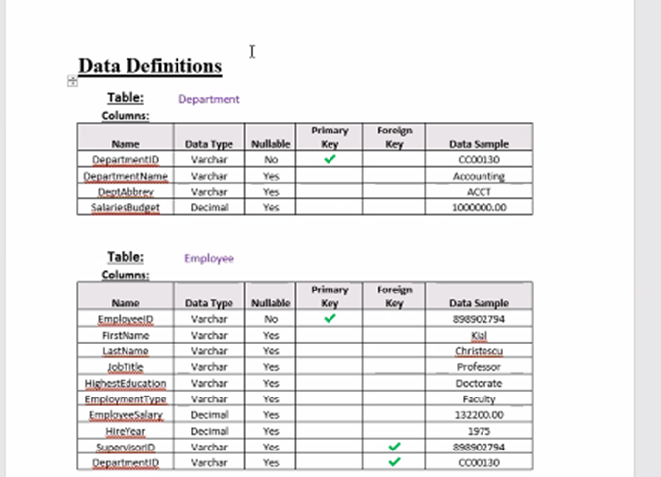

^

Sample of what it should look like. This was done in Excel

**Query Matrix**