**Solution explanation**

To adapt the microservices architecture, two Web Api were developed.

Customer Api is responsible for registering and configuring the consumer and their relationship with the services

PricingCalculator Api calculates the price based on the information retrieved from the first one.

**Customer Api**

Class model created to store the information needed to pricing calculator

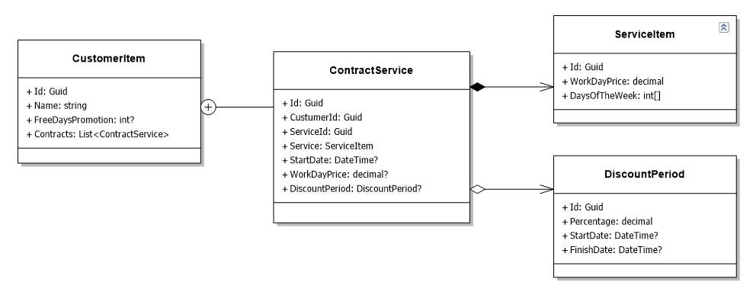

**CustomerItem**: Represents a consumer.

**ContractService**: Represents the consumer's relationship with the service.

**ServiceItem**: Represents a service.

**DiscountPeriod**: Represents a percentage discount for a service.

**Pricing Calculator Api**

To use the PricingCalculator microservice it is necessary to send the consumer and the date period, for this the 'CalculatePrice' domain class is used.

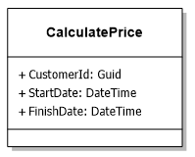

The service will only work correctly if the Customer Api service is started and with the information pre-registered.