ORDER PROCESSING SYSTEM.

Student: Trương Minh Quang

Student ID: He130060.

Instructor: TrungNT

Class: IS1301

Table of Contents

OPS system 3

1/Introduction to OPS. 3

2/ Functional and non-functional requirements of the system. 3

2.1/ Functional requirements. 3

2.2/ Non-functional requirements. 4

Online catalog 5

1/Introduction to online catalog. 5

2/List functional and non-functional requirements. 5

2.1/ Functional requirements. 5

2.2/ Non-functional requirements. 6

Financial Department. 7

1/ Introduction to financial department system. 7

2/ List functional and non-functional requirements. 7

2.1/ Functional requirements. 7

2.2/ Non-functional requirements. 8

Shipping Department 8

1/ Introduction to Shipping Department system. 9

2/ List functional and non-functional requirements. 9

2.1/ Functional requirements. 9

2.2/ Non-functional requirements. 9

Account Managing System 10

1/ Introduction to Account Managing system. 10

2/ List functional and non-functional requirements. 10

2.1/ Functional requirements. 10

2.2/ Non-functional requirements. 11

# OPS system

In this section: we will cover the following topics:

1/Introduction to OPS.

2/List functional and non-functional requirement.

1/Introduction to OPS.

* An order processing system captures order data from customer service employees or from customers directly, stores the data in a central database and sends order information to the accounting and shipping departments
* Order processing systems provide tracking data on orders and inventory for every step of the way.

* Having a solid order processing system in place creates a win-win situation for businesses and their customers.
* Customers experience more reliable deliveries and accurate order fulfillment.
* Businesses can maximize their profitability by not misplacing or misreading orders, not to mention the long-term revenue boost that comes from consistently satisfying customers.

## 2/ Functional and non-functional requirements of the system.

- In The following pages. Functional and non-functional of this system with be list with a description.

### 2.1/ Functional requirements.

- Priorities description and values:

|  |  |
| --- | --- |
| Priority value | Description |
| 1 | This is a must-have functional of the system |
| 2 | This function is nice to have but not required |
| 3 | This function will be concerned in the future |

|  |  |  |  |  |
| --- | --- | --- | --- | --- |
| Function ID | Title | Description | Priority | Actor |
| 1.f.1 | Add Items to cart | This function allows customers to add items they want to buy for later purchase | 1 | User |
| 1.f.2 | Remove items from cart | This function allows customer to remove items that they don’t want any more from cart | 1 | User |
| 1.f.3 | Check out | This function allows customer to pay for the items they wish to | 1 | User |
| 1.f.4 | Estimate arrival date | This function allows customer to estimate arrival time depends on order processing time and shipping department | 1 | User |
| 1.f.5 | Cancel transaction | This function allows customer to choose to cancel the transaction by clearing all items of the cart. | 1 | User |
| 1.f.6 | Web user interface | This function allows customer to access the cart via web browser | 1 | User |
| 1.f.7 | Mobile user interface | This function allows customer to access carts via mobile apps | 2 | User |
| 1.f.8 | Adjust items quantity | This function allows customer to increase or decrease the number of items they want to buy when checking out | 2 | User |

|  |  |  |  |  |
| --- | --- | --- | --- | --- |
| 1.f.9 | User behavior analytic | This function allows customer to have static on how much money they have spent on a specific category of item | 3 | User |
| 1.f.10 | Items suggestion | This function allows customer to have suggestion on items that they might want to buy based on previous data of user | 3 | User |
| 1.f.11 | Cart confirmation | This function allows employees to have a look on user cart and confirm to user by calling user | 1 | User, Employees |

### 2.2/ Non-functional requirements.

- Priorities description and values:

|  |  |
| --- | --- |
| Priority value | Description |
| 1 | This is a must-have functional of the system |
| 2 | This function is nice to have but not required |
| 3 | This function will be concerned in the future |

- Securities description and values:

|  |  |
| --- | --- |
| Securities value | Description |
| 1 | This is a security level with no-security at all. |
| 2 | This is a security level for end-user using: This include: secured network, all user data is encrypted and encapsulated. |
| 3 | This is a security level for employees in the company with all features of level 2 securities and 2-factor authentication, need authorization from higher level employees for every change on the system |

2.2.1/Non-functional of OPS system.

- Concurrent users: 1000 users and 10 employees.

- Securities level 2 for all function in this system.

- Response-time: 2 – 5 (s).

2.2.2/Non-functional in detail

|  |  |  |  |
| --- | --- | --- | --- |
| Function ID | Title | Description | Priority |
| 1.nf.1 | Cart capacity | Cart can have space for 100 items | 2 |
| 1.nf.2 | User interface | Human- friendly. Have a specific theme across web and mobile app | 2 |

# Online catalog

In this section: we will cover the following topics:

1/ Introduction to online catalog.

2/ List functional and non-functional requirements.

1/Introduction to online catalog.

* The system is made to replace traditional catalog which is created by paper.
* Online catalogs give user ability to search, browse through the store items.

2/List functional and non-functional requirements.

- In The following pages. Functional and non-functional of this system with be list with a description.

### 2.1/ Functional requirements.

- Priorities description and values:

|  |  |
| --- | --- |
| Priority value | Description |
| 1 | This is a must-have functional of the system |
| 2 | This function is nice to have but not required |
| 3 | This function will be concerned in the future |

|  |  |  |  |  |
| --- | --- | --- | --- | --- |
| Function ID | Title | Description | Priority | Actor |
| 2.f.1 | Add new items | This function allows employee to add new items to the catalog | 1 | Employee |
| 2.f.2 | Edit Items | This function allows employee to adjust or make change to items information | 1 | Employee |
| 2.f.3 | Remove items | This function allows employee to remove items from catalog | 1 | Employee |
| 2.f.4 | List Items | This function allows user and employee to list items based on some conditions | 1 | User, Employee |
| 2.f.5 | Search Items | This function allows user and employee to search for items base on some conditions. | 1 | User, Employee |
| 2.f.6 | New Items discussion | This function allows customers to share their thoughts on company new products | 2 | User |
| 2.f.7 | Notify user | This function notifies users on new items released | 2 | User, system |
| 2.f.8 | Web user interface | This function allows customer to access the catalog via web browser | 1 | User |
| 2.f.9 | Mobile user interface | This function allows customer to access catalog via mobile apps | 2 | User |
| 2.9.10 | Items adjustment notification | This function is when an employee done editing items, a request will be sent to their manager about the adjustments they made on items | 1 | Employees |

### 2.2/ Non-functional requirements.

- Priorities description and values:

|  |  |
| --- | --- |
| Priority value | Description |
| 1 | This is a must-have functional of the system |
| 2 | This function is nice to have but not required |
| 3 | This function will be concerned in the future |

- Securities description and values:

|  |  |
| --- | --- |
| Securities value | Description |
| 1 | This is a security level with no-security at all. |
| 2 | This is a security level for end-user using: This include: secured network, all user data is encrypted and encapsulated. |
| 3 | This is a security level for employees in the company with all features of level 2 securities and 2-factor authentication, need authorization from higher level employees for every change on the system |

2.2.1/Non-functional of Online catalog system.

- Concurrent users: 1000 users and 10 employees.

- Securities level 2 for all function in this system where actor involves users and level 3 for functions involve employee.

- Response-time: 2 – 5 (s).

2.2.2/Non-functional in detail

|  |  |  |  |
| --- | --- | --- | --- |
| Function ID | Title | Description | Priority |
| 2.nf.1 | Items comment | Each item should have 1000 limit of comment | 2 |
| 2.nf.2 | Add multiple items | The system should allow employees to insert multiple items at a time via files like csv , excel, json | 1 |
| 2.nf.3 | Platform to notify manager | When an employee made a change on items information. A notify will made to their manager via mail, and sms message | 1 |

# Financial Department.

In this section: we will cover the following topics:

1/ Introduction to financial department system.

2/ List functional and non-functional requirements.

## 1/ Introduction to financial department system.

- This is a system will work at the bank for transactions, bill paying for the company and the store.

-This is a service system will work mostly with banks.

## 2/ List functional and non-functional requirements.

- In The following pages. Functional and non-functional of this system with be list with a description.

### 2.1/ Functional requirements.

- Priorities description and values:

|  |  |
| --- | --- |
| Priority value | Description |
| 1 | This is a must-have functional of the system |
| 2 | This function is nice to have but not required |
| 3 | This function will be concerned in the future |

|  |  |  |  |  |
| --- | --- | --- | --- | --- |
| Function ID | Title | Description | Priority | Actor |
| 3.f.1 | Check Account | This function allows system to check if the input information of users or employees is valid or not. Function which check with the banks | 1 | Users, Employees |
| 3.f.1 | Transaction | This function allows users or employees to transaction to a specific account in a specific bank | 1 | Users,  Employees |
| 3.f.2 | Record Transactions | This function allows users or employees to check their transaction history | 1 | Users,  Employees |
| 3.f.4 | Burrow money | This function allows users or employees  burrow money from the company. (purchase on credit) | 1 | Users,  Employees |
| 3.f.4 | Invest money | This function allows user or employees to invest their money in the company with a specific time | 1 | Users,  Employees |
| 3.f.5 | Record bills | This function allows the company to record the bills from user for shipping purpose and taxing | 1 | Users |
| 3.f.6 | Web user interface | This function allows customer to access the financial department via web browser | 1 | User |
| 3.f.7 | Mobile user interface | This function allows customer to access financial department via mobile apps | 2 | User |

### 2.2/ Non-functional requirements.

- Priorities description and values:

|  |  |
| --- | --- |
| Priority value | Description |
| 1 | This is a must-have functional of the system |
| 2 | This function is nice to have but not required |
| 3 | This function will be concerned in the future |

- Securities description and values:

|  |  |
| --- | --- |
| Securities value | Description |
| 1 | This is a security level with no-security at all. |
| 2 | This is a security level for end-user using: This include: secured network, all user data is encrypted and encapsulated. |
| 3 | This is a security level for employees in the company with all features of level 2 securities and 2-factor authentication, need authorization from higher level employees for every change on the system |

2.2.1/Non-functional of Financial Department system.

-This system needs to be more secure than other systems.

- Concurrent users: 1000 users and 10 employees.

- Securities level 3 for all function in this system.

- Response-time: 2 – 5 (s).

2.2.2/Non-functional in detail

|  |  |  |  |
| --- | --- | --- | --- |
| Function ID | Title | Description | Priority |
| 3.nf.1 | Payment method | Users and employees should be able to make payment using visa, master card, QR code, transaction | 1 |
| 3.nf.2 | Making multiple transaction | User and employees should be able to make multiple banking transaction at once | 1 |
| 3.nf.2 | Transaction limit | For security reasons, there should be a suggestion on how much money a user should spend a day based on their banking account information. So hackers may find it difficult to make big transactions | 2 |

# Shipping Department

In this section: we will cover the following topics:

1/ Introduction to Shipping Department system.

2/ List functional and non-functional requirements.

## 1/ Introduction to Shipping Department system.

* Shipping Department System was created for managing shipment information for both user and employees
* Shipping is the last phrase of product life cycle where the product will be handled to the end user

## 2/ List functional and non-functional requirements.

- In The following pages. Functional and non-functional of this system with be list with a description.

### 2.1/ Functional requirements.

- Priorities description and values:

|  |  |
| --- | --- |
| Priority value | Description |
| 1 | This is a must-have functional of the system |
| 2 | This function is nice to have but not required |
| 3 | This function will be concerned in the future |

|  |  |  |  |  |
| --- | --- | --- | --- | --- |
| Function ID | Title | Description | Priority | Actor |
| 4.f.1 | Add shipping items | This function allows employees to add items for shipping in storage | 1 | Employees |
| 4.f.2 | Edit shipping items | This function allows employees to edit items shipping information | 1 | Employees |
| 4.f.3 | Remove Shipping items | This function allows employees to remove shipping items when a user cancel their product | 1 | Employees |
| 4.f.4 | List shipping Items | This function allows employees to list all the items need to process in a day | 1 | Employees |
| 4.f.5 | Search shipping items | This function allows employees and user to search items base on key word | 1 | Users, Employees |
| 4.f.6 | Track shipping Items | This function allows customers and employees to track their package | 1 | Users, Employees |
| 4.f.7 | Notify Shipping | This function will notify to user when the package arriving soon | 1 | Users |
| 4.f.8 | Web user interface | This function allows customer to access the shipping department via web browser | 1 | User |
| 4.f.9 | Mobile user interface | This function allows customer to access shipping department via mobile apps | 2 | User |

### 2.2/ Non-functional requirements.

- Priorities description and values:

|  |  |
| --- | --- |
| Priority value | Description |
| 1 | This is a must-have functional of the system |
| 2 | This function is nice to have but not required |
| 3 | This function will be concerned in the future |

- Securities description and values:

|  |  |
| --- | --- |
| Securities value | Description |
| 1 | This is a security level with no-security at all. |
| 2 | This is a security level for end-user using: This include: secured network, all user data is encrypted and encapsulated. |
| 3 | This is a security level for employees in the company with all features of level 2 securities and 2-factor authentication, need authorization from higher level employees for every change on the system |

2.2.1/Non-functional of Shipping Department system.

- Concurrent users: 1000 users and 10 employees.

- Securities level 2 for all function in this system where actor involves users and level 3 for functions involve employee.

- Response-time: 2 – 5 (s).

2.2.2/Non-functional in detail

|  |  |  |  |
| --- | --- | --- | --- |
| Function ID | Title | Description | Priority |
| 4.nf.1 | Hiding some private information | When user search package needs to match exactly the package code. | 1 |
| 4.nf.2 | Showing important information when user tracing packages | When users trace their package, show user where the packages are, who are delivering, delivery time, shipper contact | 1 |

# Account Managing System

In this section: we will cover the following topics:

1/ Introduction to Account Managing system.

2/ List functional and non-functional requirements.

## 1/ Introduction to Account Managing system.

* This is a system use for managing account of above systems.
* Others system can call to this common account managing system.

## 2/ List functional and non-functional requirements.

- In The following pages. Functional and non-functional of this system with be list with a description.

### 2.1/ Functional requirements.

- Priorities description and values:

|  |  |
| --- | --- |
| Priority value | Description |
| 1 | This is a must-have functional of the system |
| 2 | This function is nice to have but not required |
| 3 | This function will be concerned in the future |

|  |  |  |  |  |
| --- | --- | --- | --- | --- |
| Function ID | Title | Description | Priority | Actor |
| 5.f.1 | Register account | This function allows an account to be created | 1 | Users, Employees |
| 5.f.2 | Edit Account | This function allows users and employees to adjust their account information | 1 | Users, Employees |
| 5.f.3 | Remove Account | This function marks an account in database as deleted | 1 | Users, Employees |
| 5.f.4 | Disable Account | This function allows managers or company employees to penalty some account with bad behavior | 1 | Employees,  Users |
| 5.f.5 | Notify changing password | This function alert employees and users to change their password | 1 | Users,  Employees |
| 5.f.6 | Web user interface | This function allows customer to access the shipping department via web browser | 1 | User |
| 5.f.7 | Mobile user interface | This function allows customer to access shipping department via mobile apps | 2 | User |
| 5.f.8 | Read account information | This function allows customer to view their account status | 1 | User |
| 5.f.9 | Notify when account is logged at unrecognized devices | This function will notify user when their account is logged in unrecognized devices | 1 | User |
|  |  |  |  |  |

### 2.2/ Non-functional requirements.

- Priorities description and values:

|  |  |
| --- | --- |
| Priority value | Description |
| 1 | This is a must-have functional of the system |
| 2 | This function is nice to have but not required |
| 3 | This function will be concerned in the future |

- Securities description and values:

|  |  |
| --- | --- |
| Securities value | Description |
| 1 | This is a security level with no-security at all. |
| 2 | This is a security level for end-user using: This include: secured network, all user data is encrypted and encapsulated. |
| 3 | This is a security level for employees in the company with all features of level 2 securities and 2-factor authentication, need authorization from higher level employees for every change on the system |

2.2.1/Non-functional of Account Managing system.

-This system needs to be more secure than other systems.

- Concurrent users: 1000 users and 10 employees.

- Securities level 3 for all function in this system.

- Response-time: 2 – 5 (s).

2.2.2/Non-functional in detail

|  |  |  |  |
| --- | --- | --- | --- |
| Function ID | Title | Description | Priority |
| 5.nf.1 | Register using social media | This function allows users to register account using their social media account like facebook, twister, gmail,  Hotmail, … | 1 |
| 5.nf.2 | Logging using social media | This function allows users to logging account using their social media account like facebook, twister, gmail,  Hotmail, … | 1 |

Software design Document

1/ Use case diagram for all system

a/ Use case for OPS system

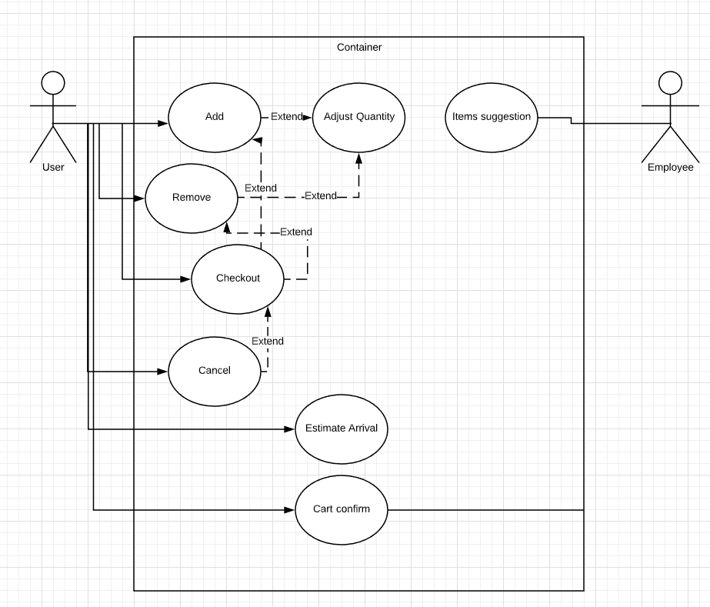

Use case diagram for OPS System.

b/ Use case for Online Catalog.

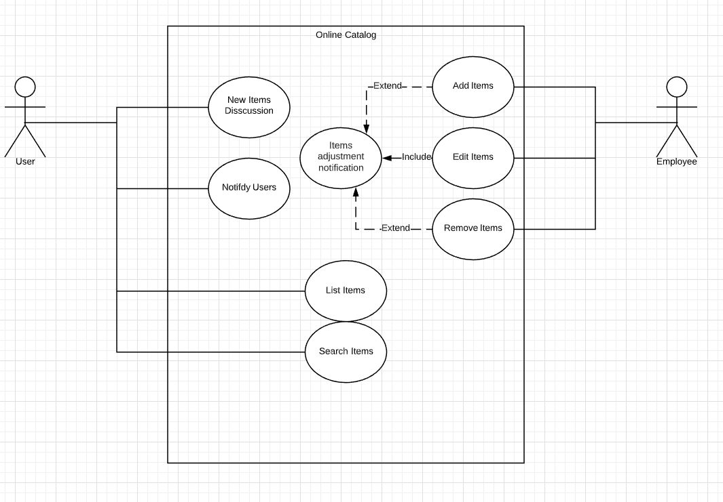

c/ Financial Department

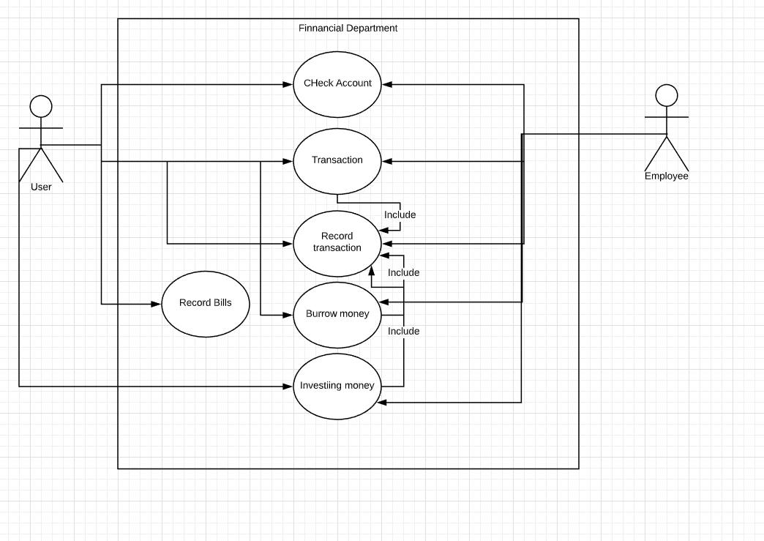

d/ Shipping Department

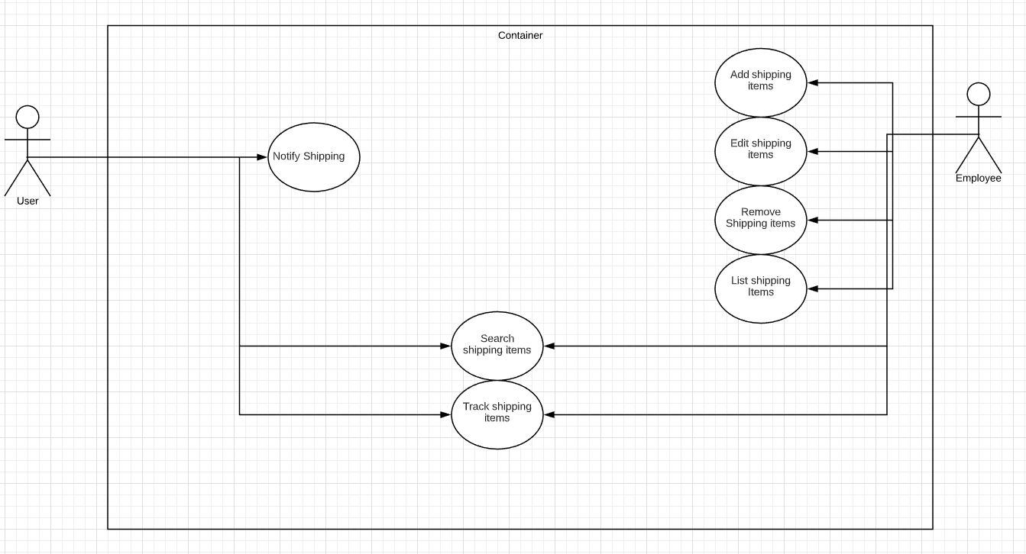

e/ Account managing system

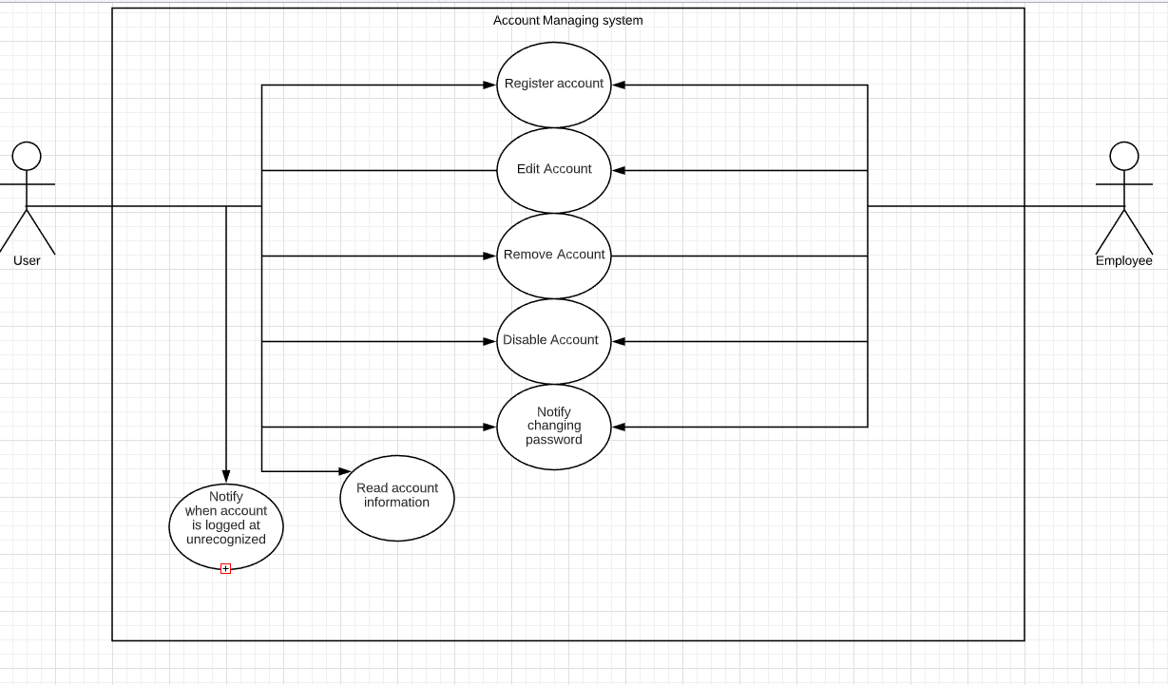

2/ Key point affect design document.

* Concurrent user: 1000 users and 10 employees.
* Response time medium: 2-5(s)
* Secure: some functions involve with money need a secure protocol and network.
* User interface must be matching for all other system across platform, human-friendly.

3/ Developing environment.

3.1/