University of Malta


CPS3230 Assignment: Part 1 – Unit Testing
CPS3230: Fundamentals of Software Testing

Julian Portelli (53299M)

B.Sc. IT (Hons) Software Development
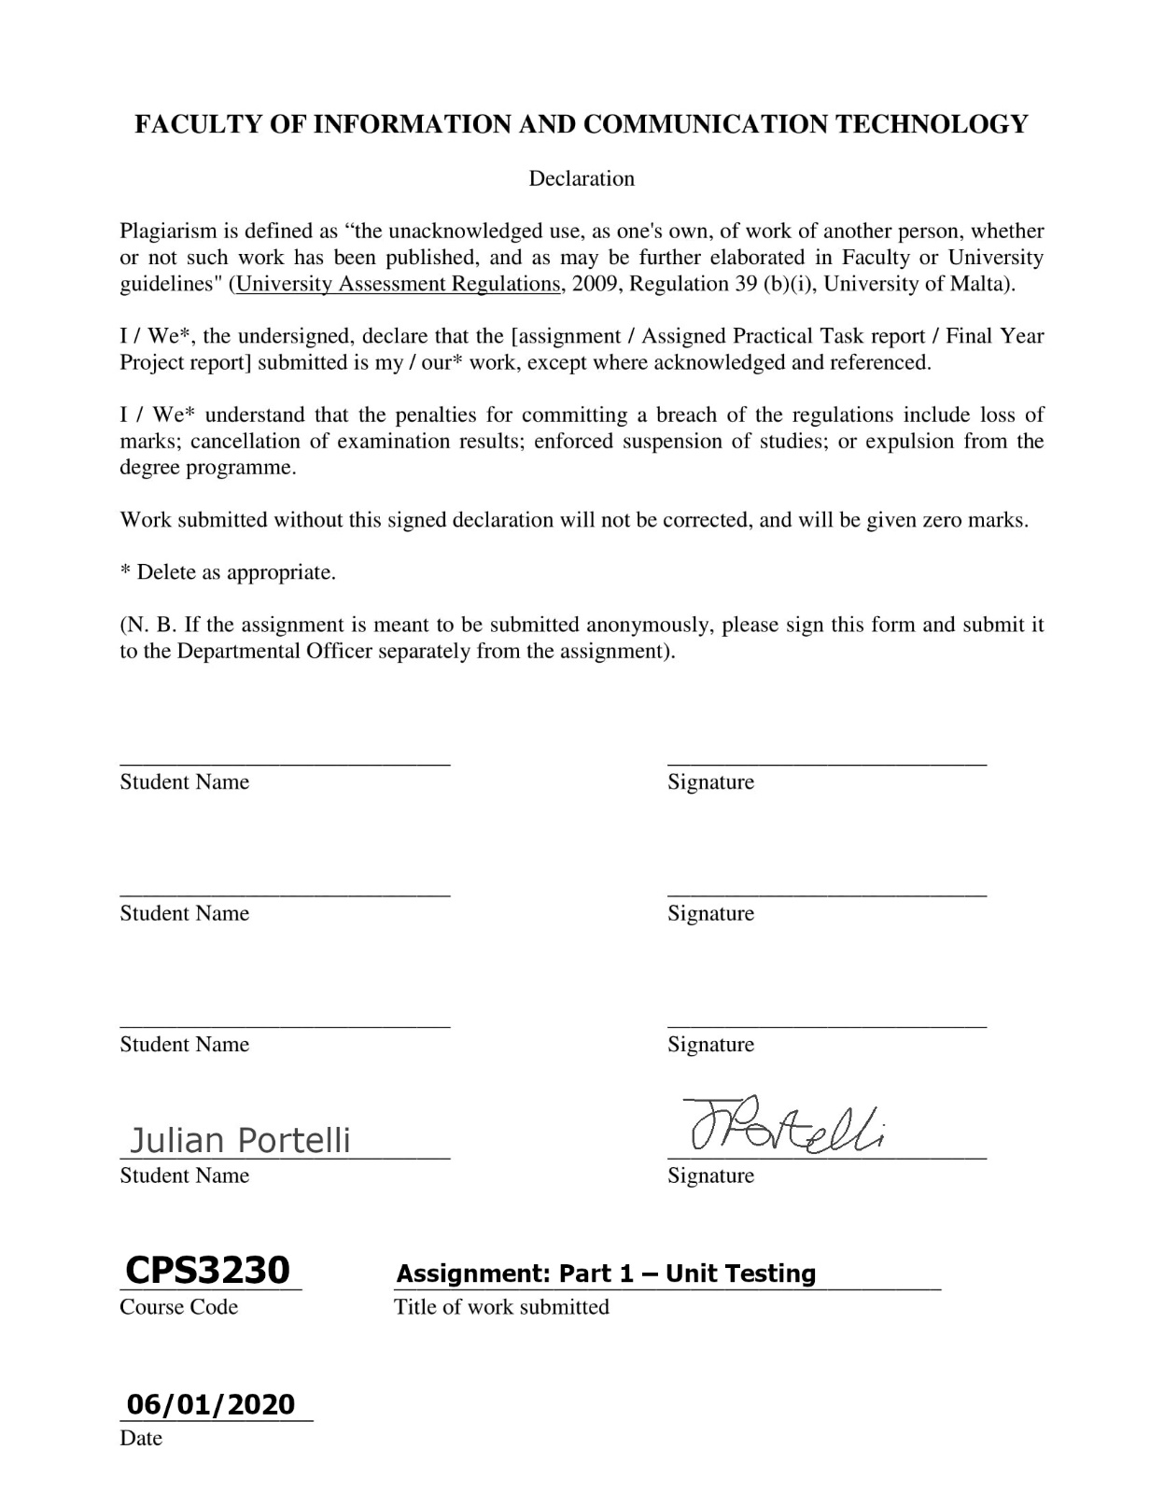

Contents
Task 1 1
Task 2 2
Task 3 3

Task 1

Task 1 was simply to set up the environment for starting to work with the source code which would the system under test, as well as understand how the code under test works, by running the main class an comprehending how the program works by analysing individual components and their interactions within the program. The git repository was created and is available on https://github.com/julianportelli/CPS3230-Assignment-Part1 (private). Commits were committed regularly to keep track of what changes were done, including the creation of unit tests and corrections therein. How and why certain tests were created will be discussed in the following section.

Task 2

It was specified that unit tests were to be created without making any changes to the system given. The original code given could not be touched and therefore any and all testing had to be done as unit tests in the test folder only. Work was performed on IntelliJ IDEA and Junit 4.12 was used as the dependency repository for unit tests. Source code was not to be modified.
It was kept in mind to achieve the maximum possible coverage for all classes provided in this assignment. Class coverage reached 100%, Method coverage reached 95% and Line coverage reached 64%. The reason method coverage did not reach 100% is mainly because the main method of the CurrencyManager class cannot be tested. The main method cannot be called from within a testing environment. This explains the relatively low line coverage outputted by the IDE when one runs the tests with coverage. Therefore, the main method cannot be tested is not covered in the end. In the following part, the main method should be separated into different methods to increase coverage.
Ideally, the functionality of the mean method would be split into different smaller methods, mainly for code re-usability. Additionally, the CurrencyDatabase class uses a specific currencies file, which contains a list of currencies. The CurrencyDatabase reads from this file and methods of this class manipulate the currencies list text file. The target currencies file is specified as a string variable which is a directory path to it. Since this string is not allowed to be changed one cannot test the exceptions that could possibly occur if the contents of the currencies text file are different. However, this would disrupt the original intentions of the code. Thus, we should not allow the user to manually enter a text file, rather we can text for exceptions by creating new text files.

Task 3

For task 3, a new branch was created, called “di_test”. It is available on https://github.com/julianportelli/CPS3230-Assignment-Part1/tree/di_test .
In this part, the system had to be refactored to eventually make it more testable. This would then allow one to prominently increase test coverage by splitting code into separate modules, increasing testability of the system as it was tightly coupled before.
The first step done in this branch was Dependency Injection. Dependency Injection is a design pattern where one object supplies the dependencies (which are pieces of code that are needed in order for something to work) of another object. This requires the creation of an interface, in this case it is called ICurrencyRepository, which will serve as the building blocks of DI. A CurrencyRepository class was created which would shift the implementation of the CurrencyManager onto this class. With this, the CurrencyDatabase class will change, adding ICurrencyRepository field and require an ICurrencyRepository object in its constructor which will bind its local ICurrencyRepository with the passed object in the parameter. All core methods from CurrencyDatabase were shifted to the CurrencyRepository class instead.
To compliment Dependency Injection, a factory pattern was used which served as the Dependency Lookup pattern as well. A Factory pattern allows a user to define an interface or abstract class for creating an object but let the subclasses decide which class to instantiate. The class CurrencyFactory was used to implement this feature. The method getCurrencyRepository() creates a new object of the CurrencyRepository class.
From the source code given, the main method was situated in the CurrencyManager class. This had to change, since no lines of code could be testable as main methods can’t be referenced in test cases. Thus, a new class called CurrencyManagerMenu was created to accommodate this need. CurrencyManagerMenu features and initMenu() method which would call the menu program like previously in the main method of the CurrencyManager class. initMenu() is not the main method, hence the program needed to be executed somewhere else. To accomplish this, a class called ‘main’ was created and would be the entry point of program execution. This class would take an create and instance of CurrencyManager and CurrencyManagerMenu which would take the latter CurrencyManager object as a parameter. Then, initMenu() would be called to start the program and present the user with the main menu.
All the methods in the switch cases had to be broken down into separate methods. For each switch case, a method was created from it. Core implementation did not change but code was simply modified for switch case methods to return something for testing. Test class CurrencyManagerMenuTests was developed to test each case’s output.
Initially, I had thought that, to increase testability of the input file (which is used as the file to read currencies), that it should be required to ask the user to input a text file manually. This was attempted but eventually failed as the method would not execute upon test but only after the test was cancelled, rendering it useless, resulting in an infinite loop. This was eventually replaced with tests in the test class CurrencyDatabaseTests which allows setting the input file by parameter in the init() method of the CurrencyRepository class. More tests were added in CurrencyDatabaseTests to test for invalid files – these invalid files were added in the project’s main/resources folder.
The following test classes are the ones which were developed and executed:
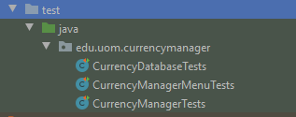
Total coverage was 100% class coverage, 97% method coverage, and 89% line coverage. Line coverage increased much more from Task 2. Most of the uncovered lines were due to the initMenu() method from the CurrencyManagerMenu class which can’t really be tested (but the methods inside of it – in the switch case – were all tested), as well as some miniscule lines of code in the CurrencyRepository class which were:
this
if (System.currentTimeMillis() - result.timeLastChecked > FIVE_MINUTES_IN_MILLIS) {
result = null;
}
and this:
} else {
System.err.println("Invalid currency code detected: " + currency.code);
}

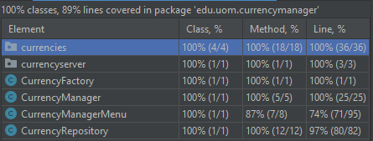
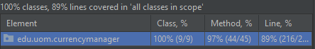
The rest of the coverage was full, as seen in the following screenshots:

