University of Malta


CPS3230 Assignment: Part 2 –
Web Testing and MBT
CPS3230: Fundamentals of Software Testing

Julian Portelli (53299M)

B.Sc. IT (Hons) Software Development
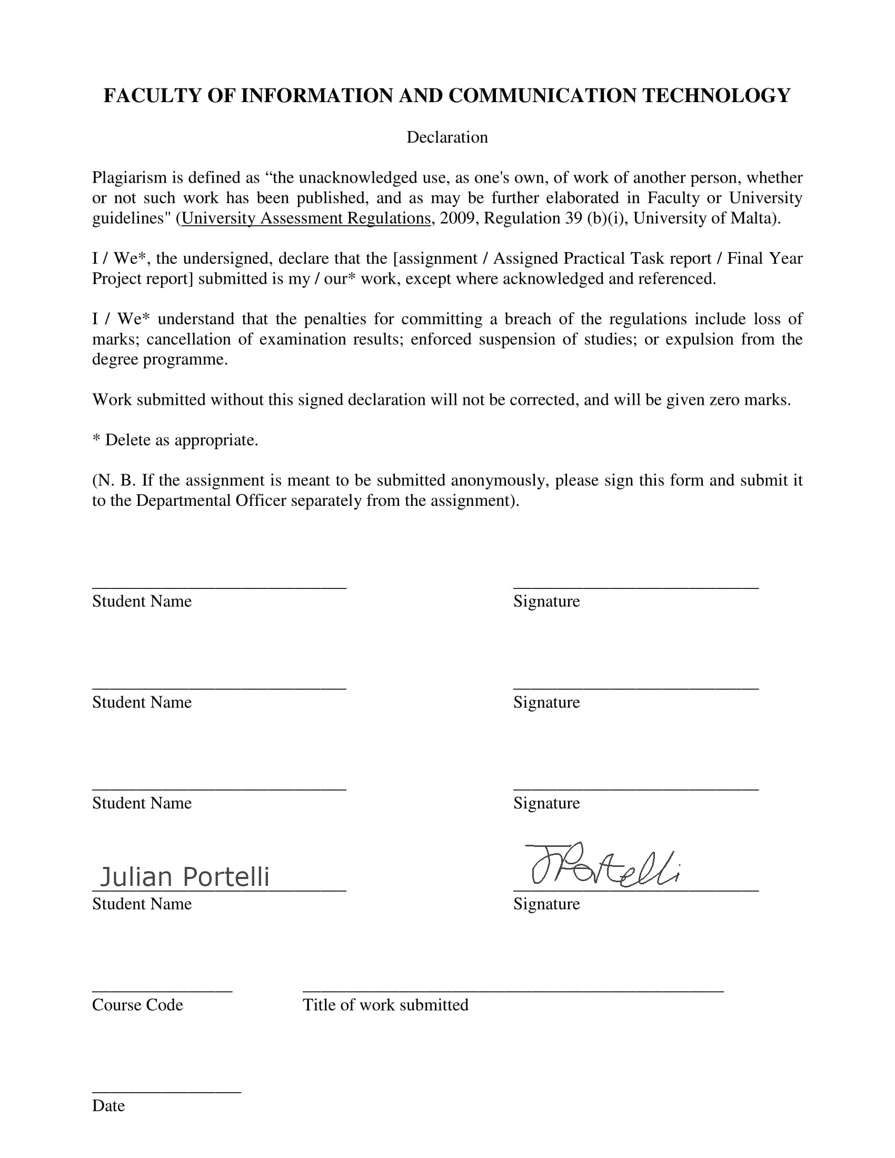

Contents
Preface 1
Task 1 2
The Feature File 3
The Step definitions file 4
Design decisions 6
Task 2 7

Preface

How to run:
- Set up Java SDK
- Download the latest chromedriver from the internet
- In WebsiteSystemTesting.java, modify the line
System.setProperty("webdriver.chrome.driver", "C:/Users/porte/Downloads/chromedriver_win32/chromedriver.exe");

And set the “C:/Users…” path to the path of your chromedriver

Task 1

The system used was the website https://recordsale.de/ which allows customers to view and purchase music in physical form, from CDs to Vinyl records. This particular website was chosen due to personal preference, as my interest in physical media has risen lately, and the site’s simple yet effective design provided a great subject for testability. The site functions like any other ecommerce site: it allows users to create accounts, log in and out, search for products, add products to a cart, view their cart, edit items in their cart, and checkout items.

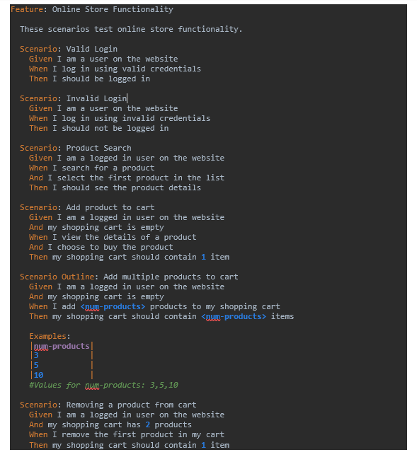
The Feature File

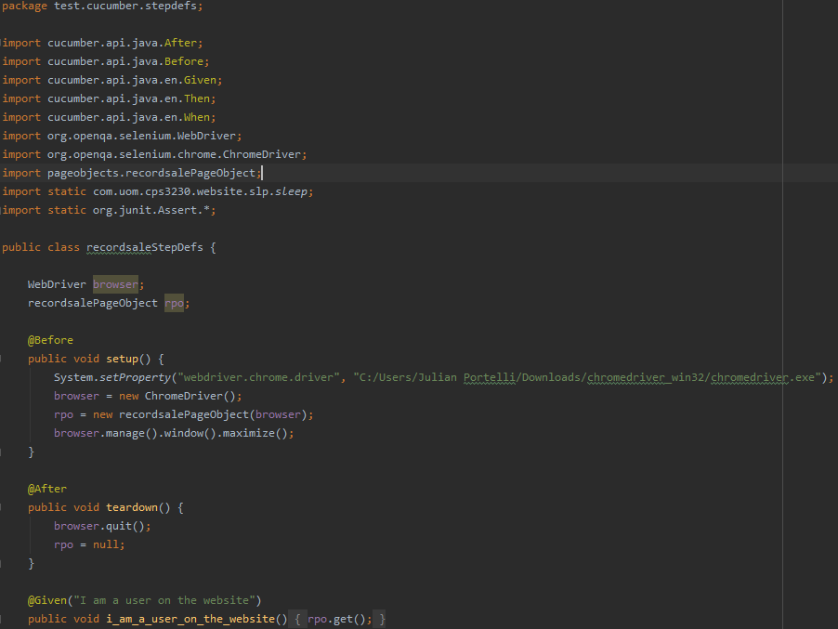
The Step Definitions File

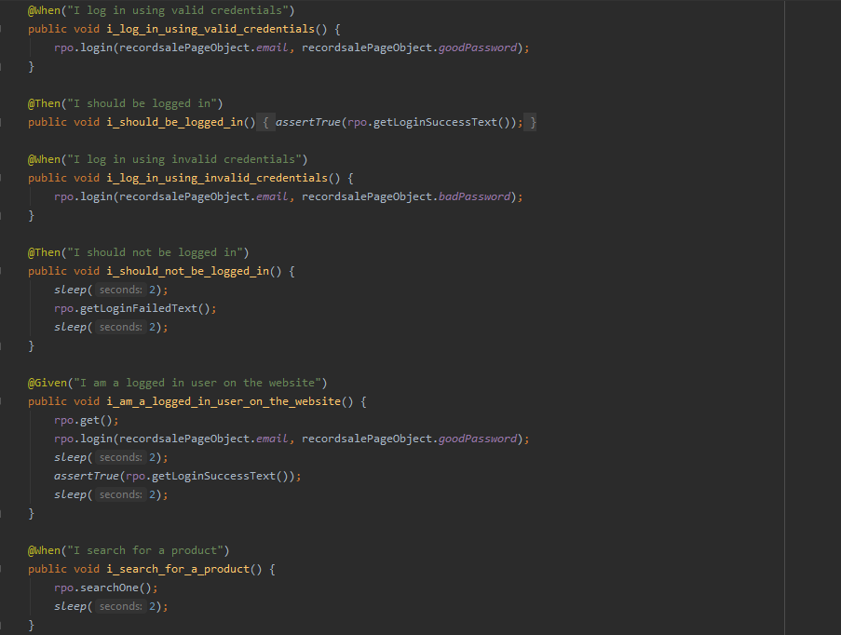

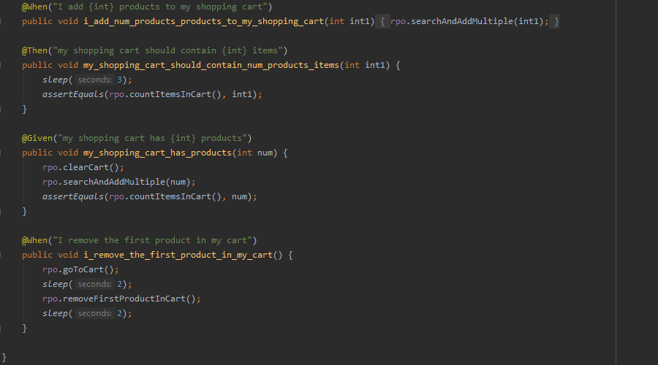
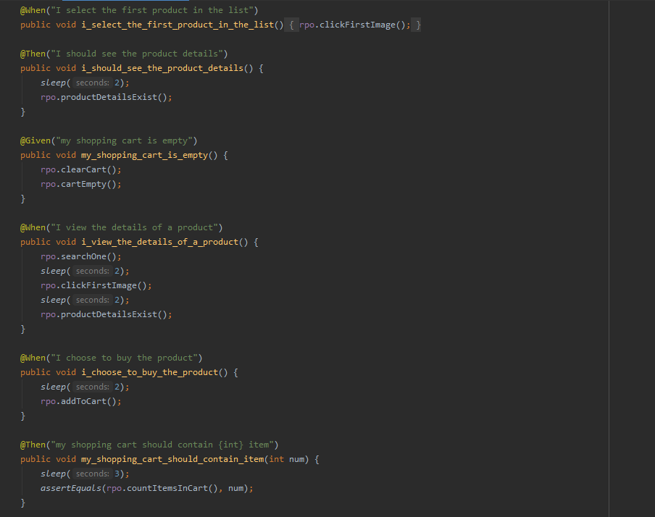
The step definitions file, known as recordsaleStepDefs, makes use of the recordsalePageObject and its methods to accommodate the scenarios given. No conditional logic was written in this file as all of this was coded in the PageObject’s methods. Some sleep() methods had to be placed in order to accommodate the loading of the webpage to delay methods just in case a user’s internet connection is not fast enough.

Design decisions

Initially, values were placed next to certain scenario steps; for example, for “Given I am a user on the website” the string “CPS3230Test@gmail.com” was placed next to it. However, the repetition of these values in each scenario proved to be a clunky way of maintaining and modifying code. Thus, the values that were to be passed in the recordsaleStepDefs were stored in the PageObject named recordsalePageObject. The recordsalePageObject reduced the need for repetition of code and simple readable scenario steps.
The feature file had to be slightly modified from the given assignment description. Scenario 5 had to be converted into a scenario outline to allow for multiple values to be processed. The outline and examples instruct cucumber to run the scenario 3 times for 3, 5 and 10 products. The 10 product names were stored in the recordsalePageObject itself in the form of a string array. The a new adding to cart method had to be created depending on the number of items that were to be added, which relied on a list of Strings of search terms which would be looped through to search 3, 5 or 10 times, depending on the scenario example.
It was important to clear the cart for most scenarios since items added to the cart in previous scenarios persisted throughout the next scenario due to the fact that cart items were being stored on the user account.
While an element might not be able to be clicked on screen, due to it not being visible unless the browser scrolls down, the webdriver is still able to click buttons not visible by locating the element in the DOM and using the .submit() method. In order to find certain HTML elements that needed to be interacted with in order to use the site, care was taken to identify the ids and classes of HTML tags so that the right elements would be interacted with at runtime.

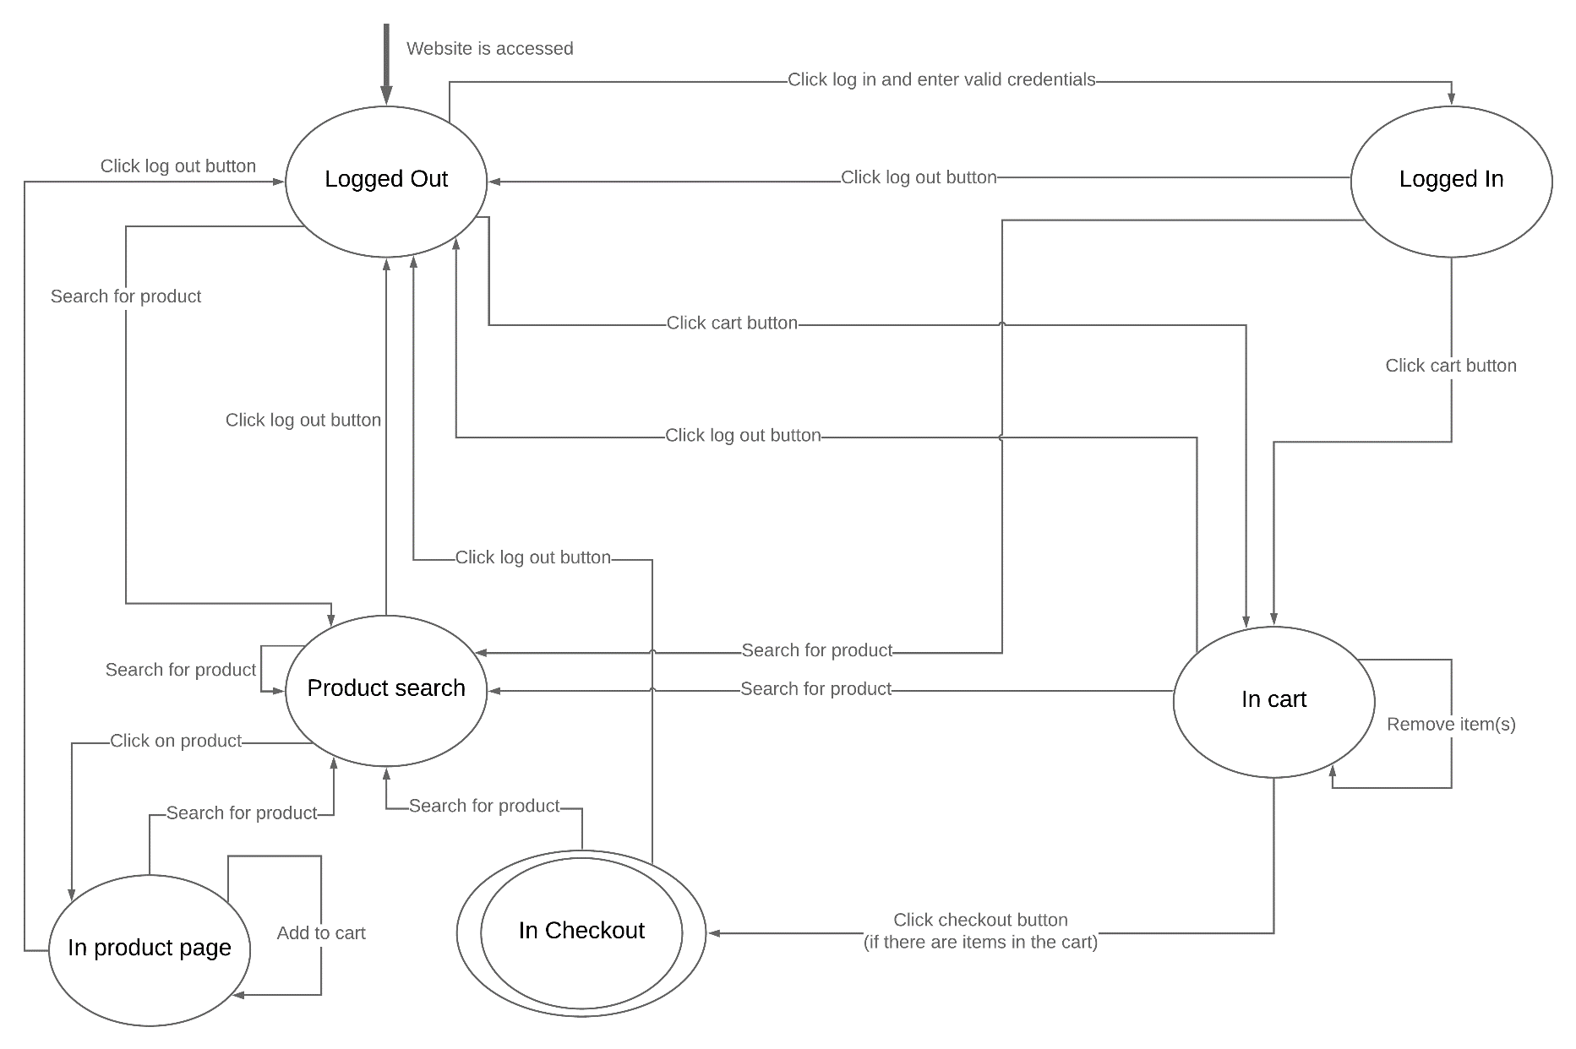
Task 2

The recordsalePageObject was initially going to be reused for the functionality of the website for model-based behaviour, but it was clearly understood that minor code changes were needed to suit the behaviour of the in website in FSM form. Therefore, some code was copied from the recordsalePageObject to the WebsiteSystem class and modified to fit the needs of the model-based tests.
Adding items and checking out does not require an account. Therefore, the diagram and hence the code take takes these two choices into consideration., Although the general consensus is that users normally create an account the first time they attempt to purchase items, one must take into account users that do not want to create an account on the website. Users normally create an account for multiple reasons, the most prominent being that users can save information about them on the account and keep track of purchases. Therefore, state transitions to the cart and checking out do not necessarily require the user to be logged in into the website.
The implementation from the model to code was adapted from some examples that were used in class. First, an enum called WebsiteSystemStates was created to create a list of immutable states which represent the state in the above diagram.
Secondly, a WebsiteSystem class was created, which was the system under test, with the ability to store and retrieve the website’s current states, while also including methods for actions that take place during regular website usage. This class was the backbone for the functionality of the system and mostly used the Chrome WebDriver like in Part1. The class WebsiteSystemModelTest contained ModelJUnit actions which assured that the correct state changes were taking place, according the previous state the user is in. Guards were used for each action to do this ensuring that incorrect state changes were caught if the current state of the system under test does not match the program’s state, an most importantly to ensure that each state can move to the correct states in accordance with the model’s diagram. Checks were made after each transition to ensure that the model is actually in the correct current state.
The WebsiteSystemTesting class collaborates everything together, setting up the webdriver and executes a greedy test, tracking state changes and coverage at the end. The greedy tester’s generated tests were set to 250 and not increased since this would take too long. The transition-pair coverage was not reaching 100% even if this number was increased, so it was kept at 250. Again, the sleep() method was used to give some leeway for the website to catch up with the webdriver.

