# Example user scenarios for Translator Text API

The Translator Text API is a cloud-based service that translates text between more than 60 languages, and also performs other language-related operations such as language detection, sentence breaking, and dictionary lookup. The Translator service translates speech, when used as part of the Speech Translator service. This document describes some examples for integrating the Translator Text API into your business solutions and processes.

## Empower comprehensive analysis of multi-lingual business intelligence

One of the key challenges for business decision makers (BDMs) today is analyzing and synthesizing large amounts of data to inform business decisions. An added complexity to analyzing data is when the data sources are in multiple languages as most analysis tools are designed to process a single language.

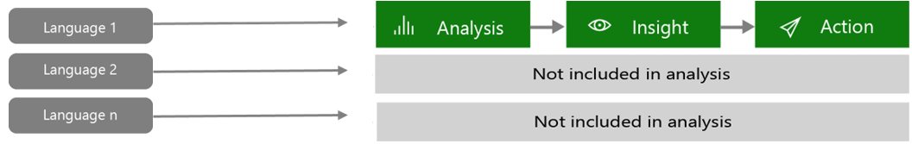

What if you could leverage all the data you have, for a more comprehensive analysis, regardless of the language or the format you receive it in, text or speech (.wav, .mp3)?

This can be easily achieved by integrating the Translator Text API, both text and voice recording into your existing analysis workflow.

A high-level description of this multi-lingual workflow can be depicted as follow:

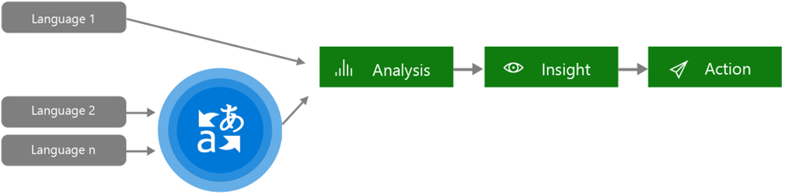

By integrating the Translator Text API into your analysis workflow, you will be able to provide a more comprehensive analysis using all of your data regardless of where it comes from, regardless of format from text to audio: CRM databases, marketing campaigns results, customer support logs or calls, translated audio files into searchable text, social media channels, etc.

## Provide sales, marketing, technical, or human resources content and training

Internal content is created faster than it is humanly possible to translate for all your internal stakeholders, as well as key partners, customers, and distributors.

A study conducted by Microsoft showed that more than 95% of pages created on internal company sites are never translated beyond their initial publishing language. For the less than 5% of sites that are translated, the translation is limited to one or, at most, two additional languages.

Worldwide GDP reach with 10 languages

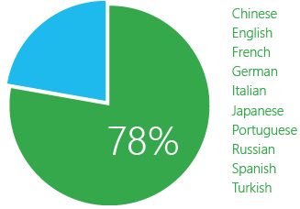

**By translating content into just the world’s top 10 languages**, this study estimated that a company will, on average, cover almost **78% of its business footprint**. Even by only supporting the top 5 languages, a business will be able to reach more than 60% of its global footprint.

This is true whether the content is:

* Training material for customer-support or field teams.
* Sales or partner readiness tools such as manuals, presentations, collateral, and training materials.
* Human-resources communications.
* R&D internal research papers.

Any area where knowledge-sharing needs to reach employees or partners in a language other than their own, machine translation is the only economically viable solution to scale across your organization’s communication channels.