**Software Requirements and Design Document**

**For**

**Group 19**

Version 1.0

**Authors**:

Dylan McClure

Julian Sweatt

Caleb Smith

Lucas Zavalía

Michael Heron

# Overview

This system is a collections of games from the childhoods of anyone born before Gen Z. This system should evoke nostalgia from the user after playing his/her favorite childhood games such as, Tic-Tac-Toe, Connect4, and Chess. The games included can be played in real life, however no one carries the materials for these games. This system offers an on-the-go version of them.

# Functional Requirements

1. 10-12 working games - high priority. Since the crux of the platform is the games, this is very important. Each game must be able to handle user input in one or more forms (mouse, keyboard, controller, etc), handle its state based on the inputs, and render a surface using pygame.
2. Menu to select desired game - high priority. Without this UI element, a user will not be able to play any games, so getting a working menu is very important. This entails loading games dynamically using importlib, creating a scrollable menu, and handling user input in the User Interface.
3. User login - medium priority. At an arcade, users have the ability, at the very least usually, to log in with a user name. Therefore, a button in the User Interface should allow a user to log in. Maybe it can be on a per-game basis and be part of the Plethora API that each game could optionally import.
4. A system that keeps track of points/high scores for each game.

# Non-functional Requirements

1. *CPU play (some games)*
2. *Non-internet dependent*
3. *Accurate game play*
4. *Settings and user preferences*

# Use Case Diagram

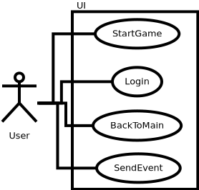

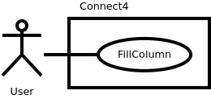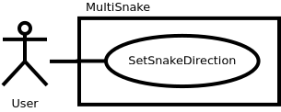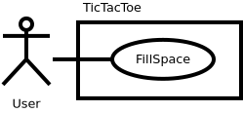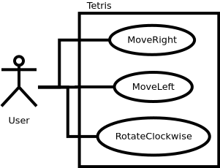

# Class Diagram and/or Sequence Diagrams

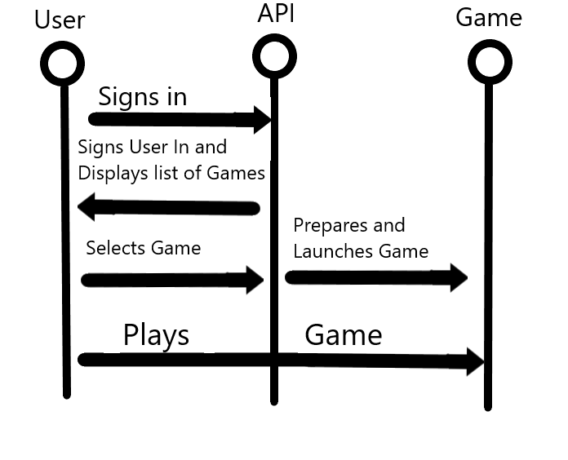

# Operating Environment

We are developing this project to run on a Raspberry Pi that will be running the Raspbian OS. Though we are designing Plythera Pi to run on a Raspberry Pi 3 Model A+, any of the available Raspberry Pis should be able to run our application just fine.

Plythera Pi is running on a Python virtual environment. Therefore the game platform could be extended to any other environment capable of supporting python3.

# Assumptions and Dependencies

For this project we are assuming that everyone who wants to play games on our application has access to at least a mouse and keyboard, but for some games actual USB controllers will also be supported.

Python3 and pygame are the only two dependencies that we have so far. There are forseen circumstances that would add to our dependencies.