ASCE Conference Proceedings Paper   
Formatting Instructions

Isabella M. Author, Ph.D.,1 Brandon Q. Writer, AIA,2 and   
Charles O. Author, P.E., M.ASCE3

1Hard Knocks Laboratory, Department of Civil and Environmental Engineering, Research State University, P.O. Box 98765, City, ST 99999-1111; e-mail: [imauthor@rsu.edu](mailto:imauthor@rsu.edu)

2Hard Knocks Laboratory, Department of Civil and Environmental Engineering, Research State University, P.O. Box 98765, City, ST 99999-1111; Writer & Bickering, LLC, 144 Main St., Megaville, ST 22222; e-mail: [bqwriter@rsu.edu](mailto:bqwriter@rsu.edu)

3Everlasting Company, Mail Stop LC 444, 2233 West 32nd Avenue, Township, ST 88888; e-mail: [co.author@everco.com](mailto:co.author@everco.com)

# ABSTRACT

A proceedings containing papers presented at this conference will be produced from the manuscripts received from authors. These instructions are formatted to resemble a final paper. The abstract should consist of one paragraph of about 150 words. The abstract should present a concise statement of the scope, principal findings, and conclusions of the paper. Abstracts cannot include lists, tables, figures, display equations, footnotes, or references.

# INTRODUCTION

An author’s central obligation is to present a concise account of his or her research, work, or project accompanied by an objective discussion of its significance. Submitted papers should contain detail and reference to public sources of information, so that the author’s peers are able to repeat the work or otherwise verify its accuracy.

ASCE requires that conference proceedings papers be original, unpublished work. Dual publication (publishing the same paper in multiple places without permission of the original publisher and agreement by the subsequent publisher) is a professional ethics violation and a legal problem. ASCE does not publish abstract-only submissions or slide presentations in conference proceedings.

It is inappropriate to submit abstracts or papers with an obvious commercial intent. It is also inappropriate to criticize another paper with personal attacks on the author(s).

Only people who have significantly contributed to the research, project, or manuscript preparation should be listed as coauthors. The corresponding author will attest that any people named as coauthors have seen the final version of the paper and agreed to its submission for publication.

The authors of proceedings papers are expected to present their papers in person at the conference or to find a substitute to present the paper.

Proceedings papers may *not* be published later as journal articles, unless the papers have been substantially revised to include new or additional material.

Proceedings papers are eligible for discussions and closures, which will be posted with the paper in ASCE Library.

# REQUIREMENTS FOR SUBMITTING A PAPER

Paper Length.

The maximum paper length is determined by your conference committee. Please consult your conference website for this information.

## Submission Deadlines.

If your paper has been accepted, please submit the final version of your paper by the deadline established by the conference committee or proceedings editor. Review your paper carefully before you submit the final version. Once a paper has been uploaded, reviewed by the author, and officially submitted, it is not possible to edit the document.

## Approvals.

Before submitting a paper, authors must obtain approvals from such interested parties as the authors' employers, clients, project owners, and government agencies.

## Copyright Transfer.

Each paper must be accompanied by an [ASCE Authorship Originality and Copyright Transfer Agreement](http://ascelibrary.org/userimages/ContentEditor/1412622184009/ASCE%20Authorship%20originality%20and%20CTA%20form.pdf) signed by the one author on behalf of all the authors. (See [*Copyright Basics*](http://dx.doi.org/10.1061/9780784478998.ch08) for more information on ASCE’s copyright requirements, an explanation of what authors can do with their own material, and sponsored access options.)

## Permissions.

Any materials that are not the original work of the authors of a proceedings paper must have the source identified at the end of a text extract or in a credit line immediately below the figure or table. The ***authors*** of each paper are responsible for securing permissions for nonoriginal materials and must be able to provide the permission documents if requested by ASCE Publications. ASCE Publications reserves the right to eliminate from the published proceedings any figures or tables lacking appropriate permission and to make editorial changes as necessary.

[*Permissions Basics*](http://dx.doi.org/10.1061/9780784478998.ch09) contains information on what needs permission and how to obtain it*.*

# MANUSCRIPT FORMATTING

A proceedings paper consists of a title; an author byline and affiliation(s); an abstract; the text with optional tables, figures, and mathematics; a conclusion; and references. Acknowledgments, appendixes, and notations are optional.

## Length.

Length is determined by the conference technical committee or proceedings editor. Total paper length includes all text, graphics, references, and appendixes.

## Point size and font.

Use 12 point type for text, captions, and author contact information. For type within figures or tables, the 12 point size is preferred. ASCE Publications recommends selecting a serif text font such as Times Roman. *Italics,* **bold,** and ***bold italics*** may be used; using only one “family” of typefaces yields the cleanest results.

## Headers and footers.

Do not put any information in the header. The only acceptable content in the footer is a single page number.

## Layout.

All text must be single-spaced. Page design should be consistent throughout the paper. Margins should be 1 inch (25.4 mm) on all sides, and all elements (text, figures, tables, captions) must fit within those margins.

## Figures and tables.

All graphics (photos, line art, and tables) must be included electronically (embedded) within the document and fit within the margin settings.

Illustrations should be numbered consecutively as they are presented (Figure 1, Figure 2, etc., and Table 1, Table 2, etc.). Each figure should be mentioned in the text or “called out” before it appears.

Figures may be placed in the text or in a “gallery” at the end of the paper. More than one figure may appear on a page. Do not wrap text around the figure, even to save space. Landscape orientation is acceptable.

## Captions and legends.

A descriptive caption, including figure number, should be placed directly *below* the illustration (see Figure 1). A descriptive legend, including table number, should be placed immediately *above* the table.

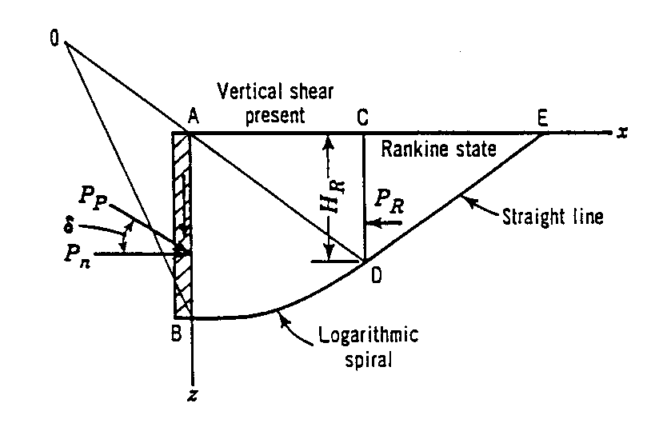

Figure 1. Sample line art illustration.

## Style.

The paper must be written in the best possible technical and grammatical English. Titles should be concise and should describe the content of the paper. If you have a long title, please consider a **Title: Subtitle** format. More information on [writing style](http://dx.doi.org/10.1061/9780784478998.ch11) is available online.

## Mathematics.

All mathematics must be embedded in the text. Equations need to be numbered *only* if they are referred to more than once. More information on [mathematics style](http://dx.doi.org/10.1061/9780784478998.ch16) is available online.

## System of units.

ASCE encourages the use of SI units. For more information about SI units, visit the Web sites of the [U.S. Metric Association](http://lamar.colostate.edu/%7Ehillger/) (USMA), Inc. or the [National Institute of Standards and Technology](http://physics.nist.gov/cuu/Units/index.html) (NIST) or consult the book [*Metric Units in Engineering: Going SI*](http://ascelibrary.org/doi/book/10.1061/9780784400708).

## Author contact information.

A sample of author contact information is shown on the first page of these instructions. The following information may be provided for all authors of the paper: author’s full name; academic degrees or honorifics; professional licenses; ASCE membership grade; current employment affiliation; mailing address; and e-mail address. Note that each author has one and only one note with contact information. Multiple authors with the same employment affiliation or mailing address must have separate notes.

## References.

All factual material that is not original with the author must be accompanied by a reference to its source. ASCE prefers the author-date system of referencing. The author-date system has two parts, the text citation and the reference list.

* The text citation appears where the material to be cited is presented and it refers readers to a source in the reference list by the author's last name and year of publication. Often, the author and date appear in parentheses; a comma is not placed between them.
* The reference list appears at the end of each proceedings paper. It should be single-spaced and list each reference alphabetically by the last name of the first author. When two or more references by the same author are listed, year of publication is taken into account, and the earliest work is listed first.

ASCE strongly discourages the use of superscripts to refer to references because the numbers often become unreadable when the pages are reproduced. Some sample references are listed at the end of this paper; see [author-date references](http://dx.doi.org/10.1061/9780784478998.ch17) for more detailed information.

# CONCLUSION

ASCE thanks you for your efforts and looks forward to providing a record of this conference that will be useful to you and your colleagues for many years to come.

# REFERENCES

ASCE (American Society of Civil Engineers). (2014) *Minimim Design Loads for Buildings and Other Structures,* Standard ASCE/SEI 7-10. Third printing. ASCE, Reston, VA.

Burka, L. P. (1993). “A hypertext history of multi-user dimensions.” MUD history, <<http://www.ccs.neu.edu>> (Dec. 5, 2013).

Committee on Curtain Wall Systems. (2014). *Curtain Wall Systems: A Primer,* ASCE Manuals and Reports on Engineering Practice No. 126. Memari, Ali M., ed. ASCE, Reston, VA.

Dhillon, Gurpreet S., Surinder Kaur, Ajila C. M., Brar, Satinder K., and Surampalli, Rao Y. (2013). “Greenhouse Gas Contribution on Climate Change.” Chapter 3 in *Climate Change Modeling, Mitigation, and Adaptation,* Rao Y. Surampalli, Tian C. Zhang, C. S. P. Ojha, B. Gurjar, R. D. Tyagi, and S. M. Kao, eds. ASCE, Reston, VA, 26-61.

Garrett, D. L. (2003). “Coupled analysis of floating production systems.” Proc., Int. Symp. on Deep Mooring Systems, ASCE, Reston, VA, 152-167.

Singh, Vijay P. (2014). Entropy Theory in Hydraulic Engineering: An Introduction. ASCE Press. ASCE, Reston, VA.

Stahl, D. C., Wolfe, R. W., and Begel, M. (2004). “Improved analysis of timber rivet connections.” J. Struct. Eng., 130(8), 1272-1279.

Zhou, H. and Attard, T. (2014). "Simplified Anisotropic Plasticity Model for Analyzing the Postyield Behavior of Cold-Formed Sheet-Metal Shear Panel Structures." *J. Struct. Eng.*, 10.1061/(ASCE)ST.1943-541X.0001152, 04014185.