**SPLENDOR PROJECT**

**Written by Julian Tjiong**

**Splendor’s official PDF:**

<https://cdn.1j1ju.com/medias/7f/91/ba-splendor-rulebook.pdf>

**Overview:**

The goal is to first create a console-based Splendor and then convert it into a java GUI game.

**Display ideas:**

1. **Main**

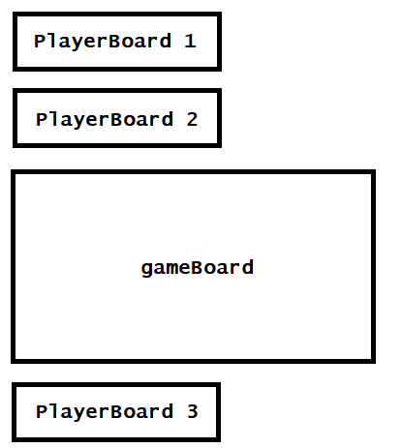

1. **PlayerDeck (public)**

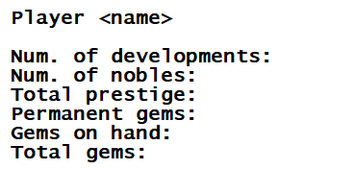

1. **PlayerDeck (personal)**

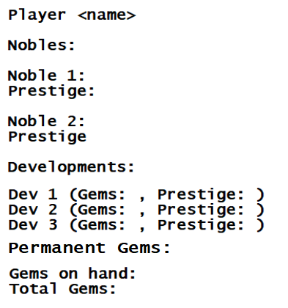

1. **Game Board**

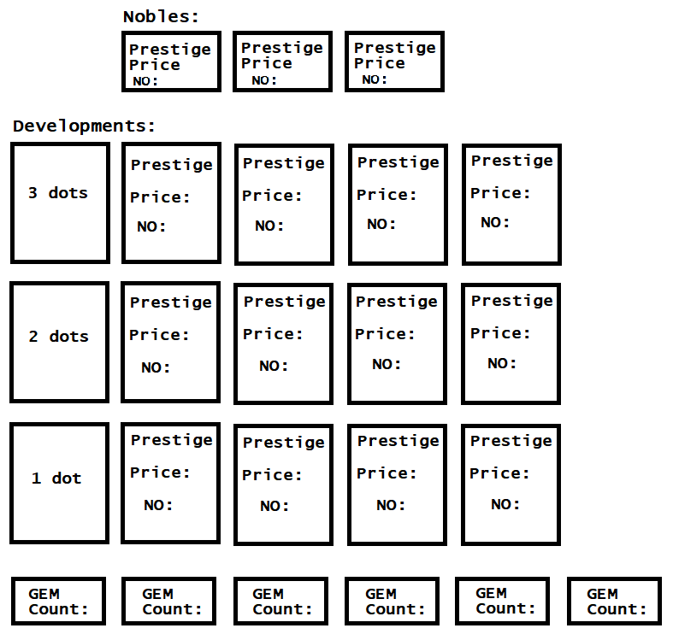

**GAMEPLAY IDEA:**

As stated on the gameplay’s PDF, on each move, a player can:

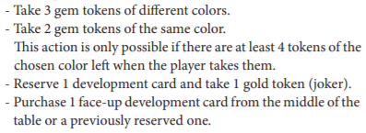

The initial part of the project will be on making a command prompt gameplay with 2 different move options, >take, >purchase, and >reserve. The gems will be indicated with the chars: W (white), R (red), G (green), O (black), B (blue), and E (gold).

If a player is to take 3 different gems:

>take R G O

Take 2 same coloured gems:

>take W W

Reserve a development card (take 1 gold token):

>reserve <development number>

Purchase a face-up-development card from the table:

>buy <development number>

Purchase a previously reserved card:

>pay <1/2/3>

Input validation checks will be provided accordingly.

**OBJECTS**

1. **Player**

The Player class will provide the following:

* Name
* Player no (1/2/3)
* Deck
* Prestige (provided in deck as well)

1. **PlayerDeck**

The PlayerDeck class will provide the following:

* Developments (collection of developments)
* Nobles (collection of nobles)
* Permanent gems
* Gems at hand
* Total gems (permanent gems + gems at hand)
* Prestige

Functionalities:

* Add development (automatically adds prestige & permanent gems)
* Add nobles (automatically adds prestige)
* Add gems (gems on hand)
* Print deck (print for personal deck & public deck)
* Check noble (whether eligible for nobles’ visits)
* Check development (whether gems are sufficient)
* Check gems (can’t have more than 10 hand gems)

1. **GameBoard**

The GameBoard class will provide the following:

* Three dot cards (collection of hard coded cards)
* Two dot cards (collection of hard coded cards)
* One dot cards (collection of hard coded cards)
* Gems:
* Gold gems 4 (always)
* 5 other gems each (3 players)
* 4 other gems each (2 players)
* Nobles (collection of hard coded nobles, number of players+1)

Functionalities:

* Take a development
* Take gems (3 different gems or 2 same gems but only if there are 4 of the same colours left in the stack)
* Reserve a development (automatically gives the player a gold gem)
* Receive gem payment (if a player purchases a development then refill the gem stacks accordingly)
* Refill development (every time a player purchases a development, refill it with cards from the developments stack according to the number of dots)
* Print board

1. **Card**

The Card class will provide the following:

* Card number
* Prestige
* Price
* Gem type (permanent)
* Print Card

1. **Noble**

The Noble class will provide the following:

* No
* Prestige
* Price
* Print Noble

1. **GameEngine**

The GameEngine class will be providing the functionalities of the game. There will be 2 GameEngine class implementing the same interface for 2 and 3 players.

After loading up the **Main** containing GameBoard and PlayerBoards as shown on the Display Ideas section, we need to **run checks on user input:**

1. **Buying development:**

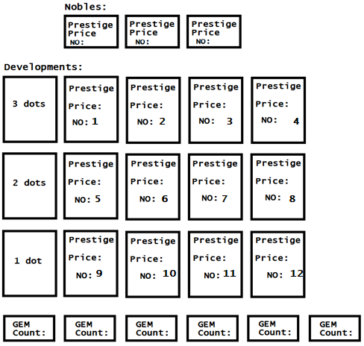

Above is the GameBoard

Now if the user’s to enter >take 11, we need to run check on whether or not the card number exists and if player has sufficient gems to pay the price.

Below is the possible scenarios for inexistent cards:

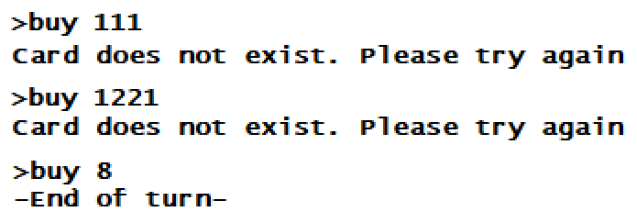

Card 8 does exist so taking it will end a player’s turn.

Now to check whether or not player has sufficient gems:

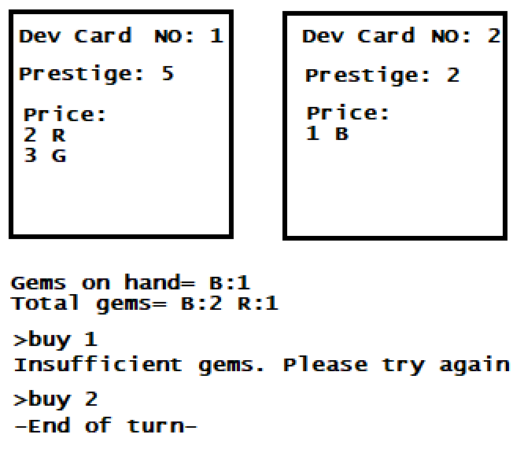

1. **Taking gems:**

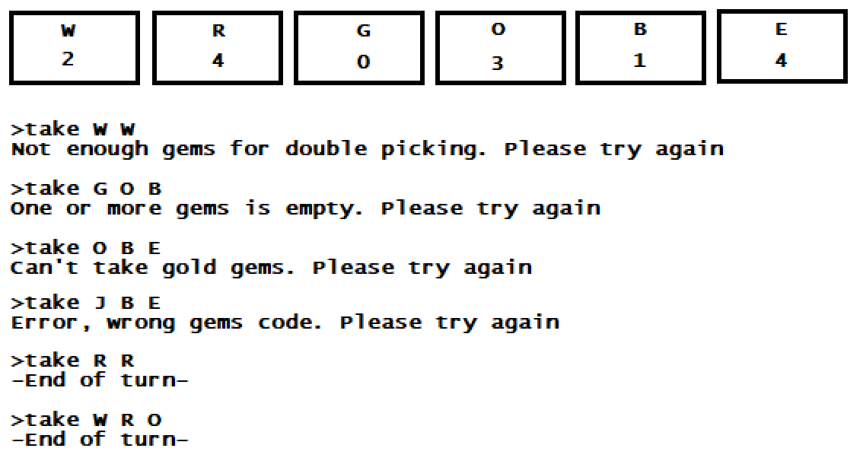

Required checks:

* If gems are available for double picking
* If one or more gems stack is empty
* If player picks gold gems
* If player enters wrong gem code (J does not exist)

As seen above there are 4 R gems so double picking is doable.

W, R, and O are all available as well.

1. **Reserving Development:**



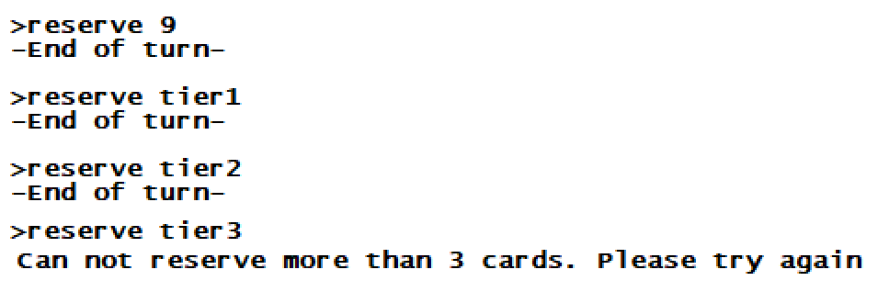

Reserving an existing card will put the card into the player’s reserved card stack. Player will automatically receive a Gold (E) gem if there are any.

Reserving tier1/tier2/tier3 will pick a random card from the selected tier card and store it in a player’s reserved stack (automatically revealing the card’s information).

A player can not have more than 3 cards reserved.

**Receiving Noble Visits:**

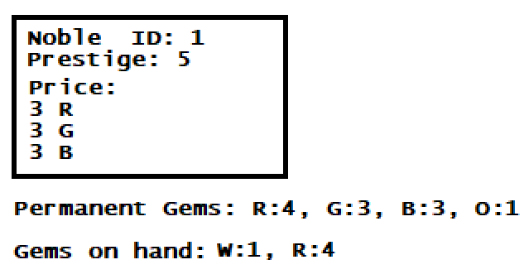

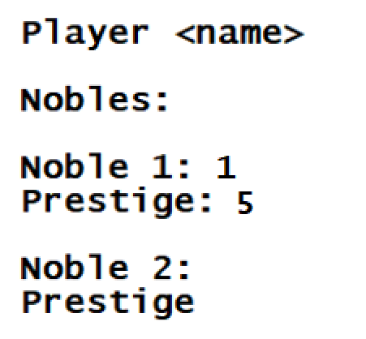

Player will automatically receive a noble’s visit, without having to purchase them.

**End Game:**

On the end of each round (after last player’s move), the game should check each player’s prestige. If one or more player has more >14 prestige, then the game ends.

**HOW TO PLAY PAGE**

The how to play page will provide quick game overview with full instruction on gameplay commands and basic how to play.

Layout:

**WELCOME TO SPLENDOR**

--Note: I wrote this command line interface version of the original board game Splendor for fun with no intention on commercial use. If you are interested, please buy the original boardgame published by Space Cowboys: <https://www.spacecowboys.fr/splendor-->

Splendor is a card development board game published by Space Cowboys, where player would acquire/collect gems and use them to purchase gem mines (development card) that will provide the player with prestige points and a gem discount (permanent gems). When you have acquired enough permanent gems, you will automatically receive noble visits that will provide you with more prestige points. At the end of the game, player with the most prestige point wins.

The game has a 2 player and 3 player modes. There will be 3 nobles and 4 each gems for a TWO player mode, and 4 nobles and 5 each gems for a THREE player mode.

---------------------------------------------------------

Game Objective:

The game ends when someone’s acquired 15 prestige points. If it’s the first player to acquire 15 prestige points, then the game will still run through all the remaining players before it quits.

Winner:

If two players acquired equal prestige points, then the one with the least number of development purchases wins.

---------------------------------------------------------

Game Units:

Gems – Gems are the unit of currency in Splendor. There are two types of gems: HAND GEMS and PERMANENT GEMS. Hand gems can be taken from the game board and will be used to buy development cards. Permanent gems can be acquired through purchasing a development and will be used as a discount for each development purchases. Purchasing a development will only reduce your hand gems without taking any permanent gems. Acquiring enough permanent gems will trigger a noble visit.

Gold Gems – Gold Gems are marked as ‘E’, and can only be acquired through reserving a card. Cannot be taken by player. A single Gold Gem can be used as a Wild Card, for instance if you need 1 more gem to pay for a development/reserve, you can use your Gold Gem.

Nobles – Nobles can be found on the first section of the game board. Provides player with prestige points. Cannot be bought, as they will be given to the player once player has the sufficient PERMANENT GEMS, and will happen automatically without player buying them.

Development Cards – Developments can be found on the second section of the game board. Each development has a No. assigned to it for the user to identify it when buying/reserving. Can be bought using TOTAL GEMS. Developments will provide player with permanent gems that will be used as a discount gems when purchasing a new development. Permanent gems.

Player Deck – On each turn, a player will be shown their personal player deck that elaborates the player’s development, noble, and reserve lists. Other players’ player deck will also be shown but with minimum information.

Prestige Points – The end-game will be triggered when a player has acquired 15 prestige points. The round will still go on when end-game is triggered.

---------------------------------------------------------

How to play:

On each turn, a player may:

1. Take gems from the provided GEMS on Game Board (You can find the gems under the G E M S section of GameBoard). Each player may only take 3 different gems OR 2 same gems. A player may only have up to 10 HAND GEMS at a time.
2. Buy development cards. A player may purchase a development from the provided development cards if they have sufficient amount of gems. (You can just refer to your Total Gems when you are to purchase a new development card). Some developments provide player with prestige points while others don’t, but all developments will provide with 1 permanent gem.
3. Reserve a development card. A player may reserve any card from the game board and receive a gold gem (if there is any on the game board). A player can have up to 3 reserves.
4. Pay reserve. A player may pay for one of the reserves they own.

---------------------------------------------------------

Gameplay Commands: (Important)

1. take

The take command consists of two different versions: take 3 different gems OR take 2 same gems.

COMMAND:

take W R G

take W W

The first one takes the gems W,R and G, while the second command takes W and W. It is important to note that you cannot take 2 same gems from a pile that has less than 4 gems in it. The format is also important as more/less space will not work.

1. buy

The buy command lets player buy a development.

COMMAND:

buy a1

buy b1

buy c1

The card no is provided under each development cards.

1. reserve

The reserve command lets player reserve a development.

COMMAND:

reserve a1

reserve a2

reserve a3

Similar to buy, card no is provided under each development cards.

1. pay

The pay command lets player pay for the reserves they own.

COMMAND:

pay 1

pay 2

pay 3

The reserve no is provided in your player deck. Can be seen as: Res 1 (...)

1. quit

If you are bored and you want to quit.

NOTE: The commands are case-insensitive, but formatting is very important (spaces), and it is important NOT to end every command with an extra space.

---------------------------------------------------------

Tip: You can always look up the commands above by entering the command “help” in-game.

--Please scroll up to read more—