**SEARCH ALGORITHMS APPLIED TO CITIZEN SAFETY AND HARASSMENT PREVENTION**

|  |  |  |  |
| --- | --- | --- | --- |
| Julián Estiven Valencia  Eafit University  Colombia   jevalencib@eafit.edu.co | Marco Gómez Patiño  Eafit University  Colombia   mgomezp17@eafit.edu.co | Andrea Serna  Universidad Eafit  Colombia  asernac1@eafit.edu.co | Mauricio Toro  Universidad Eafit  Colombia  mtorobe@eafit.edu.co |

**ABSTRACT**

Street sexual harassment is just one of the many manifestations of the unsafe situations that people go through in Medellín. These actions have negative repercussions such as anger and discomfort on women, them being the most affected by the lack of security in the streets. According to what has been exposed we consider that providing mobility options that consider the possibilities of harassment can contribute to the improvement of the situation previously stated. This project proposes the creation of an algorithm that takes harassment into account as a variable, to provide safer mobility alternatives to people.

**Keywords**

Shortest route, street sexual harassment, identification   
of safe routes, crime prevention

**1. INTRODUCTION**

Street sexual harassment is one of the main reasons people feel unsafe when it comes to transit the streets. According to “Medellín, ciudad segura para mujeres y niñas” 61,5 per cent of women, residents of communes Manrique, Villa Hermosa, La Candelaria and the corregimiento of Altavista, manifested feeling discomfort going out past 7 p.m. [1] The phenomenon is aggravated in places like the downtown, according to surveys conducted with women from commune 10, La Candelaria, shows that 57.6 per cent perceive a lot of fear in public spaces [2]. Adding to this we have robbery, for example, the stealing of vehicles in 2022 increased by 10 per cent compared to the previous year [4]. The violence among other factors threatens the citizen security of the city.

The previously stated helps us measure the levels of the problem and although it is a situation too difficult to address, we consider the importance of providing citizens with tools that allow them to have a certain degree of security while they transit through the city. Under this order of ideas, the possibility of choosing between different suggested routes considering the variables of estimated time and safety of the journey is one of the tools that can help with the reduction of harassment and perception of insecurity.

* 1. **The problem**

Considering what has been stated in the introduction when can put in perspective that sexual harassment is a reality and a problematic situation present in Medellín. We can define street sexual harassment as a particular type of violence, both physical and verbal, some of its expressions are, sexually explicit comments, follow-up, public masturbation, touching, and exhibitionism among others. Among some of the feelings generated by sexual harassment are feeling invaded, vulnerable, and insecure in places where people have been previously harassed, but they are not limited to it being the feelings of shame, helplessness, and anger, other of its many repercussions [3].

Under this order of ideas, we contemplate a tool that provides the user with mobility alternatives, which consider both safety and travel time, an option that helps prevent situations of harassment. In our specific case, three route options will be calculated considering the two variables that were mentioned above, so that the user can choose the route based on their needs.

**1.3 Structure of the article**

Next, in Section 2, we present work related to the problem. Then, in Section 3, we present the datasets and methods used in this research. In Section 4, we present the algorithm design. Then, in Section 5, we present the results. Finally, in Section 6, we discuss the results and propose some directions for future work.

**2. RELATED WORK**

Below, we explain four works related to finding ways to prevent street sexual harassment and crime in general.

**2.1 Safe & the city**

It´s a free personal security navigation app that allows you to plan and share routes while making sure to keep you safe. The user would receive a notification while walking on streets previously marked by the police as dangerous and high theft possibility. The app counts with a quick access call to 999, so the user can communicate with emergency services. It also has a section to report in case the user feels unsafe, and their reviews can help others who are going to use the same route. Safe & the city is currently available in all UK cities and also in Berlin, Germany.

**2.2 Safest Route Detection Application**

This is a project developed as a web application with react.js and the app uses an algorithm to compute the safest route, it uses the user data to do the calculations of throwing the safest path. The implemented algorithm is developed to generate a decision tree, and this is how was implemented. The documentation doesn’t specify the algorithm that the application uses.

**2.3 The Safest Path via Safe Zones**

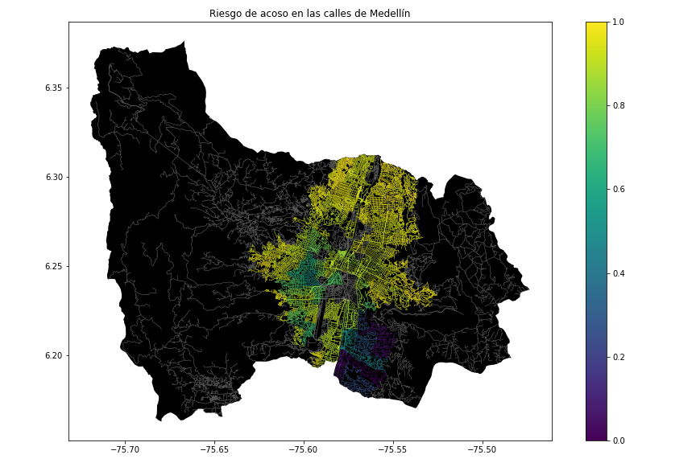This project uses safe zones as reference points, for example, if the defined path is outside the reference zones the path is considered dangerous, studying the Euclidean and spatial network variants.

This is a graph that represents the paths and the safes zones

The project doesn’t use a specific algorithm, they first transform the data into a graph of safe zones, origin, and destination, then any shortest path algorithm may be applied to find the safest path, but in the project, they proposed a novel edge pruning algorithm that utilizes hyperbolas.

**2.4 Bypass: An app that provides you with the city zones that you must avoid**

While using Google Maps you will always have the shortest path, the ones that avoid traffic jams. However, when you use the app in the city it doesn’t specify the zones that you must avoid according to their bad reputation, with this premise Bypass was presented, an app that through a map would show you which parts of the city you should avoid, based on its bad reputation, the application would do the calculation of the danger of the place with information that was obtained in the network and the valuation of the users. The system identifies using red squares, with more or less intensity, the streets that are better to avoid, and if you were to be on one of those dangerous routes, the application highlights the fastest route to get out of it. It also had the option to mark points of interest like hospitals, and shops, among others. Currently, this project is no longer available.

## **3.1 Data collection and processing**

The map of Medellín was obtained from *Open Street Maps* (OSM)[1]  and downloaded using the Python API[2] OSMnx. The map includes (1) the length of each segment, in meters; (2) the indication of whether the segment is one-way or not, and (3) the known binary representations of the geometries obtained from the metadata provided by OSM.

For this project, a linear combination (LC) was calculated that captures the maximum variance between (i) the fraction of households that feel insecure and (ii) the fraction of households with incomes below one minimum wage. These data were obtained from the 2017 Medellín quality of life survey. The CL was normalized, using the maximum and minimum, to obtain values between 0 and 1. The CL was obtained using principal components analysis. The risk of harassment is defined as one minus the normalized CL. Figure 1 presents the calculated risk of bullying. The map is available on GitHub[3] .

**Figure 1.** Risk of sexual harassment was calculated as a linear combination of the fraction of households that feel unsafe and the fraction of households with income below one minimum wage, obtained from the 2017 Medellín Quality of Life Survey.

.

## **3.2 Algorithmic alternatives that reduce the risk of sexual street harassment and distance**

## In the following, we present different algorithms used for a path that reduces both street sexual harassment and distance.

**3.2.1 Dijkstra's Algorithm**

The published algorithm in 1956, was named after his Dutch creator Edsger Dijkstra. Is an algorithm that is used to find the shortest path in a node graph. Given a start node and a finish node the Dijkstra algorithm starts exhausting the connections of the start node, to say that this node is already solved, it will put temporary tags over all connected nodes, and said tag is conformed by the name, and the distance of the start node of the connection, the tags will be temporary until the container node be solved, in this case, the tag that contains the minimum distance will be saved. This process will repeat until the target node is reached, from this final node it will return from the path that contains the labels with the lowest distance upon reaching the start node, giving us the shortest path

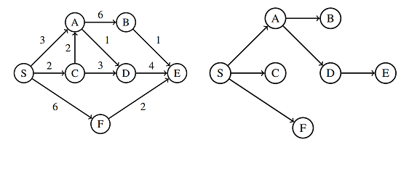

*Figure 2: Dijkstra’s Algorithm. Brilliant.org, 2022 https://brilliant.org/wiki/dijkstras-short-path-finder/*

**3.2.2 A star Algorithm**

Also known as A*, was presented for the first time in 1968 by Peter E. Hart, Nils J. Nilsson, and Bertram Raphael. It is classified within the search algorithms in graphs of heuristic or informed type, widely used to find a possible and efficient route between two points, with the lowest possible cost.

It works by labelling the different nodes according to the cost of reaching the target. This tag has the functions of showing the current distance from the source node to the tagged node and indicating the distance from the node to be tagged to the destination node. It creates a path tree, like Dijkstra’s algorithm. The main difference between A star is that each node uses a function that gives an estimate of the total cost of the route. Due to its nature, the limitations of this algorithm depend on the quality of the heuristic, being unfeasible if the latter is not optimal.

*Figure 3: Example of A* algorithm.*

**3.2.3 Bellman Ford Algorithm**

It is an algorithm for searching a graph or tree data structure. It starts at the root of a tree and goes as far from it as possible by that route then returns until it finds an unexplored route and travels through it. Each node calculates the distance between it and all others within a path and stores that information on a path. Each node then sends its table to adjacent nodes. when a node receives a distance table from adjacent nodes it calculates the shortest path to the other nodes and updates its table. A special feature of this algorithm is that it supports negative figures and allows to detection of the existence of an absorbent circuit.

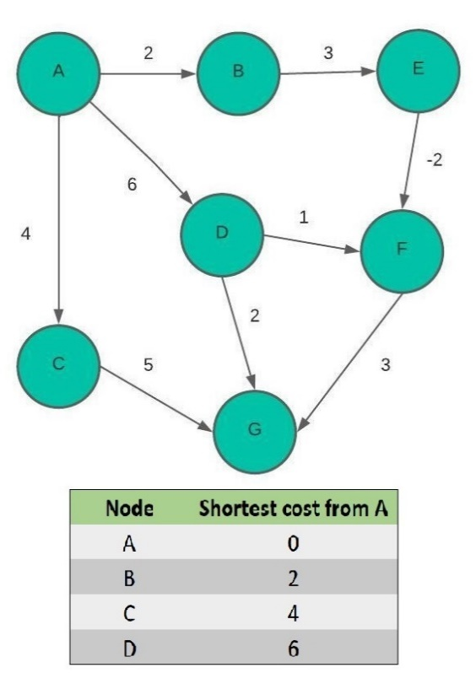

*Figure 4: Table of Bellman Fort algorithm.*

**3.2.4 Depth- First Search (DFS)**

Depth-first search is an algorithm for searching a graph or tree data structure. The algorithm starts at the root node of a tree and descends as far as it can in a given branch, then backwards until it finds an unexplored path, the explore. The algorithm does this until the entire graph has been explored. Many problems in computer science can be thought of in terms of graphs. For example, network analysis, route mapping, planning, and spanning tree finding are graph problems. To analyze these problems, search algorithms such as depth-first search are useful.

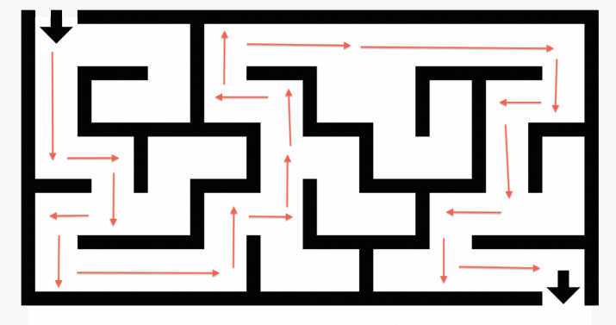

Figure 5: Example of DFS algorithm. Brilliant.org 2022, from https://brilliant.org/wiki/depth-first-search-dfs/

# **REFERENCES**

1. Brilliant. 2022. A* Search. [online] Available at:

<https://brilliant.org/wiki/a-star-search/>.

2. Brilliant. 2022. https://brilliant.org/wiki/a-star-search/. [online] Available at:

<https://brilliant.org/wiki/dijkstras-short-path-finder/>.

3. Cabrera, D., 2022. El acoso callejero 'atormenta' a las mujeres en Colombia y el mundo. rcnradio, [online] Available at:

<https://www.rcnradio.com/recomendado-del-editor/el-acoso-callejero-atormenta-a-las-mujeres-en-colombia-y-el-mundo>.

4. El Tiempo, 2019. El 99,9 % de mujeres en el Centro han sido acosadas sexualmente. [online] Available at:

<https://www.eltiempo.com/colombia/medellin/el-99-9-de-mujeres-en-el-centro-han-sido-acosadas-sexualmente-321144>.

5. García Domínguez, R., 2016. Una app que te dice que zonas de tu ciudad debes evitar. [online] BeTech. Available at:

<https://as.com/meristation/2016/10/11/betech/1476219792_538454.html>.

6. GeeksforGeeks. 2022. A* Search Algorithm. [online] Available at:

https://www.geeksforgeeks.org/a-search-algorithm/.

7. GeeksforGeeks. 2022. Bellman–Ford Algorithm | DP-23. [online] Available at:

https://www.geeksforgeeks.org/bellman-ford-algorithm-dp-23/.

8. Jazive, T., Valeria V.,, Seydi A., 2022. [ebook] Yucatán: Alternativas en Psicología, p.6. Available at:

<https://alternativas.me/attachments/article/242/Repercusiones%20psicol%C3%B3gicas%20del%20acoso%20sexual%20callejero.pdf>.

9. Juan maTIC. 2020. Algoritmo de la ruta más corta, camino más corto, algoritmo de Dijkstra 1. [video] Available at:

<https://www.youtube.com/watch?v=AU1wAHzkkMI&ab_channel=JuanmaTIC> .

10. Olivares Tobon, S., 2022. En Medellín, el robo de carros y motos ha subido hasta casi un 20%. el Colombiano, [online] Available at:

<https://www.elcolombiano.com/antioquia/en-medellin-el-robo-de-carros-y-motos-ha-subido-hasta-casi-un-20-PL17946238> .

11. Rojas R, E., 2021. Acoso sexual callejero: todo lo que dejamos de hacer las mujeres por miedo. Healthy Happiness, [online] Available at:

<https://hhmag.com/acoso-sexual-callejero-todo-lo-que-dejamos-de-hacer-las-mujeres-por-miedo/#:~:text=El%20acoso%20sexual%20callejero%20produce%20las%20sensaciones%20m%C3%A1s,produce%20cambios%20de%20h%C3%A1bitos%20que%20no%20deber%C3%ADan%20ser.

12. Safe & the city. n.d. [online] Available at:

<https://www.safeandthecity.com/>.

13. Wikipedia. 2022. A* search algorithm.[online] Available at:

https://en.wikipedia.org/wiki/A*_search_algorithm.

14. Wikipedia. 2022. Bellman–Ford algorithm. [online] Available at:

<https://en.wikipedia.org/wiki/Bellman%E2%80%93Ford_algorithm>.

15. Wikipedia. 2022. Dijkstra's algorithm. [online] Available at:

<https://en.wikipedia.org/wiki/Dijkstra%27s_algorithm>.

1. <https://www.openstreetmap.org/>
2. https://osmnx.readthedocs.io/
3. https://github.com/mauriciotoro/ST0245Eafit/tree/master/proyecto/Datasets