8.28 Budget project

* UIController: event listener for keypress & click

8.29 Budget project

* TASK1: add input income/expense to bottom UI (income & expense)
  + budgetController: record the input and save as obj
    - expense + income object
    - data obj: save exp & inc info
  + UIController: addListItem function:
    - HTML string creating
    - HTML replace placeholder
    - insert HTML to DOM:
      * insertAdjacentHTML(‘beforeend’, HTMLvar)
* TASK2: clear input fields after entering
  + clearHTML field:
    - querySelectorAll: select multi queries save as list
    - convert list to array:
      * var arr = Array.prototype.slice.call(list)

# trick to change list to array

* + - array: foreach method
      * arr.foreach(function(**currentElement, index, array**)){};
* TASK3: updateBudget() 🡪 format input
  + convert field inputs into numbers: parseFloat()
  + prevent false inputs: des != “” + value is num + value > 0
* TASK4: calculateBudget() 🡪 calculate budget and display on top UI
  + calculate total income & expense & budget & percentage
  + display budget on top UI

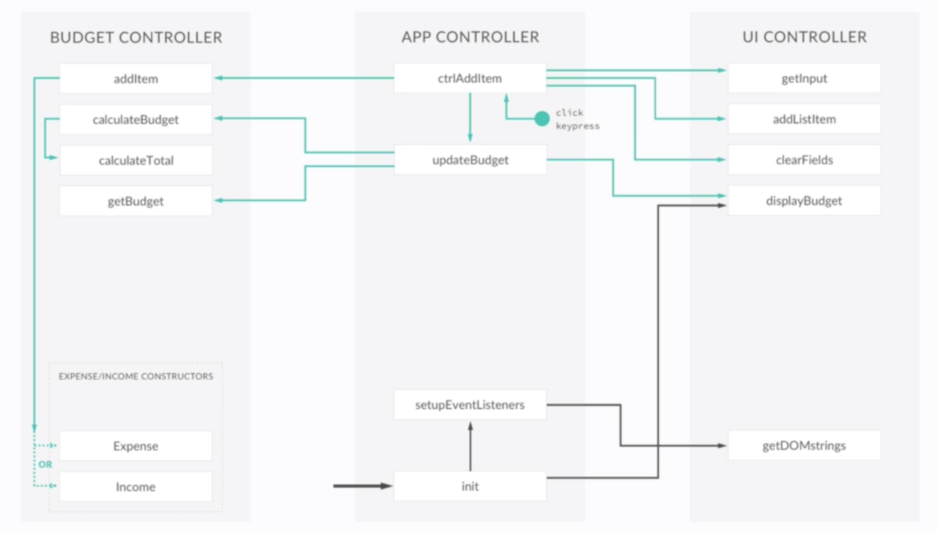

* 1. Budget project
* TASK1: delete item from the data structure
  + event bubbling: event.target.parentNode
  + controller – ctrlDeleteItem()
  + event bubbling: make the event happen on one item to happen on its parents
  + budgetController – deleteItem func() expression
    - foreach： iterate thru array NO return
    - map(): iterate thru array and return a new array
    - splice(): remove from array splice(index, 1)
* TASK2: delete item from the UI

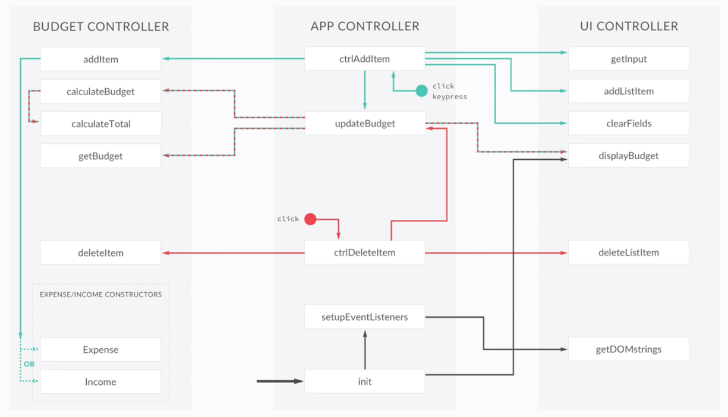

8.31Budget Project ***

* TASK1: expense percentage
  + calculate percentage; update budget & UI
  + foreach() for nodeList:
  + **!!!!! important !!!!!**

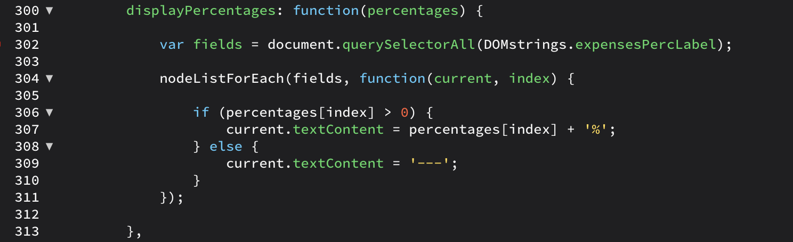

* TASK2: improving
  + display month & year
    - date() function
  + number formatting & manipulate strings:
    - add , to separate thousand; round to 2 decimal places; - / +
    - numSplit(), str.substr()
  + improve UI: + green ; - red
    - change event
      * happens when we click to select other option
      * toggle(): add when not there; remove if it is there

Final Structure:

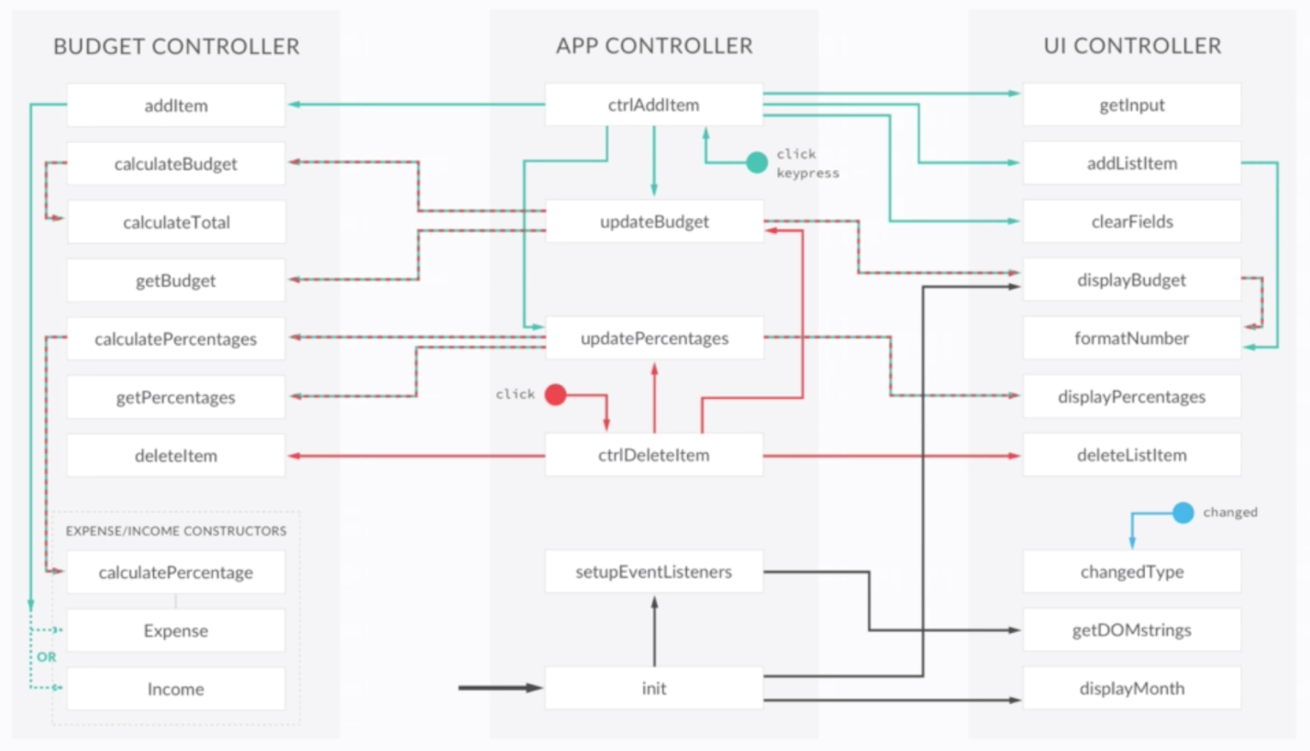

Q: addEventListener function is callback?????

UI ? UX