**Dynamic typing VS Static typing**

* Static typing: **explicitly declare**/initialize variables before (using) assigning value 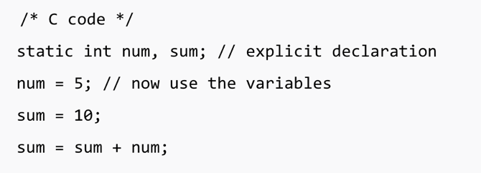
* Dynamic typing: do **NOT** require the **explicit declaration** of the variables before they’re used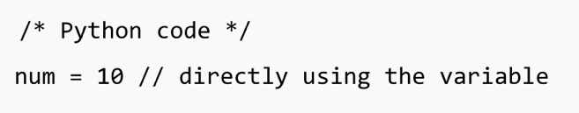

**Strong typing VS Weak typing**

* Strong typing (non-autocast): variables have specific data types; cannot concatenate two diff types

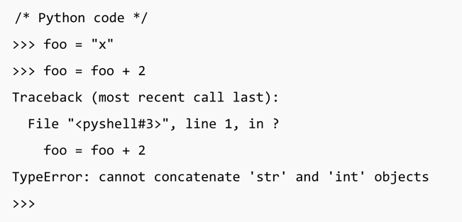

* Weak typing (autocast): variables are not **“bound”** to specific data type;

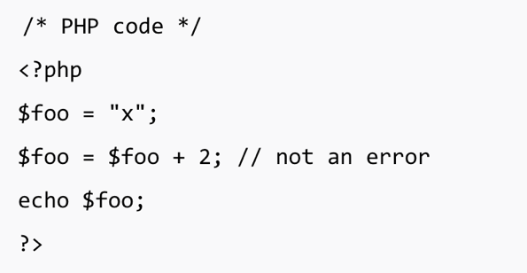

**Summary:**

