**Why react？** <https://zhuanlan.zhihu.com/p/41228208>

**Component**: split webpage into different components

* manageable
* maintainable
* reusable

**JS ES6/7:**

* var 🡪 let & const
  + let: variable
  + const: constant
* arrow function: no more issues with ‘this’ keyword
  + const myFunc = (arg) => { }
  + let myFunc = (arg) => { }
* class
  + check es6.js
* spread & rest operators …
  + spread: merge arrays/objs using new elements & existing array/obj



* + rest: merge list of function arguments into array



* destructuring: extract array/obj and store in variables
  + array destructuring



* + object destructuring



**Tools & preparations:**

* **Preprocessors:** 转码器； 将ES6转为ES5； 提供现有环境支持
  + CSS: SCSS, SASS
  + JS: babel +w preset (JS **complier**), CoffeeScript, TypeScript, LiveScript
* **Dependency Management Tool** (the npm_modules package)
  + JS: **npm**; bower; yarn
  + **npm: Node Package Manager**

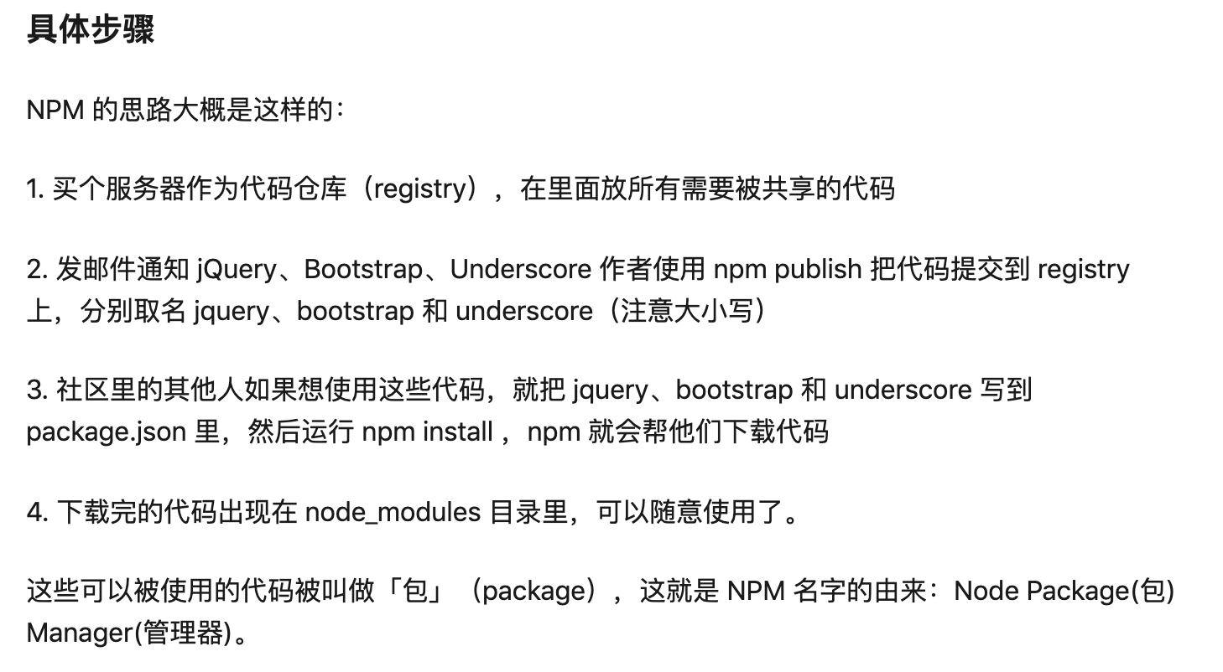

* + **npm server installation**:
    - <https://github.com/facebook/create-react-app>
    - sudo npm install create-react-app –g
    - create-react-app react-complete-guide
    - cd react-complete-guide
    - npm start
* **Bundler: 模块捆绑** (使用npm安装)
  + webpack:
    - **模块打包机：它做的事情是，分析你的项目结构，找到JavaScript模块以及其它的一些浏览器不能直接运行的拓展语言（Scss，TypeScript等），并将其打包为合适的格式以供浏览器使用。**

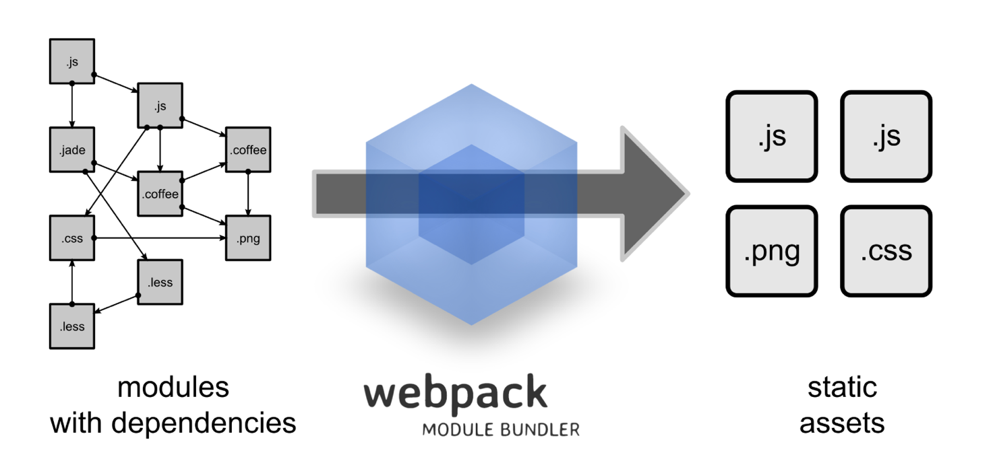

**hooks** **& class based**

* hooks: use states without writing a class

**render():**

**state & props**

* **props: (argument)** variables passed to it by its parent component
* **state: (constructor)** is still variables, but directly initialized and managed by the component

**bind():** passing arguments

**List & conditionals**

* **two-way binding:** 9.3 does not work now