**checking commands:**

* git --version
* git config
* git config --global user.name “Julian”
* git config --global user.email “julianztz@gmail.com”
* git status

**git repository initialize (general)**

1. cd to directory, git init
2. git status # check status
3. touch .gitignore
4. make changes, add files
5. git add . / git add –A
6. git reset # delete added file from staging area
7. git commit –m “commit msg”
8. git status # returns: nothing to commit, working directory is clean
9. git log # checks the commit we made

**git repository initializes from exist remote repo (master branch only)**

1. git clone <https://github.com/julianztz/2019Resume.git>
2. add file? git status # check changes
3. modify file? git diff # check changes
4. git add –A
5. git commit –m “commit msg”
6. **git pull origin master # make sure we have the latest version**
7. **git push origin master**

**git common workflow**

1. git branch new-branch2 # create a new branch
2. git branch # list all local branches, including *master
3. git checkout new-branch2 # return: switched to branch “new-branch2”
4. make some changes to the file
5. git add . # no effect on the master branch or the
6. git commit –m “new commit” # remote repository
7. git push –u origin new-branch2 **# push changes to new-branch2; -u means associate the local changes we just made with the new-branch2; next time, we can just do: git pull, git push**
8. git branch –a # list all local and remote branches

**merge branch with the master branch**

1. git checkout master
2. git pull origin master
3. git branch --merged # return the branch that has been merged
4. git merge new-branch2
5. git push origin master

**delete merged branch**

1. git branch --merged # check the merged branch again
2. git branch –d new-branch2 # **delete branch locally**
3. git branch –a
4. git push origin --delete new-branch2 # **delete branch remotely**
5. git branch -a

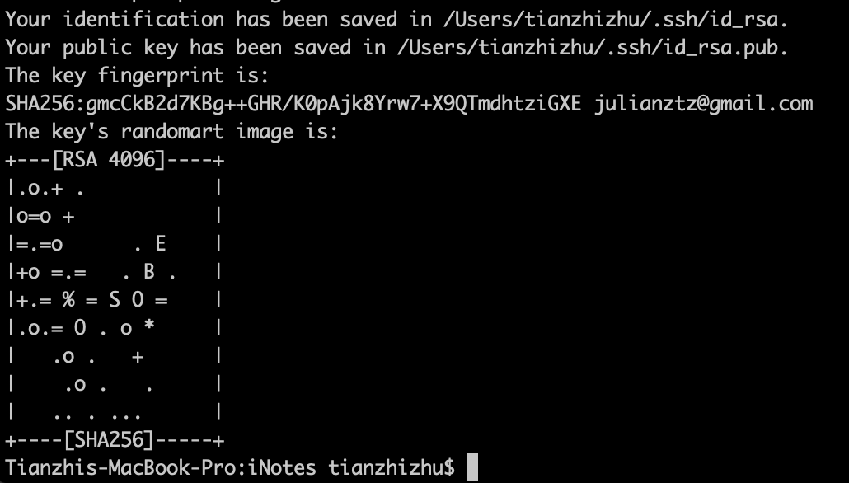

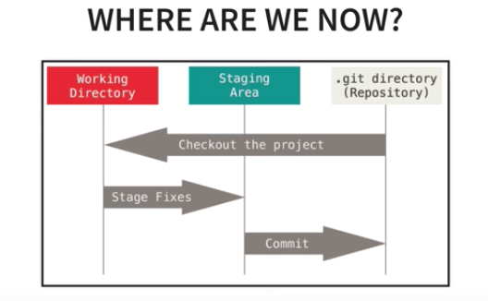

pic comes from: <https://www.youtube.com/watch?v=HVsySz-h9r4>

**Add existing project to Github:** <https://www.softwarelab.it/2018/10/12/adding-an-existing-project-to-github-using-the-command-line/>

