Sample Paper

Julia Parish1,✉, and Ted Lasso2

24 August, 2021

Lorem ipsum dolor sit amet, consectetur adipiscing elit, sed do eiusmod tempor incididunt ut labore et dolore magna aliqua. Duis tristique sollicitudin nibh sit. Lobortis elementum nibh tellus molestie nunc non blandit massa. Nibh mauris cursus mattis molestie a. Risus commodo viverra maecenas accumsan lacus vel facilisis volutpat est. Sit amet venenatis urna cursus eget nunc scelerisque viverra. At imperdiet dui accumsan sit. Non curabitur gravida arcu ac tortor. Sodales neque sodales ut etiam sit. A iaculis at erat pellentesque adipiscing commodo elit at imperdiet. Risus sed vulputate odio ut enim blandit. Egestas fringilla phasellus faucibus scelerisque eleifend donec. Sed tempus urna et pharetra pharetra massa massa ultricies mi.

1 Bren School of Environmental Science and Management, University of California Santa Barbara  
2 University of Richmond

✉ Correspondence: [Julia Parish <[jparish@bren.ucsb.edu](mailto:jparish@bren.ucsb.edu)>](mailto:jparish@bren.ucsb.edu)

Keywords: invasive plants; seabirds; climate change

Highlights: Invasive plants impact seabird nesting habitat, and climate change will decrease seabird habitat availability while increasing productivity of invasive plants.

# 1 Introduction

Here is a citation (Marwick, 2017)

# 2 Background

# 3 Methods

# 4 Results

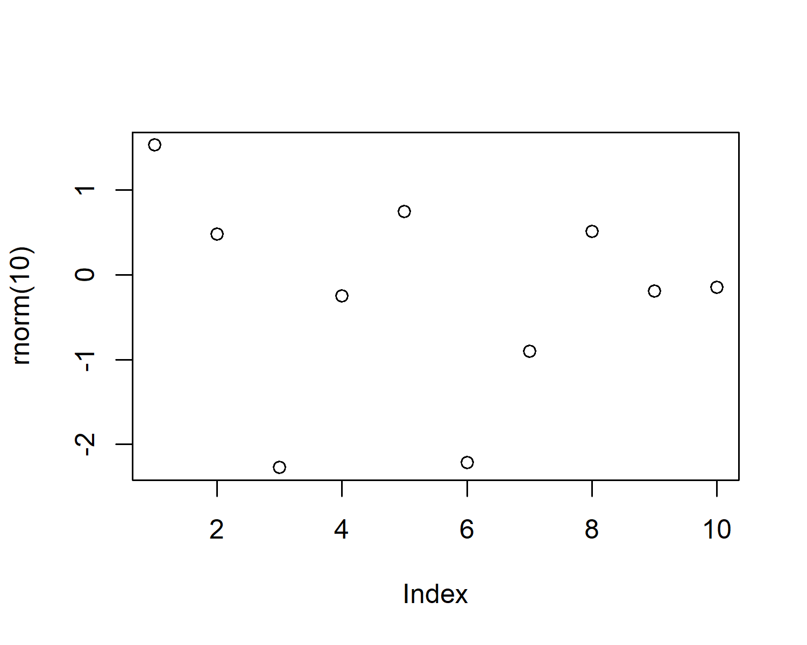

Figure 4.1: A plot of random numbers

Figure 4.1 shows how we can have a caption and cross-reference for a plot

Here is an example of inline code 3.14 in the middle of a sentence.

# 5 Discussion

# 6 Conclusion

# 7 Acknowledgements

# 8 References

Marwick, B., 2017. Computational reproducibility in archaeological research: Basic principles and a case study of their implementation. Journal of Archaeological Method and Theory 24, 424–450. <https://doi.org/10.1007/s10816-015-9272-9>

### 8.0.1 Colophon

This report was generated on 2021-08-24 13:05:31 using the following computational environment and dependencies:

#> - Session info ---------------------------------------------------------------  
#> setting value   
#> version R version 4.1.0 (2021-05-18)  
#> os Windows 10 x64   
#> system x86_64, mingw32   
#> ui RTerm   
#> language (EN)   
#> collate English_United States.1252   
#> ctype English_United States.1252   
#> tz America/Los_Angeles   
#> date 2021-08-24   
#>   
#> - Packages -------------------------------------------------------------------  
#> package * version date lib source   
#> bookdown 0.23 2021-08-13 [1] CRAN (R 4.1.1)  
#> cachem 1.0.5 2021-05-15 [1] CRAN (R 4.1.0)  
#> callr 3.7.0 2021-04-20 [1] CRAN (R 4.1.0)  
#> cli 3.0.1 2021-07-17 [1] CRAN (R 4.1.0)  
#> crayon 1.4.1 2021-02-08 [1] CRAN (R 4.1.0)  
#> desc 1.3.0 2021-03-05 [1] CRAN (R 4.1.0)  
#> devtools 2.4.2 2021-06-07 [1] CRAN (R 4.1.0)  
#> digest 0.6.27 2020-10-24 [1] CRAN (R 4.1.0)  
#> ellipsis 0.3.2 2021-04-29 [1] CRAN (R 4.1.0)  
#> evaluate 0.14 2019-05-28 [1] CRAN (R 4.1.0)  
#> fastmap 1.1.0 2021-01-25 [1] CRAN (R 4.1.0)  
#> fs 1.5.0 2020-07-31 [1] CRAN (R 4.1.0)  
#> glue 1.4.2 2020-08-27 [1] CRAN (R 4.1.0)  
#> highr 0.9 2021-04-16 [1] CRAN (R 4.1.0)  
#> htmltools 0.5.1.1 2021-01-22 [1] CRAN (R 4.1.0)  
#> knitr 1.33 2021-04-24 [1] CRAN (R 4.1.0)  
#> lifecycle 1.0.0 2021-02-15 [1] CRAN (R 4.1.0)  
#> magrittr 2.0.1 2020-11-17 [1] CRAN (R 4.1.0)  
#> memoise 2.0.0 2021-01-26 [1] CRAN (R 4.1.0)  
#> pkgbuild 1.2.0 2020-12-15 [1] CRAN (R 4.1.0)  
#> pkgload 1.2.1 2021-04-06 [1] CRAN (R 4.1.0)  
#> prettyunits 1.1.1 2020-01-24 [1] CRAN (R 4.1.0)  
#> processx 3.5.2 2021-04-30 [1] CRAN (R 4.1.0)  
#> ps 1.6.0 2021-02-28 [1] CRAN (R 4.1.0)  
#> purrr 0.3.4 2020-04-17 [1] CRAN (R 4.1.0)  
#> R6 2.5.1 2021-08-19 [1] CRAN (R 4.1.0)  
#> remotes 2.4.0 2021-06-02 [1] CRAN (R 4.1.0)  
#> rlang 0.4.11 2021-04-30 [1] CRAN (R 4.1.0)  
#> rmarkdown 2.10 2021-08-06 [1] CRAN (R 4.1.0)  
#> rprojroot 2.0.2 2020-11-15 [1] CRAN (R 4.1.0)  
#> rstudioapi 0.13 2020-11-12 [1] CRAN (R 4.1.0)  
#> sessioninfo 1.1.1 2018-11-05 [1] CRAN (R 4.1.0)  
#> stringi 1.7.3 2021-07-16 [1] CRAN (R 4.1.0)  
#> stringr 1.4.0 2019-02-10 [1] CRAN (R 4.1.0)  
#> testthat 3.0.4 2021-07-01 [1] CRAN (R 4.1.0)  
#> usethis 2.0.1 2021-02-10 [1] CRAN (R 4.1.0)  
#> withr 2.4.2 2021-04-18 [1] CRAN (R 4.1.0)  
#> xfun 0.25 2021-08-06 [1] CRAN (R 4.1.0)  
#> yaml 2.2.1 2020-02-01 [1] CRAN (R 4.1.0)  
#>   
#> [1] C:/Users/julia/Documents/R/win-library/4.1  
#> [2] C:/Program Files/R/R-4.1.0/library

The current Git commit details are: