**Experion ILP Batch – I**

**DB Task - 2**

**CASE STUDY**

**Details**

Objective: Design a comprehensive database with well-normalized tables for a real-time domain of your choice. This case study will allow you to apply your knowledge of normalization concepts and database design principles in a practical setting.

**Selected Domain: Medical – Online Child Vaccine Booking System**

‘Online Vaccine Booking System’ is a website that allows parents to easily book vaccines for children. There are several health centers that provides the immunization vaccines located at the most well-known localities of the districts in the state . Each healthcenter provides vaccines for child immunization. And the vaccines are provided on a particular week of every month. Parents can check for the vaccination availability at each health center prior to registration.

Once registered, parents can log in to the website to add their child/children's details and manage them according to their convenience. Once the details are added, the parents are free book a vaccine for their child/children from a healthcenter. Also, the vaccines are displayed based on the age of the child. Time slots are also provided to ease the process of giving vaccination to the children and avoiding unnecessary congestion at the health centers. Health workers at each healthcenters would update the child’s vaccination status based on if the recipient has arrived at the health center and got vaccinated or did not appear at the health center for vaccination. Once the child is vaccinated, the parents can print the vaccination report for their child from the website anytime.

Relevance of the the proposed system-

* **Accessibility and Convenience -** The system provides an online platform for parents to easily access information about vaccination centers and book appointments for their children. This improves accessibility, especially for parents with busy schedules who may find it challenging to visit health centers physically.
* **Timely Immunization -** By specifying the particular week of every month for vaccine administration, the system ensures that vaccinations are provided in a timely manner. This helps in adhering to recommended vaccination schedules, which is crucial for the effectiveness of immunization.
* **Transparent Vaccine Availability -** Parents can check the availability of vaccines at each health center before registration. This transparency enables informed decision-making and allows parents to plan vaccinations according to their convenience.
* **Efficient Registration and Management-**The system allows parents to register and manage their child's details conveniently. This includes adding, updating, and managing information related to their child's vaccinations, streamlining the administrative process.
* **Age-Based Vaccine Display-**Displaying vaccines based on the age of the child ensures that parents are presented with relevant and age-appropriate vaccination options. This contributes to a personalized and targeted approach to immunization.

**ER Diagram**

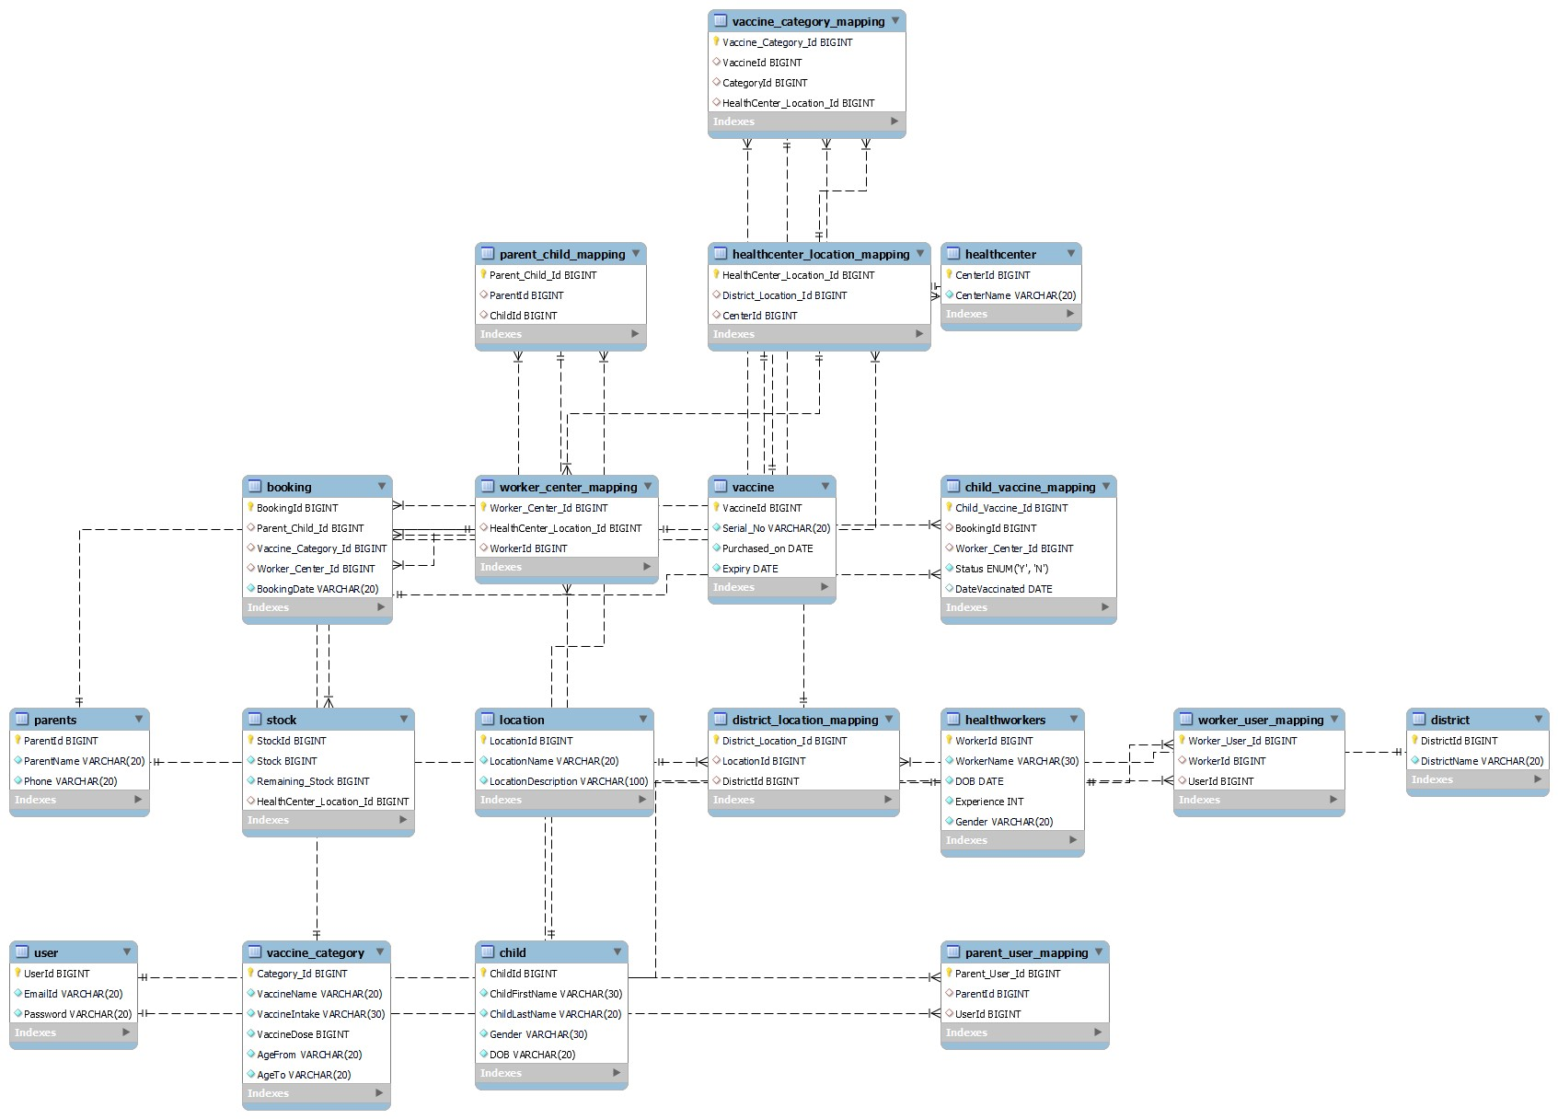

**Table Design - Normalized**

Table Name: User

Table Description: Table containing login details of each user

|  |  |  |
| --- | --- | --- |
| **Field** | **Datatype** | **Constraints** |
| UserId | bigint | Primary Key, Auto Increment |
| EmailId | varchar(20) | Unique, Not Null |
| Password | varchar(20) | Not Null |

Table Name: District

Table Description: Details of district.

|  |  |  |
| --- | --- | --- |
| **Field** | **Datatype** | **Constraints** |
| DistrictId | bigint | Primary Key. Auto Increment |
| DistrictName | varchar(20) | Not Null |

Table Name: Location

Table Description: Details of various locations within the district where the health centers are to be located.

|  |  |  |
| --- | --- | --- |
| **Field** | **Datatype** | **Constraints** |
| LocationId | bigint | Primary Key, Auto Increment |
| LocationName | varchar(20) | Not Null |
| LocationDescription | varchar(100) | Not Null |

Table Name: Healthcenter

Table Description: Details of various Healthcenters in the district.

|  |  |  |
| --- | --- | --- |
| **Field** | **Datatype** | **Constraints** |
| CenterId | bigint | Primary Key, Auto Increment |
| CenterName | varchar(20) | Unique, Not Null |

Table Name: Vaccine_Category

Table Description: Details of various vaccines.

|  |  |  |
| --- | --- | --- |
| **Field** | **Datatype** | **Constraints** |
| Category_Id | bigint | Primary Key, Auto Increment |
| VaccineName | varchar(20) | Not Null |
| VaccineIntake | varchar(30) | Not Null |
| VaccineDose | bigint | Not Null |
| AgeFrom | varchar(20) | Not Null |
| AgeTo | varchar(20) | Not Null |

Table Name: Vaccine

Table Description: Details of each vaccine

|  |  |  |
| --- | --- | --- |
| **Field** | **Datatype** | **Constraints** |
| VaccineId | bigint | Primary Key, Auto Increment |
| Serial_No | varchar(20) | Not Null |
| Purchased_on | date | Not Null |
| Expiry | date | Not Null |

Table Name: Healthworkers

Table Description: Details of health worker at each health center.

|  |  |  |
| --- | --- | --- |
| **Field** | **Datatype** | **Constraints** |
| WorkerId | bigint | Primary Key, Auto Increment |
| WorkerName | varchar(30) | Not Null |
| DOB | date | Not Null |
| Experience | Int(2) | Not Null |
| Gender | varchar(20) | Not Null |

Table Name: Parents

Table Description: Parent Registration Details

|  |  |  |
| --- | --- | --- |
| **Field** | **Datatype** | **Constraints** |
| ParentId | bigint | Primary Key, Auto Increment |
| ParentName | varchar(20) | Not Null |
| Phone | varchar(20) | Not Null |

Table Name: Child

Table Description: Child Details

|  |  |  |
| --- | --- | --- |
| **Field** | **Datatype** | **Constraints** |
| ChildId | bigint | Primary Key, Auto Increment |
| ChildFirstName | varchar(30) | Not Null |
| ChildLastName | varchar(20) | Not Null |
| Gender | varchar(30) | Not Null |
| DOB | varchar(20) | Not Null |

Table Name: District_Location_Mapping

Table Description: Table that maps location details with district

|  |  |  |
| --- | --- | --- |
| **Field** | **Datatype** | **Constraints** |
| District_Location_Id | bigint | Primary Key, Auto Increment |
| LocationId | bigint | Foreign Key |
| DistrictId | bigint | Foreign Key |

Table Name: HealthCenter_Location_Mapping

Table Description: Table that maps location details with district

|  |  |  |
| --- | --- | --- |
| **Field** | **Datatype** | **Constraints** |
| HealthCenter_Location _Id | bigint | Primary Key, Auto Increment |
| District_Location_Id | bigint | Foreign Key |
| CenterId | bigint | Foreign Key |

Table Name: Worker_Center_Mapping

Table Description: Table that maps healthworker with healthcenter

|  |  |  |
| --- | --- | --- |
| **Field** | **Datatype** | **Constraints** |
| Worker_Center_Id | bigint | Primary Key, Auto Increment |
| HealthCenter_Location _Id | bigint | Foreign Key |
| WorkerId | bigint | Foreign Key |

Table Name: Vaccine_Category_Mapping

Table Description: Table that maps individual vaccines detail with the corresponding category in each healthcenter

|  |  |  |
| --- | --- | --- |
| **Field** | **Datatype** | **Constraints** |
| Vaccine_Category_Id | bigint | Primary Key, Auto Increment |
| VaccineId | bigint | Foreign Key |
| CategoryId | bigint | Foreign Key |
| HealthCenter_Location _Id | bigint | Foreign Key |

Table Name: Parent_User_Mapping

Table Description: Table that maps parent details with user credentials

|  |  |  |
| --- | --- | --- |
| **Field** | **Datatype** | **Constraints** |
| Parent_User_Id | bigint | Primary Key, Auto Increment |
| ParentId | bigint | Foreign Key |
| UserId | bigint | Foreign Key |

Table Name: Parent_Child_Mapping

Table Description: Table that maps parent details with user child/children details

|  |  |  |
| --- | --- | --- |
| **Field** | **Datatype** | **Constraints** |
| Parent_Child_Id | bigint | Primary Key, Auto Increment |
| ParentId | bigint | Foreign Key |
| ChildId | bigint | Foreign Key |

Table Name: Worker_User_Mapping

Table Description: Table that maps health worker details with user credentials

|  |  |  |
| --- | --- | --- |
| **Field** | **Datatype** | **Constraints** |
| Worker_User_Id | bigint | Primary Key |
| WorkerId | bigint | Foreign Key |
| UserId | bigint | Foreign Key |

Table Name: Stock

Table Description:Stock/Quantity in each healthcenter

|  |  |  |
| --- | --- | --- |
| **Field** | **Datatype** | **Constraints** |
| StockId | bigint | Primary Key, Auto Increment |
| Stock | bigint | Not Null |
| Remaining_Stock | bigint | Not Null |
| HealthCenter_Location _Id | bigint | Foreign Key |

Table Name: Booking

Table Description: Bookings made by the parents.

|  |  |  |
| --- | --- | --- |
| **Field** | **Datatype** | **Constraints** |
| BookingId | bigint | Primary Key, Auto Increment |
| Parent_Child_Id | bigint | Foreign Key |
| Vaccine_Category_Id | bigint | Foreign Key |
| Worker_Center_Id | bigint | Foreign Key |
| BookingDate | varchar(20) | Not Null |

Table Name: Child_Vaccine_Mapping

Table Description: Status of the vaccine w.r.t each child

|  |  |  |
| --- | --- | --- |
| **Field** | **Datatype** | **Constraints** |
| Child_Vaccine_Id | bigint | Primary Key, Auto Increment |
| BookingId | bigint | Foreign Key |
| Worker_Center_Id | bigint | Foreign Key |
| Status | Enum(‘Y’,’N’) | Not Null |
| DateVaccinated | date | date |