**Curriculum Vitae**

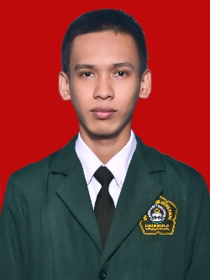**Name** : Juliar Nasution

**Sex** : Male

**Date of Birth** : 17 july, 1995

**Place of Birth** : Mikuasi, Kolaka Utara, Sulawesi Tenggara, Indonesia

**Status** : Single

**Religion** : Islam

**Nationality** : Indonesia

**Address** : Jl, Taman Sendang Sari 1 No 3A, Kalicari, Pedurungan, Semarang

**Phone** : +6285340559979

**Email** : juliarnasution@std.unissula.ac.id

**Web** : juliarnasution.blogspot.com

**Github Account** : <https://github.com/juliarnasution>

**Academic Qualifications**

2013-2017 : Bachelor of Informatic Engineering, UNISSULA.

2013-2017 : Bachelor of Islamic Civilization, UNISSULA.

**Organization Experience**

2015 - 2016 : Deputy Chairperson of Informatics Engineering Student Association

2016 – 2017 : Deputy Chairperson of History of Islamic Civilization Student Association

**Skills** :

**Programming :** PHP, ( CodeIgniter, Laravel ), HTML, Javascript, React Js, Java, Python.

**Database** : MySql, PostgreSql.

**Version Control** : Git, Tortoise Git

**Office** : Microsoft Word, Microsoft Excel, Microsoft Power Point.

**Others** : WordPress.

**Working Experience**

2015 - 2017 : Practical Assistant IT LITERACY, UNISSULA.

2017 – 2019 : Programmer at PT. DEWI RATIH PUTERA, Kendal,

2019 – now : Programmer at CV. Sekar Bumi Utama, Semarang